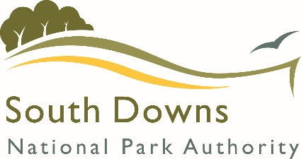
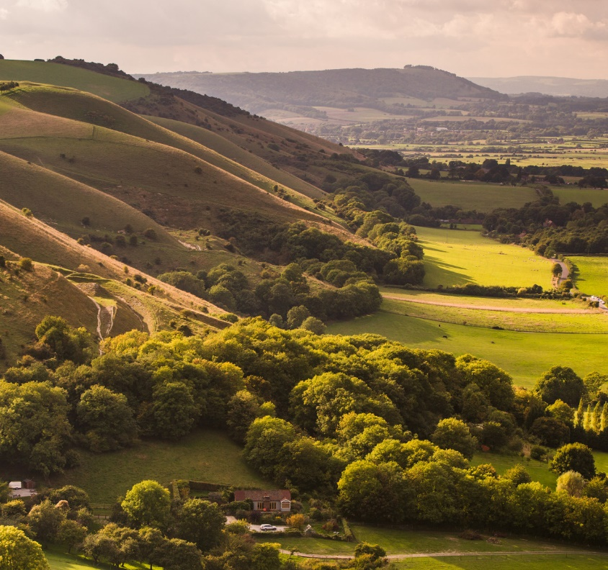



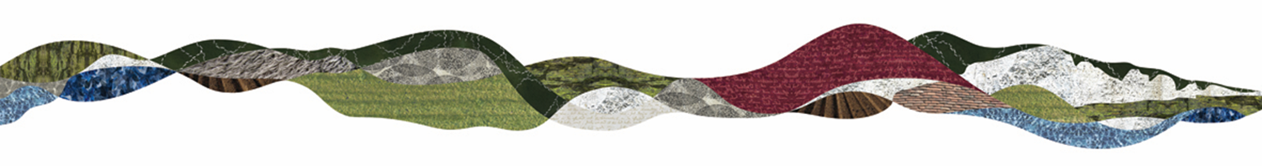

p
Independent (CIPFA) Co-opted Member of
the Policy & Resources Committee
Information for Applicants
What is the South Downs National Park?
The South Downs National Park has it all – rolling hills, glorious heathland, river valleys, ancient woodland, thriving villages and market towns, and the iconic white cliffs of the Heritage Coast. Covering over 1600 square kilometres of England’s most valued lowland landscapes in the busiest part of the UK, it has been shaped by the activities of its farmers and foresters, its large estates and communities, its charities and local businesses. It includes inspirational landscapes, internationally important wildlife, cultural heritage and lively market towns and villages.
Millions depend on the National Park’s water, benefit from its wildlife, use its timber and enjoy food and drink produced from its soils. It offers wonderful opportunities for outdoor learning and improves the health of all who simply enjoy fresh air, exercise and the tranquillity which can be found amongst its chalk Downland, farms, heaths, villages, woods and river valleys. These assets of the National Park therefore underpin the economy and quality of life in this part of southern England.
The South Downs National Park has produced many videos that give you a wonderful flavour of why the landscape is very special and unique, these are available to watch on our YouTube channel.
The Role of the South Downs National Park Authority
It is the role of the South Downs National Park Authority (SDNPA) to work to protect and enhance this landscape and promote its use not just to local residents, but as a national resource for the wellbeing of the nation. Our ambitious vision and plan for the National Park is set out in our Partnership Management Plan, which sets out 7 aims for the next five years. The Corporate Plan for the South Downs National Park Authority shows how the organisation sets its own priorities and delivers the outcomes in the Partnership Management Plan.
You can read more about our achievements over the last year in the Annual Review on our website.
Purposes and Duty of the South Downs National Park Authority
The South Downs has been nationally recognised for its natural beauty and the space it offers for people to enjoy the countryside.
The two Statutory purposes of the South Downs National Park are:
- To conserve and enhance the natural beauty, wildlife and cultural heritage of the area
- To promote opportunities for the understanding and enjoyment of the special qualities of the Park by the public
The South Downs National Park Authority is the lead organisation responsible for promoting the purposes of the National Park, working in partnership with other local authorities and organisations. In delivering Park purposes, the Authority has an important duty:
- To seek to foster the economic and social well-being of the local communities within the National Park
Membership of the Authority
The Authority is a public body made up of 27 Members and officers. The 27 Members comprise of:
      - 14 Councillors from Local Authorities within the South Downs National Park.
- 6 Councillors from Town and Parish Councils within the South Downs National Park. 2 Councillors each are appointed from East Sussex, West Sussex and Hampshire.
- 7 Members appointed by the Secretary of State following a national, open competition.
SDNPA Members are appointed to represent the National Park as a whole and not their appointing body.
The Members make the decisions and are responsible for setting policies, priorities and procedures and ensuring the Authority delivers value for money. Officers are employees of the Authority who implement the policies and procedures agreed by the Members and carry out the decisions made by Members. On routine matters, Members ask Officers to take decisions directly, in line with agreed policies (Scheme of Delegation, set out in the Authority’s Standing Orders). The overall responsibility for the work of the Officers lies with the Chief Executive Officer (National Park Officer).
The National Park Authority has statutory responsibility for access and is the statutory Planning Authority with responsibility for all planning applications and other planning matters within the National Park.
Role of the Policy and Resources Committee
The role of the Policy & Resources Committee includes ensuring good governance of the Authority by overseeing and reviewing its arrangements for audit, financial control and risk management.
Amongst other functions, the Policy & Resources Committee has the following specific functions:
  - Meeting the requirements of the Accounts and Audit Regulations 2015 in respect of conducting an annual review of the effectiveness of the system of internal control and internal audit, reviewing the outcome of the annual review of governance arrangements and approving the Annual Governance Statement, and considering and approving the Authority’s annual Statement of Accounts.
  - Providing assurance as to the adequacy of arrangements for the prevention and detection of fraud and corruption.
  - Agreeing the Internal Audit Plan and the External Auditor’s Annual Audit Plan and receive progress and other relevant reports.
  - Monitoring and reviewing the performance, including financial performance, of the Authority in the context of its business delivery and the management and maintenance of the Authority’s assets in accordance with the Authority’s agreed budget, Corporate Plan and other approved plans.
Independent (CIPFA) Co-opted Members assist in promoting public confidence in the work of the Policy & Resources Committee and in ensuring impartiality. They add value to the Committee’s work by bringing their wider experience to bear in the Committee’s deliberations. For clarity, the Independent (CIPFA) Co-opted Members are not appointed by CIPFA but are appointed by the Authority to meet the CIPFA guidance related to independent members on Audit committees.
Skills and Competencies of Independent (CIPFA) Co-opted Members
A role description is included with this information pack
The Independent (CIPFA) Co-optees will have:
- A knowledge of corporate governance and risk management
- Financial management experience
- An understanding of accountability and probity in public life
- A wish to serve the local community and uphold local democracy
- Effective questioning skills
- Some knowledge of public finance
The Independent (CIPFA) Co-optees will:
- Be a person in whose impartiality, independence, and integrity the public can have confidence.
- Understand and comply with confidentiality requirements.
- Have a demonstrable interest in local issues.
- Be a good communicator.
- Be able to demonstrate they are free from influence of party politics when undertaking this role.
Requirements of the Role
The successful candidate will be appointed to the Policy & Resources Committee to serve alongside Members of the Authority and to work/contribute to the Committee. The appointment will be for a period of 4 years, with a maximum term of office of 8 years.
The role holder must comply with the Authority’s Member Code of Conduct and disclose their interests in the Register of Members’ Interests maintained by the Monitoring Officer, in the same way as other Members. Complaints about the conduct of Co-opted members will be treated in the same way as that of other Members. An appointment may be terminated earlier where it is deemed, in the absolute discretion of the Authority, that the role holder has conducted him/herself in a way which breaches the Member Code of Conduct.
There will normally be 4 scheduled meetings of the Committee in any year. In addition to this, it is expected that co-opted Members will participate in certain meetings and activities including engaging with strategic days for Members of the Authority and other workshops and undertaking in-depth investigations into specific topics agreed by the Committee if necessary.
An Independent (CIPFA) Co-opted Member should also not have had significant previous dealings with the Authority which may compromise their impartiality, nor have a close relationship with any Member or Officer of the Authority. Further. the NPA may not appoint any person who is disqualified under Part V of the Local Government Act 1972 from being elected or being a member of a local authority. This includes any person who:
- holds any paid office or employment with, or an appointment by, the SDNPA;
- is employed by a company which is under the control of the SDNPA;
- is subject to bankruptcy orders;
- has, within the last 5 years, been convicted in the UK, Channel Islands or Isle of Man of any offence and has received a sentence of imprisonment (suspended or not) for a period of not less than three months without the option of a fine;
- is disqualified under Part III of the Representation of the People Act 1983; or
- is employed by a local authority under the direction of SDNPA on which the local authority has an appointed member.”
The Authority is committed to equity, diversity and inclusion as an employer and provider of services and welcomes applications from all sectors of the community.
Meetings, Allowance and Expenses
The South Downs National Park Authority is based in Midhurst, West Sussex. The majority of formal meetings of the Authority are held at the South Downs Centre in Midhurst. Workshops and other Member events are held at various locations across the National Park.
Formal meetings are streamed live with previous meetings available to watch online.
The time commitment is approximately 2 days a month which will include reading papers to be prepared for meetings.
Throughout the year you will be invited to attend:
- 4 Policy and Resources Committee Meetings per year.
- 1 Policy and Resources Committee Away Day
- Approximately 4 Workshops per year.
- 3/4 Strategic Days per year which are in various locations across the National Park.
An allowance of £3,322 per annum (subject to annual uplift) is payable for this role. This allowance is paid in 12 monthly instalments.
Travelling expenses will be payable at the following rates:
- Car allowance: 45p per mile first 10,000 miles, 25p per mile thereafter
- Bicycle allowance: 20p per mile
- Motorcycle allowance: 24p per mile
- Passenger supplement: 5p per mile per passenger

Induction and Training
Suitable induction and training will be provided on the role of the Committee.
Recruitment Procedure
Applications are to be submitted in accordance with the instructions in the application form, which is to be received no later than midnight, 17 May 2026. In completing the application form, candidates should give evidence of the experience they have of applying the skills and competencies for this role.
Applicants invited for interview will be notified in writing by 26 May 2026.
Shortlisted candidates will be interviewed by a panel of Members of the Authority, advised by the Authority’s Monitoring Officer, during the week of 8 June 2026. The interview panel will then select candidates to be recommended to the Authority for appointment. The appointment will be made by the Authority on 7 July 2026.
All candidates interviewed will be notified as soon as possible after interview whether or not they are being recommended for appointment.
Further Information
For further information, you may find the following websites of interest:
- South Downs National Park Authority – http://www.southdowns.gov.uk
- Department of Environment, Food and Rural Affairs (National Parks section) http://defra.gov.uk/rural/national-parks/index.htm
For an informal discussion about the role, please contact the Authority’s Monitoring Officer, Richard Sandiford, richard.sandiford@southdowns.gov.uk, Tel: 07387 419745.

Role Description for Co-opted Members of
the SDNPA Policy and Resources Committee

The South Downs National Park Authority appoints co-opted members to its Policy and Resources (P&R) Committee, in order to strengthen the breadth of experience and skills available to the Committee and the wider work of the Authority. The role of co-opted members is wide ranging and whilst co-opted members will only be appointed to the P&R committee, it is expected that they will participate in the full range of meetings and activities attended by Members of the Authority.

Purpose of the Role
The co-optee role is to complement, inform and challenge, rather than replace, the role of appointed Members who remain accountable to the Authority and are ultimately responsible for decision-making.
Whilst all co-optees are non-voting, the Authority recognises the valuable contribution that co-opted members make to the work of the Authority in supporting good governance and broadening the range of voices involved in the debate about key issues. thereby helping better, more inclusive decisions to be made
Co-optees may play specific roles, such as those appointed to contribute to effective arrangements for audit, financial control and risk management they may be appointed because they have particular expertise or experience that is not well represented on the NPA by other means. Co-optees would also play an important role in advocating and championing the National Park, helping us to reach new, wider and diverse audiences. Such an approach would run alongside existing consultative and engagement methods.
Co-opted members will have access to all of the services, support and information available to voting members of the Committee.
Co-opted members will be appointed for a four-year term, at the end of which they may be considered for reappointment. It is expected that any independent (CIPFA) co-optee will not normally serve for more than 2 terms, in order to preserve the independence of the role. Any reappointment is subject to a decision of the NPA.
Co-opted members are not eligible to vote on matters at meetings of the Policy and Resources Committee or other meetings that they may be invited to attend but will be able to fully participate in any debate or discussions held at such meetings or events.

Key Expectations of co-opted members

It is expected that all co-opted members will:
- participate in meetings of the Policy and Resources Committee and other member events/meetings
- Give presentations or specific inputs as requested to meetings or workshops
- provide input and expertise to assist the Committee in its work.
- adhere to and promote the Members’ Code of Conduct to encourage the highest standards of behaviour in public office.
- represent and act in the best interests of the Authority and in accordance with the Authority’s Standing Orders and other protocols.
- Attend an annual meeting with the Chair of the Committee and relevant Director to discuss their experience and performance
For individuals co-opted to comply with the Chartered Institute of Public Finance and Accountancy (CIPFA) guidance, it is also expected that they will have:
- A knowledge of corporate governance and risk management
- Financial management experience
- An understanding of accountability and probity in public life
- A wish to serve the local community and uphold local democracy
- Effective questioning skills
- Some knowledge of public finance

Remuneration and time commitment
Co-opted members may claim travel and subsistence and receive the payment of an allowance as set out in the SDNPA Members Allowance Scheme.

