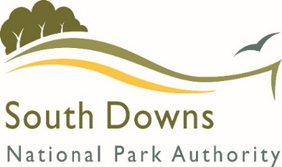
External Viability Assessment
Payment Agreement

Site Details
Site Address
Proposal

Independent Viability Appraisals
The submission of a viability appraisal is required where an application seeks to depart from specified SDNPA policies.
Submitted viability information will be assessed by the SDNPA who will seek the services of an independent assessor to give advice on viability where appropriate.
The cost of the initial independent assessment and any further associated costs will be paid for by the applicant. By completing this form you are agreeing to pay for the initial independent assessment of the viability documentation.
Upon receipt of an invoice from SDNPA a standard fee of £3,000 or £5,000 is payable prior to the independent assessor being instructed to undertake the assessment.
The fee of £3,000 will be sought for minor scale single issue proposals, such as 3-9 dwellings, agricultural, and commercial or community proposals under 1,000sqm. The higher fee of £5,000 will be sought for major scale proposals of 10+ dwellings, 1,000sqm commercial or proposals that include multiple element such as heritage, demolition or mixed use. The fee is to be confirmed by the Authority upon review of the circumstances of the case.
A quote from the independent assessor will be sought and agreed with the applicant on a case by case basis prior to instruction. Any overpayment of the standard fee will be refunded to the applicant upon written request. No further refunds will be made following instruction of the external assessor. Applicants will be advised of any costs above the standard fee and agreement to pay the additional costs prior to instruction will be sought. Costs for applications which are more bespoke in their nature will be discussed during the pre-application and application processes.
Any further assessment as may be required during consideration of the application will incur additional charges to be paid for by the applicant. Agreement to pay the additional costs will be sought and payment will be received by the SDNPA prior to the instruction of the independent assessor to carry out any additional work.
Failure to pay the independent assessor costs will result in your application being delayed or refused on lack of information.

Invoicing Details
Contact Name
Company Name (if applicable)
Address

Contact Email
Contact Telephone

Agreement to pay Independent Assessor Costs
In my capacity as (please delete as appropriate):

Agent Applicant Other: ___________________________

I agree to pay the standard fee for the services of an independent assessor upon receipt of an invoice from the SDNPA. I understand that the fee level will be confirmed by the Authority on review of the circumstances of the case.

I agree that any costs that may be incurred in addition to the standard fee will be agreed as appropriate prior to work being undertaken.

I agree to pay any agreed additional costs upon receipt of an invoice from the SDNPA.

I understand that non-payment of any costs will result in a delay to the application decision or may result in refusal on lack of information.

Signed: ______________________________________________ Date: ________________

Printed Name: ________________________________________

All data received and processed is solely for the purpose of carrying out our services (our public task). For further information about how your data is used please visit https://www.southdowns.gov.uk/national-park-authority/transparency/privacy-statement-2/

