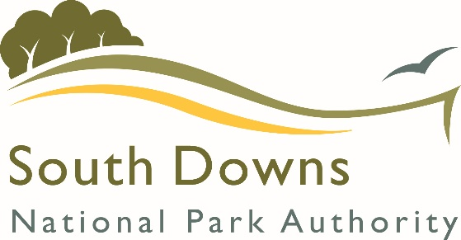 | Approved  Contractor (Countryside Works)  Application Form

Instructions
In order to be considered for the South Downs National Park Authority (SDNPA) Approved Contractor List, please complete this form and either email it to contractors@southdowns.gov.uk, or submit by post to The Procurement Team, South Downs National Park Authority, South Downs Centre, North Street, Midhurst, GU29 9DH.
Please note that acceptance on to the Approved Contractor list is not a guarantee of any contract/commission.
Please state what area of work you would like to be put on the list for (delete as appropriate) | ☐ Coppicing  ☐ Tree work  ☐ Fencing  ☐ Gates, stiles, field gates  ☐ Scrub clearance  ☐ Grazing  ☐ Other countryside (specialist) work
With reference to the map at the end of this document, please state the location(s) you are prepared to work in (delete as appropriate) | ☐ Western Area  ☐ Central Area  ☐ Eastern Area
Please state what value of work you are interested in (delete as appropriate) | ☐ 0-5k  ☐ 5-10k  ☐ 10-25k
Company Name
Address from which the contract will be delivered, including postcode.

Website
Main Contact
Name
Position
Telephone Number
E-mail

Current Legal Status  (delete as appropriate) | ☐ Sole Trader  ☐ Partnership  ☐ Public Limited Company  ☐ Private Limited Company  ☐ Public Sector (including Registered Charities, NDPBs, ☐ Housing Associations)  ☐ Other (please state)
Financial Information: please provide information for the last three financial years.
Year Ended | XX/XX/XXXX XX/XX/XXXX XX/XX/XXXX  £…………… £…………… £……………
Turnover (£)
If you cannot provide the information above please give an explanation why
Does your organisation comply with your statutory obligations under the Equality Act 2010? | Yes/No  If you have more than 5 staff, then please attach a copy of your Equality and Diversity policy and/or equal opportunities policy with your response.
Are you a relevant commercial organisation as defined by section 54 ("Transparency in supply chains etc.") of the Modern Slavery Act 2015 ("the Act")? (Under the Modern Slavery Act, a "commercial organisation" is defined as any partnership or body corporate that: supplies goods or services; and carries on all or part of its business in the UK; and has an annual turnover of at least £36million) | ☐ Yes  ☐ No
If you have answered yes to the question above are you compliant with the annual reporting requirements contained within Section 54 of the Act 2015? | ☐ Yes  ☐ No
Insurance Information

SDNPA has set minimum insurance requirements which all companies working with us must adhere to. For any contract work, it is a requirement that contractors hold the levels of insurance indicated below which will need to be in place before the commencement of any contracts. If you do not have the minimum insurance requirements and are not prepared to obtain such cover on the award of a commission, you will be excluded from the Approved Contract List. Please provide proof of insurance and expiry with this form.

Please indicate your insurance status below (please delete as appropriate):
All contracts :  Employers Liability  £5 million | ☐ Yes, I already have this  ☐ Not applicable, I am a sole trader
The levels of public liability cover will be dependent on the work involved (See below table). Please indicate the levels you already have, or are willing to obtain if you are awarded work. (please delete as appropriate).
Public Liability  £5 million | ☐ Yes, I already have this  ☐ I do not currently have but I am willing to obtain on award of a contract  ☐ I am not willing to obtain this
Public Liability  £10 million | ☐ Yes, I already have this  ☐ I do not currently have but I am willing to obtain on award of a contract.  ☐ I am not willing to obtain this
Contracted Activity | Public Liability Cover Required
Coppicing | £5m
Tree work | £10m
Fencing | £10m
Gates, stiles, field gates: | £5m-£10m
Scrub clearance | £5m
Involving Heavy Plant | £10m
On or near the highway | £10m
Grazing:
- Cattle | £10m
- Sheep | £5m
- Ponies | £10m
- Goats | £10m

Health and Safety
Does your Organisation have a written Health and Safety Policy? | Yes/No  If yes, please enclose a copy with your response
How does your organisation ensure compliance with the Health and Safety at Work Act 1974?
Does your organisation train staff in Health and Safety? | Yes/No
Please provide the name of the person in the business specifically responsible for health and safety matters
Previous Experience/Qualifications
Use the below box to provide details of previous experience. Please include any specialist skills or equipment we should be aware of together with details of qualifications obtained in relation to these.
Risk assessments and method statements

You must submit these with your application form for all of the areas of work you have selected on Page 1.

If you require a template in order to complete your risk assessments
and method statements please contact us.
Environmental responsibility and sustainability

Please let us know how you work in an environmentally responsible and sustainable way (for example this might include how you reduce your carbon footprint, use of aspen fuel, battery powered tools, use of local labour/materials/supplies, etc).

South Downs National Park Area Map
