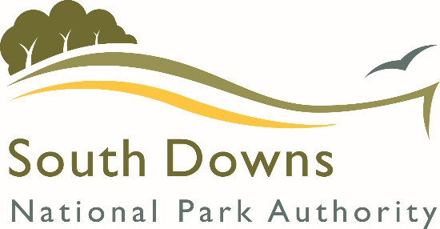

Request for Pre-application Advice (Non-householder)

For more information on our pre-application advice service, please visit our website
Pre-application advice - South Downs National Park Authority

We aim to provide a response within 25 working days from receipt of a valid request.

1 About the Applicant

Name:
Email (preferred method of contact)
Address

Postcode:
Telephone:

2 About the Agent (complete if appropriate)

Name:
Email (preferred method of contact)
Address

Postcode:
Telephone:

3 Site Location

Full Address of site

Postcode:

4 Description of the proposed development

5 About the Site

Ownership The applicant is the (please tick)
Owner Occupier Lessee Prospective purchaser

Site accessibility
Is the entire site accessible? Yes No

NOTE: The Officer may conduct an unaccompanied site visit and will only contact you if he/she cannot gain access and an appointment needs to be made.

6 Meeting request
Would you like a meeting/additional meetings? Yes* No

NOTE: Meetings are included with some levels of preapp service. Additional meeting requests are chargeable and a fee payable prior to this meeting. Please see website for current charging schedule.

7 Supporting Information

To consider your proposal we require the following (please tick to confirm).

A site location plan, which includes an indication of where the proposed development
will be sited. Please include details of all site boundaries, neighbours and adjacent roads
shown.

Appropriate fee (see website for current fees) Amount paid £
NOTE:
In regard to small and micro businesses in farming, forestry and tourism the SDNPA will provide free pre-application advice (one meeting followed up with written advice) for the following development that are all linked to the corporate priorities:
• Small scale renewable energy projects
• Development proposals that seek to incorporate sustainable design features that substantially go beyond the sustainable construction standards set out in Policy SD48 and the Sustainable Construction SPD
• Development proposals linked to the FiPL programme
• Development proposals that substantially go beyond local and national policies in contributing to nature recovery
• Development proposals that substantially go beyond local and national policies in contributing positively to health and well-being
• Small scale affordable housing schemes
Please see the Planning Position Statement Committee report for more information.
If you consider that your scheme or business should be considered for a fee exemption, please provide an explanation/justification:

We also advise that you also submit the following as the quality of the advice we can give depends on the quality of the information we receive. (please tick to confirm).

Existing drawings – site layout plan, floor plans and elevations

Proposed drawings – site layout plan, floor plans and all elevations

Photographs of the existing site and buildings are also useful

Draft Design and Access Statement

Draft Landscape and Visual Impact Statement

Important note:
This list is not comprehensive and you may be asked for additional information, depending on the nature of your scheme.
- The National Park may not be able to accept some location plans such as Land Registry based plans or other supporting documents for which a copyright is held by a third party.
- Your submission may not be validated nor allocated to an attending officer if there is insufficient information relating to your proposed scheme.
- We are unable to return any plans that are submitted.

8 Declaration

I/we the undersigned, confirm that I/we are seeking pre-application advice on the proposed development described in the attached documentation.

Please note:
Any advice given represents the officers’ informal opinion based upon the information you have provided. It is given without prejudice to any decision the SDNPA may make on any subsequent formal planning application. The SDNPA operate a transparent service, whereby the final pre-application response, although not publicised during its consideration, may be referred to and placed on the online planning register as a back ground paper where a relevant, subsequent planning application is submitted. All statutory planning applications will be the subject of publicity and consultation in accordance with current legislation and SDNPA’s procedures. These, and other matters which may subsequently come to light, may result in additional issues being raised that are pertinent to the determination of the application.

Name (please print)

On behalf of

Date

Please email/send the completed form and supporting information directly to:
- the SDNPA for sites within Adur and Worthing, Arun, Brighton & Hove, Mid-Sussex or Wealden within the National Park,
- or the relevant partner Local Authority for sites in Chichester, East Hants, Horsham, Lewes (including Eastbourne), or Winchester for sites within these Authorities within the National Park.

