Plant Power CPD Handout
- Building in the rules and expectations
- Start with short activities
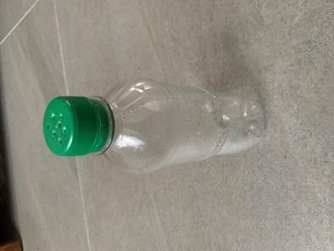
- making the most of the weather
- moments to pause
- minimal resources
- Clip boards and recording pro-forma useful
- Use ipad/ digital camera
- Repetition of activities or practices
- Scavenger hunts encourage close observation
- Know your grounds!
How to grow pea shoots

You can grow these delicious pea shoots all year around on your window sill. Water daily and one planting will give you 2 crops. Dried peas can be bought in the supermarket, they are very cheap!

- Put a handful of dried peas in a mug, cover with water and leave for about ½ an hour.
- Put about 2 cm of compost in the bottom of your pot or tray.
- Sprinkle over the peas, you need to have a thick layer.
- Cover with about 1cm of compost. Gently pat down.
- Water and put on a window sill.
- Water daily, when your shoots are 8-10cm tall they are ready to crop.
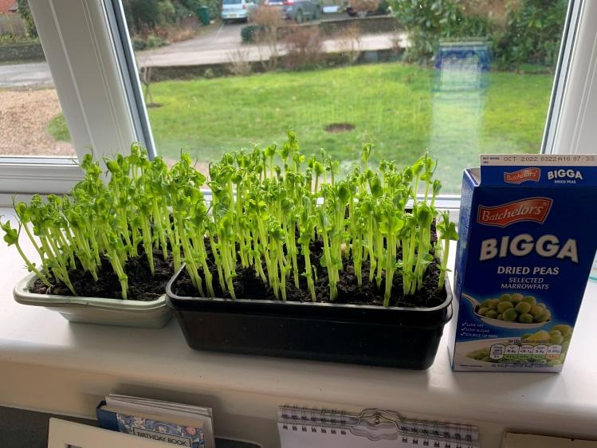
- Cut with a pair of scissors, water again and leave to grow for your second crop. 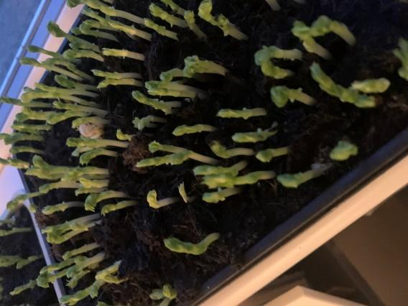
The shoots after 5 days
I used 2 food trays
Tips
Collect 2 similar trays. Poke a few holes for drainage in one and place the second underneath.

Make your own ‘watering can’ by putting holes in the lid of a plastic bottle. I used a nail and hammered about 5 holes. (be careful- get an adult to help you!)

Useful links for resources
Tree identification
https://www.imperial.ac.uk/opal/surveys/treehealthsurvey/
Including a branching key
https://www.tes.com/resource-detail/download/6358482
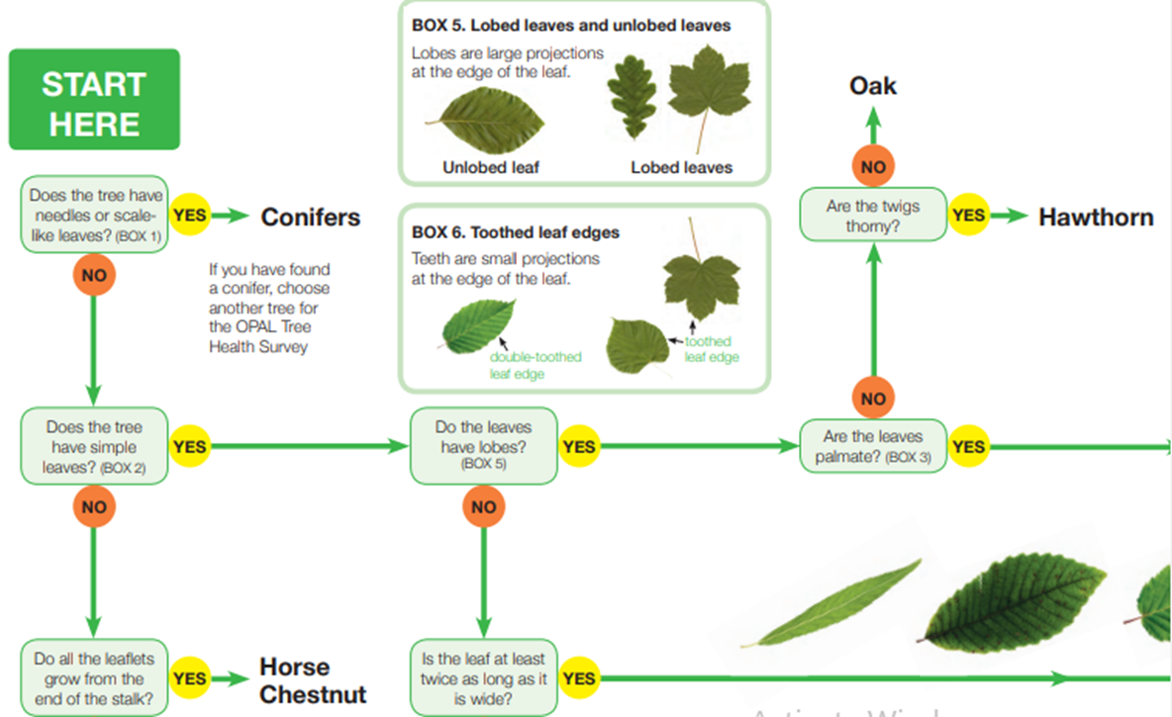
Woodland trust website has lots of useful information
https://www.woodlandtrust.org.uk/blog/2020/03/tree-id-kids/

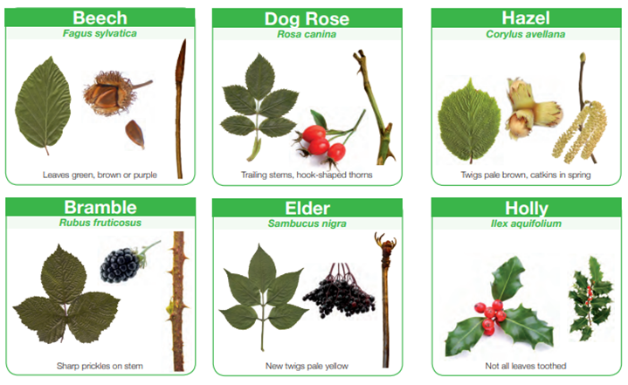
For visits to Tuppenny Barn please email: liz@tuppennybarn.co.uk or abi@tuppennybarn.co.uk

