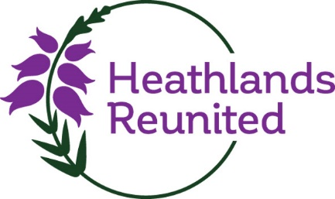

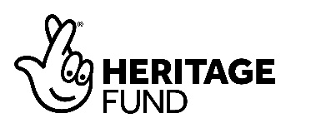
South Downs National Park Heathlands Photo competition
Terms and Conditions
By entering the competition you are deemed to accept these Terms and Conditions.
Eligibility
The competition is open to anyone aged between 3 and 10 years of age.
Your parent or legal guardian must submit the entry and fill out the entry details (mentioned below) on your behalf to heathlands@southdowns.gov.uk
The competition is open to individuals, families, households, community groups, schools and businesses.
Entrants must enter a photograph taken on heathland, this can be of plants, wildlife, sculptures or landscape.
Closing date
The Competition will be open for entries until midnight on Thursday, 30 September.

Entries received after this deadline will not be accepted.

No responsibility is accepted for network, computer hardware or software failures of any kind which may restrict or delay the sending of your entry. No responsibility is accepted by the South Downs National Park Authority (SDNPA) for entries lost, delayed, misdirected, incomplete, or which cannot be entered for technical or other reasons. Proof of entry is not proof of receipt.
Entry details
Entries should be emailed to heathlands@southdowns.gov.uk with the subject line “Discovering My Heath”.
Written applications, with a print-out photograph, will also be accepted by dropping off the details to the South Downs Centre in Midhurst.
An application should include:
- Confirmation of the age category you are entering
- At least one clear image related to the heathland.
- An image title.
- Contact details (including e-mail address, full name and address)
Prizes
Shortlisting and judging will take place after 30 September 2021.
The decision on prizewinners is final and no discussion or correspondence will be entered into in respect of the decision.
The prizes are:
1st prize: Family day ticket to Marwell Zoo
2nd prize: The Nature Hideaway Kit – The Den Kit Co
3rd prize: Get bug hunting with the amazing Entomology Kit – The Den Kit Co.
The prizes are non-transferable.
Once the winner has been notified, he/she will need to provide full contact details including name, age, address, email address and photographic proof of identity in order to claim the prize.
By entering the Competition you release SDNPA from and against all claims and damages arising from or in connection with your participation in the Competition. You agree to comply with these Rules of Entry.
Details relating to any prizes will be sent to the winner within 30 days of the winner being announced.
Entrants’ responsibilities
You are responsible for informing SDNPA of any changes to the information entered, in particular of any change of contact details at any time before the closing date.
You will not submit any photographs that are obscene, vulgar, pornographic, hateful, threatening, racist, sexist, discriminatory, or which otherwise violate any local or international laws.
If your image does feature children you must have their parents’/guardian(s)’ legal consent for the image to be published online and in hard copy. The SDNPA will ultimately decide if something is appropriate or not and whether it is eligible to be entered into the competition.
SDNPA staff, members and their immediate family members may enter this competition but will not be eligible to win a prize.
Copyright and usage
By submitting images to the competition, you confirm and warrant that:
- you are the sole author of each entry and that it is your original work
- you own the copyright and any other intellectual property rights of each image
- you have the permission of those pictured in the image (or, where the image shows any persons under 18, the consent of their parent or guardian) for the usage rights required in the section on licensing below and will indemnify SDNPA against any claims made by any third parties in respect of such infringement
- you have not licensed or disposed of any rights in the image that would conflict with uses to be made in the licensing section below
- You agree to take part in any post-competition publicity and to be potentially contacted by our Media and Public Relations Officer.
By entering the competition, you grant the SDNPA a non-exclusive, irrevocable licence to reproduce, enlarge, publish or exhibit, on any media, the images and details of the project. This may include, but is not limited to:
- News coverage of the competition
- SDNPA newsletter
- SDNPA website
- SDNPA Facebook page
- SDNPA Twitter feed
- SDNPA Instagram feed
- SDNPA YouTube feed
- SDNPA LinkedIn feed
- Exhibitions
- Publications – such as leaflets and reports
- for use in press releases to be distributed to national, regional and specialist press giving information about or promoting the competition and/or the #ReNature campaign.
You will retain full copyright for your image and, wherever possible, will be credited if your image is published by SDNPA. Failure to publish a credit due to error or oversight shall not be deemed a breach of this condition.
Please note that by entering the competition you are giving consent for the SDNPA to process your information for the purpose of administrating the competition. We will only contact you if your photo wins the competition or is selected for inclusion in our photo library. We will delete your information within a year of the close of the competition unless you ask us to sooner, the photo you have submitted wins the competition, or is selected for inclusion in our photo library. We will not share this information with any third party without your consent, unless we are required to do so by law. Your rights are set out in our Privacy Statement www.southdowns.gov.uk/privacy-statement-2/
SDNPA reserves the right to cancel or amend the competition, the rules and the terms and conditions of entry at any time and without prior notice. Any changes will be posted either within these terms and conditions or in the competition details.
The organiser of this competition is: SDNPA, The South Downs Centre, North Street, Midhurst GU29 9DH. Please email comms@southdowns.gov.uk with any queries.

