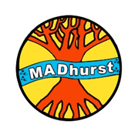

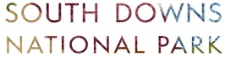

**MADhurst Short Story Competition Entry form   
Please complete and return with your entry** **by June 30th 2021. Email to [MADhurstComp@southdowns.gov.uk](mailto:MADhurstComp@southdowns.gov.uk)**

**Entrants name…………………………………………………………………………………… Entrants age………………….**

**Story Title……………………………………………………………………………………………………………………………………….**

**Parent/carer/guardian’s name *(if entrant is under 18)* ……………………………………………………………………**

**Telephone No…………………………………………… Email…………………………………………………..………………………**

I consent to my child’s story being recorded and published on the SDNPA website and social media channels *(see Terms and Conditions)*

Signature ……………………………………………………………

I have read and agree to the terms and conditions

***Notes:****No child’s name will be published without consent from the parent or legal guardian.*

*By entering the competition, you are giving consent for SDNPA to process your information for the purpose of administrating the competition. We will share names, age categories and contact details (for winning entries only) with MADhurst, for the purpose of distributing prizes and seeking further consent for publicity, and you can find further information on their privacy commitment here* [*https://madhurst.co.uk/privacy-policy/*](https://madhurst.co.uk/privacy-policy/)*.* *By entering the competition, you grant the SDNPA a non-exclusive, irrevocable license to reproduce, publish or exhibit your short story (please see Terms and Conditions for more information).**We will delete your information within a year of the close of the competition unless you ask us to sooner. We will not share this information with any third party without your* *consent, unless we are required to do so by law. Your rights are set out in our Privacy Statement* [***https://www.southdowns.gov.uk/national-park-authority/transparency/privacy-statement-2/***](https://www.southdowns.gov.uk/national-park-authority/transparency/privacy-statement-2/)