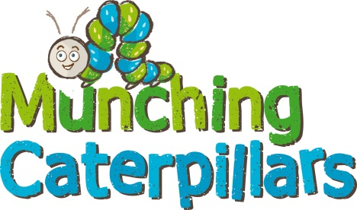
Improving School Grounds for Pollinators (and Pupils): A year-Round Project
September / October
- Plan your project. Draw a plan of your school grounds and identify south facing sunny spots. Involve your pupils by using the Polli:Nation Scale Drawings Design worksheet, or the Dream Garden creative writing worksheet.
- Think about how you can use the different features of your grounds to provide varied habitat for pollinators and ask parents to help source materials such as pallets, pots, planters, plastic bottles and tyres.
- Start learning about butterflies and moths or other pollinators; think about ways you can integrate them in your food chains, habitats, art, creative writing….
- Make some fruit kebabs for autumn butterflies
- Prepare any areas for seeding by scraping off old vegetation and sowing seeds.
- Mow any areas you intend to leave as wild patches and rake off the cuttings.
- In year 2 onwards, make sure you keep watering and deadheading your plants to extend the flowering season.
- Collect any seeds from the summer and use them to bolster your existing plots or create new areas for pollinators.

November – February
- Prepare your planters, paint tyres and pots and source any more materials you need for planting up etc.
- Continue to prepare any areas you plan to sow with wildflower seed.
- Get pupils involved in budgeting for your project, using the Polli:Nation garden budget worksheet.
- Integrate learning about butterflies and moths into your curriculum, using some of the fantastic resources available on our webpages (https://munchingcaterpillars.org/resources/ and https://butterfly-conservation.org/our-work/education/childrens-resources)
- Make use of our free video lessons on our YouTube Channel (https://www.youtube.com/playlist?list=PLLoJK9yKJP42oxCNUTGvjlTAzYlUWghvo)

March
- Prepare and sow any areas which you didn’t get to in September.
- Make newspaper plant pots and sow individual seeds, ready to transplant to your planters later in the spring.

April – July
- Plant up your tyres, pots and planters, remembering to use peat-free compost.
- Assign water and deadheading monitors to keep on top of the maintenance of your plants.
- Use our spring butterfly spotters sheet to start practicing butterfly identification.
- Download our iRecord app to report any sightings and start building up records for your school.
- Continue to integrate butterflies and moths into your curriculum
- Go on a caterpillar hunt and rear them through to adult moths or butterflies in your classroom
- Take part in the Big Butterfly Count and spread the word to your parents!

Links
www.butterfly-conservation.org – Butterfly Conservation (Go to Our Work > Education for kids resources)
https://munchingcaterpillars.org/ - Munching Caterpillars
http://polli-nation.co.uk/ - Polli:Nation
https://www.buglife.org.uk/ - Bug Life
https://www.wildlifewatch.org.uk/ - The Wildlife Trusts / Wildlife Watch
https://www.nhbs.com/ - NHBS (bug hunting kit)
https://muddyfaces.co.uk/ - Muddy Faces (outdoor clothing, kit and tools for kids)
Facebook Groups – including “Curriculum Based Outdoor Learning Ideas”
https://www.youtube.com/watch?v=1gOQ8-j-rtA – Xander Ant Boy budget moth trap (check out his other videos too!)
https://butterfly-conservation.org/sites/default/files/moths-count-factsheet-1-how-to-start-mothing.pdf - How to start moth trapping
https://www.youtube.com/watch?v=6GCcsBtUo_c – How to do Hapa Zome
https://butterfly-conservation.org/moths/striped-lychnis - More about Striped Lychnis

Please send us photos of your improved school grounds, we’d love to see them! And if you find something and can’t work out what it is, you can Ask An Expert here - https://munchingcaterpillars.org/ask-an-expert/

