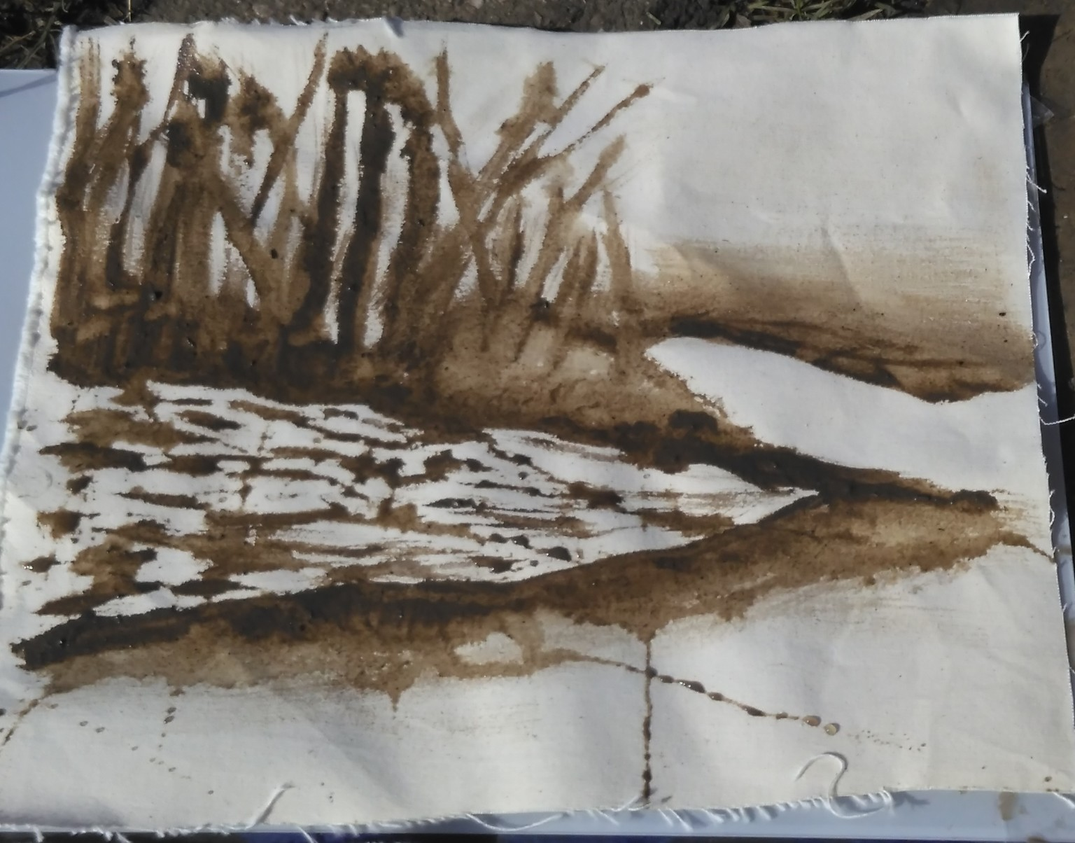
Feel better to learn better!

Making the most of your outside spaces to support pupils physical, emotional and mental wellbeing.

Pupils who visit Tuppenny Barn often reflect at the end of the sessions feeling more relaxed and positive after reconnecting with nature.
We aim to give you the confidence to use your outside spaces to achieve the same benefits.
During the session we will explore:
- Using the outdoor environment to improve pupils wellbeing
- Using natural and creative elements to help to lower stress levels and reduce anxiety
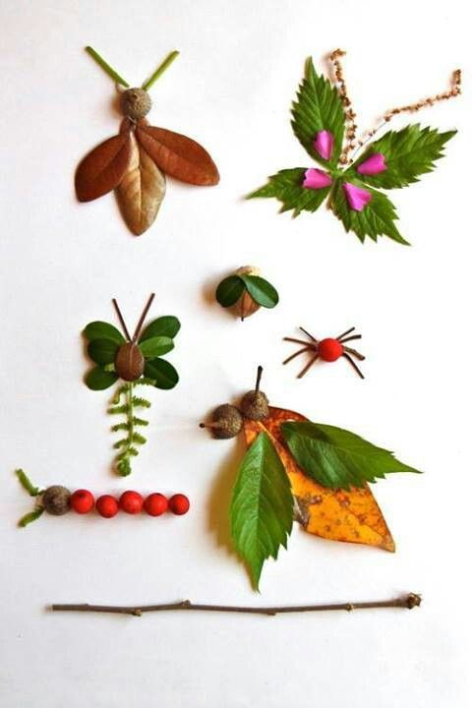
- Giving pupils a chance to reflect, relax and reconnect with nature.

Course outline:
Introduction to Tuppenny Barn
What we do and what a trip looks like.
Benefits and quotes
Outside space
Crowd control and ground rules
Activities
- short openers or brain breaks
- making the most of the weather
- moments to pause
-minimal resources, set up shared resources

Senses activities
5 finger listening- hold out your 5 fingers, close your eyes, listen, every time you hear a new sound fold your finger down.
Smelly things- Find an interesting smell- great if you have some herbs growing
Smelling cups- put some herbs into a cup and top with a piece of net or plastic bag with holes in. Pass around. EG lavender, mint, rosemary, curry plant.
Taste meditation- (use school fruit or break time snack in Covid times)
Views from different perspectives- use a mirror to look at the sky, use small card frames (made of cereal boxes) to get an unusual view, look between you legs to see things upside down, lie on the grass and watch the clouds.
Natural feely bags- Cones, wood, feathers, wool, straw, stones

Arty activities
Finger Frames- use your fingers to make a frame. Draw what you see.
Natural paints/ mark making- challenge- how many colours can you make with things that you can find?
Rubbings- Finding textures

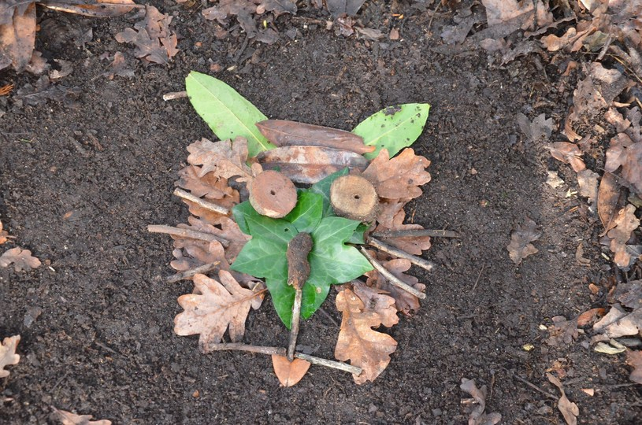

Natural pictures on the ground
Make a picture in a simple stick frame using leaves, stones, seeds etc

Motivational and meditation activities
Chalk positive words – write or draw a positive word or picture on the ground
10 breath meditation- Think about breathing for 3 or 4 breaths, on the next 5 or 6 breaths think about something that makes you smile or happy- give ideas eg person, friend, place, family member, piece of work, TV show

Positive Pebble pile- choose a stone or pebble, hold in you hand and think about how it feels, is it cold, smooth, sharp. Pause. Think about something which hasn’t been good in the last few days or something that worries you, imagine that the stone represents the bad thing. Put the pebble on a pile- imagine you are getting rid of the bad thing.

Scavenger hunts- give a list eg 5 items of different colours, different shapes, a seed, a twig, a piece of grass, a leaf.

Wildlife Watch- Be still. What wildlife do you see?

Shadow shapes- make interesting shapes with your hands/body. Work in a pair, draw around your partners shape in chalk.

Natural Writing – write words/ letters/ numbers with things you find eg sticks, stones, leaves

Physical Games-
Bean game- Runner beans, French beans, frozen beans, baked beans
Insect heads, shoulders, knees and toes- Heads, thorax, abdomen and eyes and antenna and wings and legs

Sustainable Gardening- Planting in a yoghurt pot, toilet roll, plastic bottle, egg box

Summary
South Down National Park Slides
South Downs National Park website
www.southdowns.gov.uk/learning
learning@southdowns.gov.uk
www.tuppennybarn.co.uk

Recommended reading:
Learning with Nature by Marina Robb, Victoria Mew, Anna Richardson
The Stick Book by Jo Schofield and Fiona Danks

