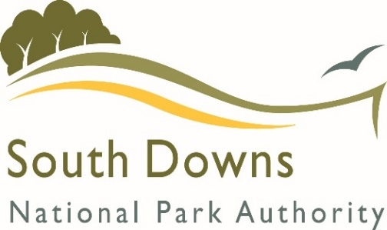
SDNPA
Community Infrastructure Levy

Grant Application Form

What should this form be used for?

The South Downs National Park Authority collects money from developments that it can then use to spend on providing infrastructure. Each year we ask organisations both across and surrounding the National Park to put forward Expressions of Interest (EOI) setting out details of infrastructure schemes for which they are seeking funding. These are assessed and the outcome is set out in the annual Infrastructure Business Plan.

You have been sent this application form because your EOI was successful and we now need further information before we can release the funds. Your letter confirming this will have set out the maximum amount of grant you can apply for. This money will be held on your behalf for three years from the date of the letter and may then be reallocated if not applied for.

If you have not been notified that your EOI was successful, please do not fill out this form as we will not consider it.

If you have any queries please do not hesitate to contact us on 01730 819360 or e-mail cil@southdowns.gov.uk

BASIC INFORMATION ABOUT YOUR PROJECT

Project Title
CIL reference (if known)
Applicant name and organisation

YOUR DETAILS

Name, address, phone number and email of the main contact.

If possible, please provide us with the name, address, phone number and email of a second person with knowledge of the project |  | This person will be contacted about the application if we cannot get hold of the main applicant
Organisation Type |  | Charity / Parish Council / CIC etc. If working with you is new to us, we may ask for Charity or Company Number to help validate an application.
Approximately how many years has your organisation been in operation?
Payment details | Please complete the attached supplier setup form and return it with your completed grant application. | Where would you like payments to be sent?

YOUR PROJECT

Project address, postcode and Eastings / Northings (where known)
Who owns the site? If it is leased, how long is that lease for?
Project Summary |  | Please provide a brief summary of the project, its objectives and likely outcomes. Why is it required? Who has been involved to date? Who are the likely beneficiaries etc.
Progress
Is planning permission required? |  | If relevant, please provide the reference number.
Please outline the progress to date on your project. What has happened so far?
Is this a one-off project or part of a phased scheme? If it is part of a larger project, what additional work is likely to be undertaken in the future?
Proposed start date |  | Of the work for which this grant application is made.
Anticipated duration of the work |  | Of the work for which this grant application is made.
Please identify any key milestones and the approximate dates of these.
Has there been any community involvement / consultation on the project?
Project Management
Who will manage your project and how they will ensure its delivery? |  | Please give a general indication of the skills of those most directly involved – this is so we can understand whether any further support might be needed to deliver the scheme.
What are the main risks to the project and how might these be mitigated? |  | We can provide you with a risk assessment template which might be useful for larger projects. Its completion is not a requirement.
Partners – Please list other organisations that will help deliver the project (if applicable)
If applicable, who will maintain the project in the future?

BUDGET
Please note that only high level budget information is requested. Remember to allow for other costs including VAT if this is applicable to you.

Project Income
Amount requested from SDNPA (£) |  |  |  | This cannot be higher than the level of grant agreed in the Infrastructure Business Plan.
Total Project Cost (£)
Other contributions towards funding (if applicable)
Source of support |  | Value (£) | Notes |  | Confirmed (Yes / No)

Project Expenses

- Items costing less than £500 do not need to be individually itemised but can be grouped together under general themes.
- For projects over £1000 please provide 3 quotes which can be attached to this application.
- Please remember that CIL can only be spent on infrastructure and cannot be used to fund feasibility studies / investigative work.

Expenditure (please break your expenditure down into the main elements) | Value (£) | Notes

Are you able to claim VAT back on any element of this project? (Yes / No)
Have you had previous project specific CIL funding? (Yes / No) |  | This does not include the Parish payments made direct to applicable Parishes twice a year.
If yes, have you submitted your end-of-year grant report? |  | Please note that we cannot offer grant support if you have not completed the end-of-year grant reports for all previous grants
Additional information |  | Please add any supporting information or documents you have. Photographs and maps are also helpful.
I confirm that I have been authorised by the above organisation to apply for this funding and that to the best of my knowledge all the information I have provided is true.  I understand that the information supplied in this application is not confidential – however any supplementary material provided, including business plans, will remain confidential unless otherwise agreed.  I understand that the SDNPA may use your project as an example to other applicants on how CIL funds can be used.  Signed: |  | Electronic signature is fine.
Date

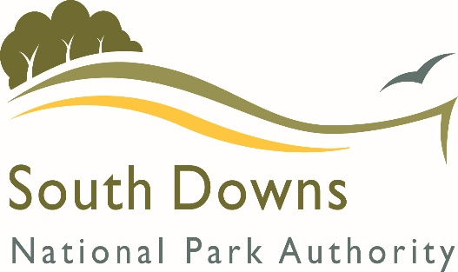 |  | CREDITORS MASTERFILE SET UP FORM  SOUTH DOWNS NATIONAL PARK
To whom it may concern,
I would like to set you up as a supplier on our payments system. In order to do so I will need from you the following information. Please complete all sections that apply.
Full name of company/organisation/trader
Main address
Phone number
Email address
Payments address (please complete if you have a separate credit control or debtors section)
Payments email
Payments phone no.

Other information
Website
VAT registration no. (if applicable)

BACS details
Bank account no. (8 digits)
Sort code
Bank account name (not the name of the Bank)
Reference/building society roll number
Contact Details of supplier

Name

Contact phone no.

Position in organisation

Brighton & Hove County Council USE ONLY

Duplicate checks made

Input by

Authorised by

