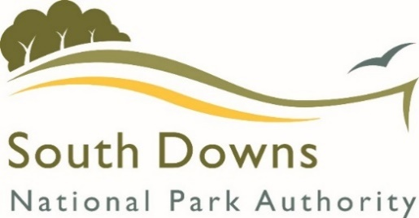

Adoption of the Sustainable Construction Supplementary Planning Document
Statement of Adoption
25th August 2020

In accordance with Regulation 11 and 14 of the Town and Country Planning (Local Planning) (England) Regulations 2012, notice is hereby given that South Downs National Park Authority adopted the Sustainable Construction Supplementary Planning Document (SPD) on the 25th August 2020. This SPD was prepared to support the implementation of Policies SD2, SD3, SD22 and SD48 of the South Downs Local Plan. The adopted Sustainable Construction SPD relates to the whole of the South Downs National Park.
Any person with sufficient interest in the decision to adopt the SPD may apply to the High Court for permission to apply for judicial review of that decision. Any such application must be made promptly and in any event not later than 3 months after the date on which the SPD was adopted.
The adopted SPD, a statement summarising the main issues raised during the formal consultation period and how these were addressed in the SPD, a copy of the Strategic Environmental Assessment (SEA) and Habitats Regulations Assessment (HRA) screening, and a copy of this adoption statement can be viewed online at:
https://www.southdowns.gov.uk/planning-policy/supplementary-planning-documents/

If you are unable to access these documents online please contact us either by email at planningpolicy@southdowns.gov.uk or by telephone on 01730 814810 and we will arrange for hard copies to be made available for you.

