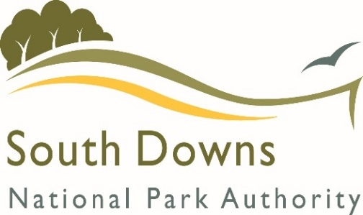
SDNPA
Section 106 Funding Form B

Funding Application Form for
Parish/Town Councils and Other Organisations

The South Downs National Park Authority (SDNPA) collects money via S106 Legal Agreements (S106 Agreement) that can then be used to spend on providing infrastructure.

This application form will be used to assess whether the proposed expenditure complies with the terms of the S106 Agreement and the SDNPA plans and policies.

It is the expectation of the SDNPA that the allocated funding will ordinarily be used for delivering the approved project within 9 months of the date of the award letter. Should a project be delayed for any reason please notify the SDNPA as soon as possible.

If you have any queries please do not hesitate to contact us on 01730 814810 or e-mail cil@southdowns.gov.uk

BASIC PROJECT INFORMATION

Project Title
Applicant name and organisation

PROJECT CONTACT DETAILS

Name, address, phone number and email of the main contact
Organisation Type
Payment details | Please ensure we have the up to date payment details for your organisation. If you need to update your payment details complete the attached supplier setup form and return it with your completed grant application.

THE PROJECT

Project address, postcode and Eastings / Northings (where known)
Who owns the site? If it is leased, how long is that lease for?
If applicable, have you contacted the relevant Parish/Town Council to discuss the project?
Project Summary
Supporting Documentation  (must include location map & quotes) | Please list all supporting documentation that is attached to your application in order to aid our assessment of the project.
Progress
Please outline the progress to date on your project including any consultations with other agencies (e.g Local Highways Authority).
Is this a one-off project or part of a phased scheme? If it is part of a larger project, what additional work is likely to be undertaken in the future?
Estimated start date
Target completion date
Has there been any community involvement / consultation on the project?
Project Management
Who will manage your project and how they will ensure its delivery?
Partners – Please list other organisations that will help deliver the project (if applicable)
If applicable, who will maintain the project in the future?

PROJECT INCOME

S106 Funds
Amount requested from SDNPA (£) |  |  | Total Project Cost (£)
Identified S106 Contributions (Application number, development address and funds available if known)
Other contributions towards funding (if applicable)
Source of support  (This may include Neighbourhood CIL funds) |  | Value (£) | Notes |  | Confirmed (Yes / No)

Further Notes
- We would ask that for projects that require funding of over £1000 you send confirmation that 3 quotations have been sought for the project, or in the case of specialist services details as to why fewer quotes have been sought.
- Please note that S106 contributions cannot generally be used to fund feasibility studies, investigative and design work.

Additional information
I confirm that I have been authorised by the above organisation to apply for this funding and that to the best of my knowledge all the information I have provided is true.

I understand that the information supplied in this application is not confidential – however any supplementary material provided, including business plans, will remain confidential unless otherwise agreed.

I understand that the SDNPA may use your project as an example to other applicants on how S106 funds can be used.

Signed:
(Electronic signature is acceptable)
Date

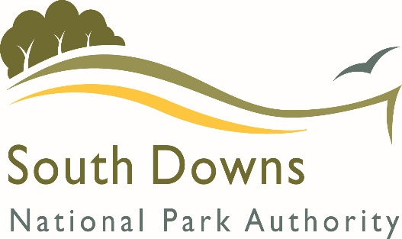 |  | CREDITORS MASTERFILE SET UP FORM  SOUTH DOWNS NATIONAL PARK
To whom it may concern,
I would like to set you up as a supplier on our payments system. In order to do so I will need from you the following information. Please complete all sections that apply.
Full name of company/organisation/trader
Main address
Phone number
Email address
Payments address (please complete if you have a separate credit control or debtors section)
Payments email
Payments phone no.

Other information
Website
VAT registration no. (if applicable)

BACS details
Bank account no. (8 digits)
Sort code
Bank account name (not the name of the Bank)
Reference/building society roll number
Contact Details of supplier

Name

Contact phone no.

Position in organisation

Brighton & Hove County Council USE ONLY

Duplicate checks made

Input by

Authorised by

