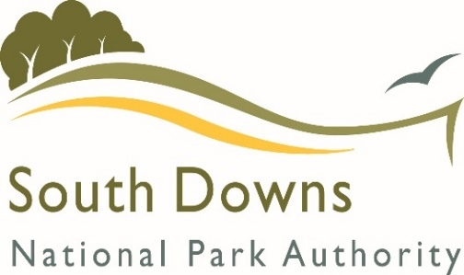
District and County Council
S106 Funding Transfer Request
(Form B)

The South Downs National Park Authority (SDNPA) collects money via S106 Agreements that can then be used to spend on providing infrastructure. Some of these funds are transferrable to District and County Councils upon reasonable written request.

The SDNPA now has to report on all S106 expenditure, with this in mind we would ask that the proposed project summary is completed, failure to disclose details of the proposed project may result in the funding request being delayed.

If you have any queries please do not hesitate to contact us on 01730 814810 or e-mail cil@southdowns.gov.uk

FUNDS REQUESTED FOR TRANSFER

Planning Application Reference
Development Address
S106 Agreement Date
S106 Covenant Details including the amount of contributions detailed

CONTACT DETAILS

Name
Council
Department
Address
Email
Telephone
Payment details | Please outline any specific payment details which will enable the payment to be allocated to the correct department.

PROPOSED PROJECT

Project location
Project Summary
Proposed start date
Expected completion date

Additional information
Please accept this as reasonable written request for the transfer of S106 funds due to the Council as detailed within the S106 Agreement outlined above.

I declare that I am authorised by my employer to make this transfer request on their behalf and take responsibility for reporting to the SDNPA on the spending of the funds.

I understand that the SDNPA needs to be provided with the project details in order to fully report on the spending of S106 contributions and agree to provide any project information as reasonably requested.
Should any potential project identified not be fulfilled for any reason, I agree to notify the SDNPA in writing of the change in use of the allocated funds and will subsequently advise them of the projects supported by the funding.

Signed:
(Electronic signature is acceptable)
Date |  | Organisation:

