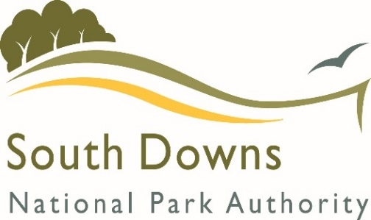
Community Infrastructure Levy

Parish / Town Council Payments (Regulation 62A)

Annual Monitoring Return

What should this form be used for?

The South Downs National Park Authority collects money from developments that can then be used to spend on providing infrastructure. Your Council has received a payment from the Community Infrastructure Levy (CIL). The Community Infrastructure Levy Regulations 2010 (as amended) require us to monitor if that money has been spent and if so, what has been provided. Therefore, please can you complete the tables below.

The money you have been paid must be used within 5 years of receipt or may have to be returned.

Please note that all payments made by 28th April each year account for a payment within the previous financial year. E.g. Payment received in April 2019 will be reported in the financial year of 2018-2019.

If you have any queries please do not hesitate to contact us on 01730 819210 or e-mail cil@southdowns.gov.uk

YOUR DETAILS

Organisation | Stoughton Parish Council
Name (& position if applicable) | Fiona Baker, Parish Clerk & RFO

Reporting Financial Year: 2018/19

CIL Receipts Retained (unspent)
What is the total amount of CIL received in this past financial year and unspent at the end of this past financial year? | 975.92
What is the total amount of CIL received in previous year(s) and unspent at the end of this financial year? | 0
What is the total CIL receipts unspent? | 975.92

Expenditure
Please provide us with a summary of what you have spent from the CIL grant during this past financial year.
Infrastructure item  E.g. Playground equipment | Total CIL spent on project Please list larger payments individually e.g. Materials £2,550.00  Items costing less than £500 do not need to be individually itemised but can be grouped together under general themes. | Notes or comments?
Total expenditure for reported year:
If your project is under way or complete, please do provide us with some photographs, publicity, notes or other interesting materials where available. We are keen to have a stock of case studies and information to share with other groups in the future.

Details of any receipts that the SDNPA have asked you to return (in accordance with regulation 59E):
Total value of CIL receipts subject to the aforementioned notices during the reported year | £0
The total value of CIL receipts subject to the aforementioned notices in any year that has not been paid. | £0

Publishing Your Report
Please indicate where you intend to publicise this report: (please delete as appropriate)  All Parish and Town Councils are required to display this form or an equivalent on their own websites no later than the 31st December after each financial year. A copy will also be placed on the SDNPA website.  If you are unable to publish this information on your own website, the SDNPA can act as a substitute, but you must inform us that this is the case. | Own Website / SDNPA

Signed: Fiona Baker

Date: 30/05/2019

