

Conservation Area Character Appraisal

and Management Plan
Exton
November 2015
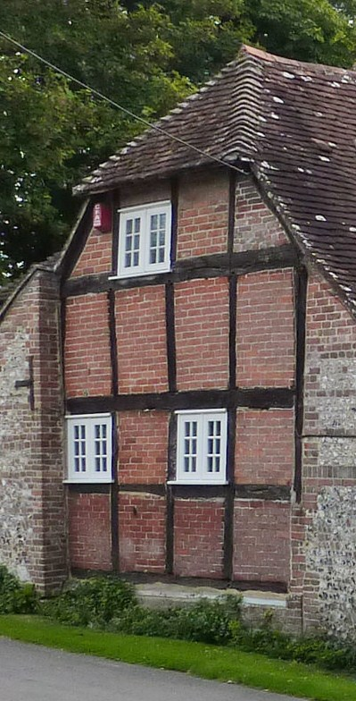 |  | 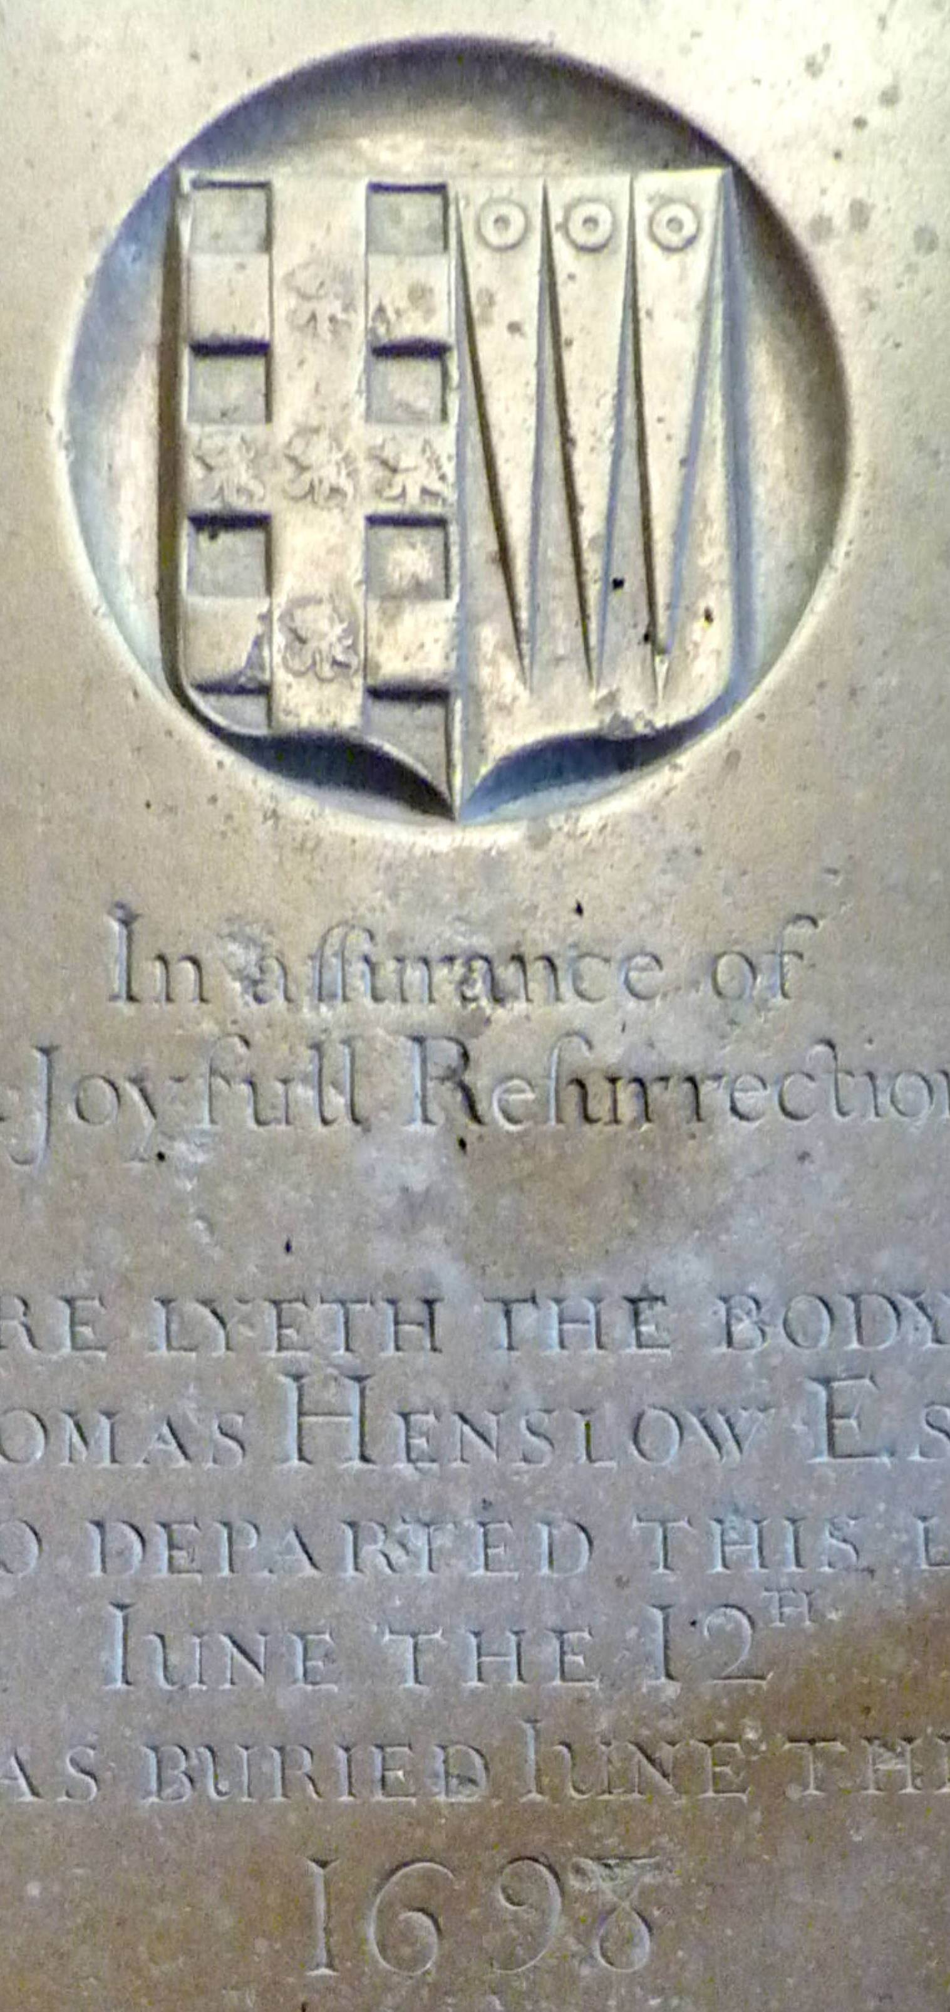 |  | 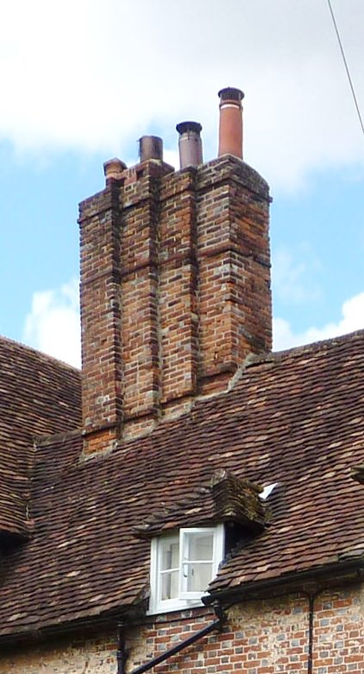

Summary of Significance

The special character of Exton Conservation Area is derived from a combination of buildings and structures, including good examples of vernacular and modest polite architecture, sitting in an historic pattern of lanes within a very attractive rural landscape. Combined, they produce an unspoiled, high quality environment.

It is one of the smaller villages located in the Meon Valley, with intimate connection with surrounding Downland. Unlike most of the other settlements, it was by-passed by the Gosport to Alton turnpike in the Eighteenth Century and retains a strong sense of tranquillity.

Prominent among the historic buildings are the Church of St Peter and St Paul, Sunnyside, Marriner’s Cottage, Church View and Sunrise. In addition to twelve buildings already listed, a further three are recognized as being of sufficient interest to justify local designation as ‘locally listed buildings’.

Introduction

1.1 Conservation Areas are defined as “areas of special architectural or historic interest, the character and appearance of which it is desirable to preserve or enhance”. (Section 69 (1) (a) of the Planning (Listed Buildings and Conservation Areas) Act 1990)
1.2 The South Downs National Park Authority (SDNPA) has a duty to determine which parts of the Park embody that special architectural or historic interest, to designate those parts as Conservation Areas, and to keep the existing Conservation Areas under review.
1.3 Exton lies within Winchester District. It was first designated as a Conservation Area by Hampshire County Council in June 1972. With the creation of the South Downs National Park in April 2011, the National Park Authority became the Local Planning Authority for the settlement.
1.4 This Appraisal seeks to set out what the National Park Authority considers are the most significant elements which define the character of the Conservation Area; it has an important role in making informed and sustainable decisions about the future of the area. Whilst comprehensiveness may be sought, the omission of any particular feature should not be taken as meaning that it is of no significance.
1.5 The document sits within a wider policy context, including:
- The Purposes and Duty of the South Downs National Park.
- The National Planning Policy Framework
- The Winchester Joint Core Strategy and the Saved Policies from the Local Plan Review 2006 (until replaced by the South Downs National Park Local Plan)
- English National Parks and the Broads. UK Government Vision and Circular 2010
- Exton Village Design Statement, adopted in December 2010
1.6 In looking at the area, issues which pose a threat to the quality of the area and any possibilities for improvement and enhancement have also been identified.
1.7 The document was the subject of a six week public consultation process from 3 August to 14 September 2015. Specific consultations were sent to the Parish Meeting, Winchester City Council, Hampshire County Council and Historic England.
1.8 Where appropriate, the initial document was amended to reflect comments received and the revised document was adopted by the South Downs National Park Authority for the purposes of Development Management and to inform other activities of the SDNPA on 12 November, 2015.

Location & Topography

2.1 Exton is a small village located in a relatively wide section of the valley floor of the River Meon, just off the A32, about ten miles north of Fareham. The nearest small town is Bishops Waltham, about three miles to the west along the B3035.
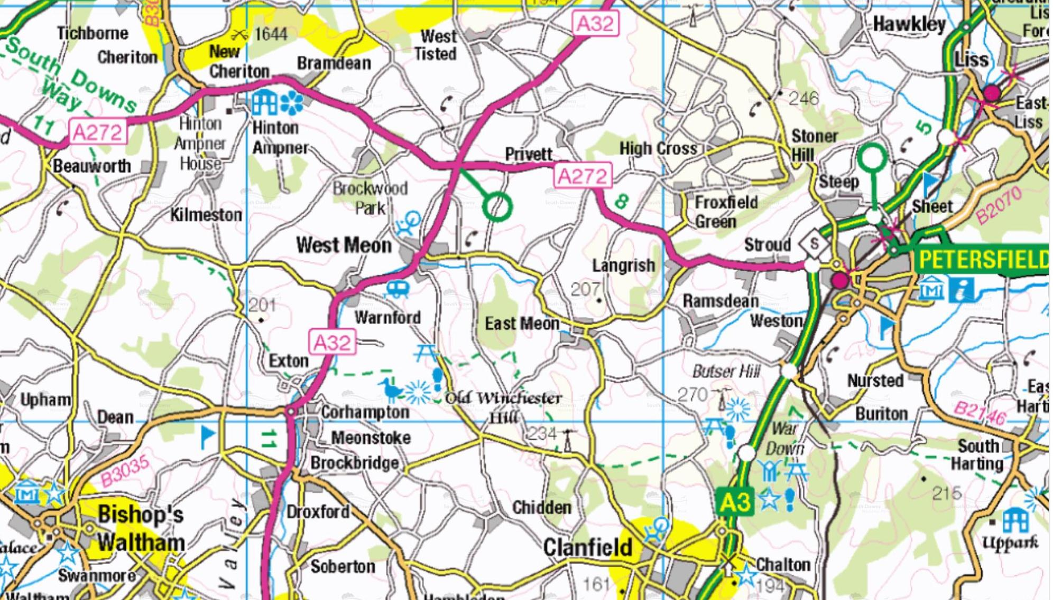
2.2 It is just one of a string of historic settlements along the Meon. Less than a mile to the south are located the closely related settlements of Corhampton and Meonstoke. Figure 1a shows the broad relationship of the village in relation to its wider surroundings.

Figure 1a: Exton and its wider surrounds

2.3 Downland rises immediately to the west and north of the village (Figure 1b). The course of the river forms the eastern edge of the settlement. The main road north was improved by Turnpike Act shortly after 1780 with the result that the modern A32 by-passes the village a short distance to the east. Somewhat beyond that, the chalk rises, ultimately reaching a high point at Old Winchester Hill.

Figure 1b: Topographical setting of Exton Conservation Area in relation to the Downs and the river Meon

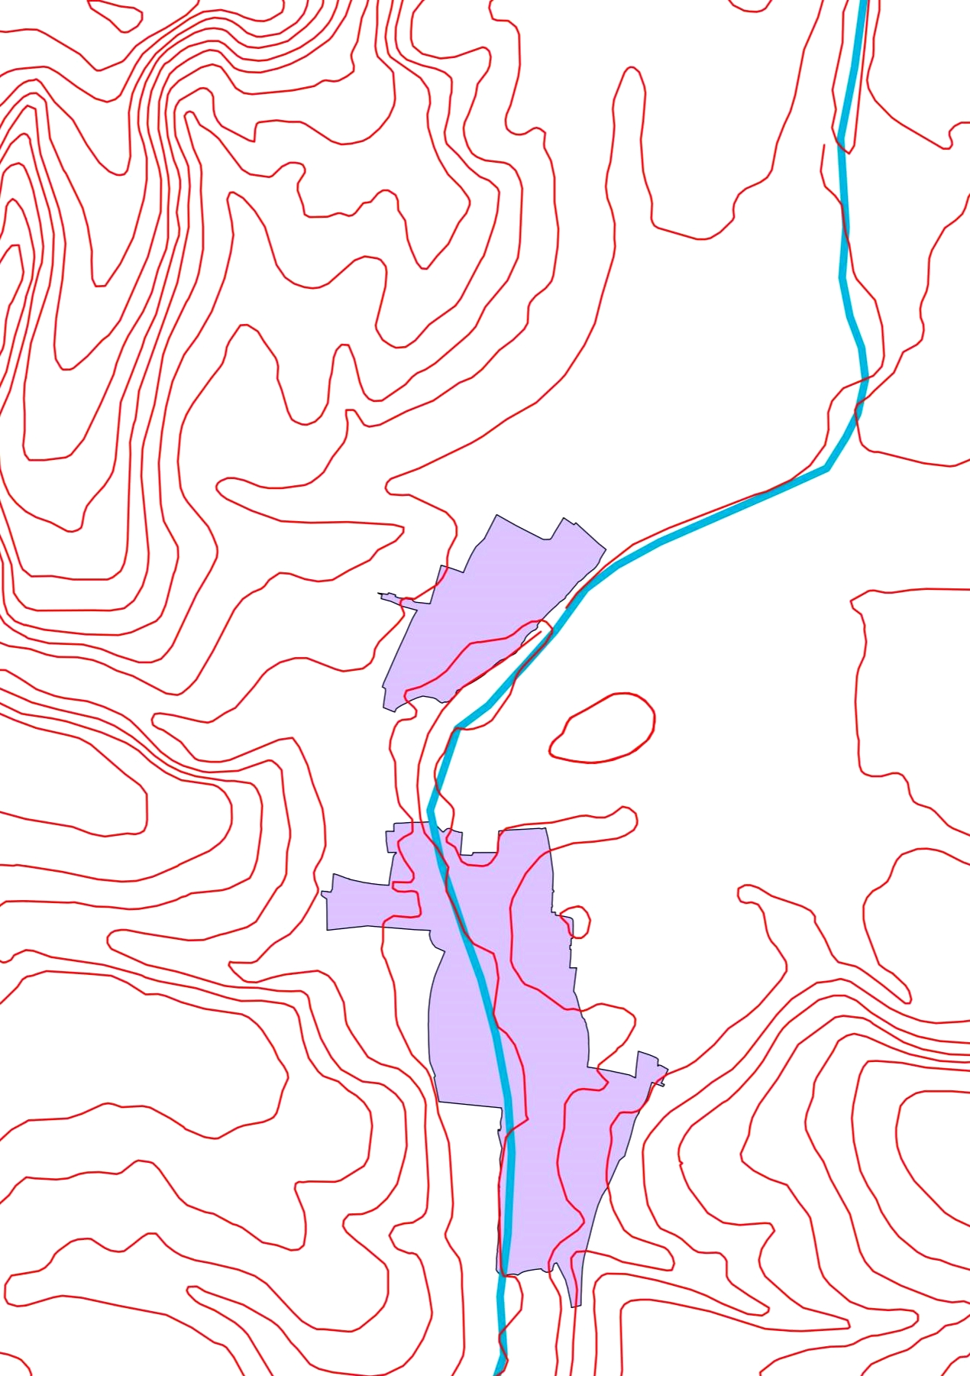
    - Historical Development

3.1 The first appearance of the settlement in written annals comes in 940, when 12 mansae at East Seaxnatune were granted by King Edmund to his thegn, Ethelgeard.
3.2 Exton’s name suggests that the village was a settlement of the East Saxons, more usually found in the lands which now form modern Essex.
3.3 By the time of Domesday it was held by the Bishop of Winchester on behalf of the priory of St Swithun. It appears in the Great Survey as a very large village of 46 households and included two mills and a church.
3.4 The settlement was a centre of recusancy in the later 16th century – the resident of the Manor House found himself gaoled in Winchester because his wife was obstincie in her Poperie and he was not hable to overrule his weife’s disposicion … the obstacle being layed upon her own carcas.
3.5 The historic road network in the Meon valley is shown in Figure 2, below, Issac Taylor’s map of Hampshire, published in 1759.
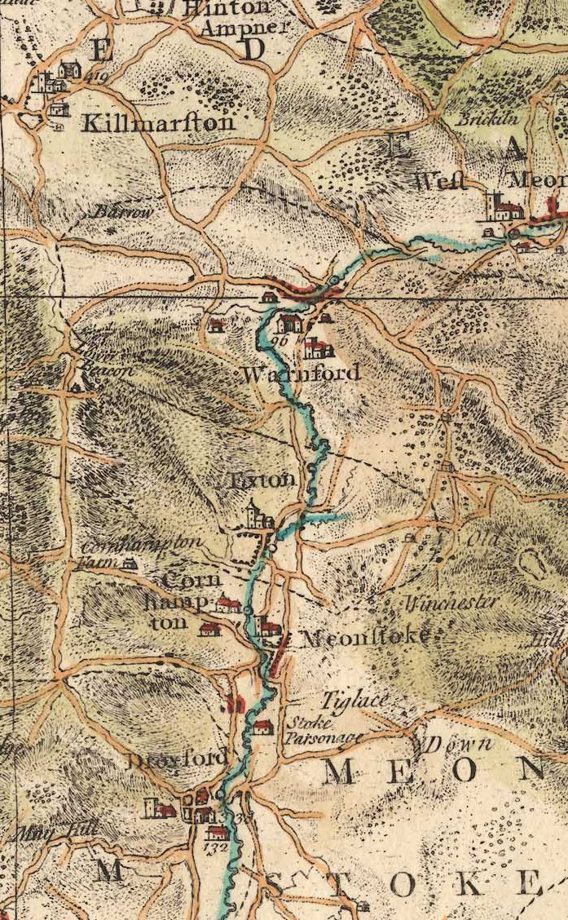

Figure 2: Isaac Taylor’s Map of Hampshire, published in 1759

3.6 The Turnpike improved the route north from Gosport to Chawton, just south of Alton. This passed through Fareham, Bishop’s Waltham and the higher reaches of the Meon valley, but narrowly by-passed Exton. The new route of the road is shown on Figure 3, Greenwood’s map of Hampshire, published in 1826.
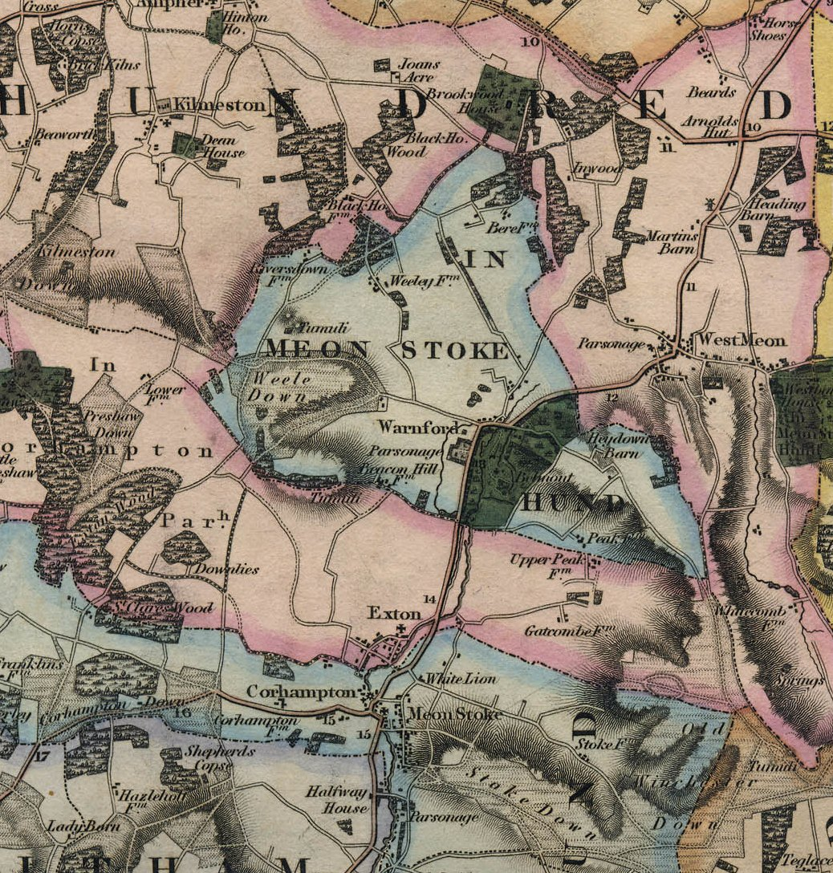

Figure 3: Greenwood’s Map of Hampshire, published in 1826

3.7 A Primary School opened in the village next to the church in 1871 and survived until 1928.
3.8 The London South Western Railway built a short-lived line along the Meon Valley in 1903, which passed a little to the east of Exton. The closest station was at Droxford, a couple of miles to the south. Passenger services ended in 1955 and all traffic on the railway had ceased by 1963.
3.9 The extent of the village in the 19th century can be seen in the Tithe map and the Ordnance Survey mapping of 1897 (both Figure 4). It is little changed today.
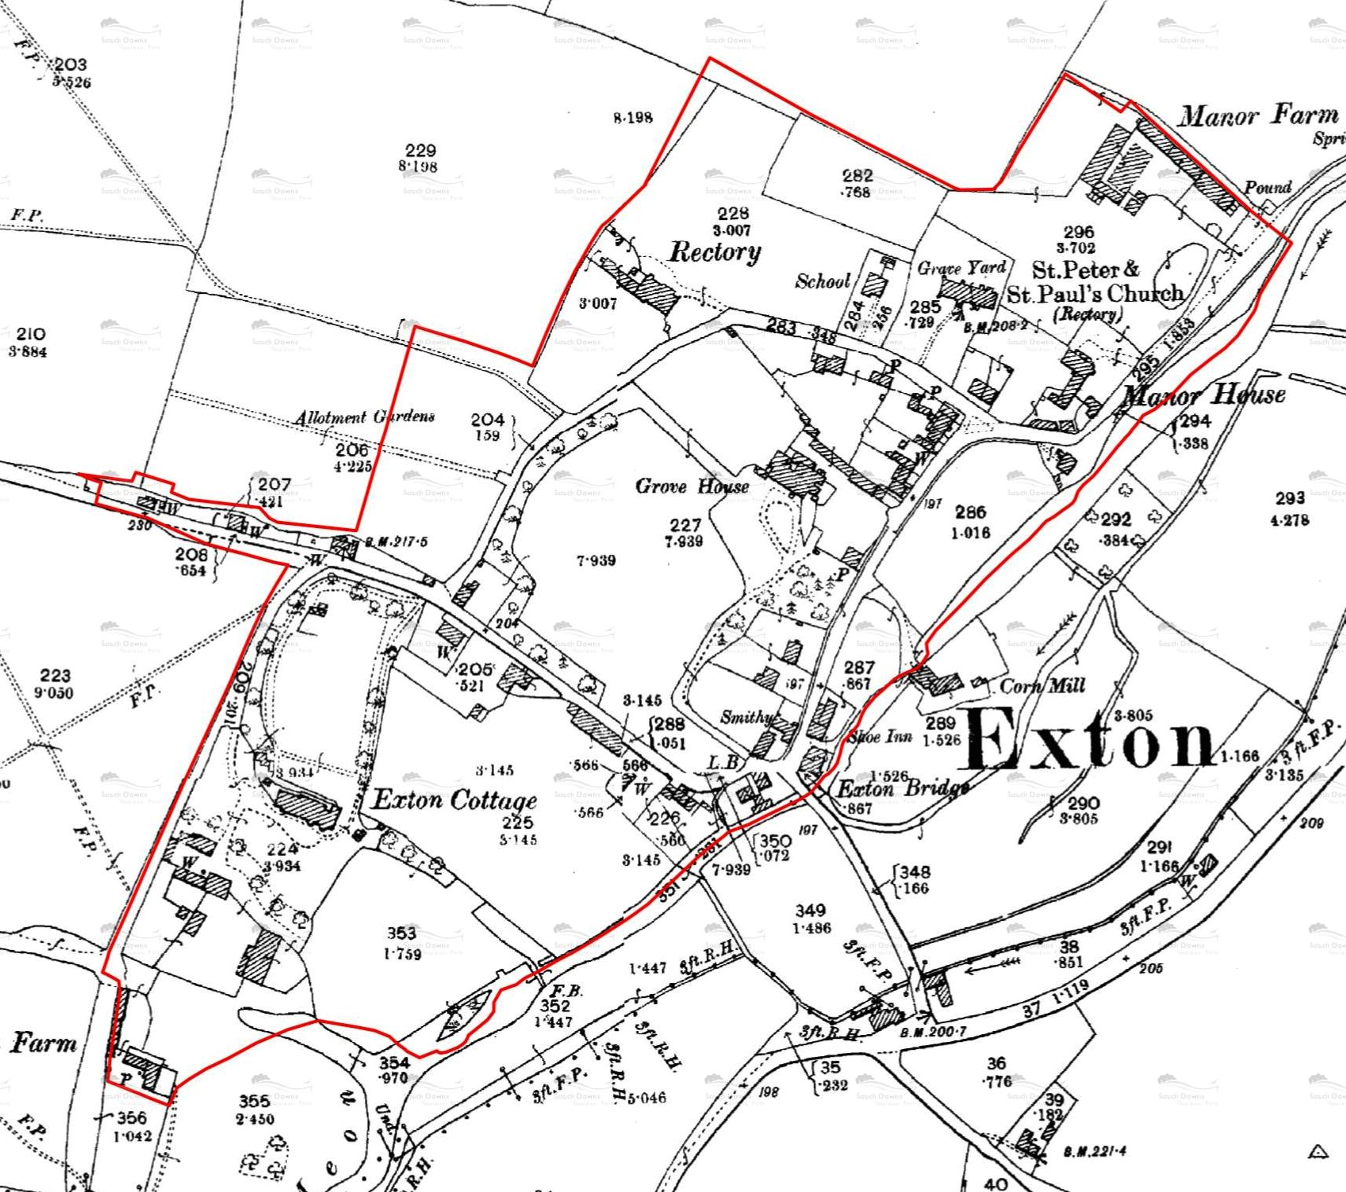
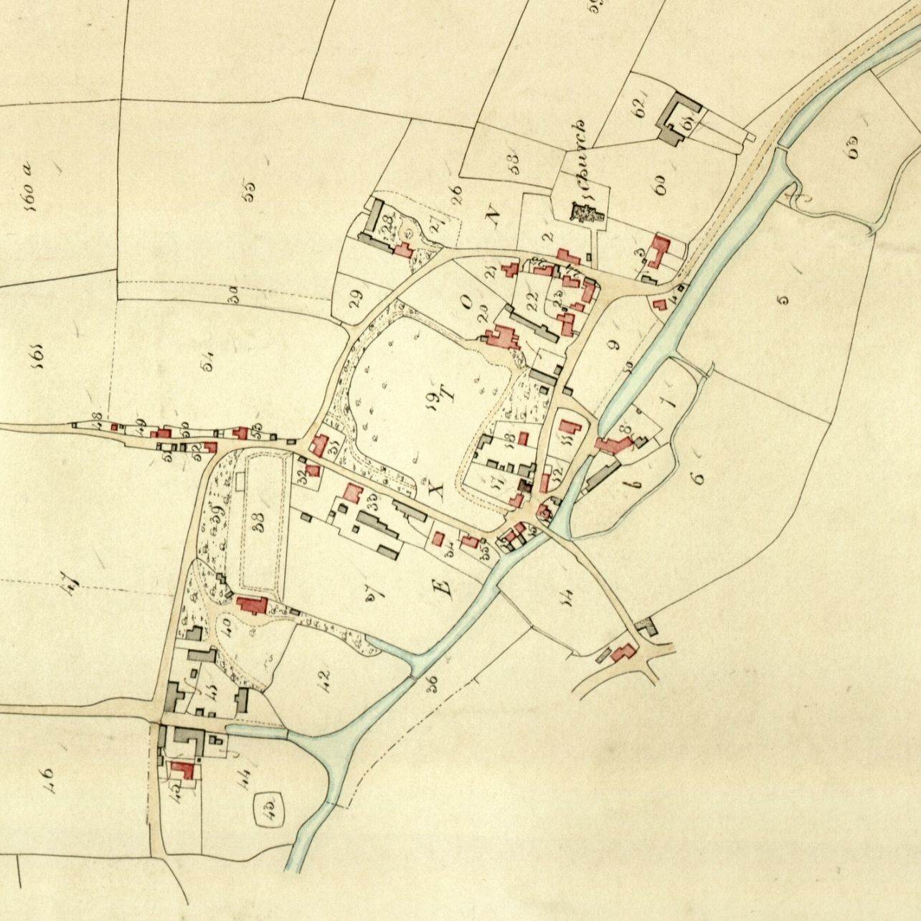
Figure 4: Exton as it appears on the Tithe Map (above) and the Ordnance Survey mapping of 1897 (below)
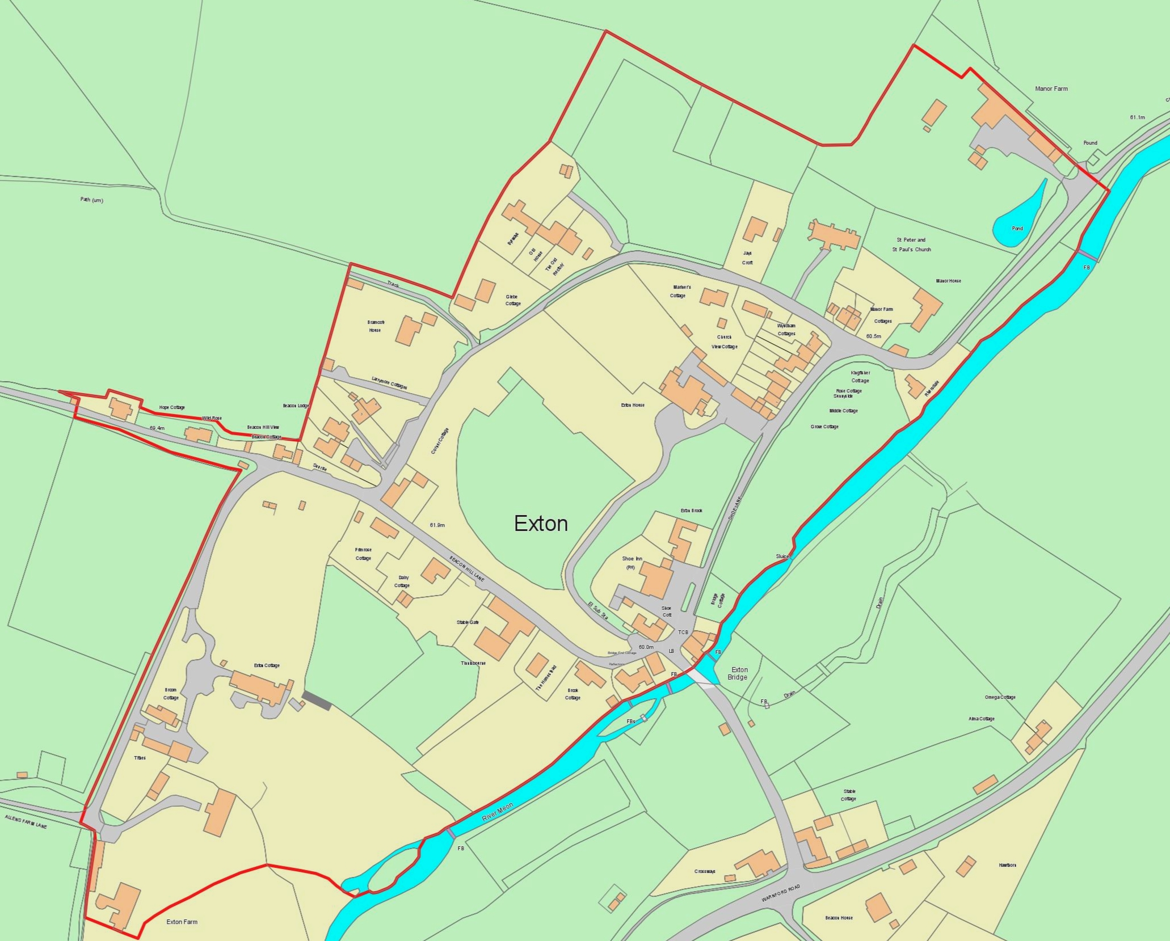
Figure 5: The Boundaries of Exton Conservation Area
(to be changed if amendments are approved)

Character Analysis

4.1 The elements which make a positive contribution to the character of the Conservation Area are mapped on Figure 38, to be found at the end of this document.
Entrance & Boundaries
4.2 The boundaries of the Conservation Area are shown in red on a modern map (Figure 5)
4.3 These boundaries have been drawn to encompass the extent of the village on the west side of the Meon at the end of the 19th century (see Figure 4). The river forms a clear boundary on the south and eastern side and elsewhere it is drawn to include the settlement buildings but little open land beyond. However, this open land defines the edges of the settlement and makes a crucial contribution to the character and rural setting of the village.
4.4 The main approach to the village remains the turn off from the old Turnpike (now the A32) and across Exton Bridge. However, the village lies astride the South Downs Way and visitors to the village are increasingly arriving on foot.
Settlement Form
4.5 Exton is an irregular settlement with a number of foci or building concentrations arranged within a sub-rectangular street plan comprising Exton Lane (Shoe Lane), Rectory Lane, and Beacon Hill Lane. In terms of character, gaps between these building groups and individual buildings can be almost as significant as the buildings themselves.
4.6 The two main concentrations are those comprising the Church and Manor House and the cluster known as ‘Bridge End’ at the junctions of Shoe Lane, Beacon Hill Lane and the bridge. Other subsidiary building groups are the linear ribbon along Beacon Hill Lane, running westwards from its junction with Church Lane, and the buildings associated with Exton Farm at the southern end of the settlement.
4.7 All of the primary roads – Shoe Lane, Rectory Lane and Beacon Hill Lane - are minor and rural in character and make a significant contribution in establishing the rural character of the settlement as a whole (Figure 7 & 9). From this core run a number of lanes – little more than tracks – that further reinforce the rural character (Figure 8).
Use & Activities
4.8 The presence of two farmsteads – Exton Farm and Manor Farm, a Corn Mill and a Smithy on old OS maps bear testimony to the former agricultural basis of the village economy and the village still nestles in a wider agricultural landscape. However, the fact that neither of the farmsteads remains in agricultural use and the past loss of the mill and smithy offer equally eloquent evidence that the village itself has evolved into a largely residential, commuter settlement, with most residents either leaving to work each day or retired. The Shoe Inn is now the only commercial building in the Conservation Area, with the Post Office/Village Store having closed in the 1960s. Another commercial operation, Exton Stud, lies at the end of Allen’s Farm Lane, Just outside the Conservation Area.
Buildings & Structures
4.9 The original core of the settlement is presumably that around the Church and Manor.
4.10 The Domesday Survey records the presence of a church in the late 11th century and this must have been replaced by the existing Church of St Peter and St Paul, which is largely 13th century in origin but heavily restored in the mid 19th century (Figure 10).
4.11 The church is a relatively modest example, Grade II listed, comprising an aisle-less nave, chancel and a bell-turret. It combines an attractive mix of materials, with the walls being mostly of flint, clay tiles on the nave and chancel roofs, and a bell turret of vertical timber boarding topped by a shingle-covered spire. Monuments in the churchyard possess great evidential value as a historical resource.
4.12 The site of the medieval Manor House is 50 metres south-east of the Church. However, the existing building is not the original. It is L-shaped in footprint, with the north-south range being 18th century in date and the taller east-west range being an early 19th century addition. The building is largely brickwork, with a mix of English and Flemish bonds with blue headers, but the north elevation facing the garden has a more ‘polite’ feel with a short colonnade and is stuccoed. Clay tiles are used on the roof on the original building, with slate for the addition.
4.13 The buildings of Manor Farm are north-east of the manor and church (Figure 12) and include the farm house, a staddle stone granary and a long range of farm buildings. These are all within the boundaries of the Conservation Area but just beyond that boundary is the village pound (Figure 13), which should be brought into the Conservation Area. It may also be included on a local list.
4.14 Other early buildings in this group are Marriner’s Cottage (Figure 14) and Church View (Figure 15). Both have 16th century timber frames with brick infill. The former is thatched (albeit not the long-straw thatch that appears in old photographs) whilst the latter has clay tiles. However, old photographs show that it too was originally thatched in long straw. Of comparable antiquity is Grove Cottages (Figure 16), a late medieval hall with cross-wings, subsequently sub-divided to form three cottages.
4.15 The present bridge is post-medieval but probably stands at the original crossing point of the Meon. Known locally as ‘Bridge End’, the building group here forms another node within the village.
4.16 Prominent in views across the bridge is Shoe Cottage (Figure 17), with its large and attractive clay tile roof. Interestingly, photographic regression demonstrates that it too was originally thatched in long straw. None of the buildings in this node are included on the statutory list but most make a positive contribution to the Conservation Area, including Bridge End Cottage (figure 18), and Bridge Cottage, the former Post Office and Village Store (Figure 20), which retains its former shopfront and the attached cottage (Figure 21). The boundary walls, whether flint and brick, are particularly important in this part of the village. Also significant is the presence of the well maintained K6 telephone kiosk, designed by Sir Giles Gilbert Scott in 1935.
4.17 The Shoe Inn is a 1930s replacement of the original pub, which once stood on the opposite side of the road in the current beer garden. The building itself is quite traditional in form and materials and makes a positive contribution to the Conservation Area. However, the same cannot be said of the bare expanse of tarmac forming the car park around the pub. Some improvements to this area – a front boundary wall or some planting – would help to soften and mitigate this negative impact.
4.18 Reflections (Figure 23) represents a quite contemporary insertion into the village scene, albeit one that uses traditional materials for the most part.
4.19 At the southern end of the village, grouped along Allen’s Farm Lane, is another cluster of buildings. Exton Cottage (figure 24) is a melange of different periods, predominantly 18th century in date but including assorted 19th century extensions and possibly an earlier core.
4.20 Exton Farmhouse marks the southern extremity of the Conservation Area, with its farmstead buildings lying to the north between it and Exton Cottage. Particularly impressive is the Barn some 60 metres to the north-east (figure 25), which comprises a five-bay 18th century timber frame with aisles all round. The walls are boarded and the roof tiled.
4.21 Other former farm buildings include Broom Cottage and Tithes (figure 26), formed out of a 17th century timber framed barn, and the buildings, currently derelict, standing opposite (figure 27). The latter has consent for conversion to residential use which should secure its repair and the continuation of its positive contribution to the character of the Conservation Area.
4.22 Other Grade II listed buildings within the conservation area include Sunrise, a late 18th century cottage constructed of cob (figure 28), The Homestead (figure 29) a thatched cottage with 18th century timber-frame, The Old Rectory (figures 30 and 31) a late 18th century building given a gothic ‘make-over’ in the mid 19th century and Exton House (once known as Grove House) (figure 32).
4.23 A number of unlisted buildings make a positive contribution to the Conservation Area and are identified in blue on Figure 38. Corner Cottage (figure 33) is probably worthy of inclusion on a Local List.
4.24 Viewing the buildings as a single assemblage, a number of points can be synthesised and these reflect the other villages in the Meon Valley.
4.25 A recurring theme is one of modesty in scale, with little being of more than two storeys in height, and vernacular in form and material. A few buildings have some ‘polite’ pretensions, frequently overlain onto earlier buildings in the 19th century.
4.26 In terms of function the village is overwhelmingly residential. Some buildings retain evidence of a different original purpose – farm buildings, shop and post office – but mostly, these have already been converted to residential use or are vacant and ripe for conversion.
4.27 The palette of materials is typical of the vernacular architecture of the Meon Valley. Timber-framing is well represented, as is brick construction. Beyond the church, there are few examples of flint being externally used for whole buildings but the material is very important for its use in boundary walls. The examples of cob construction at Sunrise and Hope Cottage are important survivals and may testify to the wider use of this material in the past.
4.28 The evidence of the surviving examples and of photographic regression show that thatch was once the most significant roof covering. However, as found elsewhere in the Meon Valley, it is clear that some examples have been lost within the 20th century, usually replaced with clay tiles. Those which do remain show a transition from the long-straw tradition to other styles of thatching. Clay tile is now the predominant roofing material and there is some slate.
4.29 Joinery is represented by the typical range of traditional sash and casement windows and boarded and panelled doors.
Open Spaces & Greenery
4.30 The village is loosely knit, with significant spaces between the buildings, and this characteristic is an important aspect of its special interest and visual appeal. The two open areas that are particularly prominent in the public realm are the churchyard and the open land between Shoe Lane and the riverside.
4.31 Trees are very important to the visual character of the village in many places. There are a number of tree preservation orders within the Conservation Area and these are shown on Figure 38.
Views & Vistas
4.32 The central core of the village is quite low lying. These lanes are frequently enclosed by boundary walls, trees and buildings which channel and contain many views from the public realm. Consequently, many of the views unfold gradually as the lanes curve and are intimate rather than expansive in nature. In much of the settlement, this is an important determinant of character.
4.33 Wider views of Downland to the east do present themselves from the river at Bridge End and continuously along Shoe Lane.
4.34 Wider views to the north and north west are available from the Churchyard of St Peter and St Paul.
4.35 The southern end of the settlement stands on gently rising ground. The string of dispersed historic buildings along Allens Farm Lane is located exclusively on the eastern side of the road. The open side of the road allows extensive views to higher ground to the west and to the south.
4.36 An attractive winter view across the valley to the hills to the east may also be appreciated over the boundary wall of Exton Cottage, though this would be obscured by foliage in the summer months.
4.37 Exton House is located at the northern end of expansive grounds and despite its size and status, it is not a conspicuous presence within the conservation area. However, distant views of its handsome south-facing garden facade may be glimpsed over the southern boundary wall in places along Beacon Hill Lane.
4.38 Given the position of the village in a valley location, there are significant views of it sitting in the landscape from wider afield, important to its setting.
Sources
- Exton and Lomer Historic Rural Settlement publication
http://documents.hants.gov.uk/landscape/historic-settlement/ExtonLomerHistoricRuralSettlementpublication.pdf
- 'Parishes: Exton', A History of the County of Hampshire: Volume 3 (1908), pp. 319-321.
URL: http://www.british-history.ac.uk/report.aspx?compid=41983
Date accessed: 03 December 2014
- Exton Village Design Statement, adopted in December 2010
http://www.winchester.gov.uk/planning-policy/village-design-statements/exton-village-design-statement/
Issues & Opportunities

5.1 Having considered the positive characteristics of the Conservation Area, it is necessary to look at those less positive aspects which present opportunities for improvement.

5.2 There is little need or opportunity for works in the public realm. The character of the lanes and tracks is informal and this is a central component of character. One exception to this is the car park of the Shoe Inn, which is currently an open expanse of tarmac (figure 22). The addition of an attractive flint wall on the boundary with the road would help to knit the site back into the village scene and some well-judged planting would soften the impact of the hard surface

5.3 A second potential enhancement would be the undergrounding of the overhead wires and removal of telegraph poles within the village. In places, especially on Shoe Lane, these are quite obtrusive features which detract from character.

5.4 The National Park Authority commissioned a Building at Risk survey in 2012-2013 which looked at both listed and unlisted buildings within the Conservation Area. Of the 15 buildings surveyed, none were found to be at risk and only one was considered as ‘vulnerable’, this being Sunrise. A staddle stone granary, an undesignated heritage asset at Manor Farm is also vulnerable and in poor condition.

5.5 The gradual loss of architectural features and historic joinery always carries the potential to incrementally degrade the character of any Conservation Area. On unlisted buildings, some of these changes lie beyond the normal ambit of the planning system but can be addressed by using an Article 4 Direction, an administrative instrument provided within the planning acts which can remove specified householder permitted development rights.

5.6 There are few examples of uPVC windows and doors within the Conservation Area but there are several examples of joinery made of wood but not fabricated or finished in a traditional manner. Reinstatement of traditional joinery would enhance the appearance of these buildings as well as their contribution to the wider Conservation Area.

5.7 Photographic regression shows that another change in the building traditions of the village is the gradual loss of thatched roofs. Even where they do survive, combed wheat reed has often been substituted for the original long straw. Prominent buildings which were once thatched include Shoe Cottage at Bridge End and Church View in Rectory Lane.

5.8 Undoubtedly, other small but incremental changes have occurred within the village; a detailed photographic survey, repeated periodically, could provide an accurate picture of the situation and this is a task that might be undertaken by the Parish Meeting and volunteers, should the community perceive a problem. However, the general impression is that the issue does not seem to be acute and an Article 4 Direction may represent an over-reaction at present.
5.9 As a historic settlement, the whole of Exton has archaeological potential for below ground archaeological remains as well as evidence embedded in historic buildings and structures. The Exton and Lomer Historic Rural Settlement publication identifies some areas of high archaeological potential and these are shown on figure 6.

5.10 Archaeological remains, whether above ground structures, earthworks, or buried deposits, often contribute directly to the sense of place evident in the present day-area. They also represent a potentially rich resource for future research, interpretation and education. For further information on archaeological interest contact tmatthews@winchester.gov.uk

Contact

The Historic Buildings Officers, Living Landscapes, SDNPA

South Downs Centre, North Street, Midhurst, West Sussex, GU29 9RH

e-mail: historic.buildings@southdowns.gov.uk
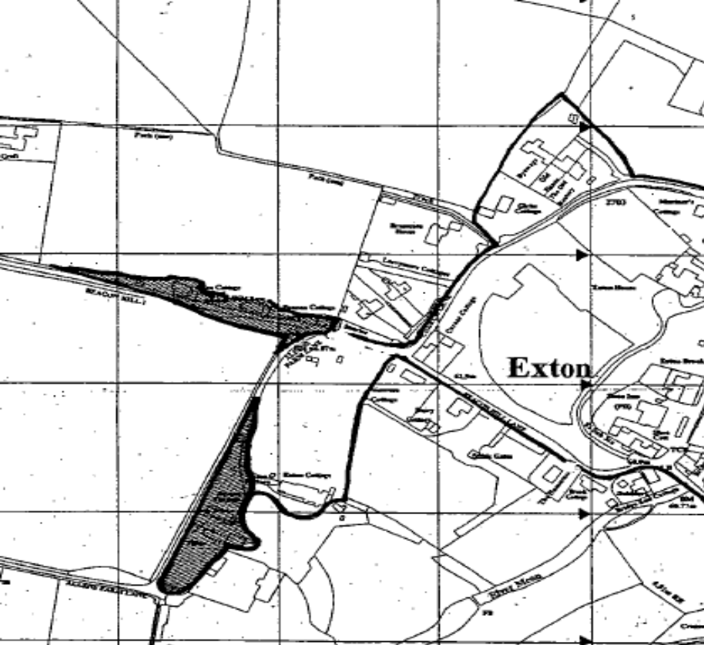
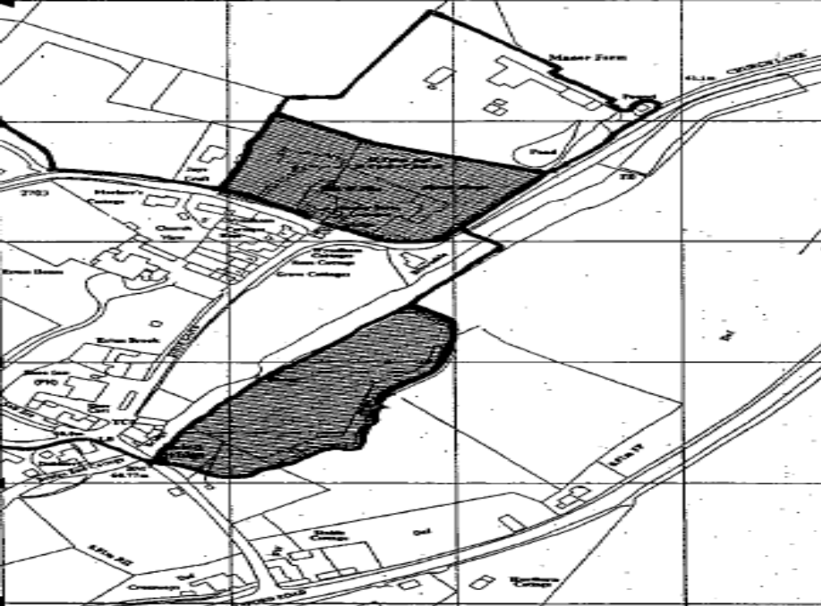

Figure 6: Areas of High Archaeological Potential, as identified in the Exton and Lomer Historic Rural Settlement publication

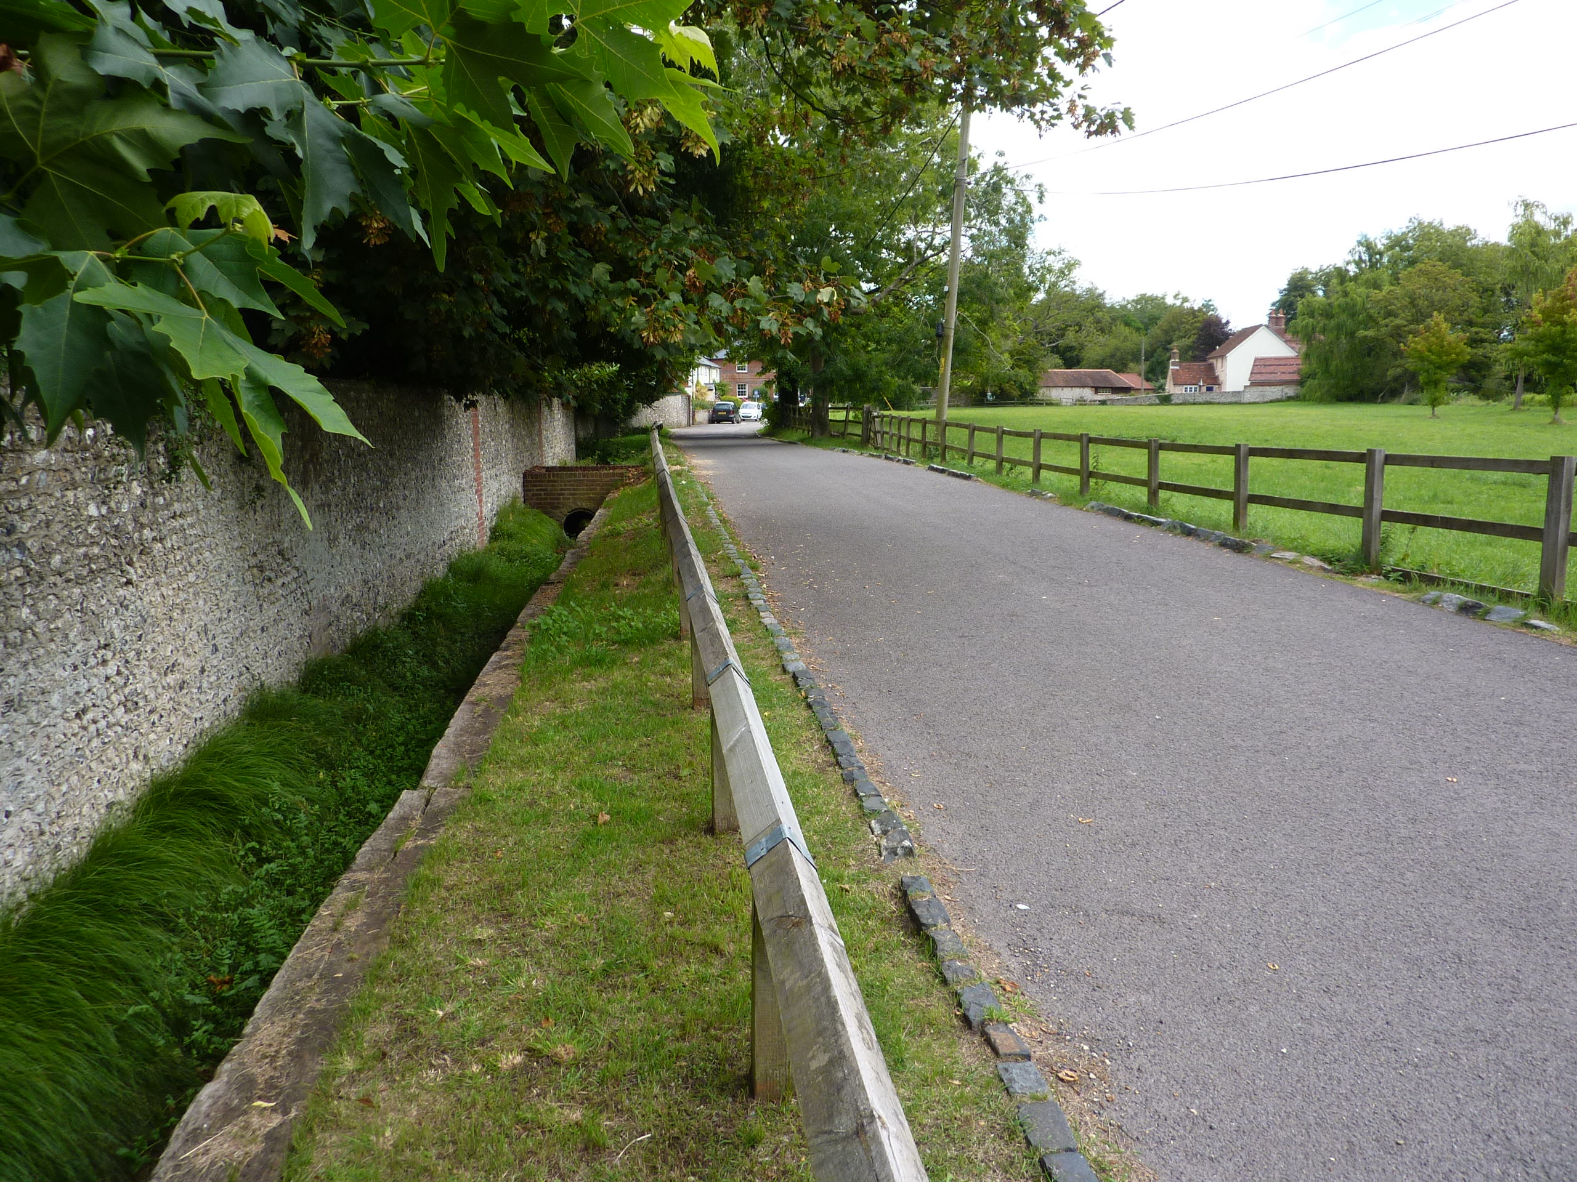
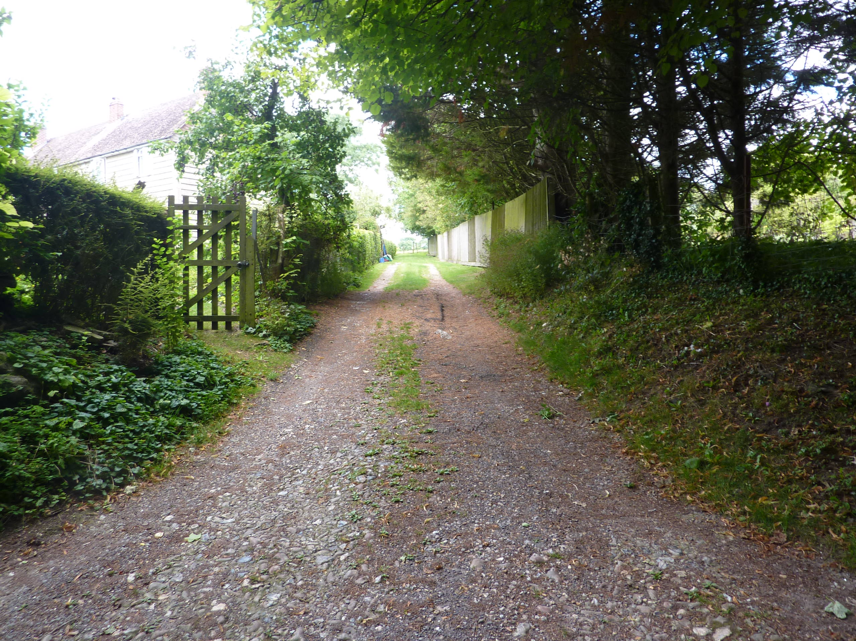
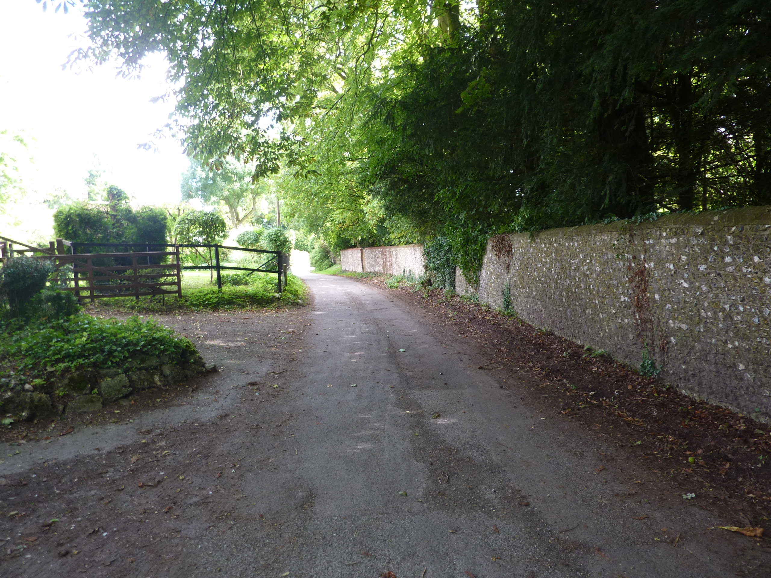

Photographic Survey
Figures 7-9; Street scenes within the Conservation Area, showing the rural and informal nature of the lanes. Also note the intrusive overhead wire-scape in Shoe Lane (top)

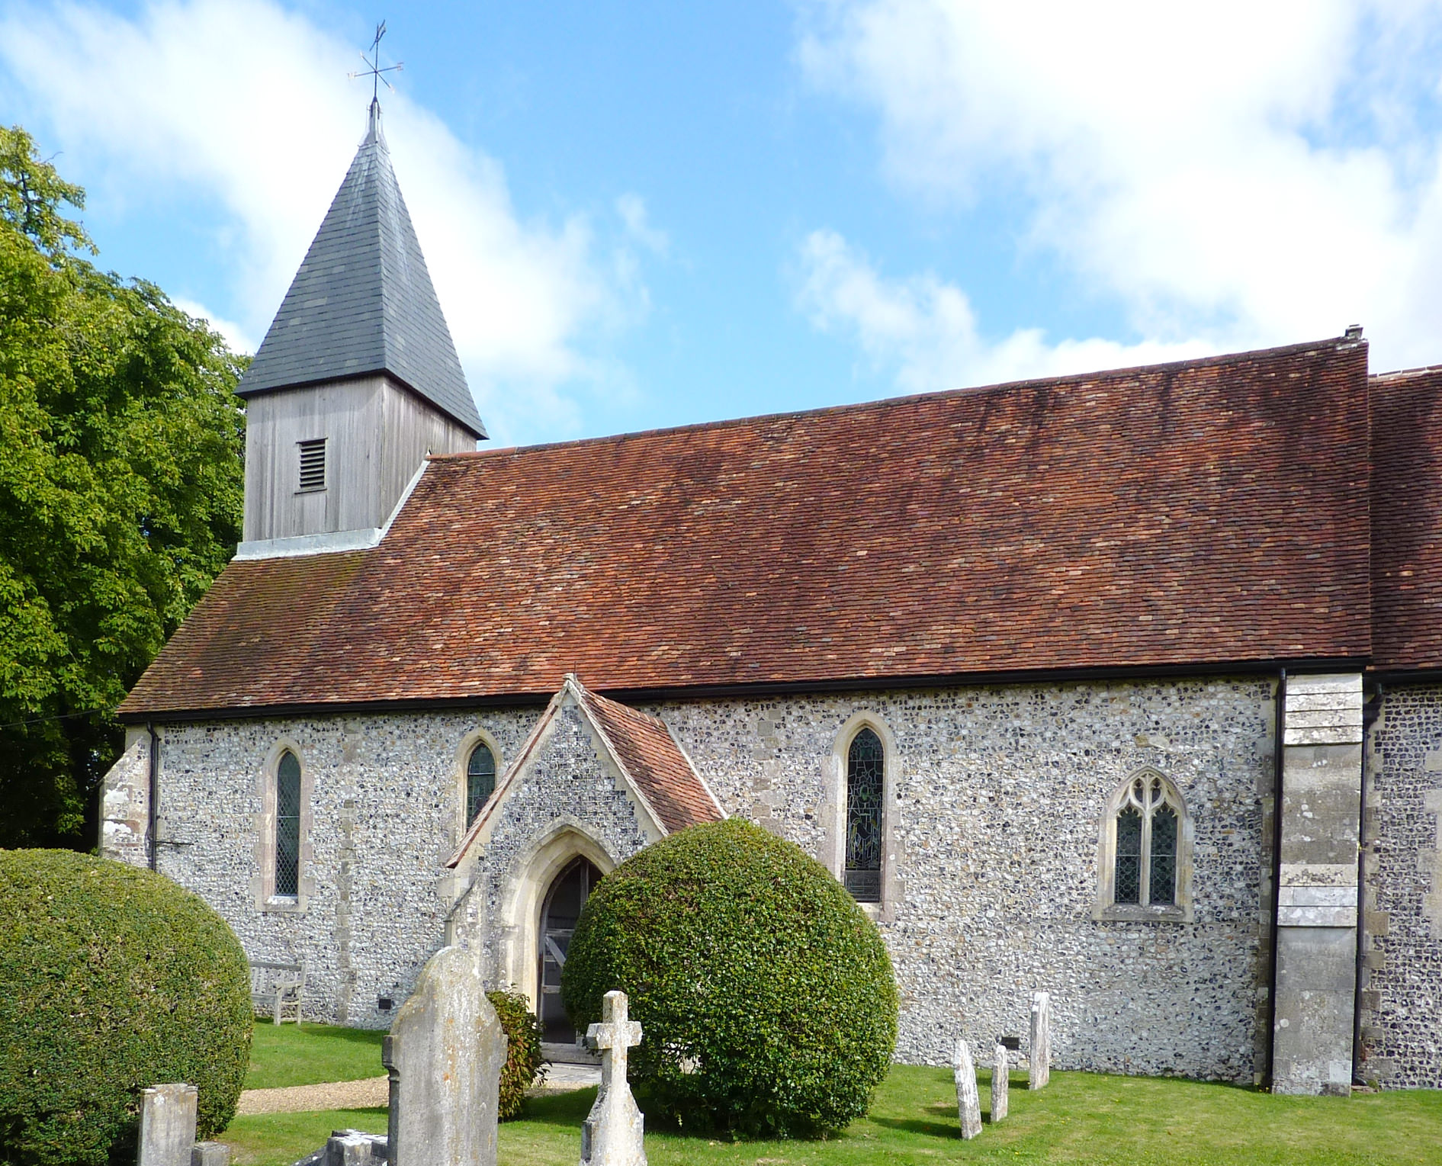
Figure 10: Parish Church of St Peter and St Paul

Figure 11: The garden frontage of Manor House seen from the churchyard

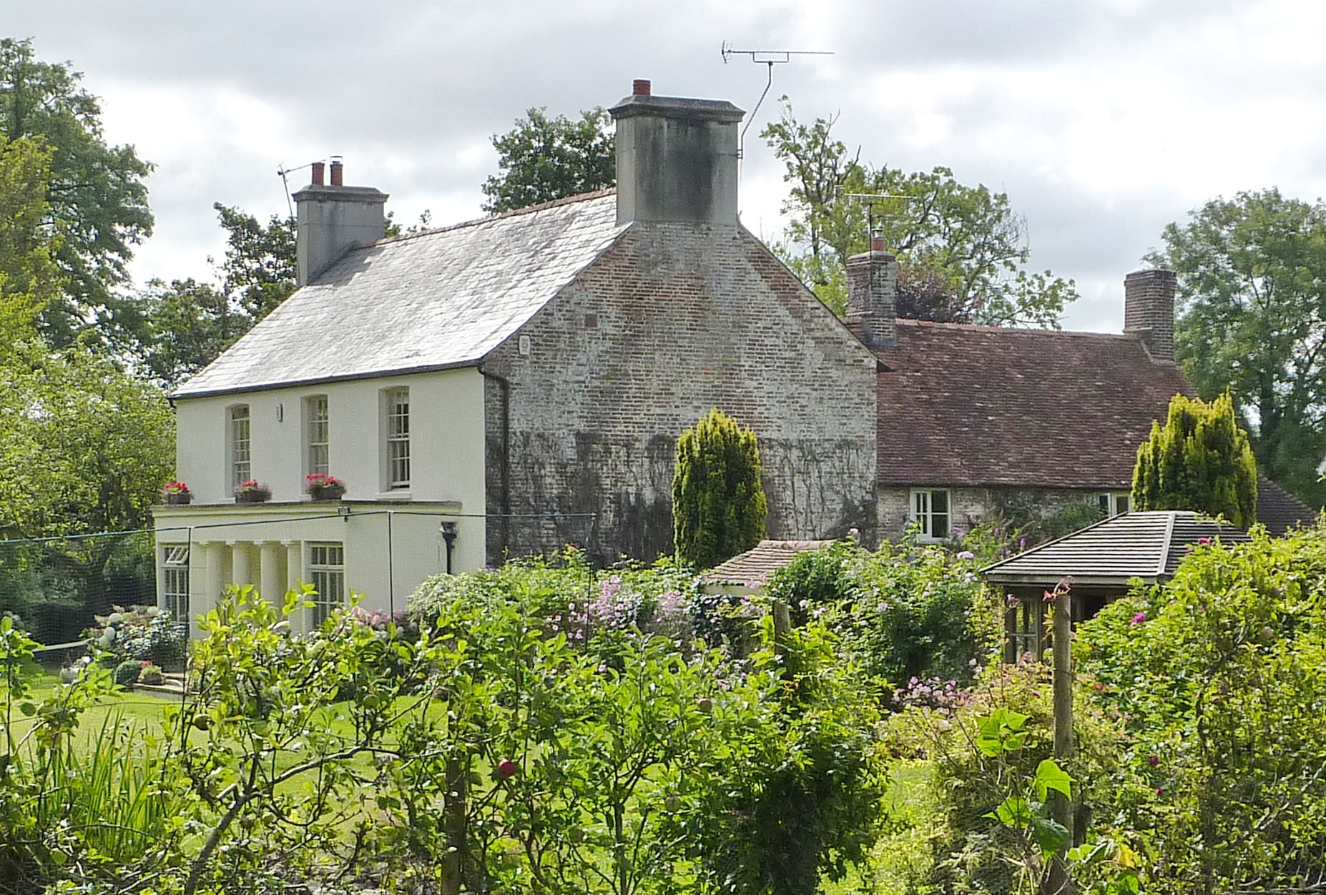

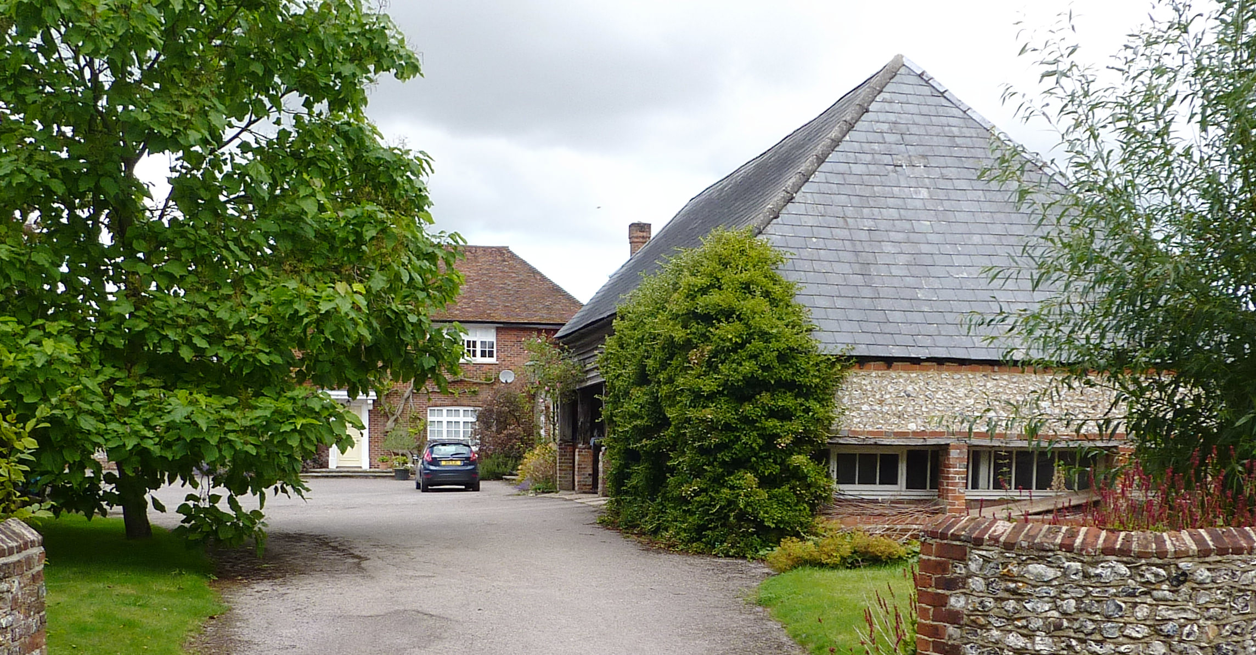
Figure 12: Manor Farm

Figure 13: The Village Pound which is currently just outside the conservation
area boundary

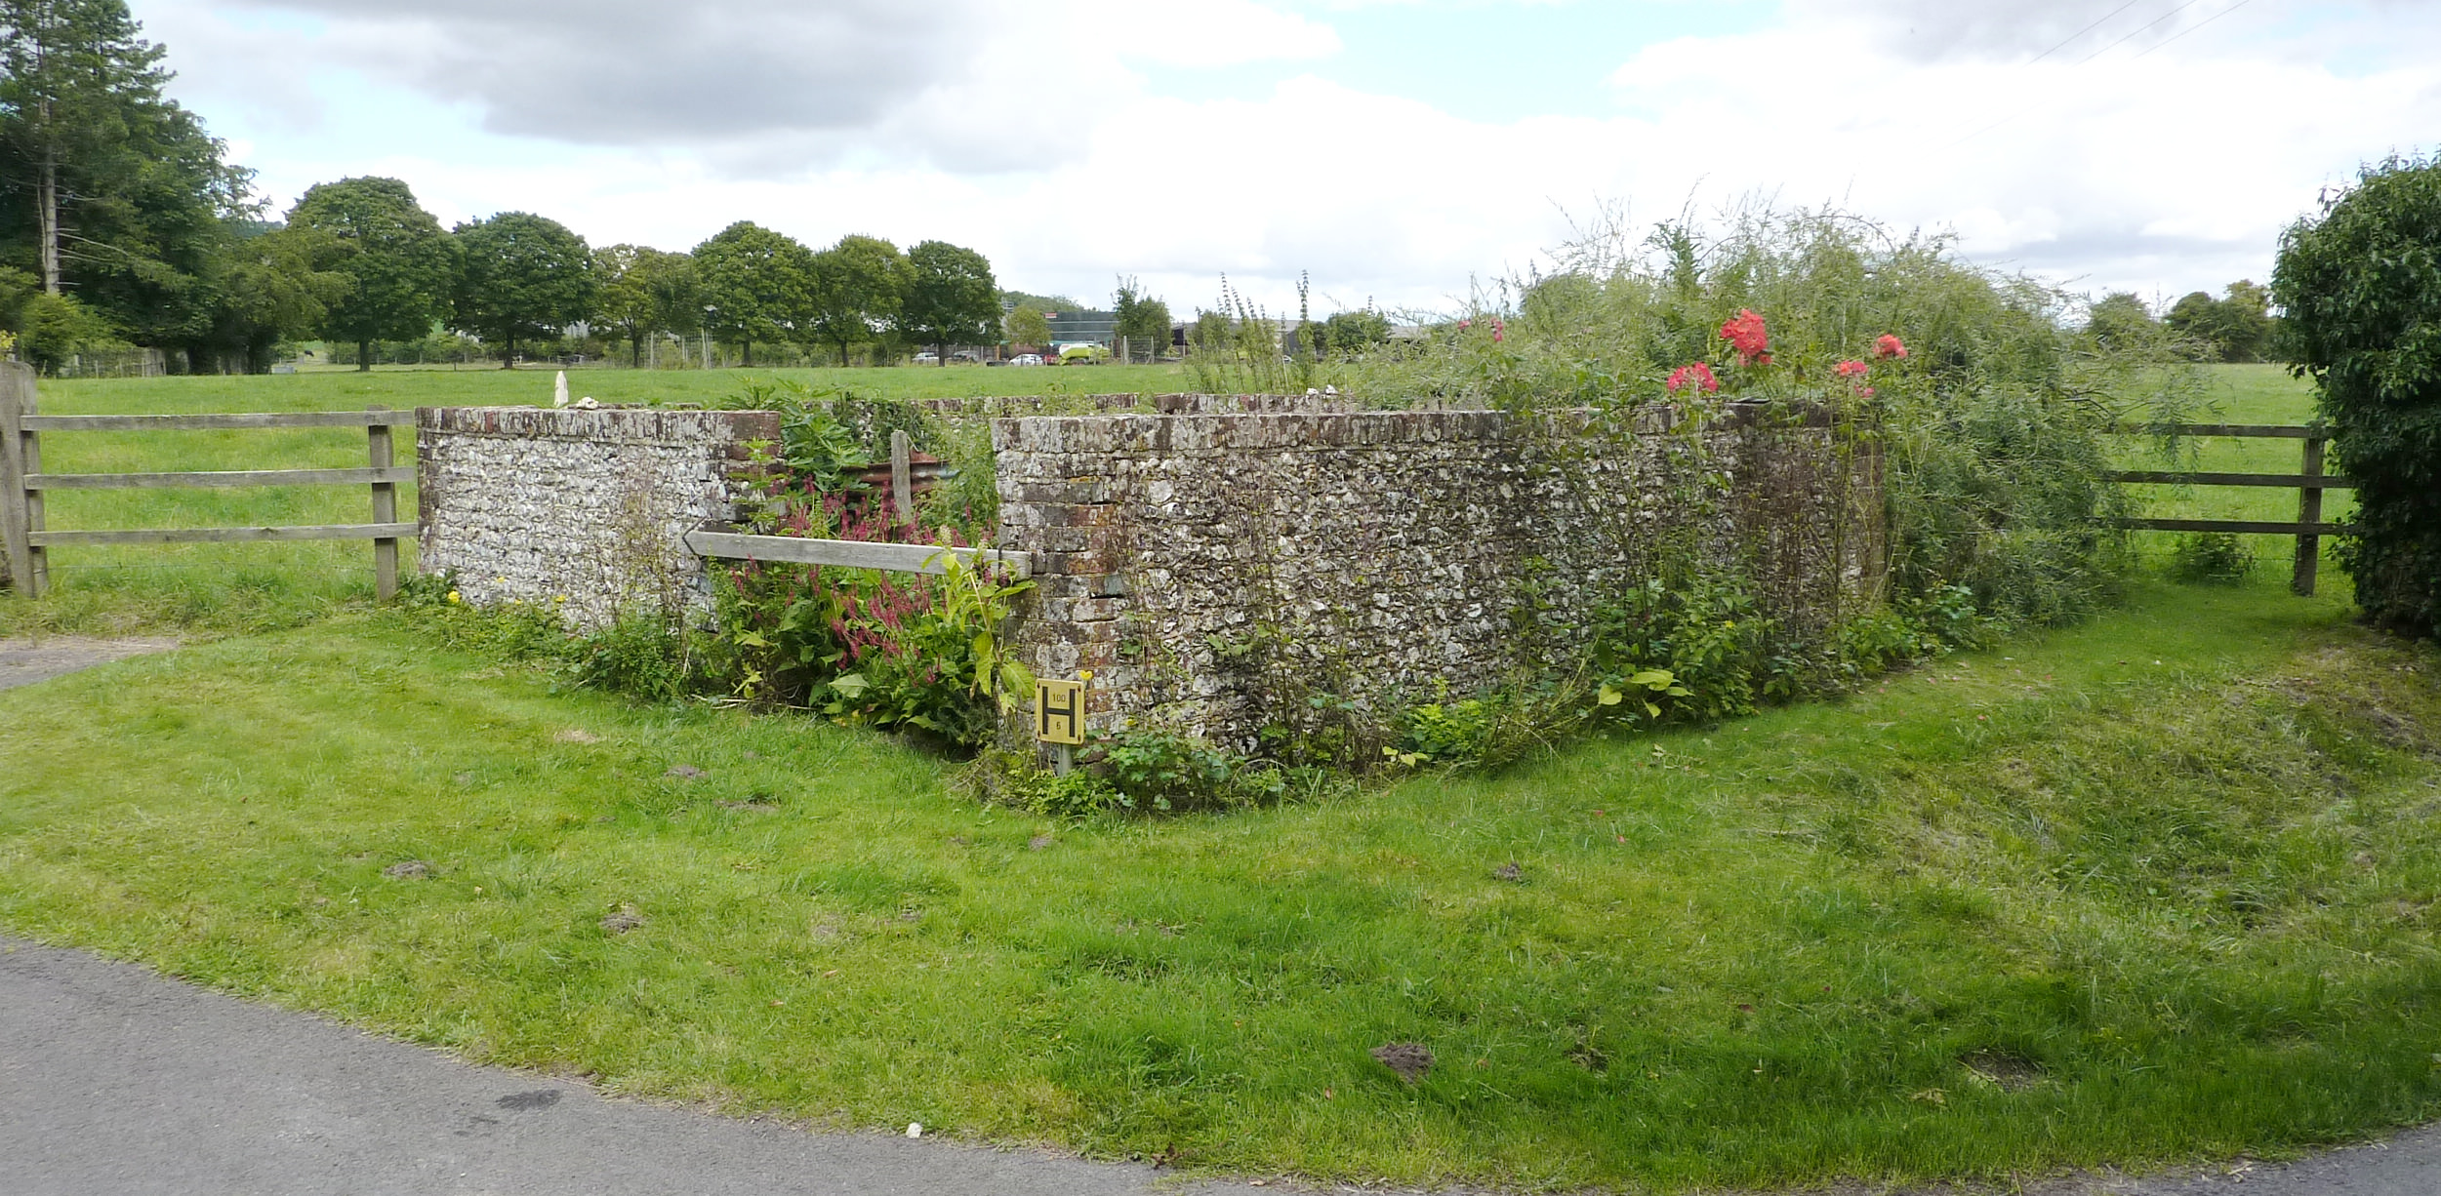

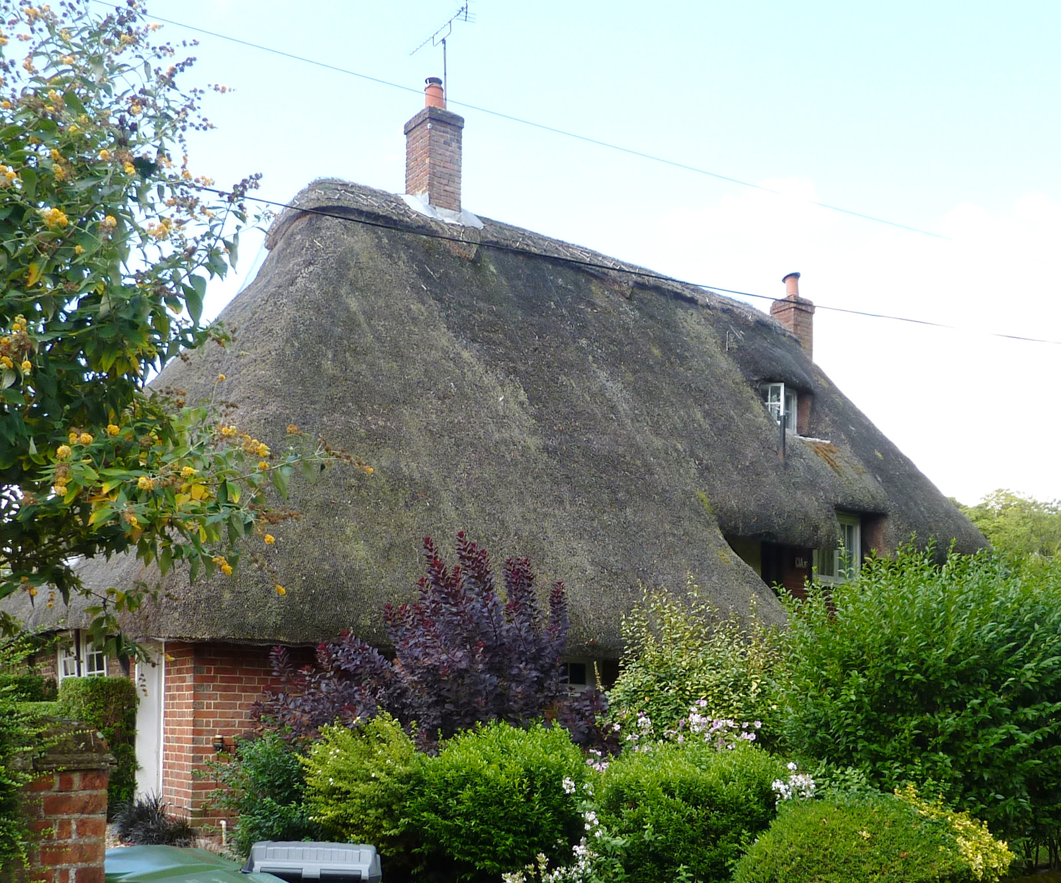
Figure 14: Marriner’s Cottage

Figure 15: Church View

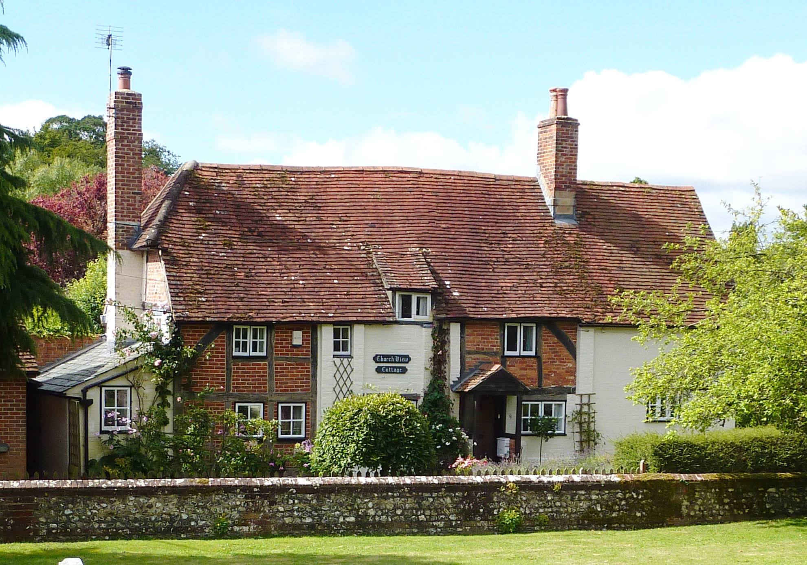
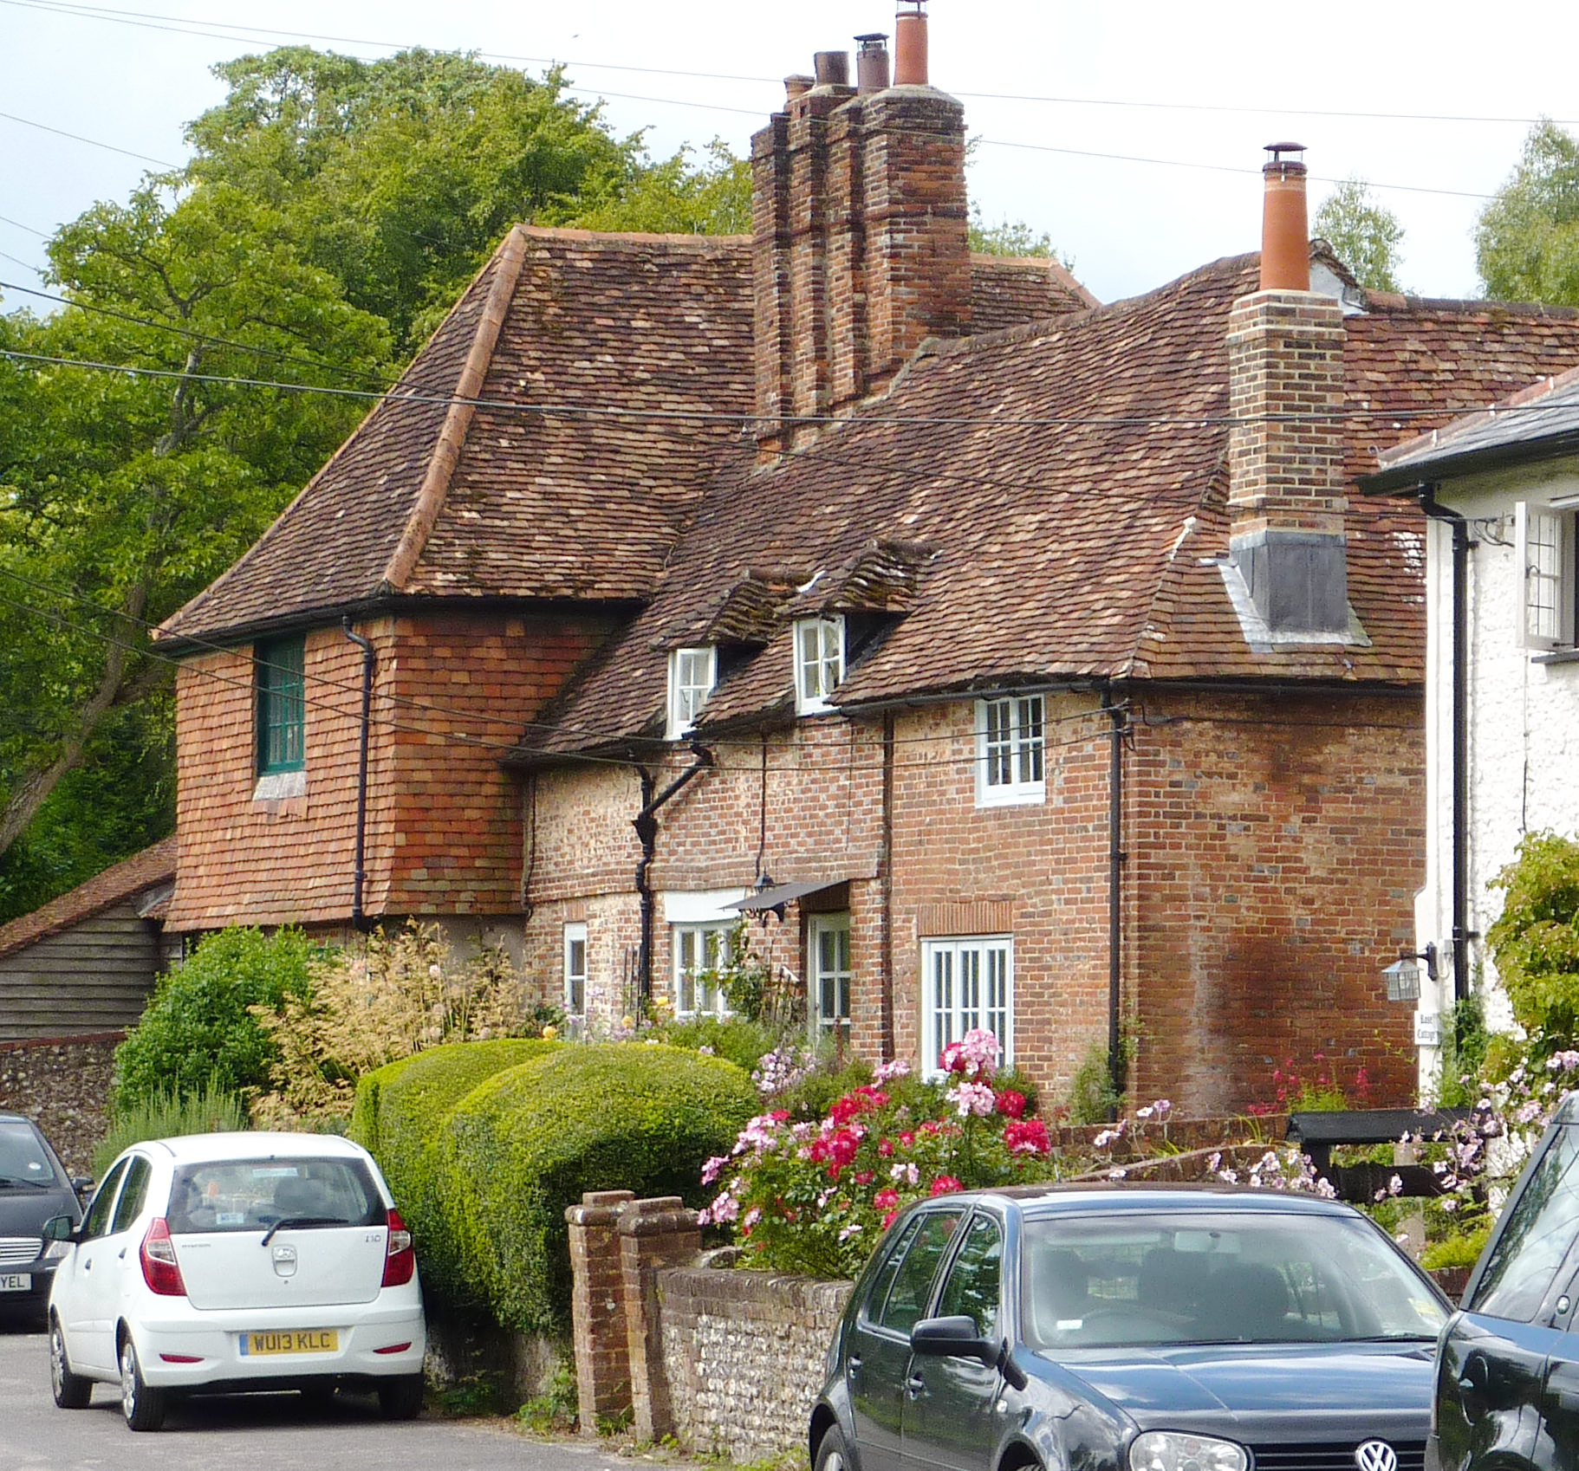
Figure 16: 1 Grove Cottages, Middle Cottage and Sunnyside

Figure 17: Shoe Cottage. This cottage sits in a prominent position when viewed from across the bridge into the Conservation Area. Removal of the telegraph pole and undergrounding of the wires would produce a significant visual improvement.
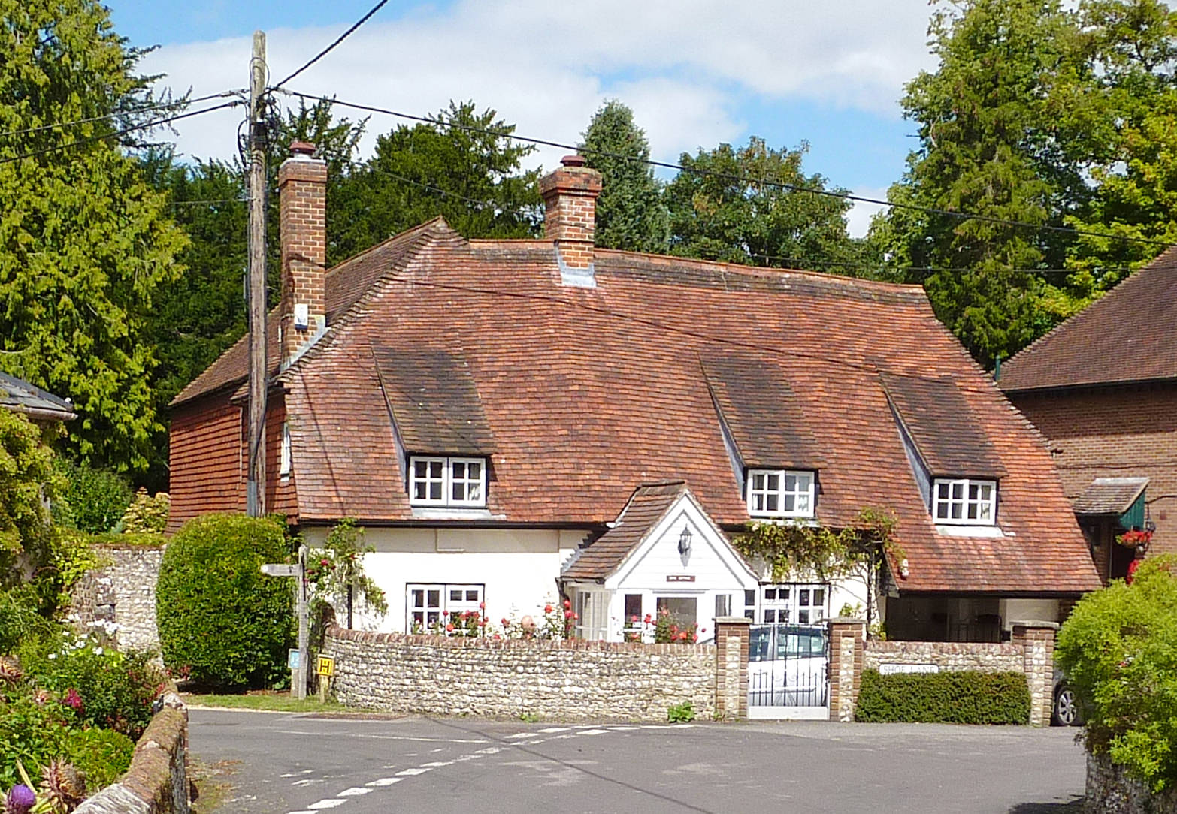

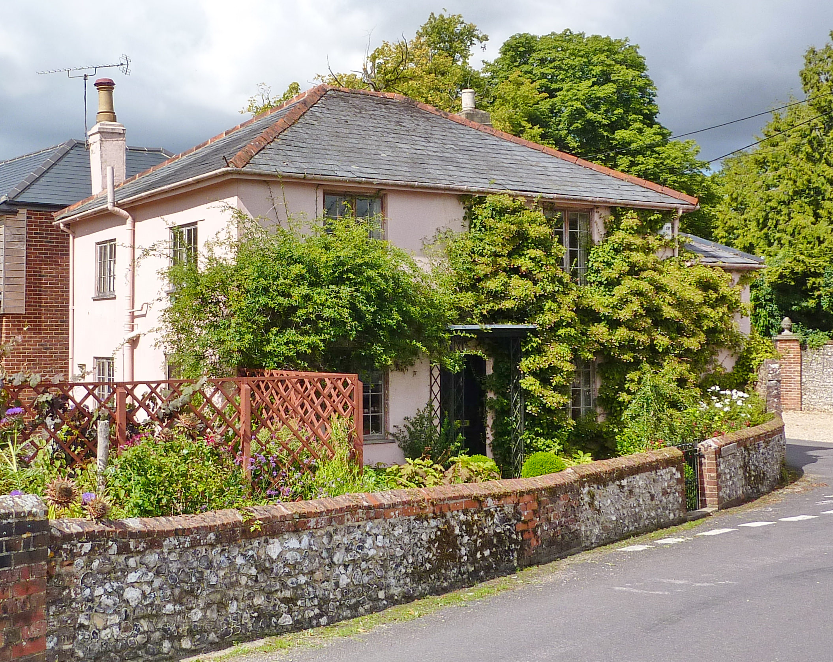
Figure 18: Bridge End Cottage
Figure 19: K6 telephone kiosk
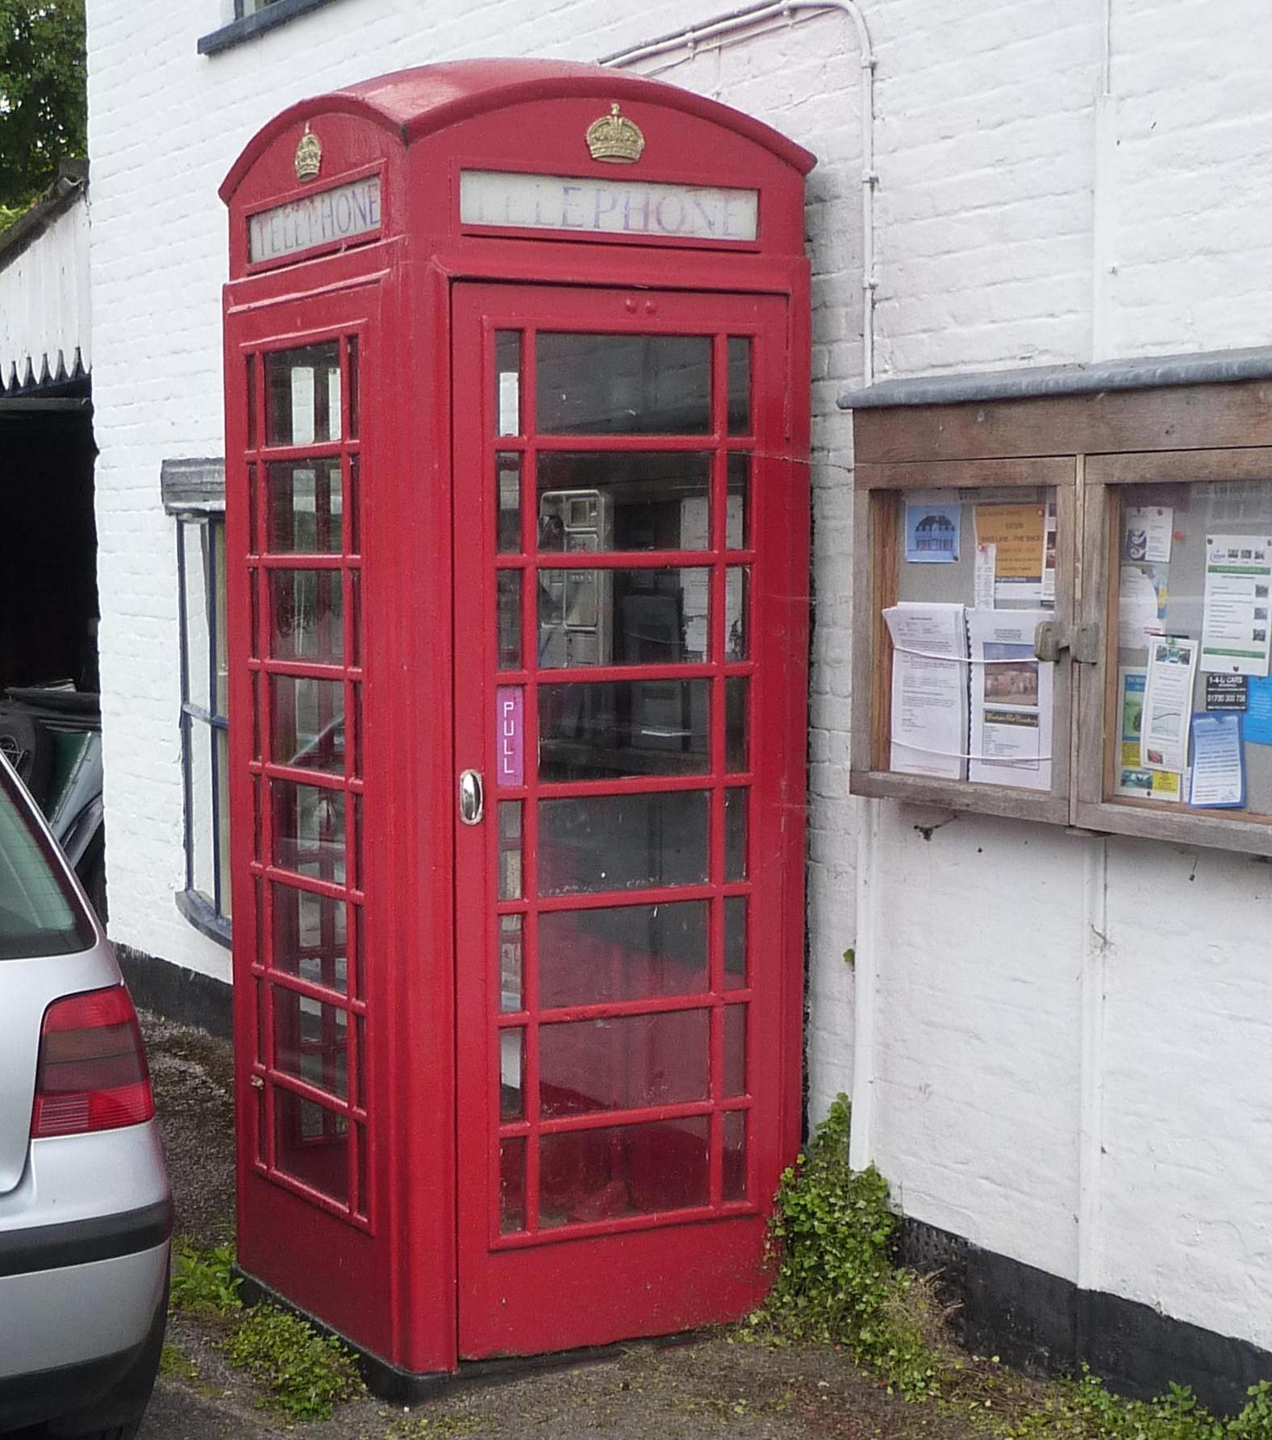

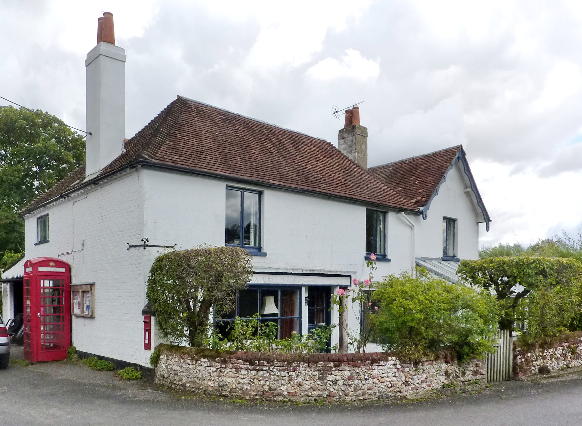
Figure 20 and 21: Bridge Cottage, formerly incorporated the Village Post Office and Store, is now residential and stands at the bridge head.

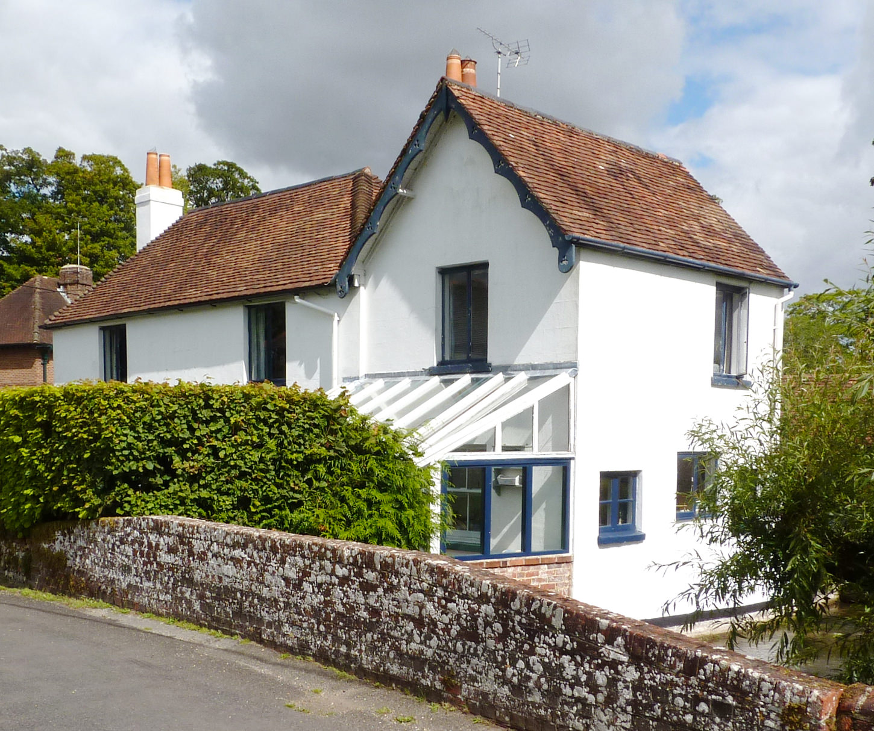

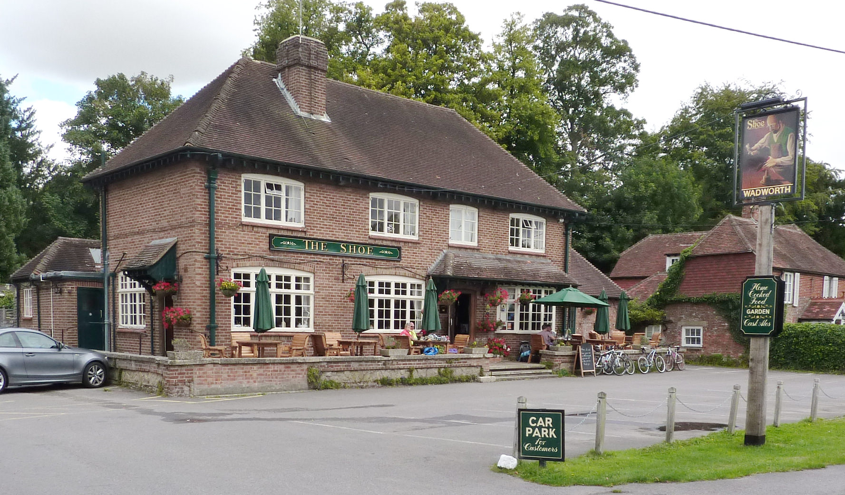
Figure 22: The Shoe Inn. The existing building replaced the original pub, which stood on the opposite side of the road, in the 1930s (or ‘50’s?). The addition of a flint and brick boundary wall combined with planting within the car park would knit the site back into the village-scape and soften the visual impact of the tarmac.

Figure 23: Reflections represents a modern intervention into the Conservation Area

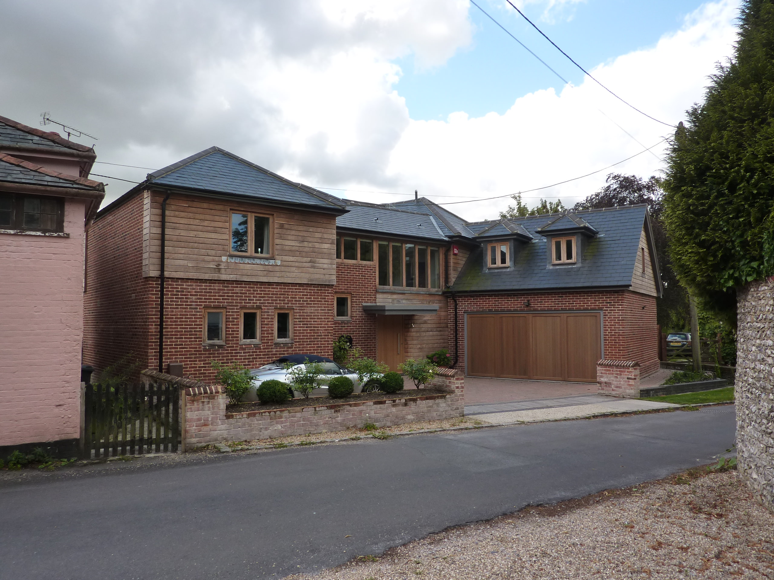

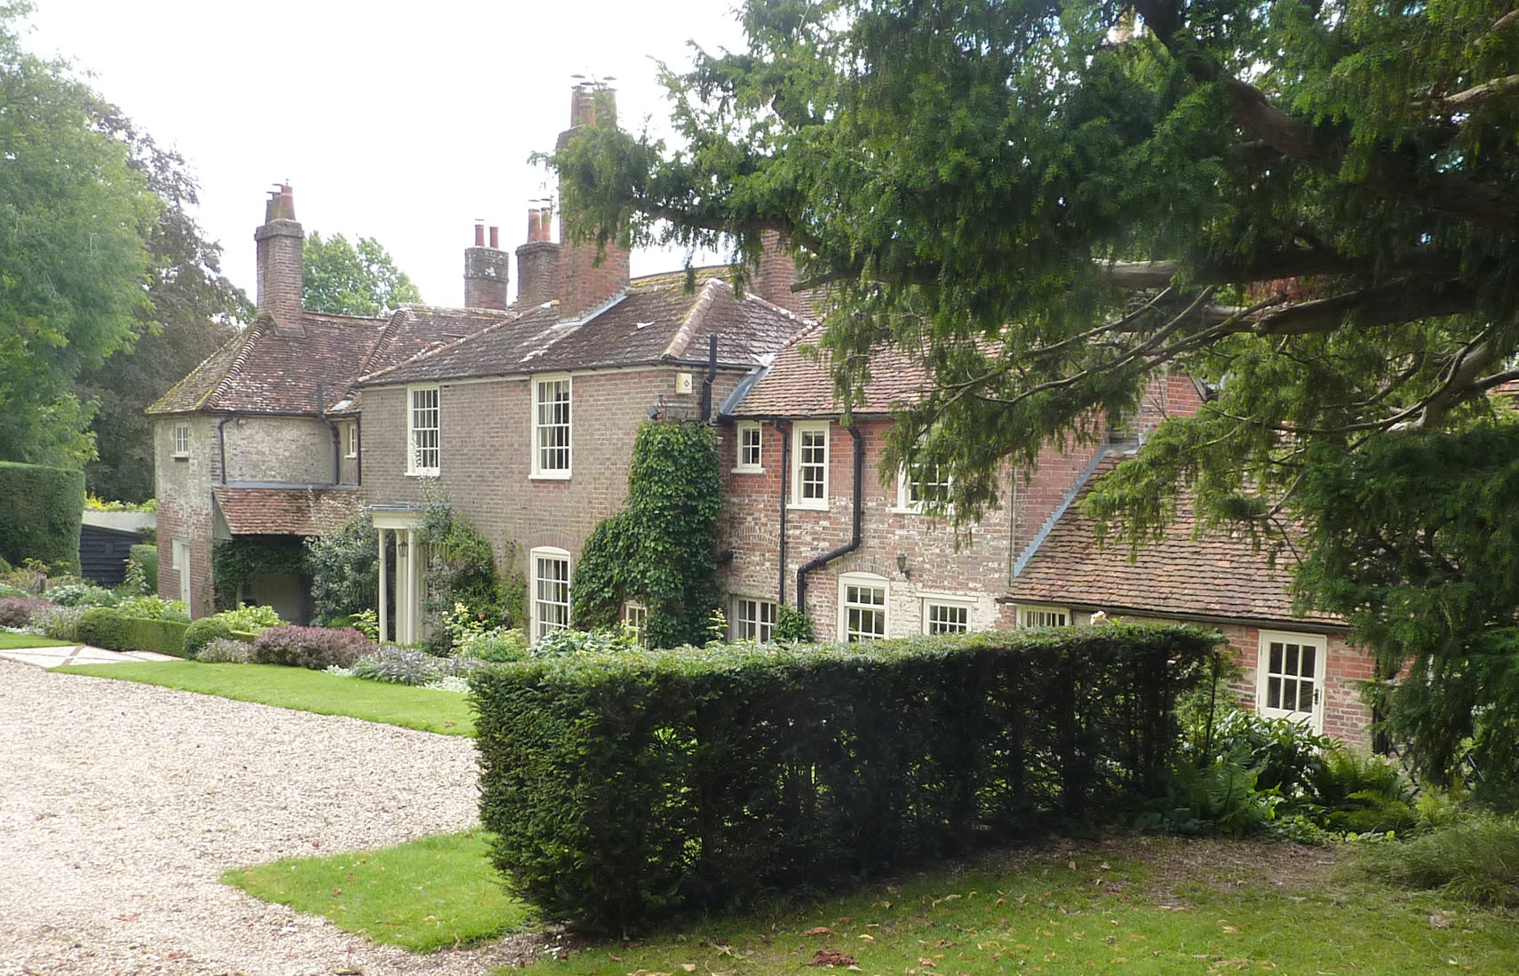
Figure 24: Exton Cottage

Figure 25: Barn 60 metres north-east of Exton Farmhouse

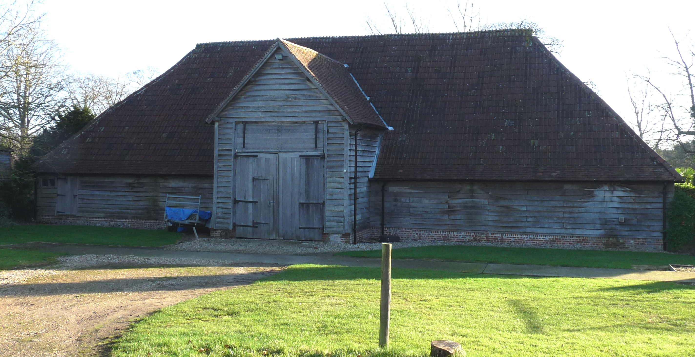

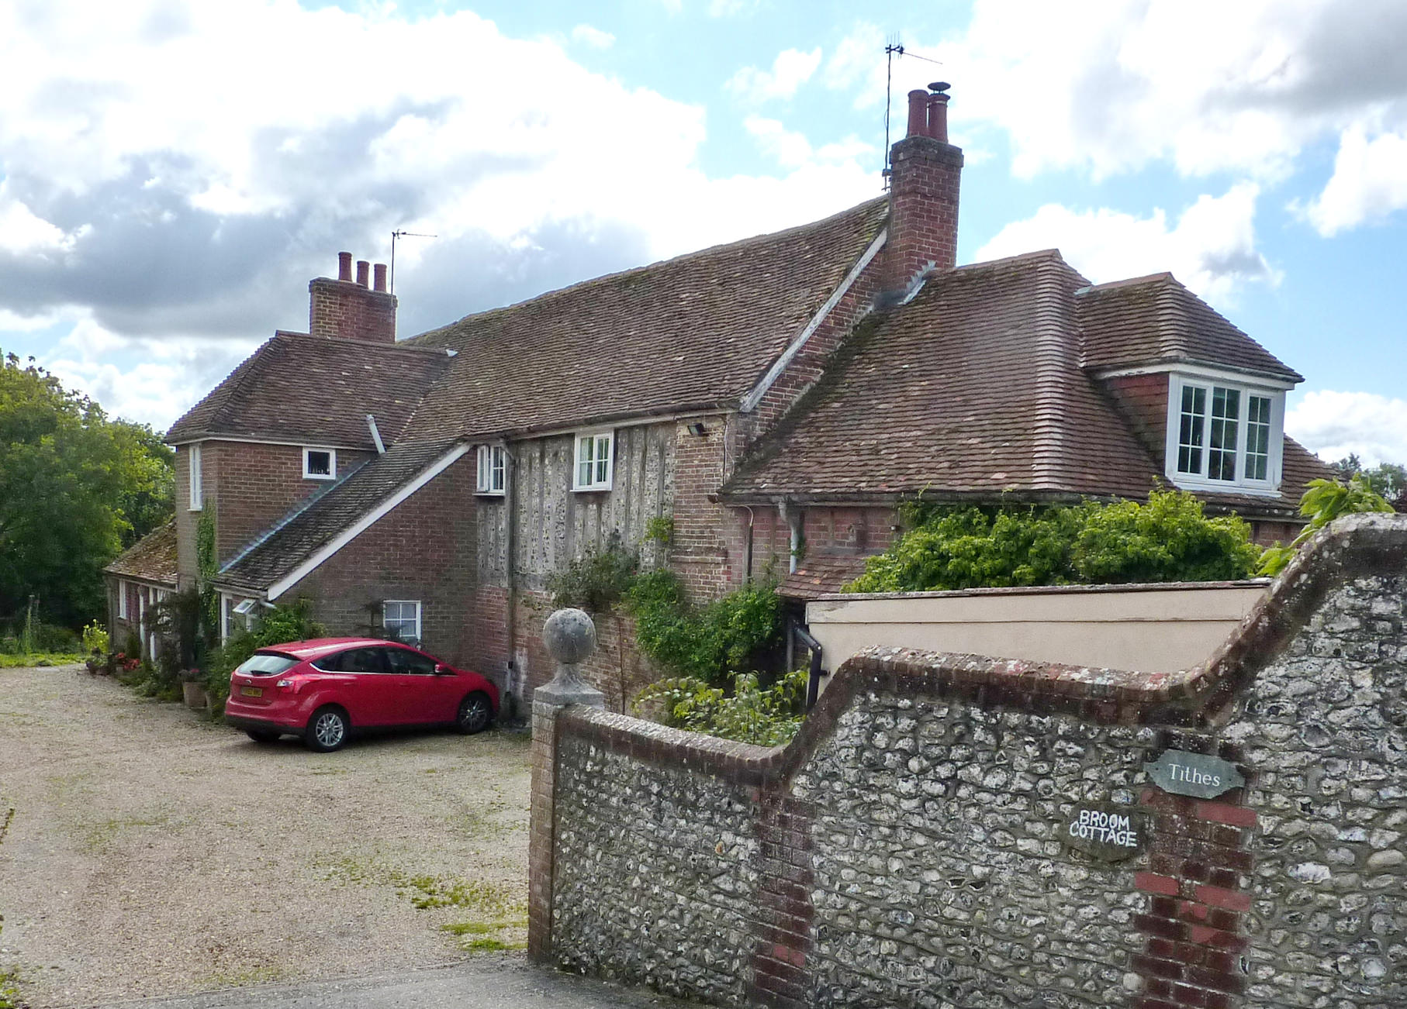
Figure 26: Broom Cottage and Tithes

Figure 27: Redundant farm buildings on Allens Farm Lane. Planning permission has been granted for the conversion of this building into a dwelling and the implementation of that permission would secure and sustain the positive contribution made by these buildings to the character of the Conservation Area.

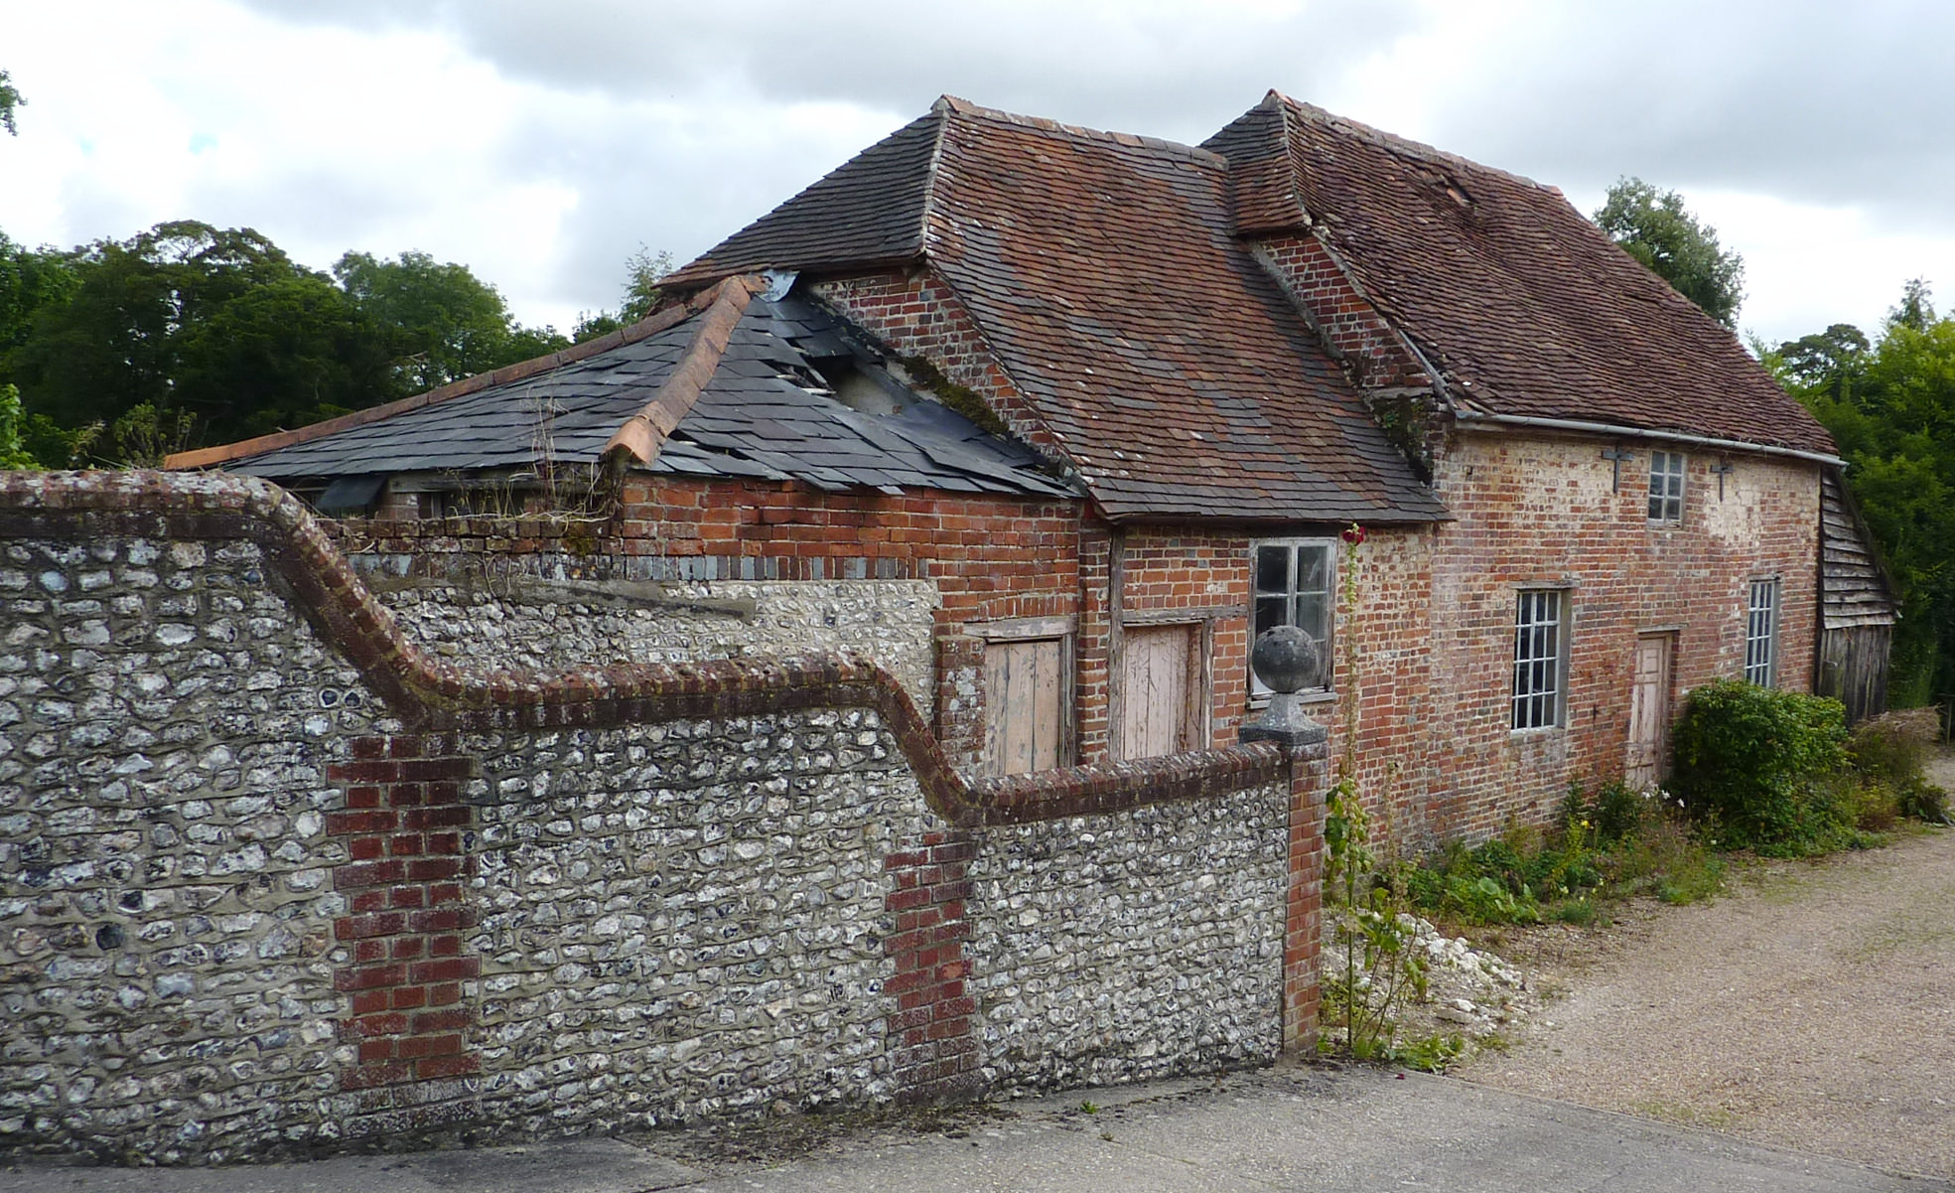
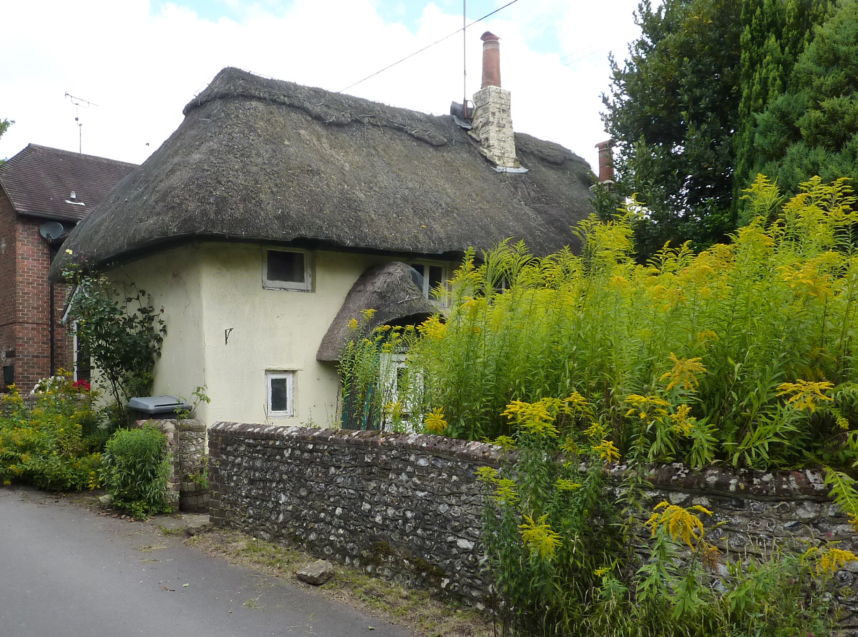
Figure 28: Sunrise; an important survival of cob construction within the village and a building identified as ‘vulnerable’ in the National Park’s Buildings at Risk Survey. The cottage has been recently re-thatched.

Figure 29: The Homestead.

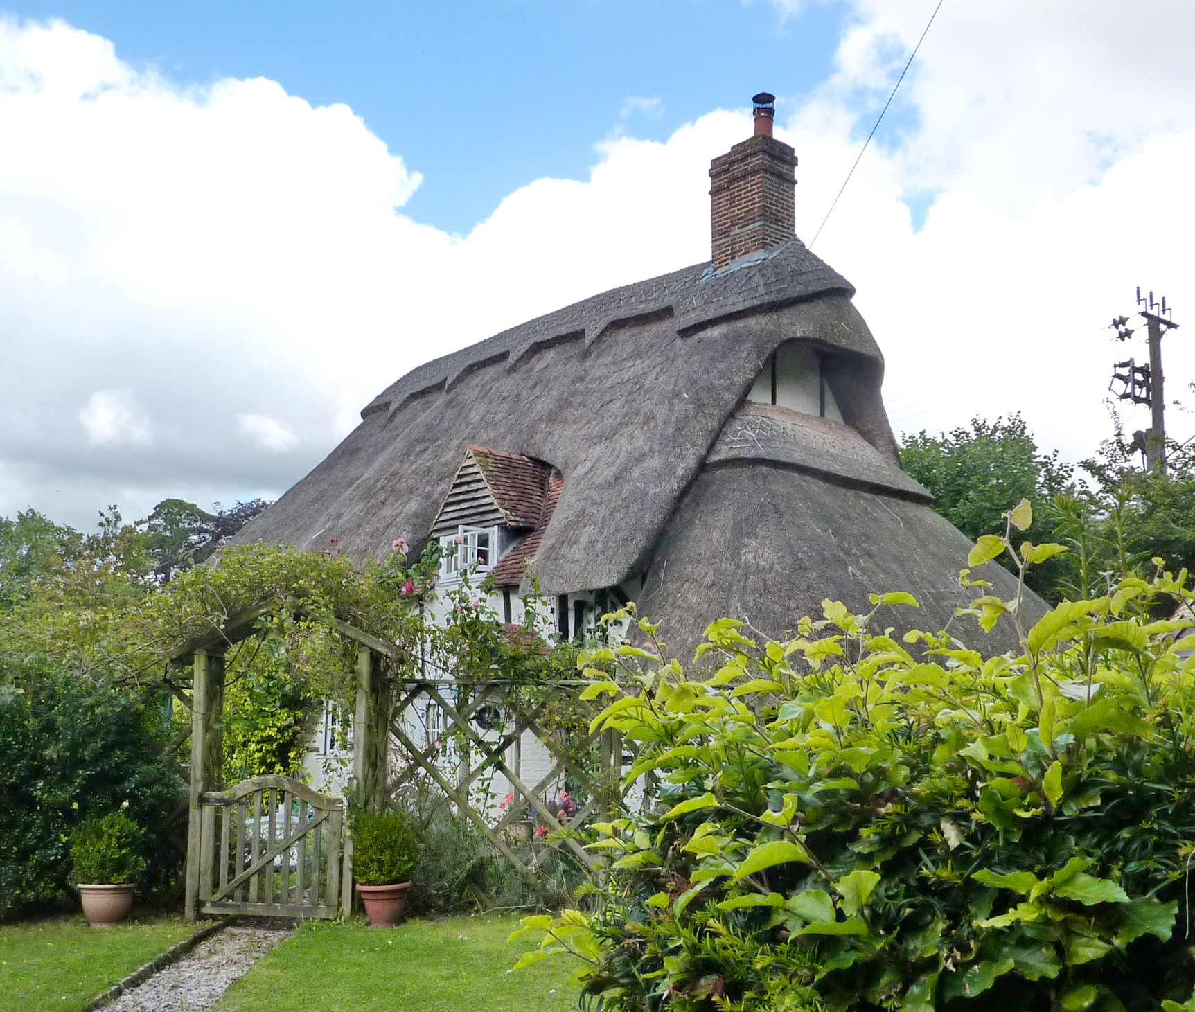

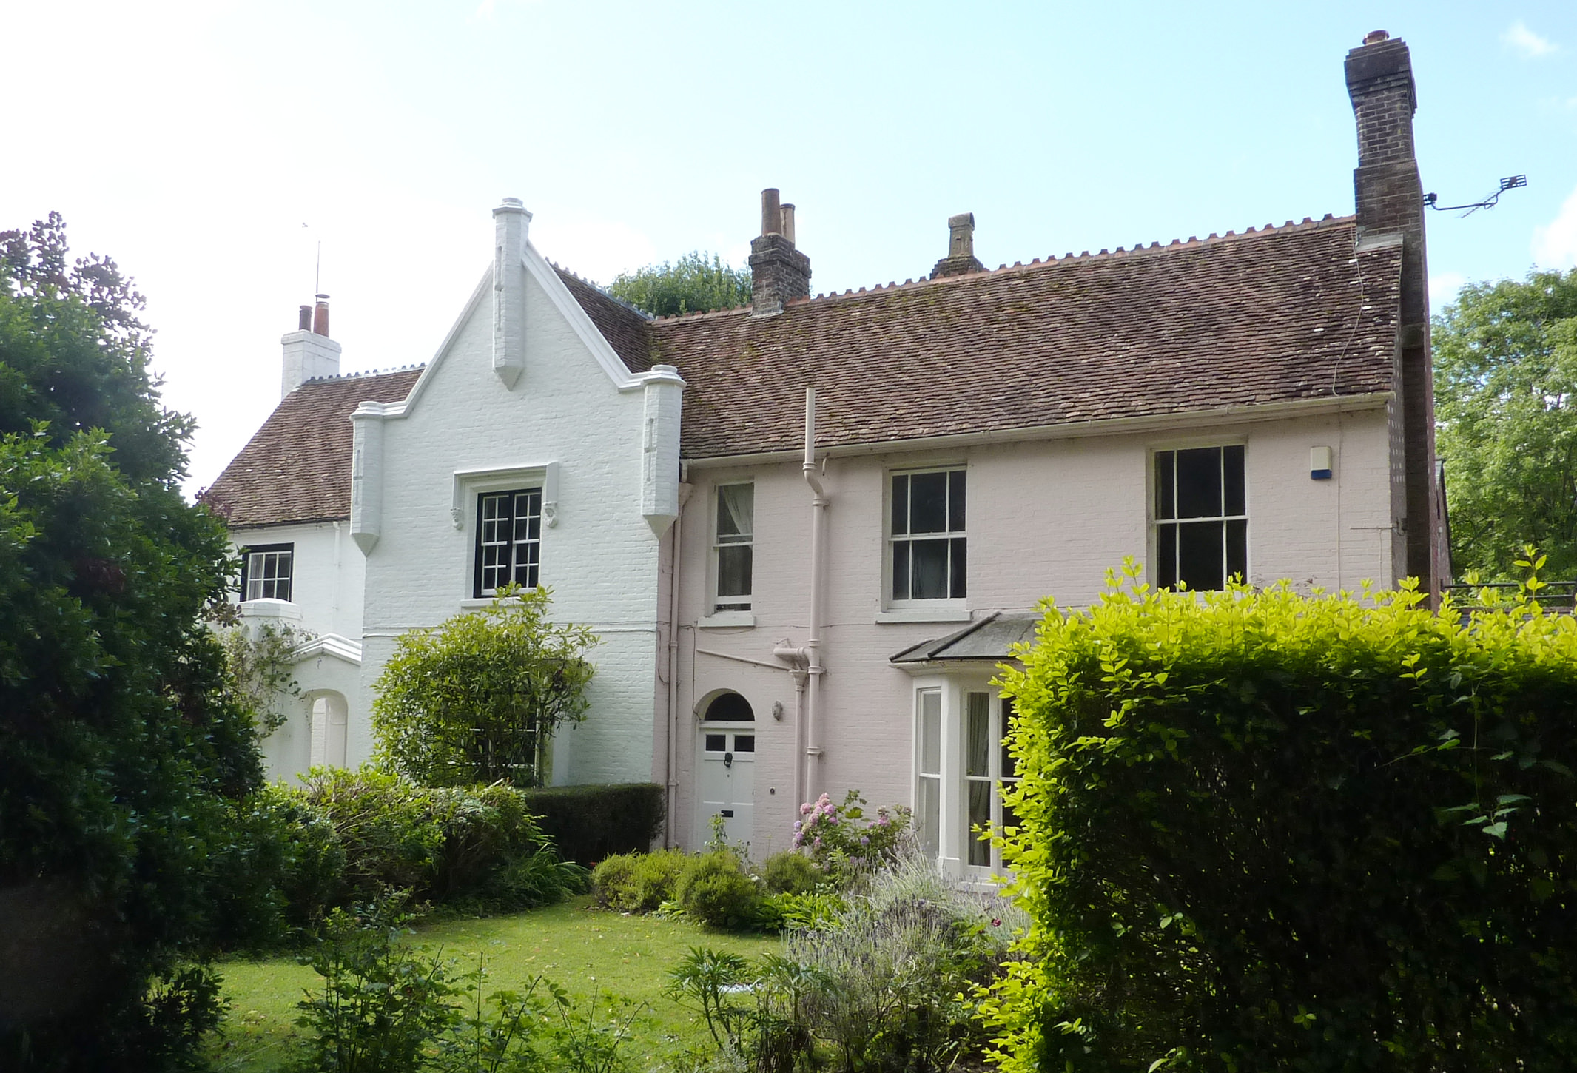
Figures 30 and 31: The Rectory, now divided into two dwellings known as The Old Rectory and The Old House.

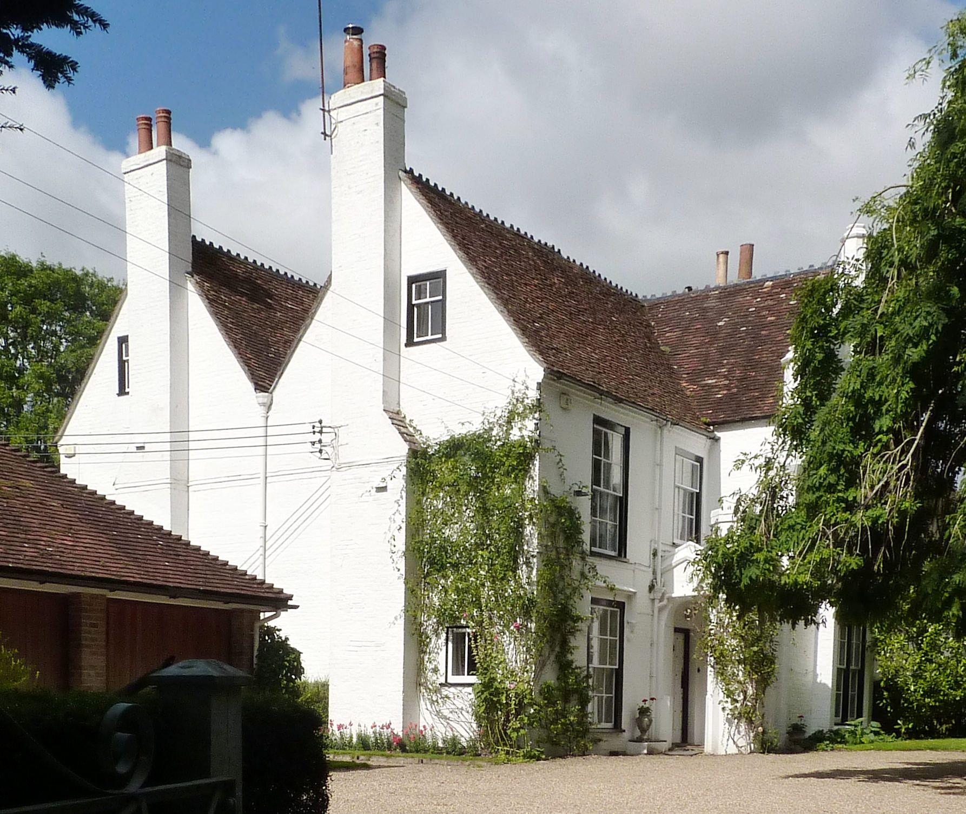

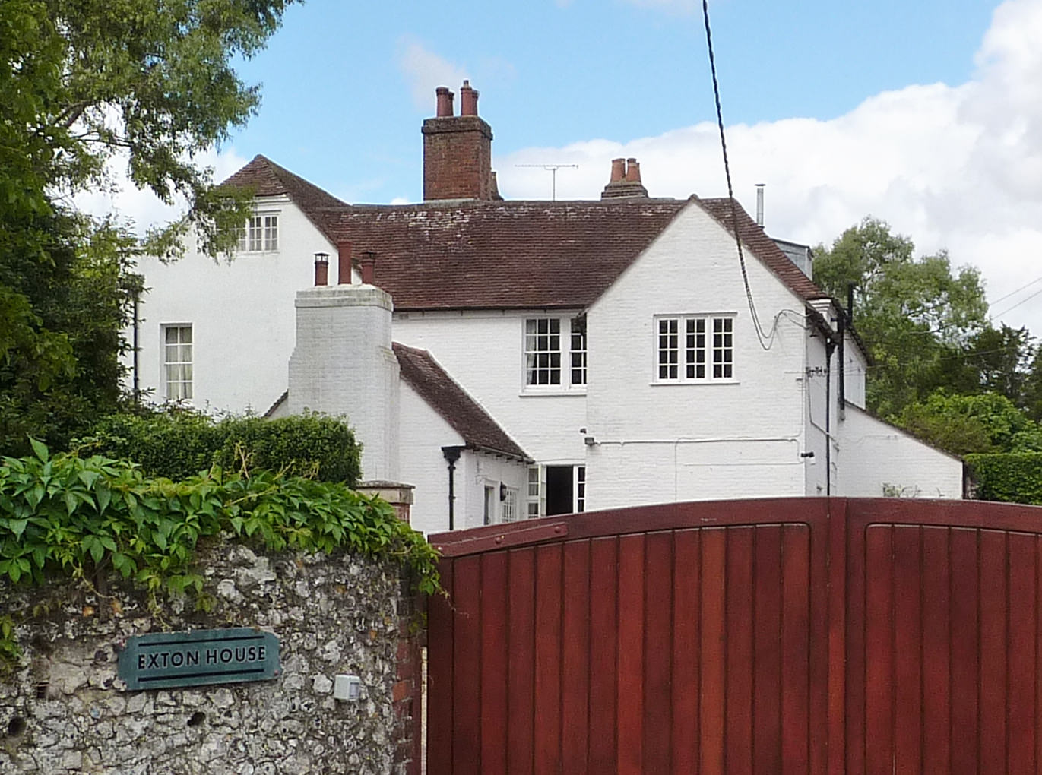
Figure 32: only the side elevation of Exton House appears prominently from the
roadside. The south facing garden façade is a far more imposing elevation

Figure 33: Corner Cottage; a potential entry on the emerging Local List of Buildings

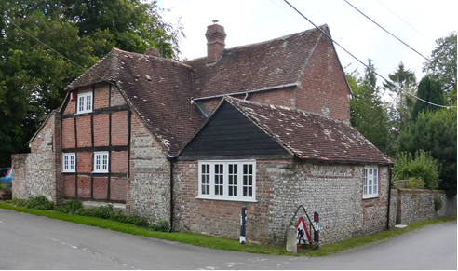

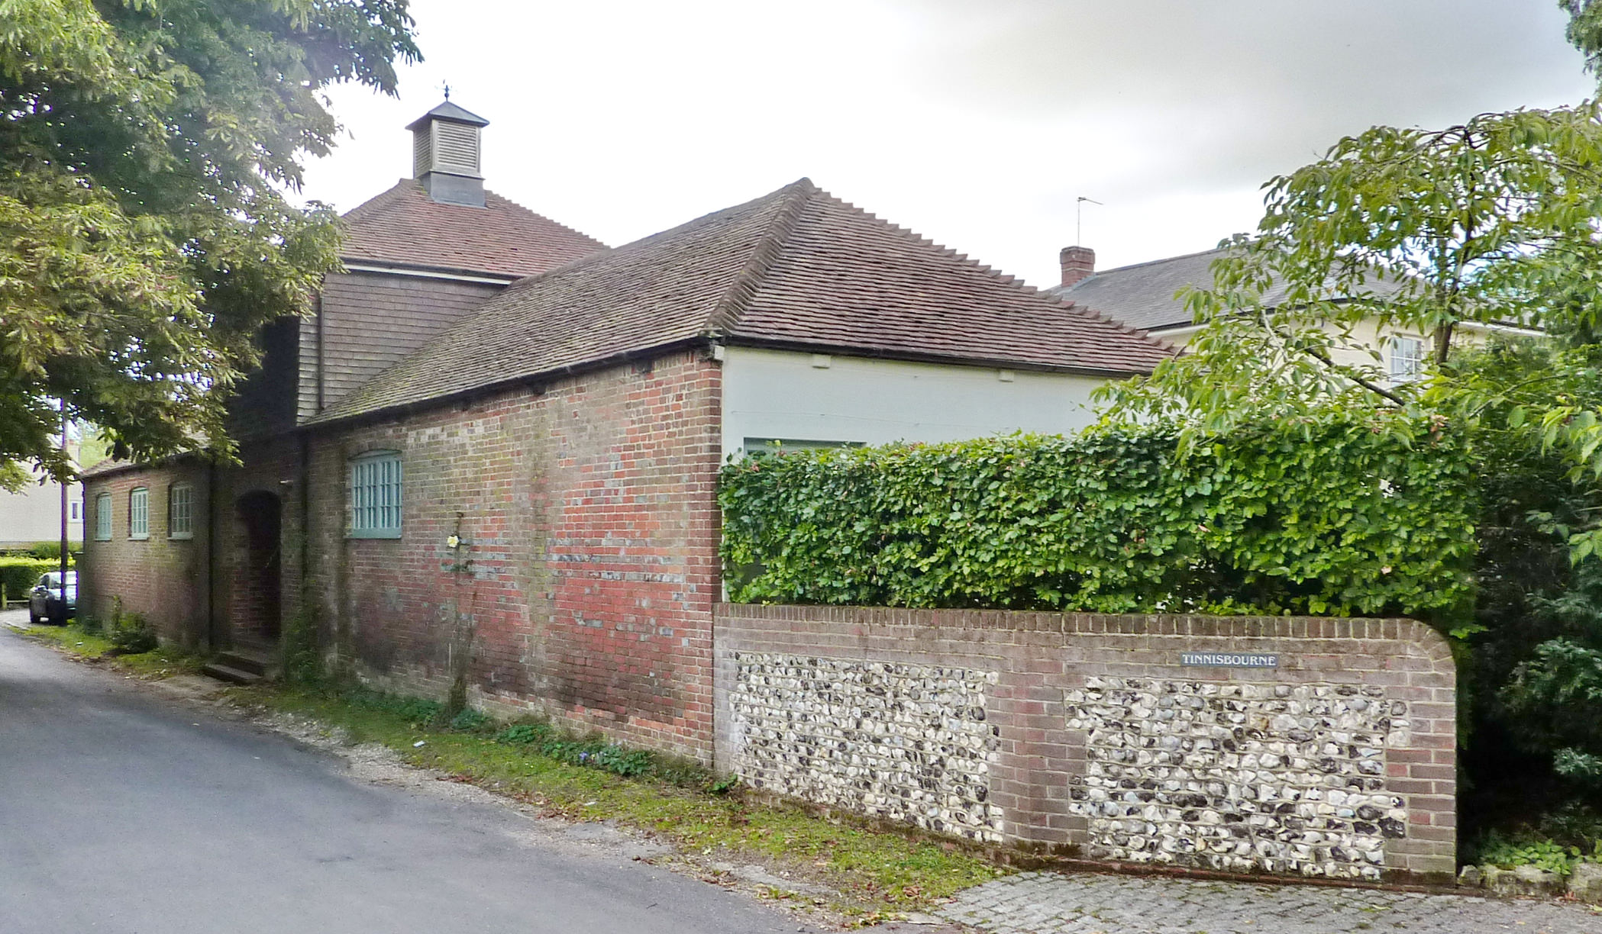
Figure 34: Stable Gate, a successful domestic conversion

Figure 35: Rose Cottage, Kingfisher Cottage and Wyndham Cottage

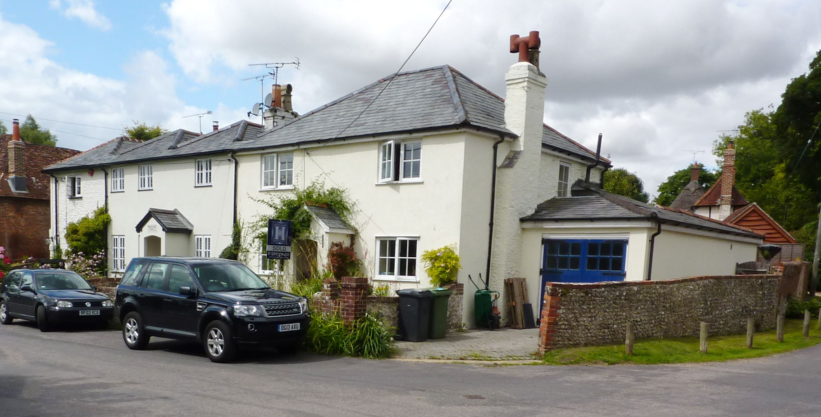
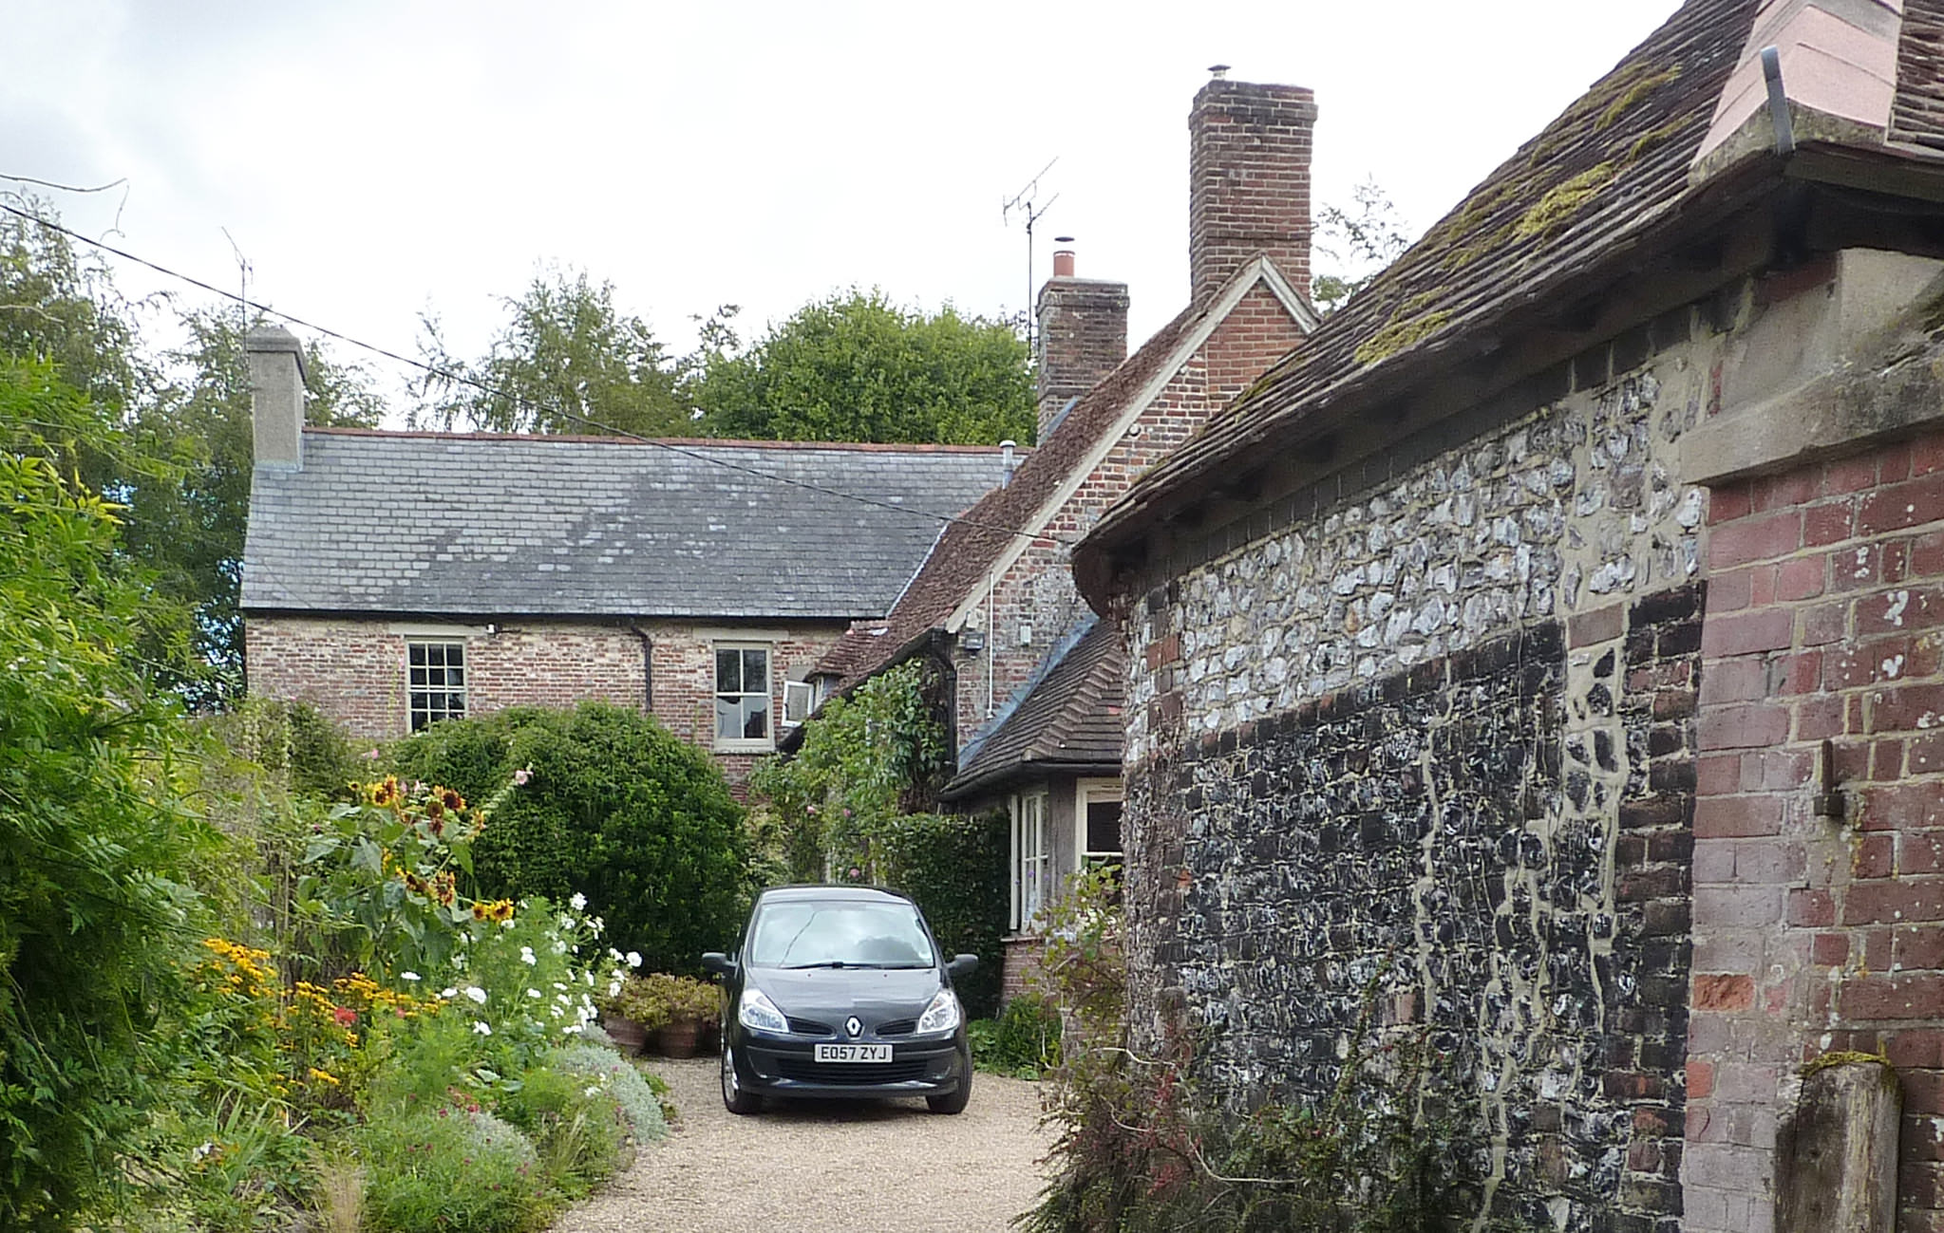
Figure 36: Manor House
Figure 37: Riversdale, a potential entry on a Local List

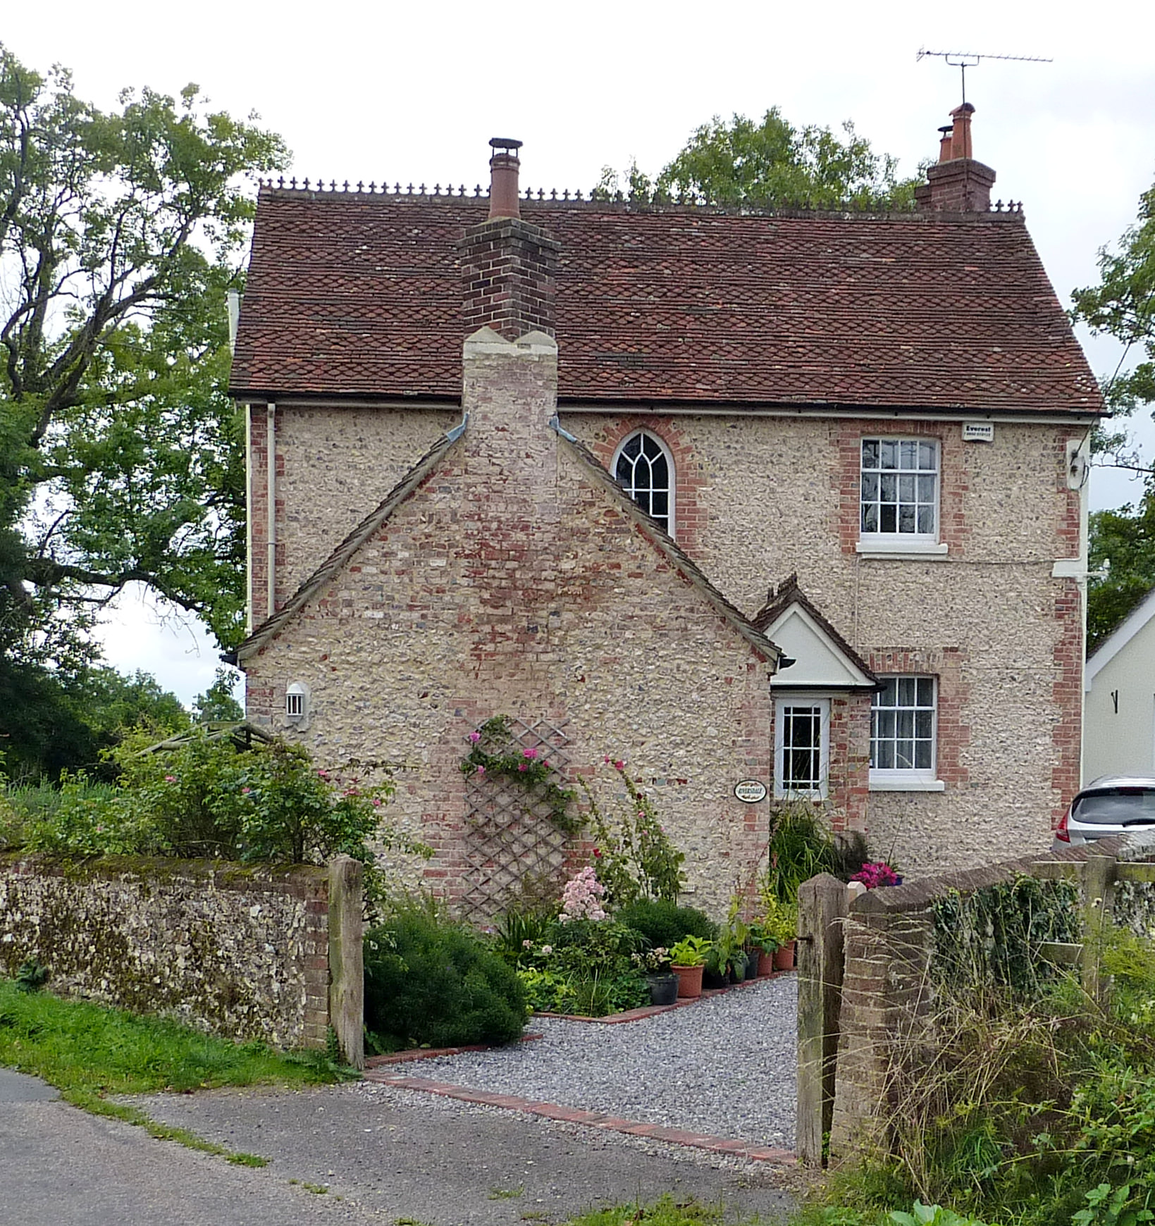

Management Plan
6.1 At the beginning of this document the legal definition of a Conservation Area as “areas of special architectural or historic interest, the character and appearance of which it is desirable to preserve or enhance” was acknowledged.
6.2 Taking this definition as a starting point, it follows that the proper management of a Conservation Area will have as its objective both the protection of its existing qualities and its enhancement in ways that build upon its special interest. Four broad aims can be defined:
- To ensure that the Heritage Assets (the Conservation Area and its constituent buildings and other historic features) are properly and effectively designated
- To ensure that the Heritage Assets are in good condition
- To secure the conservation and enhancement of the character and appearance of the Heritage assets
- To secure the enhancement of the spaces within and around the Heritage assets

Proper Designation of the Conservation Asset

6.3 In addressing this objective, it is necessary to consider whether:

- there are any areas outside the Conservation Area boundary which should be brought into it
- there are any areas within the current Conservation Area boundary that have seen inappropriate changes erode their quality to the extent that they should be removed from the Conservation Area
- there are any buildings which should be added to the Statutory List of Buildings of special architectural or historic interest
- there are any buildings which should be added to a Local List of Historic Buildings.

6.4 In undertaking this review of the Conservation Area, one small potential amendment to the existing boundaries was identified, this being the inclusion of the pound on Church Lane.

6.5 In reviewing the existing unlisted buildings, none were identified as potential candidates for statutory listing, at least from a superficial external inspection. However, three were considered to be eligible for addition to the emerging Local List, the Village Pound on Church Lane, Corner Cottage, and Riversdale.

ACTION 1 – that the Conservation Area boundary be amended to include the Village Pound and bridge, as shown on Figure 38.

ACTION 2 – that the Village Pound, Corner Cottage and Riversdale be added to the emerging Local List of Historic Buildings.

Condition of the Heritage Asset

6.6 To meet this objective it is necessary to identify those buildings or other features of the Conservation Area that are currently in poor condition and to identify a strategy to secure their renovation.

6.7 A ‘Buildings at Risk’ survey is, as its name suggests, a systematic inspection of buildings, looking at their overall condition and specific areas of decay as well as their status in terms of use or vacancy. It would normally include a photographic record of each building, although this would not usually comprise more than one photograph per building.

6.8 Buildings at Risk surveys are frequently restricted to listed buildings but that commissioned by the National Park Authority in 2012-13 also looked at unlisted buildings within the rural Conservation Areas, allowing some overview for each one.

6.9 Condition monitoring is an on-going process. This is best achieved at a local level, perhaps led by the Parish Meeting, which is likely to have better means of informal access to buildings within the village.

ACTION 3 – that the Buildings at Risk survey data for Exton commissioned by the National Park Authority be enhanced with more photographs to form as comprehensive as possible an overview of the condition of the historic assets.
6.10 As reported in paragraph 5.4, the historic building stock in the village is generally in good condition but the important cob structure, Sunrise is vulnerable and requires monitoring. A staddle stone granary at Manor Farm is in poor condition and will require some repair if it is not to be lost. The condition of dilapidated farmbuildings opposite Broom Cottage and Tithes should be resolved by forthcoming residential conversion.

ACTION 4 – that the National Park Authority monitors the condition of Sunrise, the staddle stone granary at Manor Farm and redundant buildings opposite Broom Cottage and Tithes.

Conservation and enhancement of the character and appearance of the Heritage Asset

6.11 Protection of existing quality will be achieved through careful application of the planning system in general and Development Management processes in particular. An effective way to facilitate this is by the provision of pre-application advice to householders and developers to achieve a high quality of design. The National Park Authority provides such advice, explained on its website.
ADVICE – that anyone considering development which affects Exton Conservation Area or its setting should seek pre-application advice from the National Park Authority before submitting an application and ideally, before starting any design work

6.12 Exton has archaeological interest and potential for below ground archaeological remains as well as historic buildings and structures. Archaeological remains, whether above ground structures, earthworks, or buried deposits, often contribute directly to the rich sense of place evident today. They also represent a potentially rich resource for future research, interpretation and education. For further information, contact the Archaeologist at Winchester City Council.
ADVICE – that anyone considering development of any form which falls within the village should seek pre-application advice from the National Park Authority’s archaeological advisor, Winchester City Council, before submitting an application and, ideally, before starting any design work
6.13 Once an application has been received, it will be assessed against a range of national and local planning policies. At present these include the Planning (Listed Buildings and Conservation Areas) Act 1990, the National Planning Policy Framework, the Purposes and Duty of the National Park, the relevant Local Plan, and conservation best practice (including this document).
6.14 Whilst discussing proposals with applicants, both at pre-application stage and in the course of determination, opportunities may arise to achieve improvements both to the proposal itself and its contribution to the wider character of the Conservation Area. These may not originally form part of the proposal. The Local Planning Authority will seek to maximise these opportunities as far as possible.
ACTION 5 – that Planning and Listed Building Consent applications be determined in accordance with all relevant legislation and guidance, with any opportunities to secure improvements during that process being secured as far as possible
6.15 The special character of any Conservation Area can be degraded through the loss of architectural features and traditional materials, particularly roofing materials. Individually, these changes may be relatively minor but taken collectively they can represent a real threat to the special character.
6.16 This problem can be addressed in two ways. One would be to bring those minor works within the ambit of the planning system using a measure called an Article 4 Direction, which removes ‘permitted development rights’ from specific domestic properties. The other, complementary, way would be to encourage the reinstatement of architectural features and traditional materials with a grant scheme targeted at such works.
6.17 At present there does not appear to be a significant problem of this nature in Exton. It must also be acknowledged that the provision of a grant budget is unlikely in the current circumstances and for the foreseeable future. Both factors inform the Action below. Nevertheless, it is important that the historic building stock should be monitored so that an appearance of an emerging problem is identified at an early stage. In reality, this means that everyone, National Park and District Authority officers and members, Parish Councillors and the community, should keep an eye on gradual changes affecting the character of the village.
ACTION 6 – that the loss of architectural features and traditional materials be monitored by all parties and for the National Park Authority to consider making an Article 4 Direction, in consultation with the community, should it emerge as a problem adversely affecting the special character of Exton Conservation Area.

Enhancement of the spaces within the Heritage Asset

6.18 Conservation Area designation is a response to the qualities of the settlement as a whole and it is important to recognise that the spaces between the buildings are a significant component in this.
6.19 Nevertheless, significant improvements to that quality can be achieved by pro-active work in the public realm. Although it remains difficult to secure finance for such projects, it is by no means impossible to put together a funding package from a number of sources.
ACTION 7 – that the National Park Authority supports, in principle and in association with other partners, the enhancement of the car park at The Shoe Inn.

6.20 Another less significant but still worthwhile identified improvement would be the undergrounding of the overhead cables through the village.

ACTION 8 – that the National Park Authority supports, in principle and in association with other partners, the undergrounding of overhead wires within the Conservation Area

Responsible Conservation is a Partnership!

6.21 This document has been prepared by the National Park Authority as the Local Planning Authority for Exton. However, it is very important to stress, and for other parties to understand, that effective management of any Conservation Area is the responsibility of all organisations and all parties who undertake works which affect the character of the area.

6.22 Section 11A(2) of the National Parks and Access to the Countryside Act 1949 sets out a wide range of bodies to which the National Park duties apply.

6.23 At a local level, this includes the residents of the village and the Parish Meeting. Slightly more removed, it Winchester City Council, Hampshire County Council as the Local Highway Authority and in its other activities, and all those Statutory Undertakers which undertake works in the public realm.

Annex: Listed Buildings

EXTON
Exton Cottage
6.3.67
II

House. Mainly C18 version of an older building, with many and varied early and mid C19 rear extensions. Front walls rendered, plinth: other walls of painted brickwork in Flemish bond with blue headers and Flemish Garden Wall bond, some cambered openings. Tile roof, the higher front range masking a variety of lower roof shapes at the rear, formed by the juxtaposition of separate roofs above different (again joined) rear extensions. South front elevation of two storeys and attic eight windows. Mainly sashes in exposed frames, two casements, one C20 splayed bay. Half-octagonal bay contains the entrance, via a half- glazed door. The several rear extensions indicate the earlier date of the main (front) block, and there are large tapered stacks at each end.

EXTON
Barn 60 metres north-east of Exton Farmhouse
II

Barn. C18. Timber frame of five bays with aisles all round, and projecting central waggon entrance. Queen post truss, diagonal braces in the aisles. Boarded walls. Hipped pantile roof, tiles above the entrance.

EXTON
Sunrise
II

Cottage. Late C18, with early C19 features. Rendered walls (on cob). Hipped thatch roof. East front elevation of two storeys four above two windows. Small casements. One boarded porch with a gabled thatch roof, another plain doorway.

EXTON
RECTORY LANE
Manor Farmhouse (now known as Manor House)
7.2.52
II

House. C18, with early C19 taller wing, forming an L-shape. Brick walls of English and Flemish bond with blue headers, stucco to the front. Tile roof, slate above the wing. The older north-south block is two storeys with irregular fenestration, casements, a plain doorway and an early C20 half-glazed porch. The east-west wing has a symmetrical north-east front elevation of two storeys three windows, sashes: the ground-floor being formed as a splayed bay across the whole front, recessed in the centre behind four plain columns. Coupled sashes, 6- panelled door within an architrave.

EXTON
RECTORY LANE
Marriners Cottage (formerly 6.3.67 listed as Mariner's Cottage)
GV
II

Cottage. C16 three-bay timber frame, with outshots at each end, and C20 north extension. Exposed frame with brick infill, other walls of brickwork. Hipped thatch roof, brought to a low eaves at each end and above the north extension. Two storeys and attic, irregular fenestration. Casements. Plain doorways.

EXTON
EXTON LANE (now known as Shoe Lane)
Grove Cottages, Nos 1, 2, and 3 (Sunnyside)
II

Late-medieval hall with cross-wings, now forming three cottages. C16 and C17 timber frame, with C18 and C19 cladding, and C20 rear extension. Front walls of brickwork in Flemish bond and flemish Garden Wall bond with blue headers, plinth, central section with 1st floor band and rubbed flat arches, tile-hung upper floor to the south side (No1), small exposure of frame. Tile roof, hipped with a gablet at the north end, hipped and raised at the south wing, hipped dormers: shafted stack. South east front elevation of two storeys, the middle part one storey and attic, 1.2.1 windows. Casements. Plain doorways. The rear parts show the extending wings, with exposed framework, the centre being a C20 extension with a flat roof.

EXTON
RECTORY LANE
Church of St Peter and St Paul Parish church.
6.3.67
II

C13 building, with much restoration of 1847, including a new nave roof, a porch, and the removal of the west gallery. Walls of coursed flint rubble with stone dressings; lancets (one original) and a 3-light Perpendicular (restored) window. Tile roof, shingled spire above a western bell turret of vertical board- ing. Aisless nave and chancel, north vestry, south porch. The chancel has a double piscina, two niches with canopies on the east wall and some good C18 wall monuments, other wall monuments being on the west wall of the nave. Victorian stone Perpendicular frames with Prescriptions (now on nave wall). Victorian font of tall Early English style.

EXTON
BEACON HILL LANE
The Homestead
II

Cottage. C18 timber frame with C19 outshot. Walls have exposed frame with painted brick infill, boarded outshot, tile-hung south wall (upper part). Thatch roof, hipped at the south end, separate hipped roof to the outshot, eyebrow dormer, and a gabled dormer with tiled roof, cheeks and aprons. One storey and attic, irregular fenestration. Casements. Plain doorway in small gabled wood porch.

EXTON
ALLEN’S FARM LANE
Tithes and Broom Cottage
II

Once a barn, now two houses in a single range. C17 timber frame, with early C19 cladding and C20 renovation. The frame is exposed on the north elevation, with close-studding and flint infill above low brickwork in Flemish Garden Wall bond: the front is partly brickwork in English bond and mostly flintwork with brick quoins and bands. Tile roof. South front elevation of two storeys five windows. C20 casements and doors. The west side has a C20 wing of brickwork with a hipped roof. Timber framing exposed within Tithes.

EXTON
EXTON LANE (Exton Lane is now called Shoe Lane, but the main entrance to the property is actually from Beacon Hill Lane)
Exton House
6.3.67
II

House. Late C18, with early and mid C19 rear extensions. Stuccoed front, with parapet and moulded cornice, stone cills: other walls of painted brickwork in Flemish Garden Wall bond. Hipped half-hipped and gabled tile roof. Wide symmetrical south front elevation of two storeys, five windows. Sashes, triple above the central entrance. Open half-octagonal porch, with two pilasters and two columns of a simple Tuscan Order, concave metal roof, arched doorway with radiating fanlight. Vernacular rear extensions, with casements.

EXTON
RECTORY LANE
Church View (formerly 16.7.84 listed as Nos 1 and 2 Church View)
GV
II

Cottage. C16 timber frame, with early C19 and C20 cladding. Exposed frame to part with painted brick infill, other walls of painted brickwork with coupled and single pilaster strips. Tile roof, half-hipped at the east end. Two storeys and one storey and attic, irregular fenestration. Mostly small casements. Two gabled boarded porches.

EXTON
RECTORY LANE
The Old House & The Old Rectory. (Formerly the Old Rectory)
II

House, divided into two dwellings. Late C18, with early and mid C19 changes and extensions. Painted brick walls in Flemish Garden Wall bond, later part unpainted, plinth, some cambered openings: Gothic stucco facade to part. Tile roof, small area of slate. The north front has two original window openings at the east side, then a Gothic projecting gabled feature with porch in the angle, the mid C19 westward extension of three windows partly masking the earlier regular facade and being forward of it. Two storeys and attic and two storeys, 2.1.3 windows. The Gothic section has hoodmoulds, a bold octagonal corner to the porch with oval chamfered arches, a ground-floor shallow bay with a hipped slate roof on brackets, chamfered reveals, and octagonal projections at the base and head of the gable. Sashes. Studded door. The western Victorian section has a plain arched door beneath a narrow window, a splayed bay to the ground-floor, sashes with narrow side-panes. The rear elevation is irregular, with a lower west side, of two storeys, 1.2.2 above 2.2.2 windows. Sashes, a tall staircase window, and some casements. Glazed doors.

Character Appraisal Map
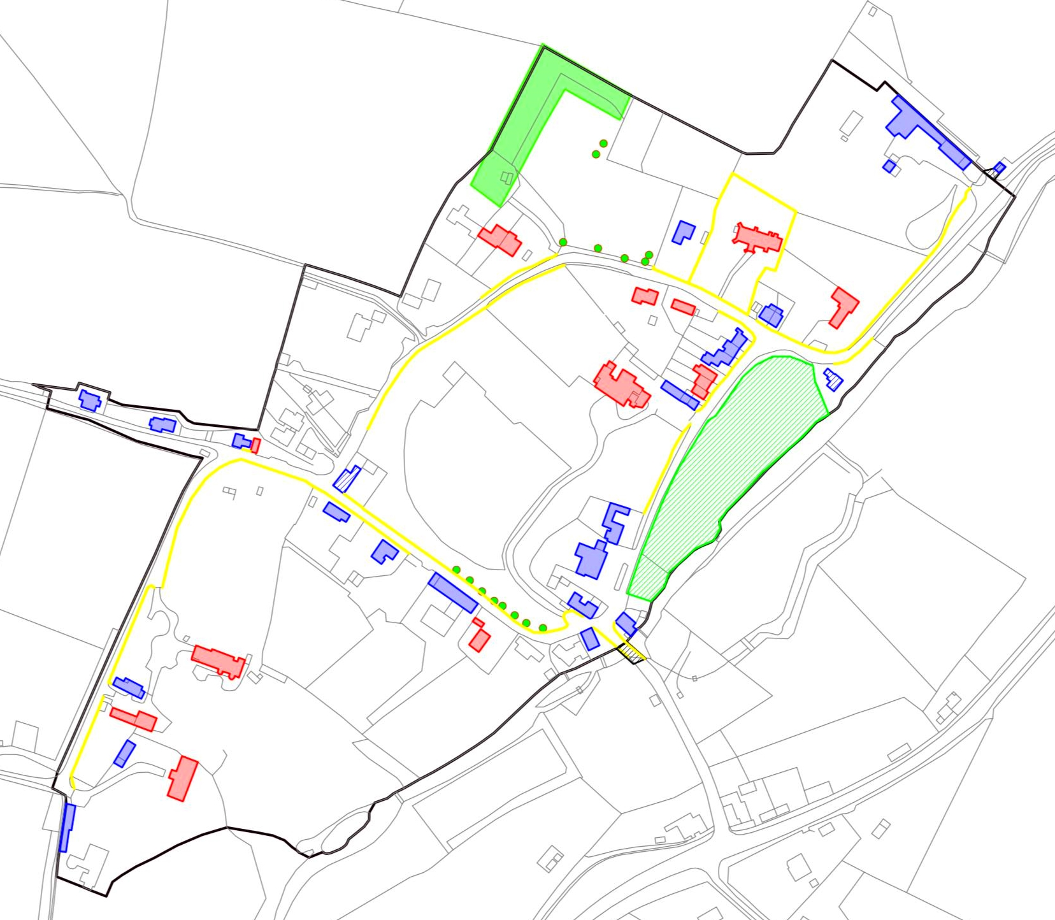

Figure 38: Map showing the elements which make a positive contribution to the character of the Conservation Area, including listed buildings (red), positive unlisted buildings (blue), significant boundaries (yellow), tree preservation orders (solid green areas and spots), important open areas (shaded green), and significant views (orange arrows). Buildings eligible for the Local List are shaded in pale blue.

The small extensions to bring the village pound and bridge within the Conservation Area boundary are shaded in black.
POSTSCRIPT

The extensions to the Conservation Area boundary were approved by the National Park’s Planning Committee on 12 November 2015 and the revised map below shows the new boundary

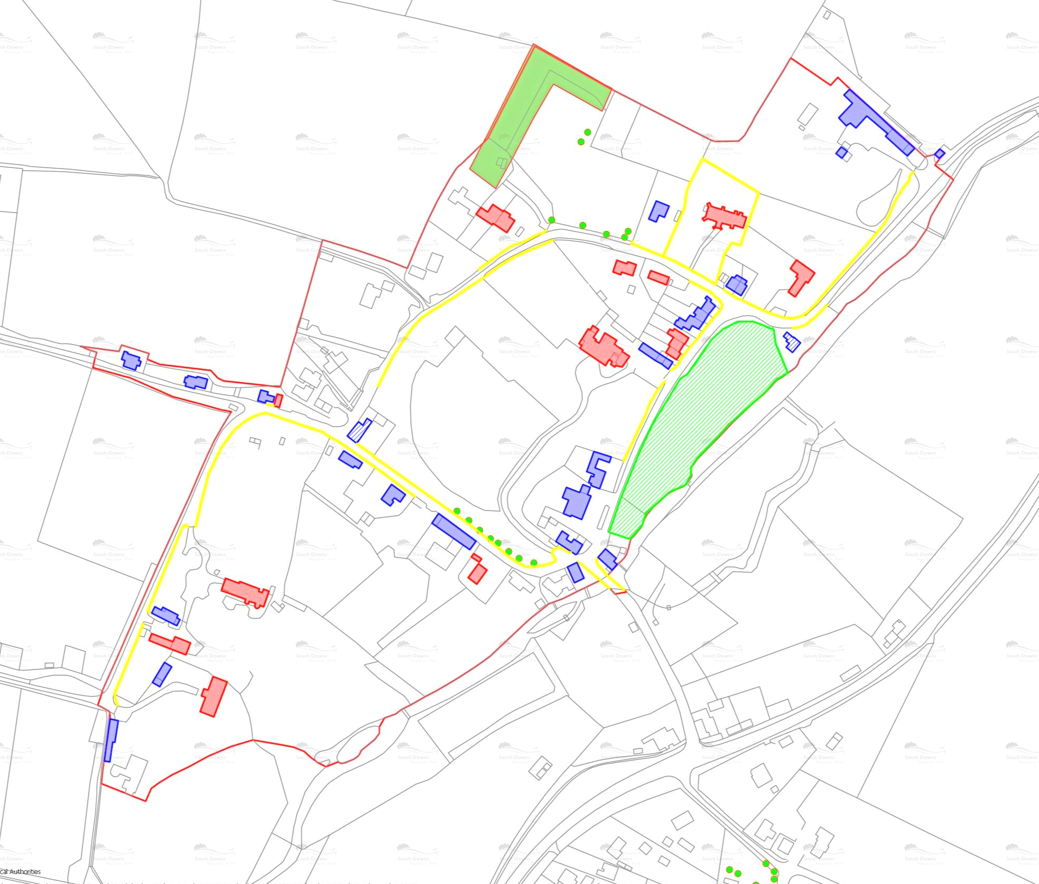

In practice, the development management service for Exton is currently (2015) delivered by Winchester City Council, acting as agents for the South Downs National Park Authority, and any requests for pre-application advice should be directed in the first instance to the planning team at that Council.

