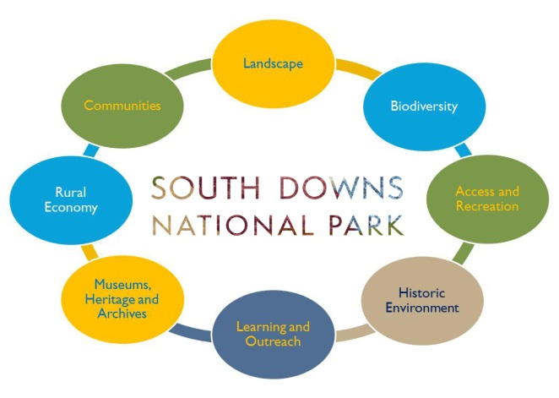

4th July 2019
Submission Form

Please complete this form and email as an attachment to researchconference@southdowns.gov.uk Please note that all proposals and presentations must be in English. For more information please visit our website https://www.southdowns.gov.uk/discover/research/researchconference/
Leading Author Details
Please complete in BLOCK CAPITALS
Title
Surname
First Name
College/University (if applicable)
Level of study
Email
Telephone
Address
Postcode
Additional Authors (if applicable)
Please provide the full names of any additional authors of this research

Presentation Details
Presentation title
Presentation type | ☐ Oral Presentation  ☐ Poster Presentation
Abstract
Up to 400 words. Please structure as: (i) brief introduction, (ii) main aim of the project, (iii) brief details of the study and methods to be used, (iv) the main outcomes and their implications.
Theme selection  Choose which theme best describes your research. Theme selections will be used to organise presentations and the conference proceedings publication. | ☐ Landscape, Biodiversity and Conservation  ☐ Tourism, Access and Recreation  ☐ Historical features and Cultural Heritage  ☐ Outdoors, Health and Wellbeing  ☐ Sustainable Business, Economics  ☐ Open

The deadline for submissions is Wednesday 8th May 2019. The leading author will be informed of the outcome within 3 weeks of this date.

For further information please email researchconference@southdowns.gov.uk

