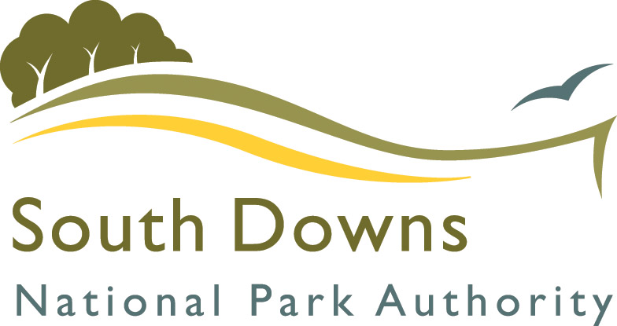
TOWN AND PARISH COUNCIL NPA WORKSHOP

PARTNERSHIP MANAGEMENT PLAN - PROJECT IDEAS

Outcome:

Which outcomes does this project relate to (see Partnership Management Plan outcome displays)

Existing projects

Who is leading:

Name of Council:
New projects/Aspirations over the next 5 years

Who is leading:

Name of Council:
Other groups to contact:

Please return completed forms to info@southdowns.gov.uk or post to South Downs Centre, North Street, Midhurst, West Sussex, GU29 9DH. Please make all returns for the attention of Chris Paterson.

