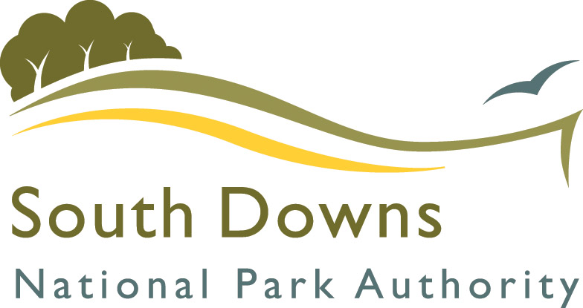
Film on a Farm #TaketheLead promotion, 7 June 2018

Terms and conditions

- Promotion run by South Downs National Park Authority, South Downs Centre, North Street, Midhurst, West Sussex, GU29 9DH.
- The promotion is open to residents of the United Kingdom aged 18 or over, excluding employees and agents of the South Downs National Park Authority and anyone professionally connected with the promotion.
- The promotion will run from 08:30 on 7 June 2018 and will close at 17:00 on 7 June 2018.
- To enter, entrants must respond to the Facebook post with how they are a responsible dog owner in the South Downs National Park
- Entrants can only enter once.
- Entrants must live in or around the South Downs National Park or immediate surrounding area and regularly walk their dog in the South Downs National Park.
- The winning entry will be picked at random on Friday 8 June 2018.
- We reserve the right to disqualify or reject any entry we believe to be in conflict with our promotion or not made in good faith or on other reasonable grounds.
- Notification shall be sent to the winner no later than Friday 8 June 2018. Notification shall take place by public message on Facebook.
- Once the winner has been notified, he/she will need to provide full contact details including name, proof of age, address and email address by return in order to arrange ticket collection for Saturday evening’s performance.
- All reasonable endeavours will be made to contact the winner. If the winner cannot be contacted or fails to provide an address for delivery or fails to meet the eligibility requirements as set out in these terms and conditions or otherwise fails to comply with these terms, this may result in forfeiture of the prize and the Promoter reserves the right to withdraw prize entitlement and award the prize to a reserve drawn at the same time as the original winner
- The winner’s name is available by request, by emailing info@southdowns.gov.uk.
- The Promoter's decisions in all matters to do with the promotion will be final and the Promoter reserves the right not to enter into correspondence in respect of this promotion except with the prize winner.
- South Downs National Park Authority reserves the right at any time to modify or discontinue, temporarily or permanently, this promotion with or without prior notice due to reasons outside their control or to amend or modify these Promotion Entry Rules at any time.
- The Promoter reserves the right to amend any element of the prize for reasons beyond their reasonable control.
- These terms and conditions will be interpreted in accordance with the laws of England.
- This Promotion is in no way sponsored, endorsed or administered by, or associated with Facebook.
- Entrants agree to be bound by the above Promotion Entry Rules.
- By entering the promotion, all entrants consent to the transfer of their personal data to the Data Controller for the purposes of the administration of this promotion and the winners consent to the transfer of their personal data to the Data Controller for the purposes of advertising, promotion and/or publicity in connection with the promotion. We will delete your information within a month of the close of the competition unless you ask us to sooner. Your rights are set out in our Privacy Statement www.southdowns.gov.uk/privacy-statement-2/ Promoter and Data Controller: South Downs National Park Authority, South Downs Centre, North Street, Midhurst, West Sussex, GU29 9DH

