MONITORING FORM | 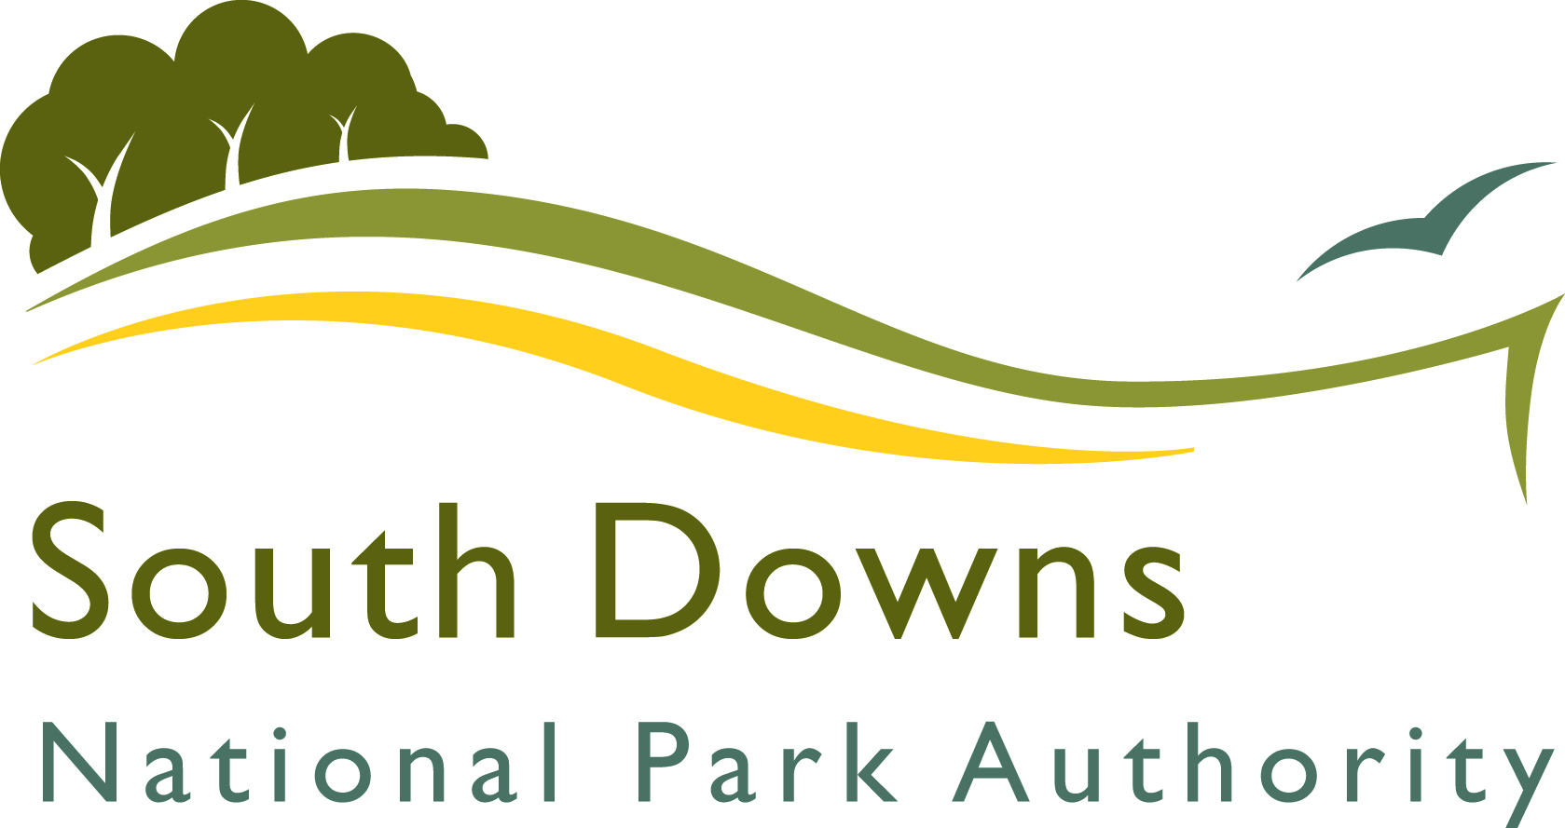

Equal Opportunities Policy Statement

• We seek to ensure that no job applicant is discriminated against, either directly or indirectly on such grounds as sex or sexuality, colour, creed, ethnic or national origin, disability, age, marital status, trade union activity, responsibility for dependants, political or religious beliefs.
• We will endeavour to ensure that all actions and decisions affecting job applicants are made on fair, objective grounds without personal prejudices or discrimination.
_____________________________________________________________
You are required to complete this page which is part of your application and enables us to monitor our recruitment policies and practices. It also provides other information required if you are successful.

The information you give will not be seen at the preliminary stage by anyone connected with making an appointment to this post. If you are selected for interview, any information given at Section 2 relevant to the post for which you are applying will be passed on for discussion at interview.

SECTION 1

Application for the post of:
Surname: | Forenames: |  | Title:
Address:

National Insurance Number: |  | Date of Birth:
Please note if you are successful in your application verification of your eligibility to work in the UK will be sought, normally from an original document showing your National Insurance Number.

SECTION 2

Do you have a disability?

If yes, please give details of that disability

Please specify if you have any special needs as a result of a disability or are aware of any reasonable adjustment which could be made to help you fulfil any part of our job requirements.

SECTION 3
Please tick or mark the boxes which apply
(a) My gender is: 1 Female 2 Male

(b) My age is: 1 16-20 2 21-39 3 40-59 4 60+

SECTION 4
Please tick one box only. (The categories are those used in the census classification)
I would describe myself as:

(a) White: British Irish Any other please write

(b) Mixed: White and Black Caribbean White and Black African

White and Asian Any other please write

(c) Asian or Asian British: Indian Bangladeshi Pakistani

Any other please write
(d) Black or Black British: Caribbean African

Any other please write

(e) Chinese or other ethnic group: Chinese Other please write

The question is optional
(f) Religion None Christian Buddhist

Hindu Jewish Muslim

Sikh Any other religion or belief

Prefer not to say

This application form should be returned by email to:
Recruitment@southdowns.gov.uk

