SUBJECT ACCESS REQUEST FORM | 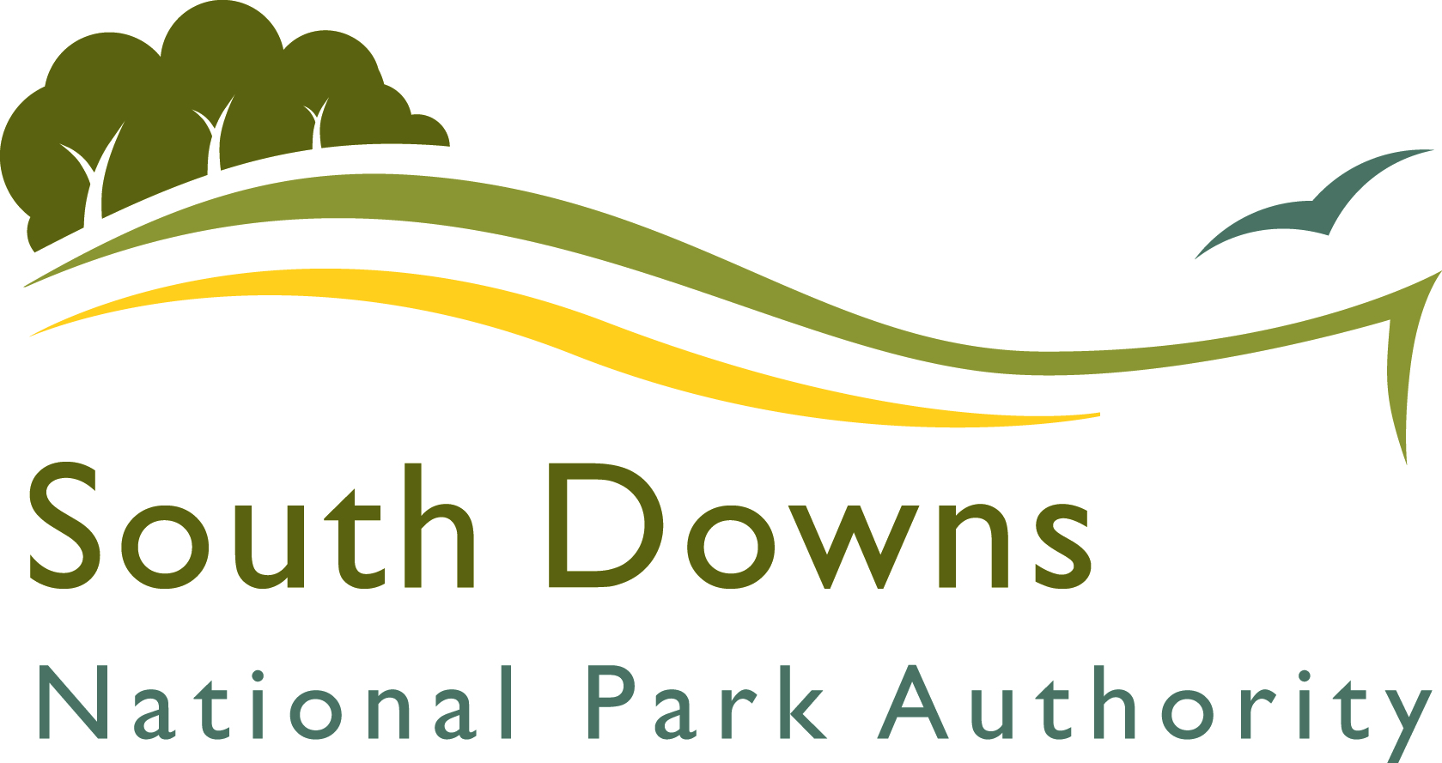

PART 1 - Notes to help you complete the Subject Access Form

Please complete this form if you want us to give you a copy of any personal information which we may hold about you.

Your rights and our obligations:
Subject to certain exemptions you have the right to be told whether personal information is held about you and a right to a copy of that information in a readable form. We have a duty to hold information securely and information will only be released when we are satisfied that the identity of the person making the request has been proved to our satisfaction. We will not release information that identifies other people, unless those person(s) agree(s). Any material you supply, including details on this form, will be used to confirm your identity and to process your Subject Access request.

Reply: We aim to provide you with the information as quickly as possible and in any event within the permitted time of 1 month at the latest after:
- our receipt of this request; or
- our receipt of any further information from you which is required to enable us to comply with your request.
Please note that we are able to extend the period for disclosure by a further two months where requests are complex or numerous. If this is the case, we will inform you within one month of the receipt of the request and explain why the extension is necessary.

Proof of identity:
You will need to provide:
- Copies of two official documents, which between them clearly show your name, date of birth and current address, such as passport, driving licence, birth/adoption certificate.
If you are requesting the information on behalf of someone else you will need to provide information about yourself and the person you are requesting the information for.

Retention of material:
We will keep the information including the copies of the evidence of identity so we have a record of your request in accordance with our records retention policy and statutory obligations. In most instances we will provide you with the information you request. Sometimes we may not release information if the work involved in finding and collating it would take “disproportionate effort”.

Postal details and checklist:
Please fill in and sign the form and send it to us, along with copies of the two official documents which prove your identity and the identity of the person you are requesting information for, if you are doing it on behalf of someone else.
PART 2 – South Downs National Park Authority Subject Access Request Form

Section 1:
Personal Details.
To help us help you please write or type as clearly as possible.

Title. Please tick one option.
Given or family name:

First name:

Preferred name:

Date of birth:

Current Address including postcode:
All correspondence from us to you about your request will be sent to this address.
Telephone number:
This is useful if we need to contact you quickly to help us deal with your request for information

Section 2:
Details of the information about which you are making your request. Please provide any other supporting information that you think will help us deal with your request. For example, details of when you corresponded or contacted us previously and supplied personal information, or anything else you believe will help us provide a quick response.

Declaration
The information I have supplied in this subject access form is correct and I am the person to whom it relates.

Signature:

Date:

WARNING
A person who impersonates or attempts to impersonate another may be guilty of an offence. We will assist law enforcement agencies in investigations should we believe an offence has been committed or a person is attempting to commit an offence.

PART 3 – South Downs National Park Authority Subject Access Request Form

a) The address to which you should send  your completed Subject Access Form or  to contact should you need any further  advice or guidance in completing this form:  The Data Protection Officer  South Downs National Park Authority  North Street  Midhurst  West Sussex  GU29 9DH  Telephone 01730 814810  Email info@southdowns.gov.uk  Website: http://www.southdowns.gov.uk/ | b) The address you should use for  obtaining general advice about your rights as a data subject :  The Office of the Information Commissioner  Wycliffe House  Water Lane  Wilmslow  Cheshire  SK9 5AF  Switchboard: 01625 545 700  Fax: 01625 524 510  DX: 20819 Wilmslow  Website:www.ico.org.uk/
Note: Please do not send your completed application form and supporting details to the Office of the Information Commissioner.

For Official Use Only

Date Subject Access Application  form received | Date
Identification documents received | Yes | No
Details of documents supplied as  evidence of identity | Item 1 | Item 2
Date confirmation that Subject Access form and supporting details were received sent to person seeking the information. | Date
Person responsible for completing this section

Signature..............................................................................................................................

Print full name .................................................................................................................

Ensure copies of the completed SAR forms, supporting details and a copy of the receipt are retained for the record and are held securely.

