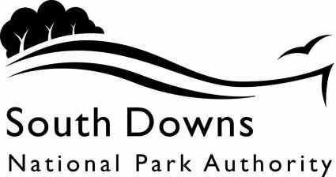

REQUEST FOR INFORMATION FORM
Name
Address
Contact Telephone number
Email Address
Please note that we cannot provide you with the information you require unless you provide your name and a means of contacting you to provide the information ( e.g. address or e-mail address)
Description of the information you require
Please provide a description of the information you would like the Authority to provide you with. If your request relates to specific document(s), please provide any details of the document you may have (e.g. date of production, author etc) and its likely location (e.g. the relevant staff member, service area, subject). If you are uncertain how to describe the information you require, we will be happy to provide you with advice and assistance, or direct you to others who can help (contact details are shown at the bottom of this form):
Q1. Format of information
Where your request covers information that is already published by the Authority, we will provide you with details on how to locate the appropriate information in its usual published format.

Otherwise, we can provide you with (please tick your preference):
- the opportunity to view the information by appointment with the Information Officer
- the information in ‘permanent’ form (e.g. photocopies of the relevant information)
- the information in summary/ ‘digest’ form (available only if the information is in a format that can be summarised coherently and in reasonable time)
- some other form (please specify)……………………………………………………………

Q2. In cases where the Authority holds only some of the information requested, we will respond as fully as we can. Should we need to redirect an enquiry to some other public body you can you advise what action you would like us to take:
a) Advise you of the details of the other public authority.
b) Advise you of the details and forward your details to the other public authority for you.
Please Circle your option.
NOTES
1) The Authority has the right to ask for clarification of any request for information where it does not prove possible to identify the information needed from the original description provided above.
2) Though there is no limit to the scope of the information you may request, please note that the Authority may have the right to refuse vexatious requests (under the terms of Section 14 of the Freedom of Information Act 2000), to obscure or suppress information that relates to other third parties (under the terms of Principles 1, 6 and 7 of the Data Protection Act 1998) and to not disclose information that is covered by relevant exemptions allowed by the Freedom of Information Act 2000.
3) If your request is refused or is only answered partially, a full explanation for our decision will be provided. You will be entitled to request a review of the process undertaken to disclose information and contact details will be provided for you to do so . You will also be provided with details of how to make an external appeal to the Information Commissioners Office.

Please return this form to:
FOI Requests
South Downs Centre North Street Midhurst
GU29 9DH

Or

Email it to: info@southdowns.gov.uk

