

South Downs Proposed Submission Local Plan
Regulation 19

Integrated Impact Assessment

APPENDIX B
SETTLEMENT APPRAISALS

March 2026

Stage B and Stage C – Settlement Appraisal and In-Combination Assessment
- Please note that stage A is set out in the main IIA document dated February 2026. This Appendix is stages B and C. See the main document for information on the 3 stages.
- The following pages include details of each settlement (where relevant), and the sites proposed for allocation in the Regulation 19 Proposed Submission Local Plan document and are appraised in combination with the other sites within the settlement. Whilst details of the Neighbourhood Plan (NDP) and outstanding/not developed sites within the adopted Local Plan (LP) sites are not appraised within this report – the impact will be considered through the ‘in combination’ assessment process. Please note that some settlements fall outside of the National Park. Potential development sites within that settlement will be set out in the relevant local authority’s Local Plan. They are not considered in this appendix.
- Settlements are also appraised as standalone locations – against the sustainability objectives. This is a high-level snapshot of the settlement and not a detailed technical appraisal. Where there are isolated sites (usually existing sites that are being redeveloped) and these are not located within a settlement and are not near to other sites, then they are not included within this appendix. An example is - Site SDA68 Clayton Court, Rogate Road, Hill Brow.
- Below each table (where relevant), there is a reference made to sites that were considered not to be appropriate to allocate within the Proposed Submission Local Plan. These are listed as excluded and/or rejected sites according to their LAA site reference number and the settlement/parish within which they are located. Further details can be found in the LAA. It is important to note that some settlements are not set out in this appendix. This is because there are no allocated sites. To establish which settlements fall into this category, please consult the LAA documents.
- The sites are listed below alphabetically according to the local authority where they are located. This tallies with the stage A in the main IIA document. For example – the first settlement is Lancing as this is located within Adur District. A general commentary on each of the settlements and the sites within and the in-combination impact is set out after the maps and tables for each settlement. The Proposed Submission Local Plan site assessment and appraisal results are lifted from the main IIA document (stage A). A conclusion on the sites (as they stand now) is provided in the main IIA document. The IIA February 2026 includes an appraisal of each policy as written for the individual sites. In several cases, the scoring has changed from the appraisal of the site as it stands now compared to the appraisal of the site policy.
- The following assumptions/considerations have been made regarding the appraisal of settlements. This assessment of the settlement is current (without development/other enhancement work/improvements):
- Settlements that are located within the National Park (not all settlements are) are appraised has having a positive impact on landscape (SO1). Where the settlement is located outside of the National Park, this has been appraised as having a neutral impact on SO1.
- Settlements that contain a conservation area and/or listed buildings are appraised as having a positive impact on heritage (SO3).
- Settlements with limited employment opportunities and/or limited public transport options (those with no train station and/or limited bus service at peak times to areas of employment/larger settlements/schools) will score negatively against SO6 and SO9.
- Existing settlements will include a variety and range of housing and therefore score positively for SO10. The appraisal has not considered the details of the range of housing available and the percentage of affordable homes.
- Settlements with historic centres and/or are highly attractive in design terms will score as having a positive impact on SO11. The settlements with an element of urban sprawl, will generally be scored as having a negative impact on this SO.
- The map legend is as follows:
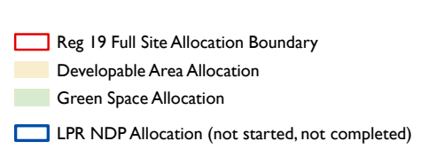
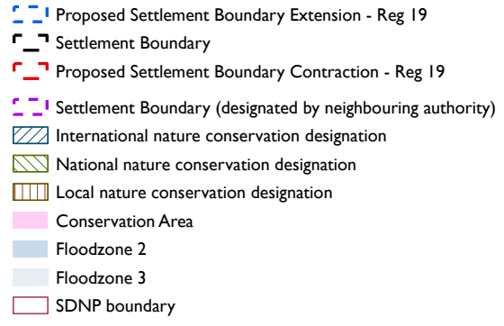

Lancing (Adur District)
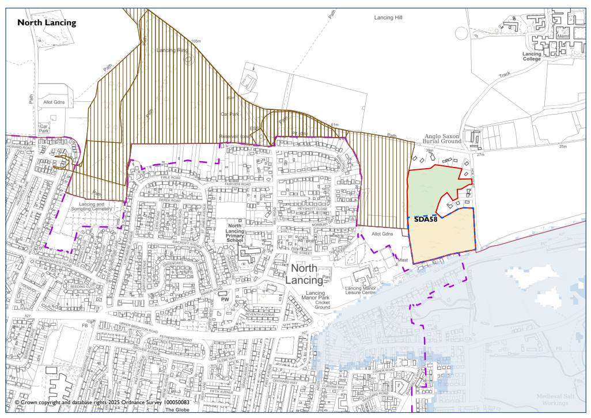

LANCING (NORTH)
 |  | National Park’s landscape character, functionality and perception and special qualities. | Biodiversity and contribution to nature recovery. | Historic environment heritage assets and their settings and cultural heritage. | Impacts of climate change and to address the causes of climate change. | Protection & Sustainable Use of Resources | Employment and Economy. | Promote equality of opportunity and the elimination of discrimination | Holistic health and well-being. To create and sustain healthy and sustainable vibrant communities. | Efficient transport network | Good quality home, suitable to their need. New affordable homes. | Character of settlements, neighbourhoods and rural buildings. Highest quality of design.
Site appraisal | Stage A
Site | Policy
Hoe Court | SDA58 | - | + | 0 | ? | - | 0 | 0 | + | + | + | 0
Settlement Appraisal | Stage B
Lancing |  | 0 | 0 | + | ? | - | + | + | + | + | + | +

General Comments
There is only one Proposed Submission Local Plan site in Lancing within the National Park. Therefore, an in-combination assessment has not been made. The main part of Lancing (including North lancing) is located outside of the National Park.
This part of Lancing is north of the A27. Directly opposite (and south of the A27) in the Monks Farm housing development. There is a pedestrian crossing across the A27 (which is a dual carriageway) thus allowing access to Lancing village centre and the railway station. There is a leisure centre on the same side of the site within easy access. There are areas of employment, open space and opportunities for education within the settlement. Lancing Ring Local Nature Reserve and public footpaths are near to the site. Due to severance of the A27 and associated noise, the assessment of Lancing (and the site) concludes to have a negative impact on the protection and sustainable use of resources (one of the objectives).
Excluded site: AD010

Sompting (Adur District)
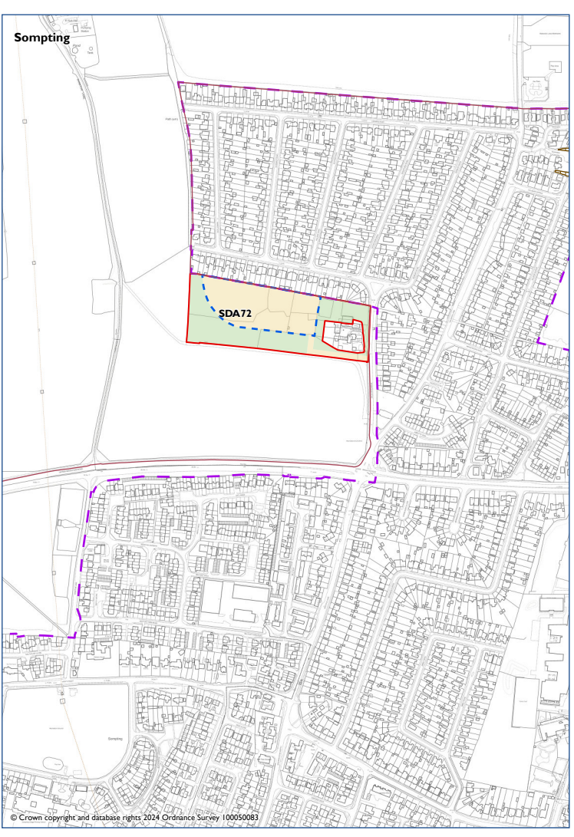

SOMPTING
 |  | National Park’s landscape character, functionality and perception and special qualities. | Biodiversity and contribution to nature recovery. | Historic environment heritage assets and their settings and cultural heritage. | Impacts of climate change and to address the causes of climate change. | Protection & Sustainable Use of Resources | Employment and Economy. | Promote equality of opportunity and the elimination of discrimination | Holistic health and well-being. To create and sustain healthy and sustainable vibrant communities. | Efficient transport network | Good quality home, suitable to their need. New affordable homes. | Character of settlements, neighbourhoods and rural buildings. Highest quality of design.
Site appraisal | Stage A
Site | Policy
Land off Steepdown Road | SDA72 | - | + | - | ? | + | 0 | - | ? | - | ++ | -
Settlement Appraisal | Stage B
Sompting |  | 0 | 0 | + | ? | - | + | + | ? | - | + | -

General Comments
There is only one Proposed Submission Local Plan site in Sompting within the National Park. Therefore, an in-combination assessment has not been made. The main part of Sompting is located outside of the National Park.
This part of the settlement is north of the A27 and in a landscape sensitive area. There are limited areas of nature conservation designation within this part of the settlement. There is a conservation area and several listed buildings south of the A27. There are areas of employment, open space and opportunities for education within the settlement. However, opportunities for health and wellbeing are unknown. There is a wide variety of building styles and characteristics within Sompting.
Rejected site: AD008

Findon (Arun District)
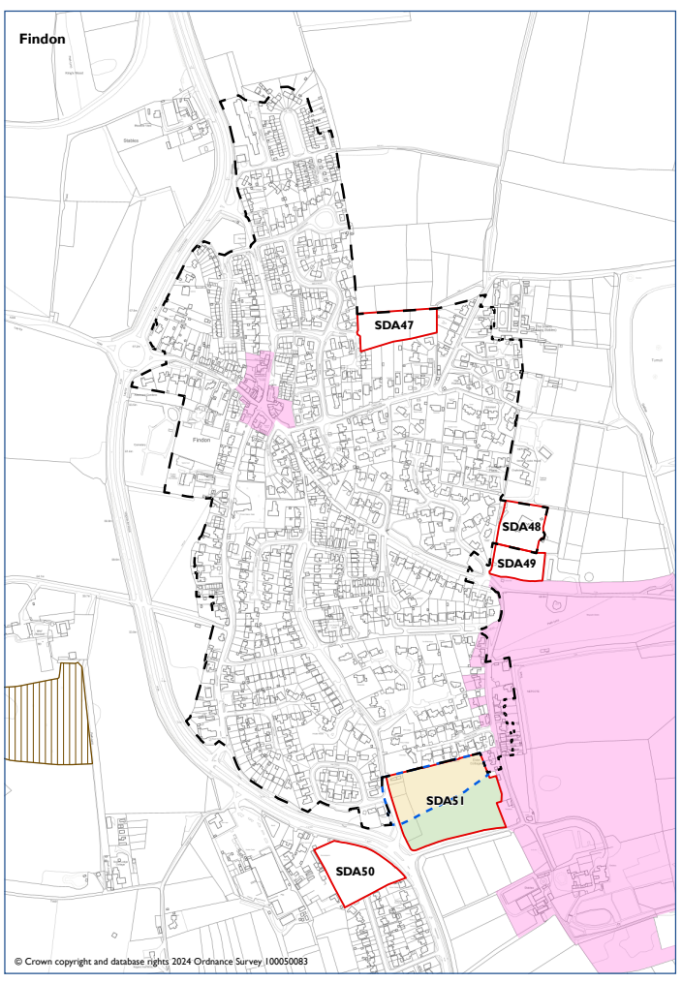

FINDON
 |  | National Park’s landscape character, functionality and perception and special qualities. | Biodiversity and contribution to nature recovery. | Historic environment heritage assets and their settings and cultural heritage. | Impacts of climate change and to address the causes of climate change. | Protection & Sustainable Use of Resources | Employment and Economy. | Promote equality of opportunity and the elimination of discrimination | Holistic health and well-being. To create and sustain healthy and sustainable vibrant communities. | Efficient transport network | Good quality home, suitable to their need. New affordable homes. | Character of settlements, neighbourhoods and rural buildings. Highest quality of design.
Site appraisal | Stage A
Site | Policy
Former allotments site | SDA50 | 0 | + | 0 | ? | ? | ? | ? | ? | ? | ++ | 0
Land south of Soldiers Field House | SDA49 | 0 | 0 | - | ? | + | 0 | ? | + | - | + | -
Land South of Finden (Wyatt's Field) | SDA51 | - | + | - | ? | ? | 0 | - | ? | - | + | -
Settlement Appraisal | Stage B
Findon |  | + | 0 | + | ? | - | - | ? | + | - | + | -
In combination | Stage C
 |  | 0 | + | 0 | ? | - | - | ? | + | ? | + | 0

General Comments
There are three Proposed Submission Local Plan sites in Findon. There are 2 adopted Local Plan sites (see map for SDA47 Land at Elm Rise and SDA48 Soldiers Field House) and therefore an in-combination assessment is made.
Findon is located within the National Park which is of high landscape value. There are 2 conservation areas and nature conservation designated areas are located outside of the settlement. Due to the presence of the A24 road, parts of the settlement can experience traffic noise and other impacts from the road network. There are few employment opportunities (especially larger employers) within the settlement. Further information is needed on the promotion of equality and opportunity (SO). There is a school and some services/facilities within Findon, but a greater variety are in Worthing. There are limited transport options (due to no train station), and it is reasonable to consider that many journeys are made by car. There is evidence of urban development/sprawl but there is a historic centre and open space surrounding Findon centre.
The in-combination assessment considers there to be a neutral impact on some of the sustainability objectives. The sites do provide an opportunity for nature recovery and are not located near designated areas. Due to severance of the A24 and associated noise, the combination of sites is considered to have a negative impact on the protection and sustainable use of resources (one of the objectives). The few employment opportunities currently in Findon will not be addressed/improved by the sites coming forward. More details are needed in terms of transport. There remains no train service, but further development may encourage improvements in pavements/a crossing over the A24 and other benefits.
Excluded site: AR017, AR034, AR063
Rejected sites: AR013, AR015, AR016, AR019, AR020, AR021, AR047, AR059, AR060, AR061, AR062

Bury (Chichester District)
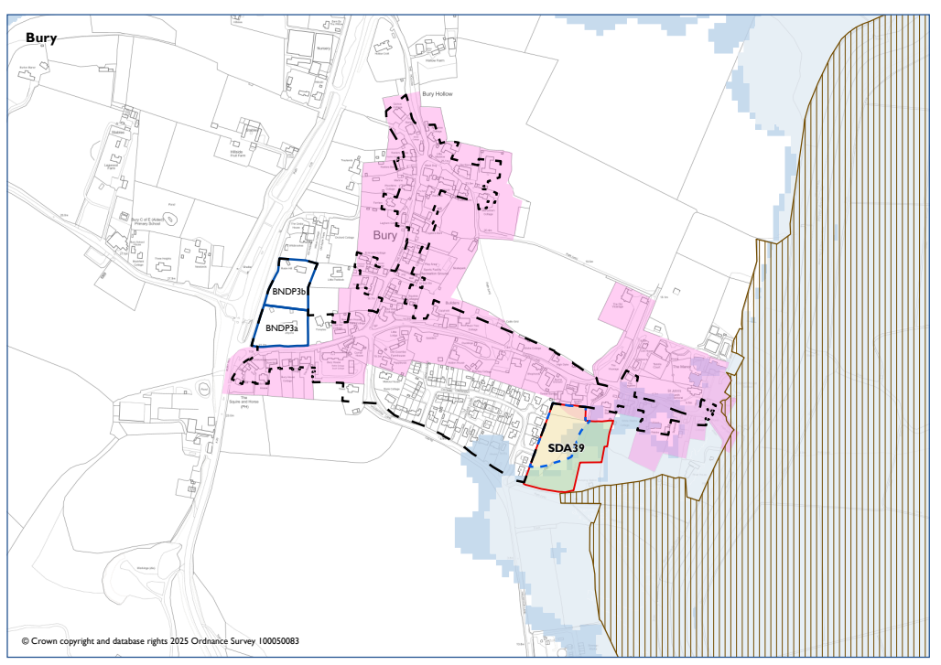
BURY
 |  | National Park’s landscape character, functionality and perception and special qualities. | Biodiversity and contribution to nature recovery. | Historic environment heritage assets and their settings and cultural heritage. | Impacts of climate change and to address the causes of climate change. | Protection & Sustainable Use of Resources | Employment and Economy. | Promote equality of opportunity and the elimination of discrimination | Holistic health and well-being. To create and sustain healthy and sustainable vibrant communities. | Efficient transport network | Good quality home, suitable to their need. New affordable homes. | Character of settlements, neighbourhoods and rural buildings. Highest quality of design.
Site appraisal | Stage A
Site | Policy
Land East of Coombe Crescent | SDA39 | - | - | - | ? | - | 0 | -- | + | - | ++ | ?
Settlement Appraisal | Stage B
Bury |  | + | - | + | ? | - | - | - | + | - | + | +
In combination | Stage C
 |  | 0 | + | - | ? | - | 0 | - | + | - | ++ | ?

General Comments
There is one Proposed Submission Local Plan site in Bury and there are 2 NDP sites (see map above) and therefore an in-combination assessment is made.
Bury is located within the National Park, which is of high landscape value. There are several nature conservation designated areas within the settlement and a conservation area. The settlement is historic in character. There is an area of flooding potential to the south and east of the settlement and the surrounding land is in agricultural use. There are few employment opportunities. Access to facilities is limited even though there is a school within the settlement. There are opportunities to access the countryside for health walks. There is no train station, and it is assumed most travel is made by private vehicle.
The in-combination assessment considers the impacts of the three sites. There will be a neutral impact on landscape value. However, there will be a negative impact on heritage and protection and sustainable use of resources (one of the objectives) due to the impact of noise from the A24 and flood zones. The developments will not promote equality of opportunity because there are limited local resources and access to these. The sites will not improve matters of transport options as the use for the private car will continue. Further details are needed on design as Bury is highly characteristic and the sites will need to embrace high-level design concepts to enable them to be incorporated within the settlement with minimal impact.
Excluded sites: CH002, CH169 CH197
Rejected sites: CH190, CH192, CH193, CH194, CH195, CH196, CH281

Easebourne (Chichester District)
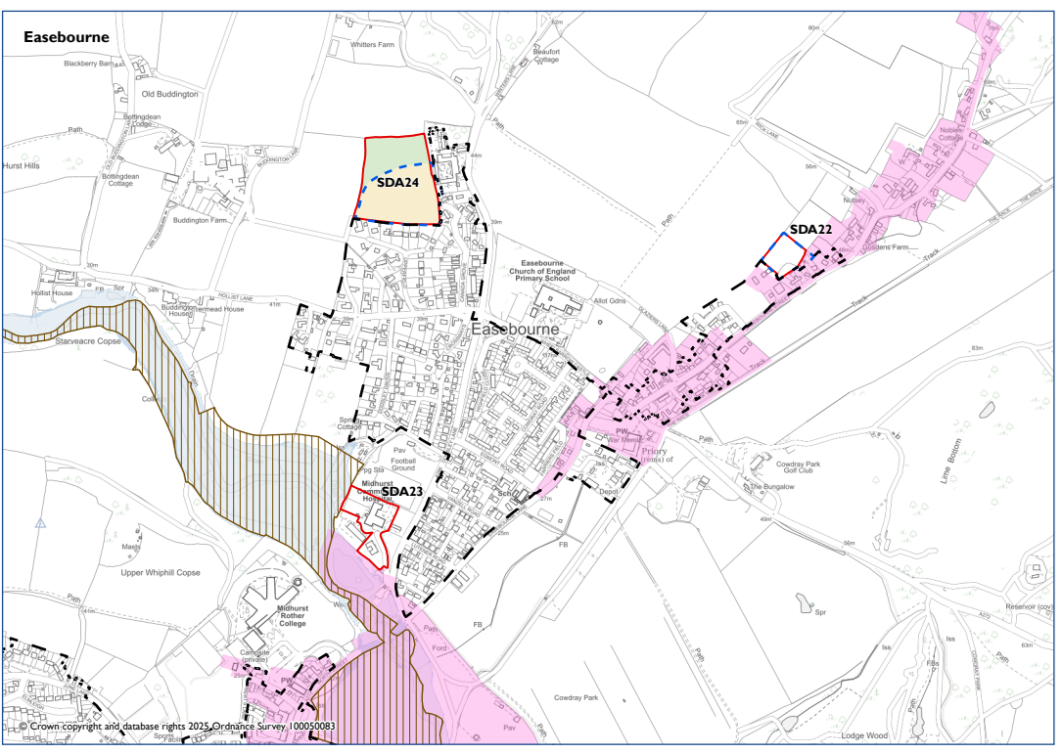

EASEBOURNE
 |  | National Park’s landscape character, functionality and perception and special qualities. | Biodiversity and contribution to nature recovery. | Historic environment heritage assets and their settings and cultural heritage. | Impacts of climate change and to address the causes of climate change. | Protection & Sustainable Use of Resources | Employment and Economy. | Promote equality of opportunity and the elimination of discrimination | Holistic health and well-being. To create and sustain healthy and sustainable vibrant communities. | Efficient transport network | Good quality home, suitable to their need. New affordable homes. | Character of settlements, neighbourhoods and rural buildings. Highest quality of design.
Site appraisal | Stage A
Site | Policy
Land adjacent former Easebourne School | SDA22 | - | - | - | ? | - | 0 | - | - | - | + | ?
Land west of Budgenor Lodge | SDA24 | - | - | - | ? | - | 0 | + | + | - | + | -
Midhurst Community Hospital and 1-2 Rotherfield Mews | SDA23 | - | - | - | - | 0 | - | + | + | + | ++ | ?
Settlement Appraisal | Stage B
Easebourne |  | + | - | + | ? | - | + | + | + | - | + | +
In combination | Stage C
 |  | - | 0 | - | ? | - | 0 | + | + | 0 | + | ?

General Comments
There are three Proposed Submission Local Plan sites in Easebourne and therefore an in-combination assessment is made.
Easebourne is located within the National Park, which is of high landscape value. There are several nature conservation designated areas within the settlement and a conservation area (as well as the Midhurst conservation area). There are areas of flooding, and the settlement is within the Sussex North Water Resource Zone. Easebourne is close to Midhurst (as shown on the settlement map) and therefore this assessment considers the proximity of Easebourne to Midhurst. Midhurst contains a range of employment options, open space, education and other facilities. There is no train service, although Midhurst is served well by buses. Some rural roads in Easebourne have no pavements. Easebourne has a strong sense of place and character with an historic part to the settlement.
The in-combination assessment considers the three sites coming forward. Cumulatively, these will have a negative impact on landscape and heritage due to extent of the conservation area and historic character of the settlement. The developments will have a neutral impact on employment and will not detract from the ability to access facilities, open space and other benefits. This is considered to have a positive impact on sustainability objectives 7 and 8. Whilst there remains no train line in Easebourne, the developments will have a neutral impact on the transport system (as the area is served well by buses) and may bring forward improvements to pedestrian access to education, employment and retail facilities. Further information is needed on the design and layout of each development.
Excluded sites: CH059, CH270
Rejected sites: CH065, CH162, CH163, CH204, CH205

Fernhurst (Chichester District)
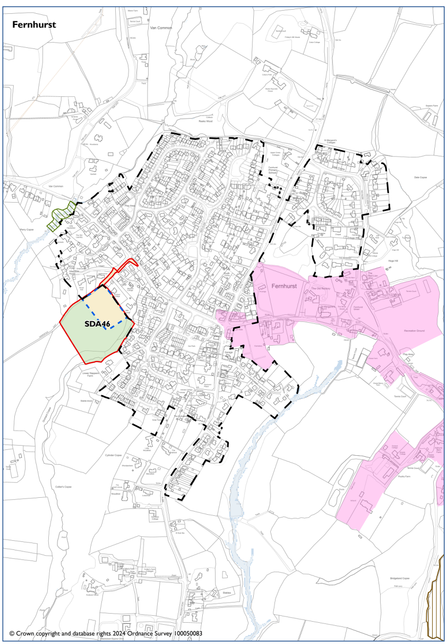
FERNHURST
 |  | National Park’s landscape character, functionality and perception and special qualities. | Biodiversity and contribution to nature recovery. | Historic environment heritage assets and their settings and cultural heritage. | Impacts of climate change and to address the causes of climate change. | Protection & Sustainable Use of Resources | Employment and Economy. | Promote equality of opportunity and the elimination of discrimination | Holistic health and well-being. To create and sustain healthy and sustainable vibrant communities. | Efficient transport network | Good quality home, suitable to their need. New affordable homes. | Character of settlements, neighbourhoods and rural buildings. Highest quality of design.
Site appraisal | Stage A
Site | Policy
Land at Hawksfold | SDA46 | - | - | - | ? | - | 0 | ? | + | ? | + | ?
Settlement Appraisal | Stage B
Fernhurst |  | + | 0 | + | ? | 0 | - | - | + | - | + | 0

General Comments
There is one Proposed Submission Local Plan site in Fernhurst. Therefore, an in-combination assessment has not been made.
Fernhurst is located within the National Park, which is of high landscape value. There are very few areas of nature conservation designations. The impact on the sustainability objective (SO1) is neutral. There is a conservation area and therefore the settlement is positive for heritage. There are few employment opportunities and facilities, opportunities and educational premises are not within an easy distance from the residential areas. There is no train service, and it is assumed that more travel is undertaken by private vehicle. Whilst the conservation area is outside of most of the settlement and there has been some urban sprawl, the impact is considered neutral (on heritage).
Excluded sites: CH022, CH028, CH176
Rejected sites: CH150, CH267, CH024, CH025

Lodsworth (Chichester District)
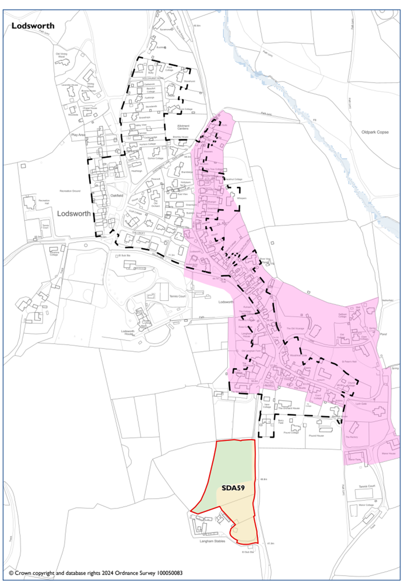

LODSWORTH
 |  | National Park’s landscape character, functionality and perception and special qualities. | Biodiversity and contribution to nature recovery. | Historic environment heritage assets and their settings and cultural heritage. | Impacts of climate change and to address the causes of climate change. | Protection & Sustainable Use of Resources | Employment and Economy. | Promote equality of opportunity and the elimination of discrimination | Holistic health and well-being. To create and sustain healthy and sustainable vibrant communities. | Efficient transport network | Good quality home, suitable to their need. New affordable homes. | Character of settlements, neighbourhoods and rural buildings. Highest quality of design.
Site appraisal | Stage A
Site | Policy
Land West of The Street | SDA59 | - | - | ? | ? | - | 0 | - | ? | ? | + | ?
Settlement Appraisal | Stage B
Lodsworth |  | + | 0 | + | ? | - | - | - | + | - | + | +

General Comments
There is only one Proposed Submission Local Plan site in Lodsworth. Therefore, an in-combination assessment has not been made.
Lodsworth is located within the National Park, which is high landscape value. There is a conservation area, so the settlement is scored positively for heritage. Lodsworth is within the Sussex North Water Resource Zone but there are no flood zones. There are limited employment opportunities and facilities within a manageable walking distance (considering topography and rural roads). Therefore, the settlement has a negative score for objectives 6 and 7. There are no trains, and public transport is minimal.
Rejected sites: CH213, CH214

Midhurst (Chichester District)
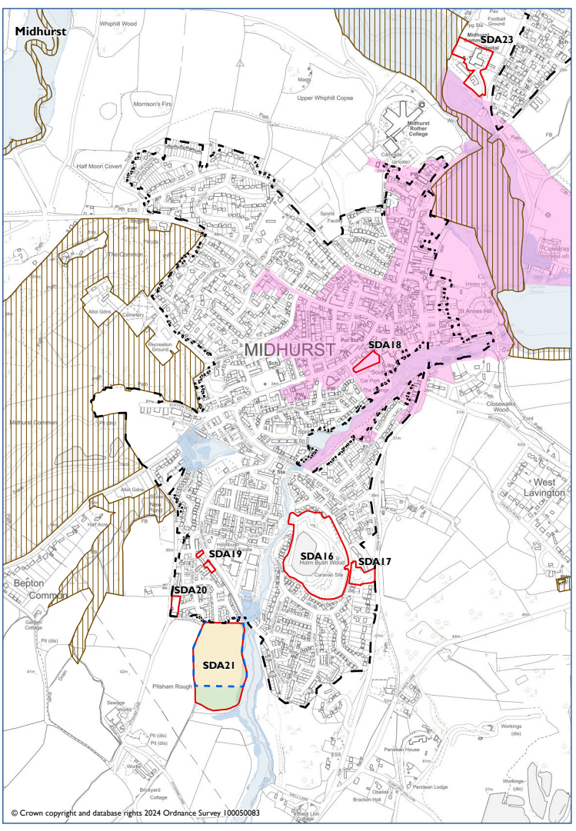

MIDHURST
 |  | National Park’s landscape character, functionality and perception and special qualities. | Biodiversity and contribution to nature recovery. | Historic environment heritage assets and their settings and cultural heritage. | Impacts of climate change and to address the causes of climate change. | Protection & Sustainable Use of Resources | Employment and Economy. | Promote equality of opportunity and the elimination of discrimination | Holistic health and well-being. To create and sustain healthy and sustainable vibrant communities. | Efficient transport network | Good quality home, suitable to their need. New affordable homes. | Character of settlements, neighbourhoods and rural buildings. Highest quality of design.
Site appraisal | Stage A
Site | Policy
Land east of Pitsham Lane | SDA21 | - | - | ? | ? | - | 0 | + | + | ? | ++ | ?
Land adjacent to The Grange Car Park | SDA18 | - | - | - | ? | - | ? | + | + | + | + | ?
Former Bus Depot, Pitsham Lane | SDA20 | + | - | 0 | ? | - | 0 | + | + | - | + | ?
Land at Forest Road | SDA19 | + | - | + | ? | - | ? | + | + | - | + | ?
Settlement Appraisal | Stage B
Midhurst |  | + | - | + | ? | - | + | + | + | - | + | +
In combination | Stage C
 |  | 0 | 0 | ? | ? | - | 0 | + | + | 0 | + | ?

General Comments
There are four Proposed Submission Local Plan sites in Midhurst. There are 2 adopted Local Plan sites (see map above for SDA16 Holmbush Caravan Park and SDA17 Land at the Fairway). An in combination assessment is made.
Midhurst is located within the National Park, which is high landscape value. There are several nature conservation designated areas within the settlement and a conservation area. The settlement scores positively for biodiversity and heritage. There are employment opportunities and several facilities, including a secondary school. The settlement scores positively against many objectives. There is no train station and although there are several buses and bus routes, the settlement does not have an efficient transport system (due to a lack of station).
The in combination appraisal considers there to be a neutral impact on landscape. Whilst there are several nature conservation designated areas, it is considered the sites will have minimal impact on these and there are opportunities for nature recovery. More details are needed on how the schemes will impact on the historic environment and heritage assets. The sites will have a negative impact on protection and sustainable uses of resources (one of the objectives) due to noise and pollution from the through traffic, flood zones and being located within the Sussex North Water Resource Zone. There is neutral impact on employment, and the sites are within proximity to a wide range of facilities and open space. The area will have limited transport options but the cumulative impact on this is neutral. Further details are needed on the design and layout for all the sites.
Excluded sites: CH060, CH061, CH129, CH167, CH221, CH272,
Rejected sites: CH264, CH265, CH062, CH067, CH130, CH131, CH134, CH137, CH166, CH188, CH219, CH220

Milland (Chichester District)
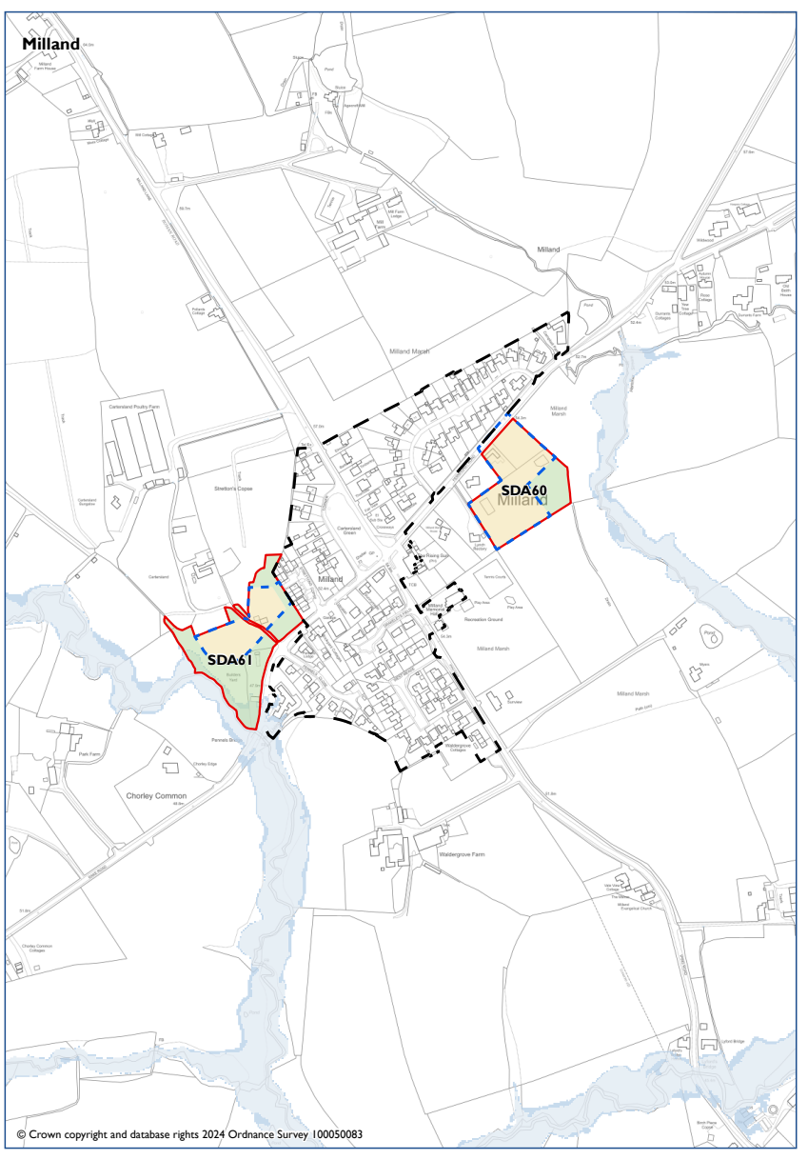

MILLAND
 |  | National Park’s landscape character, functionality and perception and special qualities. | Biodiversity and contribution to nature recovery. | Historic environment heritage assets and their settings and cultural heritage. | Impacts of climate change and to address the causes of climate change. | Protection & Sustainable Use of Resources | Employment and Economy. | Promote equality of opportunity and the elimination of discrimination | Holistic health and well-being. To create and sustain healthy and sustainable vibrant communities. | Efficient transport network | Good quality home, suitable to their need. New affordable homes. | Character of settlements, neighbourhoods and rural buildings. Highest quality of design.
Site appraisal | Stage A
Site | Policy
Land at Rake Road | SDA61 | - | - | + | ? | - | 0 | - | + | - | + | ?
Land at Fernhurst Road | SDA60 | - | - | + | ? | - | 0 | - | + | - | + | ?
Settlement Appraisal | Stage B
Milland |  | + | 0 | 0 | 0 | - | - | + | + | - | + | ?
In combination | Stage C
 |  | 0 | 0 | 0 | 0 | 0 | - | 0 | + | - | + | ?

General Comments
There are two Proposed Submission Local Plan sites in Milland. Therefore, an in combination assessment is made.
Milland is located within the National Park, which is high landscape value. It is located between Liphook (3 miles), Midhurst (5 miles), Petersfield (7.5 miles) and Haslemere (8 miles). The core village of Milland developed in the mid-20th century around the Rising Sun crossroads. The primary school is located at Wardley Green, half a mile to the east. The main settlement has a village hall, pub, nursery, small garage, community shop, recreation field, playground, tennis courts, village green, and small business/workshop centres. There are no nature conservation designated areas within the settlement. The settlement scores neutral for biodiversity and heritage. There are areas of flood risk and the settlement scores negatively against sustainable objective 5. It scores positively for equalities and health as local opportunities do exist but negative for the economy.
The in combination appraisal considers there to be a neutral impact on landscape and biodiversity. One of the sites is located close to areas liable to flood but in combination, this does not result in a negative impact. There is a negative impact on employment and transport as the developments will not improve the current situation and may mean there is more demand for employment and pressures on transport options.
Excluded sites: CH275, CH276, CH223

Northchapel (Chichester District)
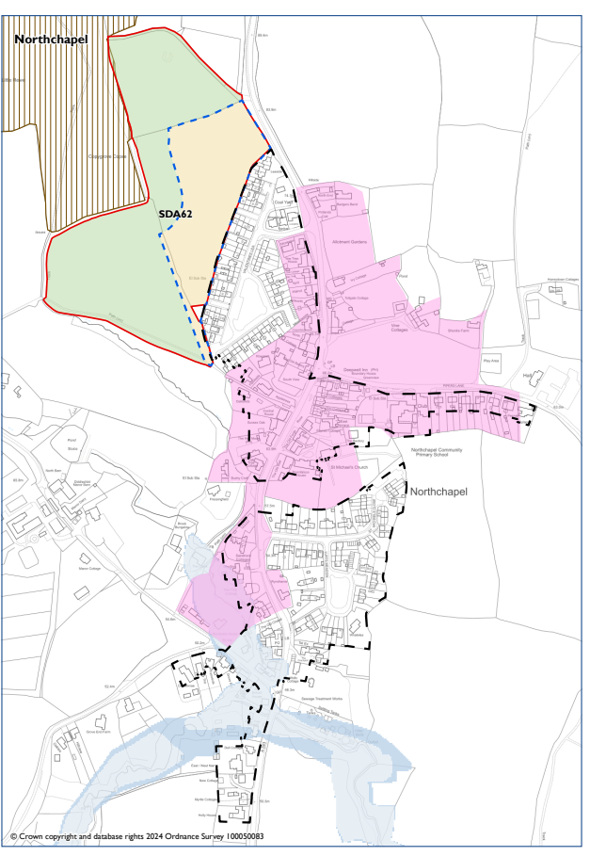

NORTHCHAPEL
 |  | National Park’s landscape character, functionality and perception and special qualities. | Biodiversity and contribution to nature recovery. | Historic environment heritage assets and their settings and cultural heritage. | Impacts of climate change and to address the causes of climate change. | Protection & Sustainable Use of Resources | Employment and Economy. | Promote equality of opportunity and the elimination of discrimination | Holistic health and well-being. To create and sustain healthy and sustainable vibrant communities. | Efficient transport network | Good quality home, suitable to their need. New affordable homes. | Character of settlements, neighbourhoods and rural buildings. Highest quality of design.
Site appraisal | Stage A
Site | Policy
Land west of Valentines Lea | SDA62 | - | - | - | ? | - | 0 | ? | + | - | + | ?
Settlement Appraisal | Stage B
Northchapel |  | + | + | + | ? | - | 0 | - | + | - | + | +

General Comments
There is only one Proposed Submission Local Plan site in Northchapel. Therefore, an in combination assessment has not been made.
Northchapel is located within the National Park, which is high landscape value. The settlement has a conservation area and protected spaces – it scores positively against these objectives. There are limited opportunities for employment in the settlement and other facilities are sparce, although there is a primary school. Therefore, the settlement scores negatively for equality. There are also limited transport options. Due to the conservation area, the settlement is considered to score positively for design and character.
Excluded sites: CH075, CH078, CH079, CH080, CH081, CH083, CH084, CH154
Rejected sites: CH266, CH076, CH077, CH145, CH224

Petworth (Chichester District)
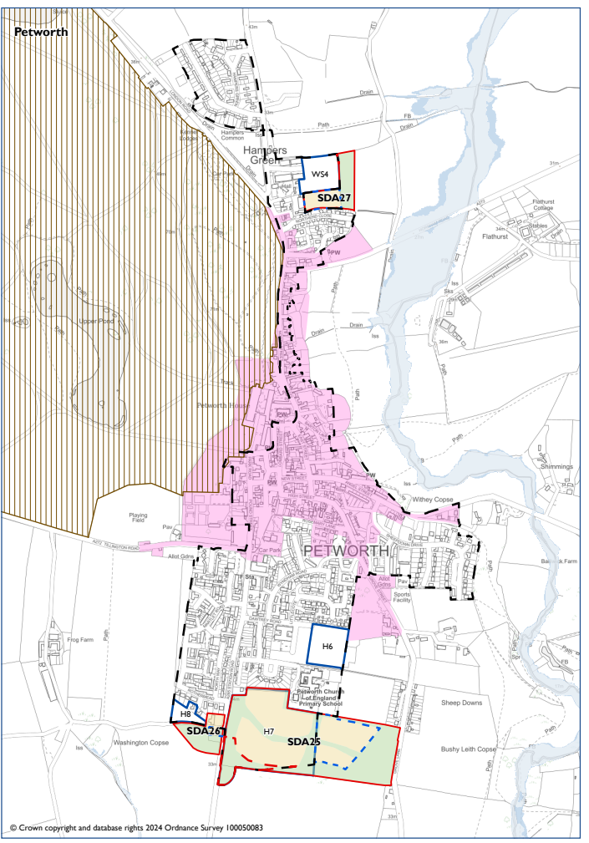

PETWORTH
 |  | National Park’s landscape character, functionality and perception and special qualities. | Biodiversity and contribution to nature recovery. | Historic environment heritage assets and their settings and cultural heritage. | Impacts of climate change and to address the causes of climate change. | Protection & Sustainable Use of Resources | Employment and Economy. | Promote equality of opportunity and the elimination of discrimination | Holistic health and well-being. To create and sustain healthy and sustainable vibrant communities. | Efficient transport network | Good quality home, suitable to their need. New affordable homes. | Character of settlements, neighbourhoods and rural buildings. Highest quality of design.
Site appraisal | Stage A
Site | Policy
1/2 - Land at Rotherbridge Lane  (Parcel: Land to the rear of Rothermead) | SDA26 | - | - | 0 | ? | - | - | + | + | - | + | +
2/2 - Land at Rotherbridge Lane  (Parcel: Land west of Station Road) | SDA26 | - | ? | 0 | ? | - | 0 | + | + | - | + | -
Land north of Northend Close | SDA27 | 0 | - | 0 | ? | - | ? | + | + | - | + | +
Land south of Herbert Shiner School | SDA25 | - | - | 0 | ? | - | 0 | + | + | - | + | ?
Settlement Appraisal | Stage B
Petworth |  | + | - | + | ? | - | + | + | + | - | + | +
In Combination | Stage C
 |  | - | ? | 0 | ? | - | 0 | + | + | - | + | ?

General Comments
There are three Proposed Submission Local Plan sites in Petworth. There are four NDP sites (one for employment) and therefore an in combination assessment is made.
Petworth is located within the National Park, which is high landscape value. It has an historic town centre and there are several nature conservation designated areas. There is a flood zone area to the east of the settlement, which is located within the Sussex North Water Resource Zone. There are a variety of employment opportunities and a dedicated employment/industrial estate to the north of the settlement. However, there is no railway station and transport is likely to include the private car.
In combination – with all the sites coming forward, this will have a negative impact on the landscape value. More information is needed on how the sites will impact on nature conservation designated areas. The impact on the historic environment is considered neutral, despite the importance of Petworth. Whilst one of the sites within the NDP is an expansion of the employment area – overall there is a neutral impact on employment. The sites will not improve the transport situation and may increase the level of traffic, especially to the south of the settlement. Whilst the design and layout of each development is unknown, these will be of high design value due to the character of Petworth, especially as some of the sites are near the conservation area. However, more details are needed to ensure that the designs reflect the character of the settlement.
Excluded sites: CH141, CH142, CH143, CH144
Rejected sites: CH099, CH101, CH102, CH103, CH139, CH140, CH228, CH230, CH231, CH097

Rogate (Chichester District)
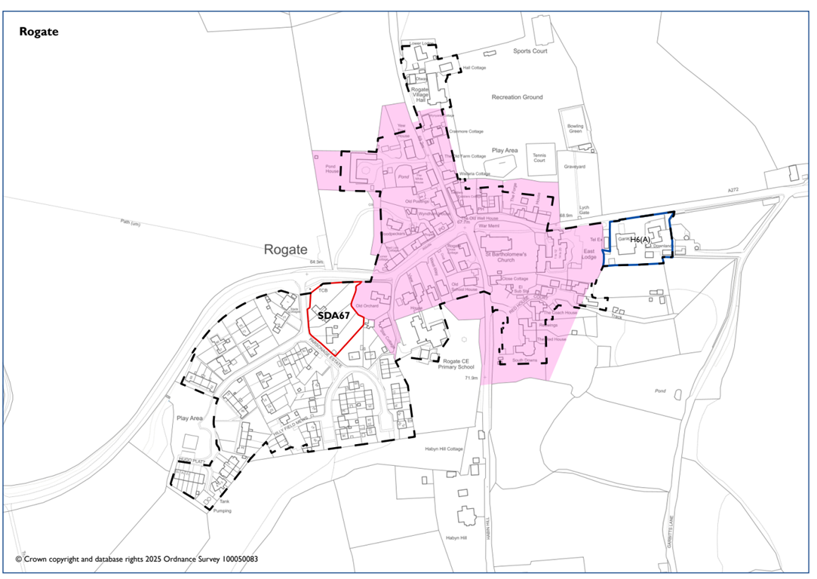
ROGATE
 |  | National Park’s landscape character, functionality and perception and special qualities. | Biodiversity and contribution to nature recovery. | Historic environment heritage assets and their settings and cultural heritage. | Impacts of climate change and to address the causes of climate change. | Protection & Sustainable Use of Resources | Employment and Economy. | Promote equality of opportunity and the elimination of discrimination | Holistic health and well-being. To create and sustain healthy and sustainable vibrant communities. | Efficient transport network | Good quality home, suitable to their need. New affordable homes. | Character of settlements, neighbourhoods and rural buildings. Highest quality of design.
Site appraisal | Stage A
Site | Policy
1-4 Parsonage Estate | SDA67 | - | 0 | 0 | ? | 0 | 0 | - | + | - | + | ?
Settlement Appraisal | Stage B
Rogate |  | + | 0 | + | ? | - | - | - | + | - | + | +
In Combination | Stage C
 |  | + | 0 | - | ? | _ | 0 | - | 0 | - | + | ?

General Comments
There is one Proposed Submission Local Plan sites in Rogate and one NDP site and therefore an in combination assessment is made.
Rogate is located within the National Park, which is high landscape value. There are few areas of nature conservation designation, and the impact is scored as neutral. There is a conservation area and Rogate is a settlement with historic character. Transport links are limited with some roads having no pavements. There is no train station but there is through traffic from the A272. There are few facilities within Rogate, and travel to areas outside of Rogate will be needed for employment and other services.
In combination – the sites will have a positive impact on the landscape as they are previously developed land. They will have a negative impact on heritage due to the proximity to the conservation area. The settlement is within the Sussex North Water Resource Zone and, combined with noise and pollution from the through traffic, the impact on the protection and sustainable use of resources is negative. There is a neutral impact on open space and play area within the settlement. More information is needed on the design and layout of the sites, especially as the settlement has a distinct and historic character.
Excluded sites: CH234, CH104, CH108
Rejected sites: CH235, CH236, CH238, CH239, CH273, CH105, CH106, CH107, CH109, CH262, CH263

Binsted (East Hampshire District)
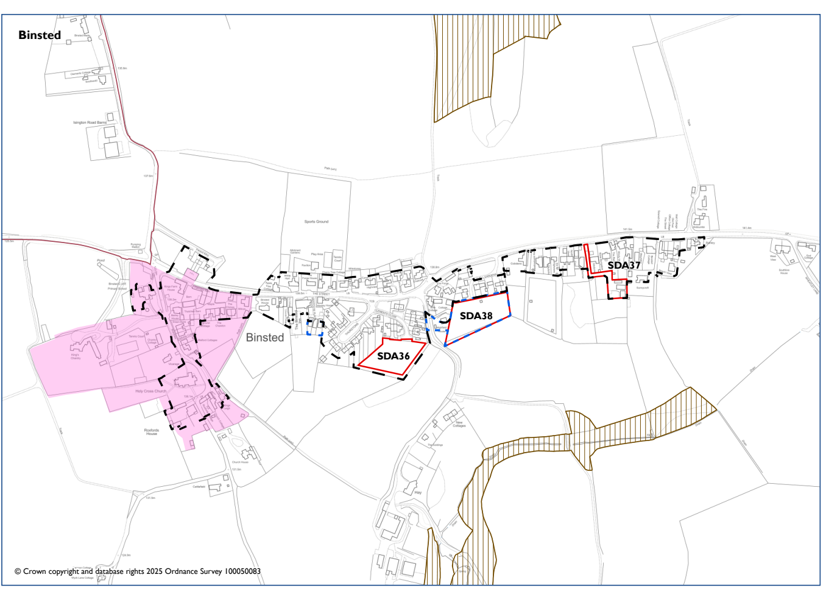
BINSTED
 |  | National Park’s landscape character, functionality and perception and special qualities. | Biodiversity and contribution to nature recovery. | Historic environment heritage assets and their settings and cultural heritage. | Impacts of climate change and to address the causes of climate change. | Protection & Sustainable Use of Resources | Employment and Economy. | Promote equality of opportunity and the elimination of discrimination | Holistic health and well-being. To create and sustain healthy and sustainable vibrant communities. | Efficient transport network | Good quality home, suitable to their need. New affordable homes. | Character of settlements, neighbourhoods and rural buildings. Highest quality of design.
Site appraisal | Stage A
Site | Policy
Land south of Lovell Gardens | SDA38 | - | - | 0 | ? | ? | 0 | - | + | ? | + | ?
Settlement Appraisal | Stage B
Binsted |  | + | + | + | ? | 0 | - | - | + | - | + | +
In Combination | Stage C
 |  | - | 0 | 0 | ? | 0 | 0 | - | 0 | - | + | ?

General Comments
There is one Proposed Submission Local Plan site in Binsted. There are two adopted Local Plan sites (see map above for SDA36 Land at Clements Close and SDA37 New Barn Stables, The Street). Therefore, an in-combination assessment is made.
Binsted is located within the National Park, which is of high landscape value. There are several areas of nature conservation protection, and this is scored as having positive impact on the settlement. There is also a conservation area. There are limited employment opportunities and access to facilities is also limited. There is access to open space for health and wellbeing. The settlement has no train station and public transport is limited.
The in-combination assessment considers there will be a negative impact on landscape but a neutral impact on biodiversity and heritage. There will be a neutral impact on employment as there will be no change to the current situation. This is the same for transport where the existing situation is negative, and the development sites will have a neutral impact. More information is needed on design and layout considering the position of the sites to the south of the settlement and the negative impact on landscape.
Excluded sites: EA228, EA249, EA250, EA251
Rejected sites: EA234, EA124

Liphook (East Hampshire District)
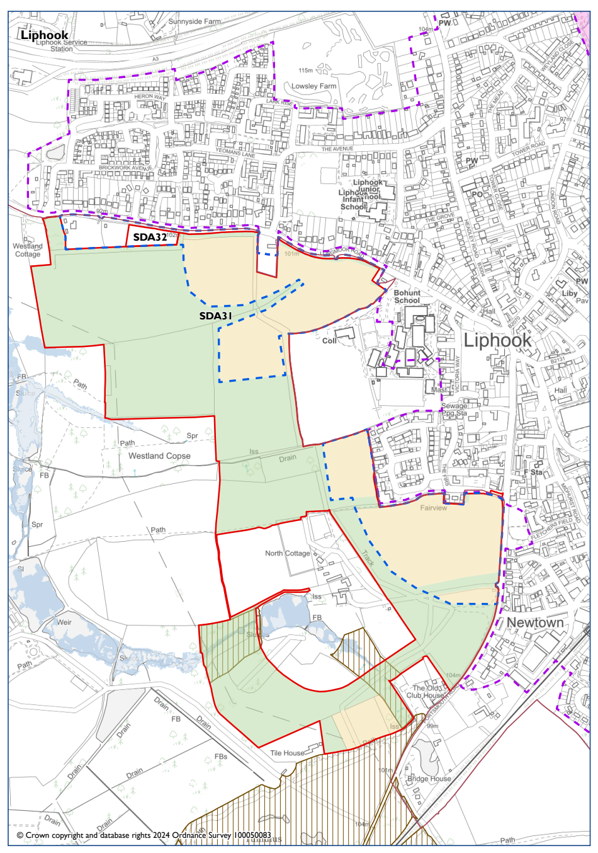

LIPHOOK
 |  | National Park’s landscape character, functionality and perception and special qualities. | Biodiversity and contribution to nature recovery. | Historic environment heritage assets and their settings and cultural heritage. | Impacts of climate change and to address the causes of climate change. | Protection & Sustainable Use of Resources | Employment and Economy. | Promote equality of opportunity and the elimination of discrimination | Holistic health and well-being. To create and sustain healthy and sustainable vibrant communities. | Efficient transport network | Good quality home, suitable to their need. New affordable homes. | Character of settlements, neighbourhoods and rural buildings. Highest quality of design.
Site appraisal | Stage A
Site | Policy
Land at Westlands | SDA32 | - | - | 0 | ? | - | 0 | + | + | + | + | ?
Land west of Liphook /  Land at Westlands Park | SDA31 | -- | - | - | ? | - | + | + | + | + | ++ | ?
Settlement Appraisal | Stage B
Liphook |  | 0 | - | 0 | ? | - | + | + | + | + | + | +
In Combination | Stage C
 |  | - | - | 0 | ? | - | 0 | 0 | 0 | 0 | + | ?

General Comments
There are two Proposed Submission Local Plan sites in Liphook. There are no NDP or adopted Local Plan sites in this part of the settlement. Therefore, an in-combination assessment is made.
The town and settlement of Liphook is not located within the National Park, but these sites are. It has an historic town centre, which is located outside of the National Park. There are several nature conservation designated areas within proximity of the settlement and sites. The settlement has areas of flooding and open agricultural land. There are employment areas within the settlement and a train station. Transport is considered efficient with a range of transport options. There are several facilities within the town including a secondary school.
In combination, the two sites will have a negative impact on the landscape and areas of nature conservation. There is a neutral impact on health and wellbeing, equalities and employment as the developments will not change the existing situation. More information is needed on design and layout considering the impact on landscape.
Excluded sites: CH279, EA029
Rejected sites: EA214

Liss (East Hampshire District)
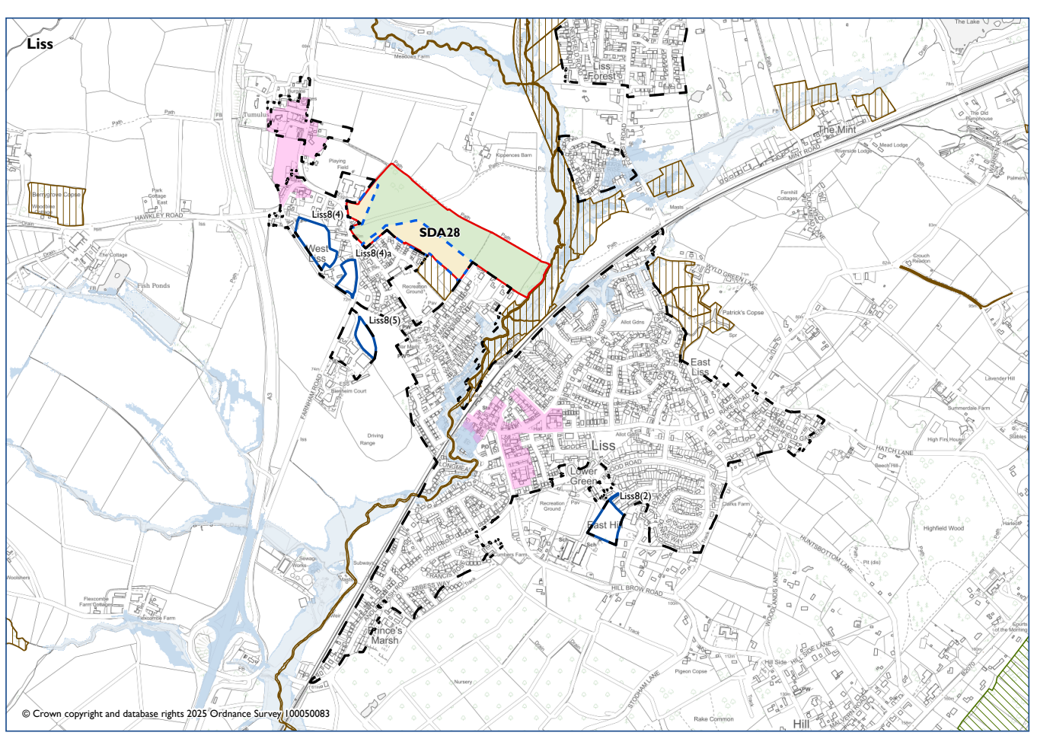

LISS
 |  | National Park’s landscape character, functionality and perception and special qualities. | Biodiversity and contribution to nature recovery. | Historic environment heritage assets and their settings and cultural heritage. | Impacts of climate change and to address the causes of climate change. | Protection & Sustainable Use of Resources | Employment and Economy. | Promote equality of opportunity and the elimination of discrimination | Holistic health and well-being. To create and sustain healthy and sustainable vibrant communities. | Efficient transport network | Good quality home, suitable to their need. New affordable homes. | Character of settlements, neighbourhoods and rural buildings. Highest quality of design.
Site appraisal | Stage A
Site | Policy
Land at Farnham & Station Roads | SDA28 | -- | - | - | ? | - | 0 | + | + | + | ++ | ?
Settlement Appraisal | Stage B
Liss |  | + | + | + | ? | - | 0 | 0 | + | + | + | +
In Combination | Stage C
 |  | 0 | - | 0 | ? | - | 0 | 0 | + | + | + | ?

General Comments
There is one Proposed Submission Local Plan site in Liss and several NDP sites. Therefore, an in-combination assessment is made.
Liss is located within the National Park, which is of high landscape value. It has two conservation areas - West Liss and central Liss. There are areas of nature conservation designation and an efficient transport system, due to the train station. There are limited opportunities for employment but as there is a train station – locations to the north (Liphook and Guildford) and to the south (Petersfield and Portsmouth) are accessible.
In combination – bringing all the sites forward will have a neutral impact on landscape. There will be a negative impact on nature conservation designated areas but a neutral impact on heritage. The locations are near to open space countryside, but more details are required on design, layout and impact on the character of the settlement.
Excluded sites: EA035, EA039, EA119, EA120, EA156, EA245
Rejected sites: EA104), EA142, EA158, EA220, EA221 EA222, EA240, EA040, EA041, EA042

Petersfield (East Hampshire District)
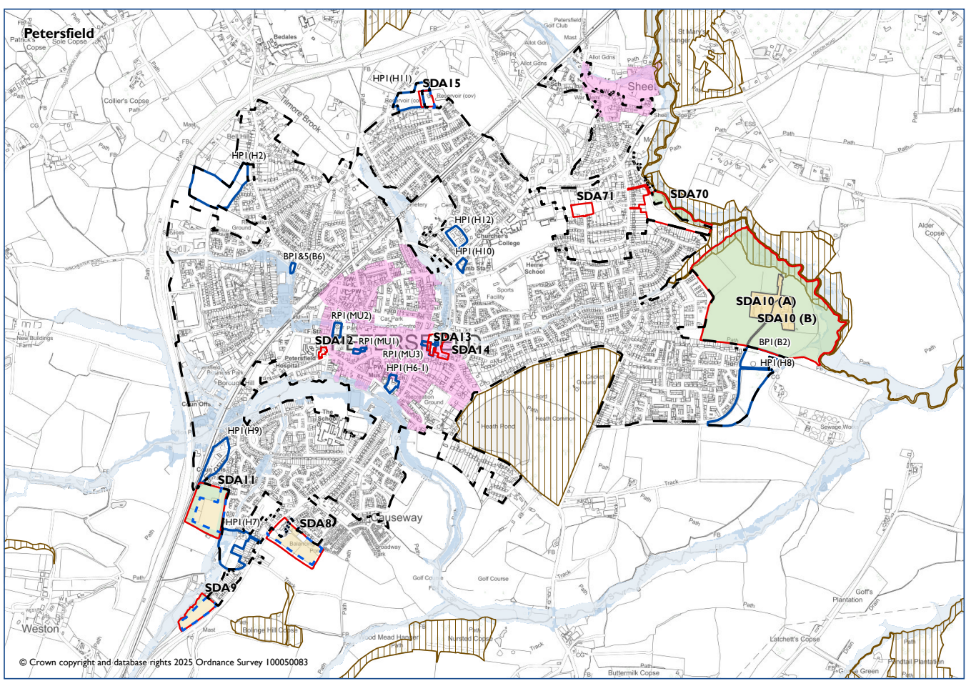
PETERSFIELD
 |  | National Park’s landscape character, functionality and perception and special qualities. | Biodiversity and contribution to nature recovery. | Historic environment heritage assets and their settings and cultural heritage. | Impacts of climate change and to address the causes of climate change. | Protection & Sustainable Use of Resources | Employment and Economy. | Promote equality of opportunity and the elimination of discrimination | Holistic health and well-being. To create and sustain healthy and sustainable vibrant communities. | Efficient transport network | Good quality home, suitable to their need. New affordable homes. | Character of settlements, neighbourhoods and rural buildings. Highest quality of design.
Site appraisal | Stage A
Site | Policy
Land south of Paddock Way | SDA11 | - | - | 0 | ? | - | + | + | - | + | ++ | ?
Land at Drum Court, The Spain | SDA12 | 0 | ? | - | ? | 0 | - | + | + | + | ++ | ?
Land at Festival Hall | SDA14 | 0 | + | - | ? | - | + | + | + | + | ++ | ?
The Courtyard, Heath Road | SDA13 | 0 | ? | - | ? | 0 | + | + | + | + | + | ?
Windward, Reservoir Lane | SDA15 | - | + | 0 | ? | + | 0 | - | + | - | + | ?
Land at Penns Place | SDA10 | - | - | 0 | ? | 0 | - | - | - | ? | ++ | ?
Land South of the Causeway | SDA9 | - | - | 0 | ? | 0 | - | - | - | ? | + | ?
Land at Causeway House | SDA8 | - | - | 0 | ? | 0 | - | - | - | ? | + | ?
Settlement Appraisal | Stage B
Petersfield |  | + | + | + | ? | - | + | + | + | + | + | +
In Combination | Stage C
 |  | - | - | 0 | ? | - | 0 | 0 | 0 | 0 | + | ?

General Comments
There are eight Proposed Submission Local Plan sites in Petersfield. There are also several NDP sites in settlement. Therefore, an in-combination assessment is made.
Petersfield is located within the National Park, which is of high landscape value. It has an historic town centre, with a central conservation area. There are several areas of nature conservation designation. The settlement has areas of flooding. It has with a range of employment opportunities, education, medical and other facilities. It has a train station and has several transport options.
The in-combination impact of all the sites coming forward means there is a negative score on landscape value. Several of the sites are on the edge of the settlement especially those to the south and east. These will also have a negative impact on nature conservation designations. They will have a neutral impact on employment. Whilst some of the individual sites will result in the loss of some employment opportunities, there will be new opportunities, and this impact is neutral overall. There is also a neutral impact on heritage, even though a handful of small sites are located within the conservation area. There is a need to gain more information about design and layout of the sites.
Excluded sites: EA049, EA077, EA080, EA118, EA185, EA190
Rejected sites: EA226, EA236, EA237, EA046, EA047, EA061, EA063, EA065, EA073, EA108, EA112, EA115, EA145, EA183, EA184, EA189, EA191, EA192, EA193

Sheet (East Hampshire District)
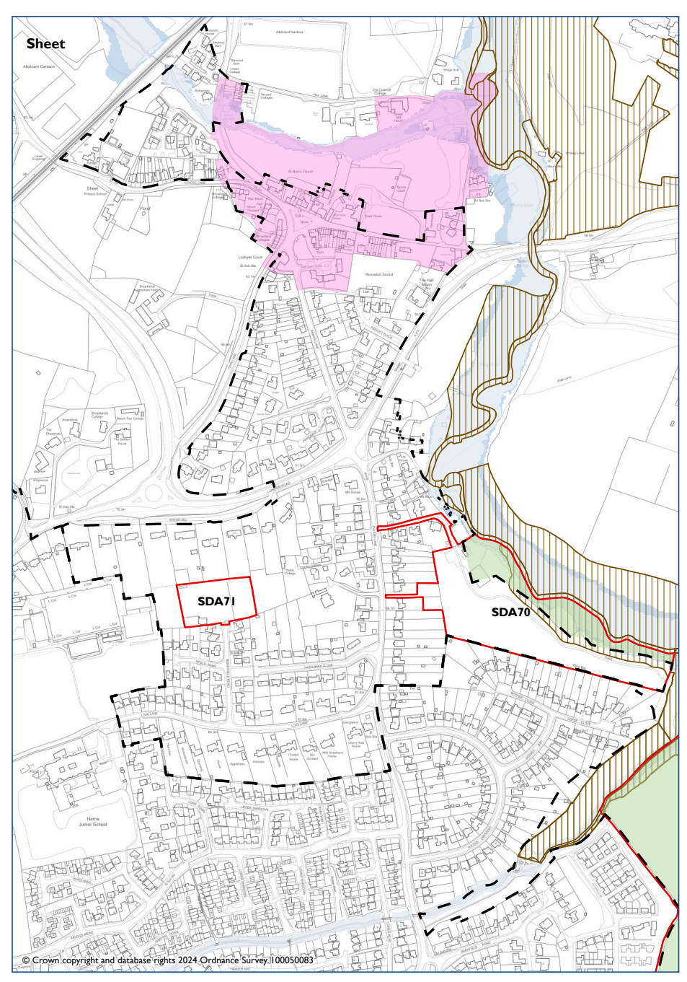
SHEET
 |  | National Park’s landscape character, functionality and perception and special qualities. | Biodiversity and contribution to nature recovery. | Historic environment heritage assets and their settings and cultural heritage. | Impacts of climate change and to address the causes of climate change. | Protection & Sustainable Use of Resources | Employment and Economy. | Promote equality of opportunity and the elimination of discrimination | Holistic health and well-being. To create and sustain healthy and sustainable vibrant communities. | Efficient transport network | Good quality home, suitable to their need. New affordable homes. | Character of settlements, neighbourhoods and rural buildings. Highest quality of design.
Site appraisal | Stage A
Site | Policy
Land off Merryfield Road | SDA71 | 0 | - | 0 | ? | 0 | 0 | + | + | + | + | ?
Settlement Appraisal | Stage B
Sheet |  | + | + | + | ? | - | 0 | + | + | + | + | +
In Combination | Stage C
 |  | 0 | - | 0 | ? | - | 0 | 0 | 0 | 0 | + | ?

General Comments
There is one Proposed Submission Local Plan site in Sheet. There is one LP site (see map above - SDA70 Land at Pulens Lane) in this part of the settlement. Therefore, an in-combination assessment is made.
Sheet is located within the National Park, which is high landscape value. There are areas of nature conservation designation and a conservation area. The settlement has flooding susceptibility to the east. There is limited employment in Sheet, but Petersfield is nearby. Due to the proximity of Petersfield, the settlement scores positively for equality, health and wellbeing and transport.
In combination – with the two sites coming forward – this would have a neutral impact on the landscape but a negative impact on biodiversity. It would have a negative impact on protection and sustainable use of resources. Further information is needed on the proposed design and layout of each site. Development would have a neutral impact on transport, health and equalities – mostly due to the proximity to Petersfield.
Excluded sites: EA056, EA060, EA064, EA066, EA095, EA239
Rejected sites: EA053, EA197, EA201, EA202, EA203

Stroud (East Hampshire District)
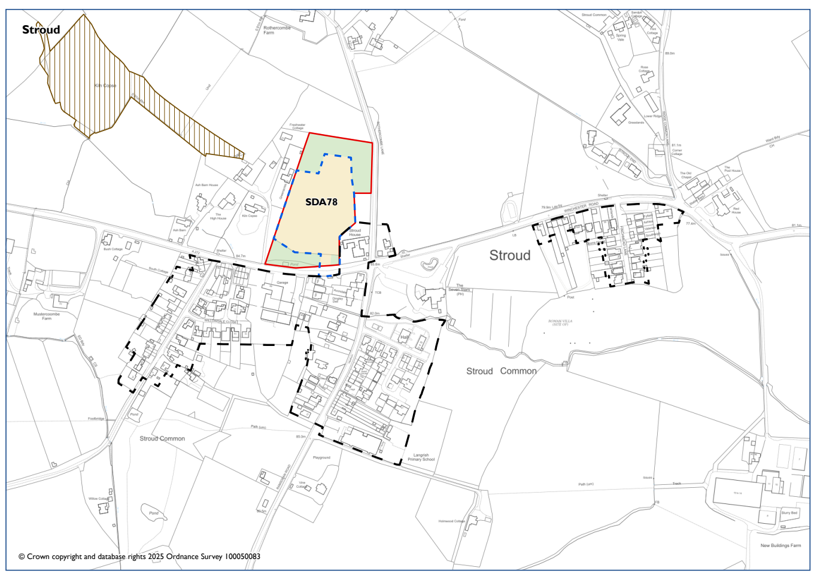

STROUD
 |  | National Park’s landscape character, functionality and perception and special qualities. | Biodiversity and contribution to nature recovery. | Historic environment heritage assets and their settings and cultural heritage. | Impacts of climate change and to address the causes of climate change. | Protection & Sustainable Use of Resources | Employment and Economy. | Promote equality of opportunity and the elimination of discrimination | Holistic health and well-being. To create and sustain healthy and sustainable vibrant communities. | Efficient transport network | Good quality home, suitable to their need. New affordable homes. | Character of settlements, neighbourhoods and rural buildings. Highest quality of design.
Site appraisal | Stage A
Site | Policy
Land north of Winchester Road | SDA78 | -- | - | 0 | ? | - | 0 | - | + | - | + | 0
Settlement Appraisal | Stage B
Stroud |  | + | 0 | 0 | ? | - | - | - | + | - | + | 0

General Comments
There is only one Proposed Submission Local Plan site in Stroud. Therefore, an in-combination assessment has not been made.
Stroud is located within the National Park, which is of high landscape value. There is no conservation area and only a few areas of nature conservation designation. The settlement scores as having a neutral impact on these objectives. It scores negatively against employment due to limited opportunities. Due to noise pollution from the A272, the settlement has a negative impact on the use of resources. There are also limited facilities within the settlement and no train station. On this basis, there is a negative impact on an efficient transport network.
Excluded sites: EA096, EA098, EA099, EA105
Rejected sites: EA103, EA211, EA213

Amberley (Horsham District)
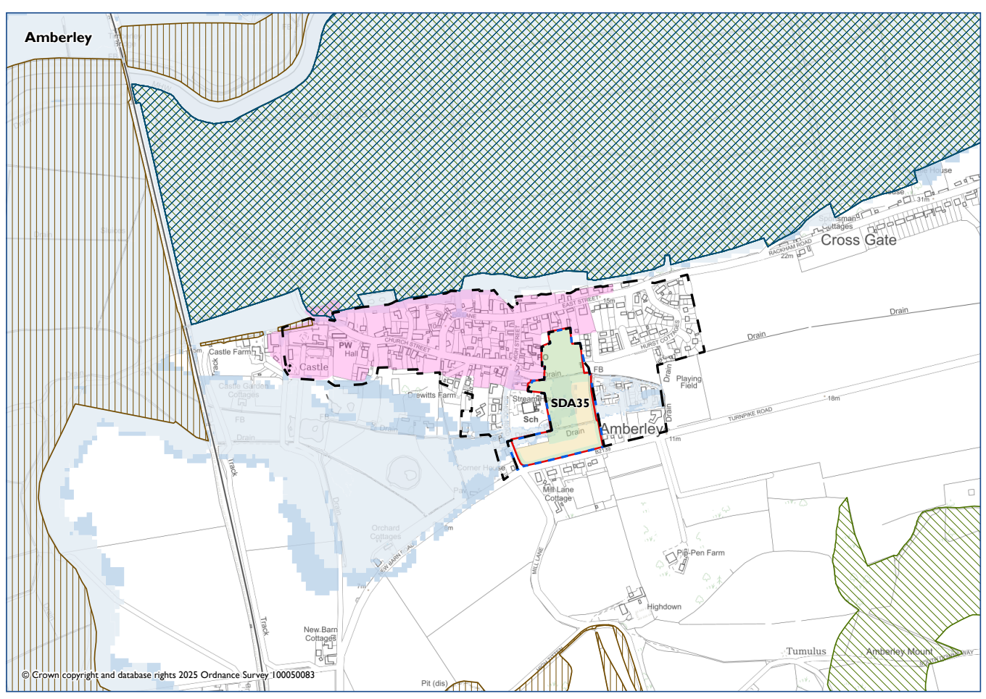

AMBERLEY
 |  | National Park’s landscape character, functionality and perception and special qualities. | Biodiversity and contribution to nature recovery. | Historic environment heritage assets and their settings and cultural heritage. | Impacts of climate change and to address the causes of climate change. | Protection & Sustainable Use of Resources | Employment and Economy. | Promote equality of opportunity and the elimination of discrimination | Holistic health and well-being. To create and sustain healthy and sustainable vibrant communities. | Efficient transport network | Good quality home, suitable to their need. New affordable homes. | Character of settlements, neighbourhoods and rural buildings. Highest quality of design.
Site appraisal | Stage A
Site | Ref
East Street Farm | SDA35 | - | - | - | ? | 0 | + | - | + | ? | ++ | ?
Settlement Appraisal | Stage B
Amberley |  | + | - | + | ? | - | - | - | + | 0 | + | +

General Comments
There is only one Proposed Submission Local Plan site in Amberley. Therefore, an in-combination assessment has not been made
Amberley is within the National Park and has high landscape value. There are significant areas of nature conservation designation. There is a conservation area and areas within a flood zone. There is a train station, albeit not central to the settlement. This is neutral. Due to limited offers of employment opportunities and facilities – the settlement scores negatively for employment and equalities.
Excluded sites: HO035, HO036
Rejected sites: HO053

Steyning (Horsham District)
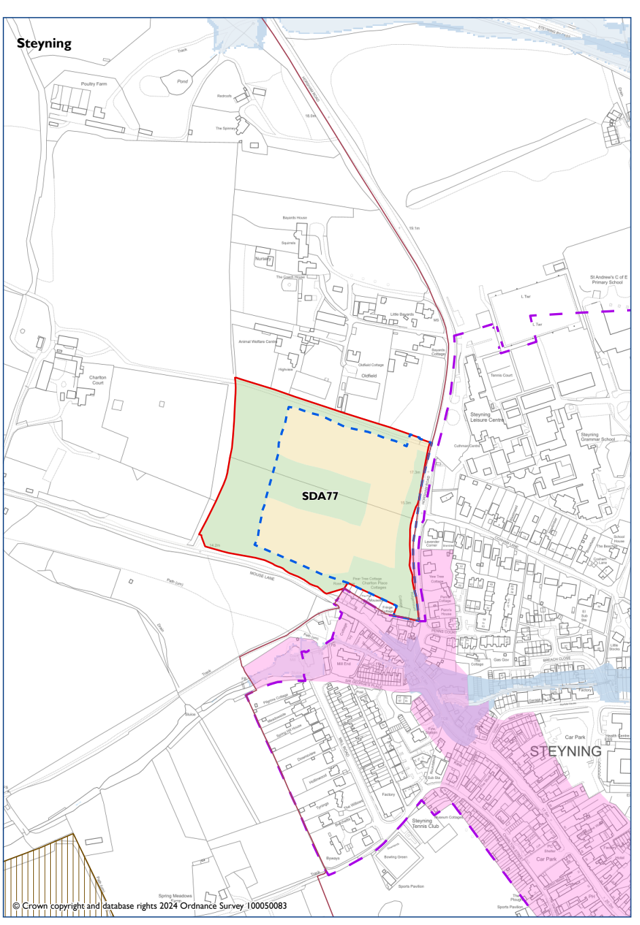

STEYNING
 |  | National Park’s landscape character, functionality and perception and special qualities. | Biodiversity and contribution to nature recovery. | Historic environment heritage assets and their settings and cultural heritage. | Impacts of climate change and to address the causes of climate change. | Protection & Sustainable Use of Resources | Employment and Economy. | Promote equality of opportunity and the elimination of discrimination | Holistic health and well-being. To create and sustain healthy and sustainable vibrant communities. | Efficient transport network | Good quality home, suitable to their need. New affordable homes. | Character of settlements, neighbourhoods and rural buildings. Highest quality of design.
Site appraisal | Stage A
Site | Policy
Land at Horsham Road | SDA77 | - | + | ? | ? | ? | 0 | + | + | ? | + | +
Settlement Appraisal | Stage B
Steyning |  | 0 | + | + | 0 | - | + | + | + | 0 | + | +

General Comments
There is one Proposed Submission Local Plan site in Steyning. An in combination assessment is not made.
This part of Steyning is within the National Park and has a high landscape value but the settlement of Steyning is not in the National Park. It is a small rural town of around 5,500 people in the Horsham district of West Sussex. It is located at the north end of the River Adur gap in the South Downs, four miles north of Shoreham-by-Sea. The land to south and east of the town is within the National Park. Facilities include a nursey, primary and secondary school provision, local shops, post office, leisure centre, GP surgery, pharmacy, village hall, library, play areas and pubs. There is no train station, but buses do serve the town.
Rejected sites: HO006, HO032

Cooksbridge (Lewes and Eastbourne District)
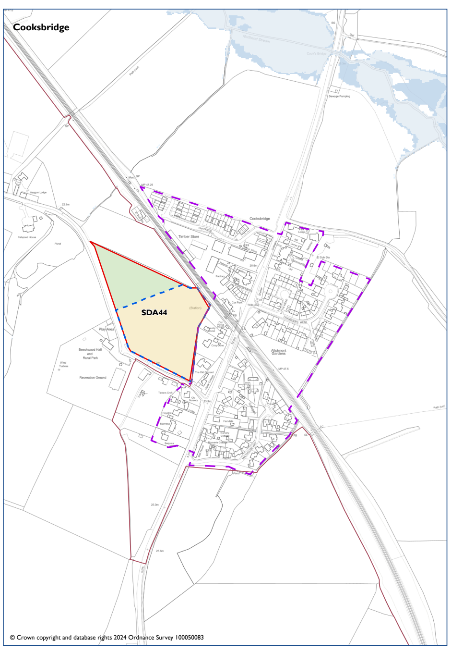

COOKSBRIDGE
 |  | National Park’s landscape character, functionality and perception and special qualities. | Biodiversity and contribution to nature recovery. | Historic environment heritage assets and their settings and cultural heritage. | Impacts of climate change and to address the causes of climate change. | Protection & Sustainable Use of Resources | Employment and Economy. | Promote equality of opportunity and the elimination of discrimination | Holistic health and well-being. To create and sustain healthy and sustainable vibrant communities. | Efficient transport network | Good quality home, suitable to their need. New affordable homes. | Character of settlements, neighbourhoods and rural buildings. Highest quality of design.
Site appraisal | Stage A
Site | Policy
Land at Beechwood Lane | SDA44 | 0 | - | 0 | ? | - | 0 | + | + | + | ++ | ?
Settlement Appraisal | Stage B
Cooksbridge |  | 0 | 0 | 0 | ? | - | - | - | + | + | + | 0

General Comments
There is only one Proposed Submission Local Plan site in Cooksbridge. Therefore, an in-combination assessment has not been made.
The settlement of Cooksbridge is not within the National Park. This is no conservation area and the settlement scores as neutral on heritage and biodiversity. Railway and traffic noise and pollution means that the settlement scores negatively against protection and sustainable use of resources. There are limited employment opportunities, but the existence of a railway station means that Cooksbridge is positive for transport networks.

Rejected sites: LE115

Kingston near Lewes (Lewes and Eastbourne District)
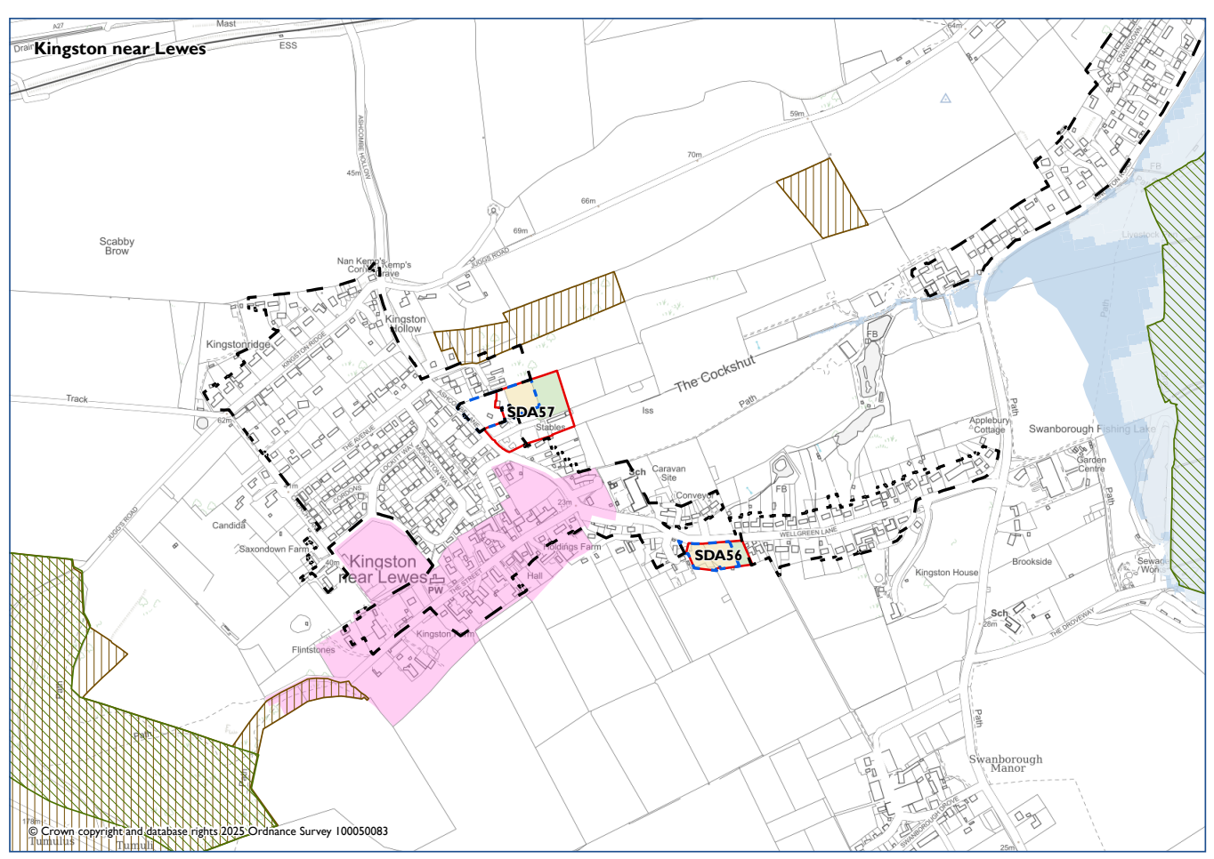

KINGSTON NEAR LEWES
 |  | National Park’s landscape character, functionality and perception and special qualities. | Biodiversity and contribution to nature recovery. | Historic environment heritage assets and their settings and cultural heritage. | Impacts of climate change and to address the causes of climate change. | Protection & Sustainable Use of Resources | Employment and Economy. | Promote equality of opportunity and the elimination of discrimination | Holistic health and well-being. To create and sustain healthy and sustainable vibrant communities. | Efficient transport network | Good quality home, suitable to their need. New affordable homes. | Character of settlements, neighbourhoods and rural buildings. Highest quality of design.
Site appraisal | Stage A
Site | Policy
Audiburn Farm, Ashcombe Lane | SDA57 | - | + | 0 | ? | 0 | 0 | - | + | - | + | ?
Land at Holdings Farm, Wellgreen Lane, Kingston | SDA56 | - | + | - | ? | 0 | 0 | - | + | - | + | ?
Settlement Appraisal | Stage B
Kingston |  | + | + | + | ? | 0 | - | - | + | - | + | +
In Combination | Stage C
 |  | - | - | 0 | ? | 0 | 0 | 0 | + | 0 | + | ?

General Comments
There are two Proposed Submission Local Plan sites in Kingston near Lewes. Therefore, an in-combination assessment is made.
Kingston near Lewes is located within the National Park which is of high landscape value. There are nature conservation designations and a conservation area. Transport is limited with no train station. There are few employment opportunities but there is access to open space and countryside.
In combination – if the two sites were developed – this would have a negative impact on the landscape. It would also have a negative impact on biodiversity but a neutral impact on heritage as the locations are not near the conservation area. Other matters would be neutral as the developments do not create negative situation – for example, the transport network would remain the same. Further details on design and layout are needed, especially due to the impact of the sites on landscape value.
Excluded sites: LE002, LE007, LE019, LE022, LE099, LE117, LE181
Rejected sites: LE123, LE011, LE020, LE029, LE096, LE100

Lewes (Lewes and Eastbourne District)
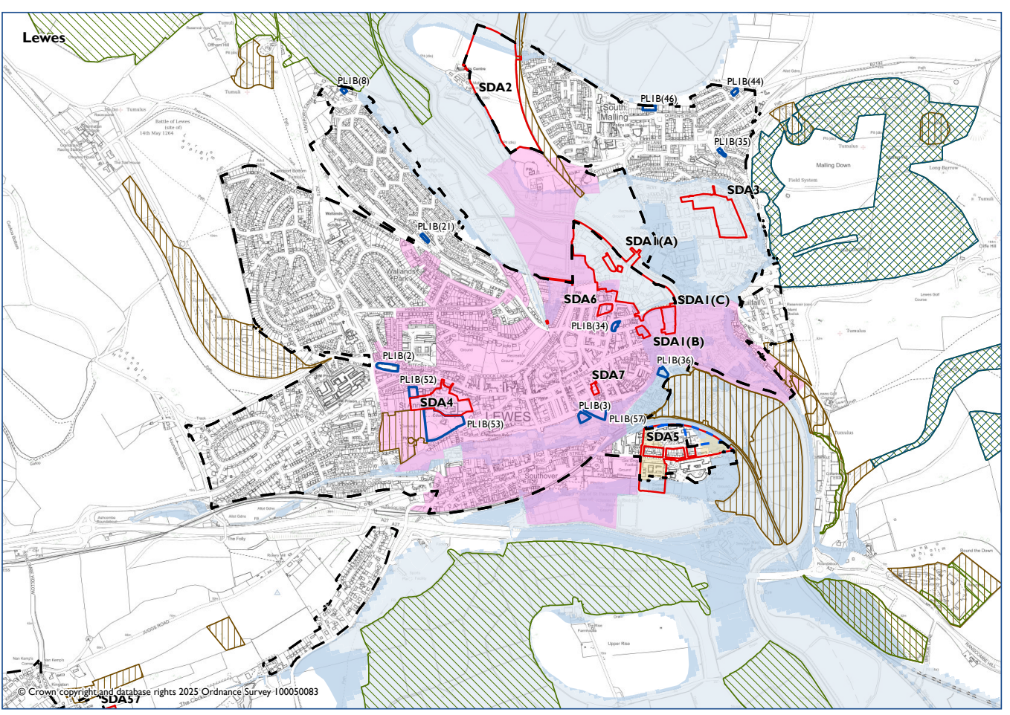

LEWES
 |  | National Park’s landscape character, functionality and perception and special qualities. | Biodiversity and contribution to nature recovery. | Historic environment heritage assets and their settings and cultural heritage. | Impacts of climate change and to address the causes of climate change. | Protection & Sustainable Use of Resources | Employment and Economy. | Promote equality of opportunity and the elimination of discrimination | Holistic health and well-being. To create and sustain healthy and sustainable vibrant communities. | Efficient transport network | Good quality home, suitable to their need. New affordable homes. | Character of settlements, neighbourhoods and rural buildings. Highest quality of design.
Site appraisal | Stage A
Site | Policy
East Sussex College, Mountfield Road | SDA5 | 0 | ? | - | ? | - | - | + | + | + | ++ | ?
Land behind the White Hart, 55 High Street | SDA7 | - | ? | - | ? | - | - | + | + | + | + | ?
Springman House, 8 North Street | SDA6 | - | ? | - | ? | ? | 0 | + | + | + | + | ?
County Hall, St Anne’s Crescent | SDA4 | - | - | - | ? | 0 | + | + | + | + | ++ | ?
Settlement Appraisal | Stage B
Lewes |  | + | + | + | ? | - | + | + | + | + | + | +
In Combination | Stage C
 |  | 0 | ? | - | ? | - | 0 | 0 | 0 | 0 | 0 | ?

General Comments
There are four Proposed Submission Local Plan sites in Lewes and several LP sites (see map above for SDA1 North Street Quarter: Phoenix Area; Former Bus Station; and Eastgate Wharf, SDA2 Land at Old Malling Farm, SDA3 Malling Brooks) and several NDP sites. Therefore, an in-combination assessment is made.
Lewes is located within the National Park which is of high landscape value. There are nature conservation designated areas and a conservation area. The settlement is subject to flooding. The settlement scores positively for a wide range of objectives including employment, equality, wellbeing and transport. It is a well-connected settlement with an extensive range of services and facilities.
In combination – with several sites coming forward – there will be a neutral impact on landscape, with the vast majority being located within the settlement. Further details are needed to assess the impact on areas of biodiversity value and design/layout of the developments. There will be a negative impact on heritage as the historic core of Lewes is significant. There will be a neutral impact on transport, equalities, wellbeing and employment as these issues will remain the same.
Excluded sites: LE027, LE038, LE053, LE060, LE125, LE128, LE136, LE143, LE144, LE161, LE163, LE164, LE165, LE166, LE167, LE168, LE176, LE190
Rejected sites: LE122, LE130, LE131, LE132, LE134, LE135, LE137, LE138, LE140, LE142, LE169, LE170, LE179, LE182, LE183, LE184, LE010, LE021, LE035, LE047, LE051, LE054, LE059, LE102,

Keymer (Mid Sussex District)
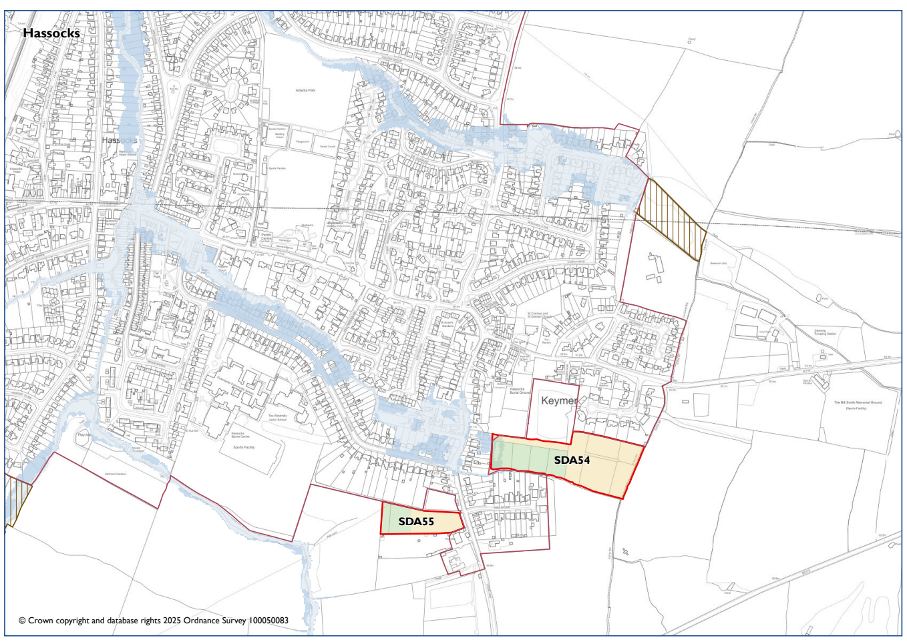
KEYMER
 |  | National Park’s landscape character, functionality and perception and special qualities. | Biodiversity and contribution to nature recovery. | Historic environment heritage assets and their settings and cultural heritage. | Impacts of climate change and to address the causes of climate change. | Protection & Sustainable Use of Resources | Employment and Economy. | Promote equality of opportunity and the elimination of discrimination | Holistic health and well-being. To create and sustain healthy and sustainable vibrant communities. | Efficient transport network | Good quality home, suitable to their need. New affordable homes. | Character of settlements, neighbourhoods and rural buildings. Highest quality of design.
Site appraisal | Stage A
Site | Policy
Land east of Lodge Lane | SDA54 | - | + | ? | ? | + | 0 | + | + | + | ++ | -
Land at Southdowns Farm | SDA55 | - | + | ? | ? | + | 0 | + | + | + | + | -
Settlement Appraisal | Stage B
Keymer |  | 0 | + | + | ? | - | 0 | - | + | + | + | 0
In Combination | Stage C
 |  | 0 | + | ? | ? | + | 0 | + | + | + | + | 0

General Comments
There are two Proposed Submission Local Plan site in Hassocks. Therefore, an in-combination assessment has been made.
Part of Keymer is within the National Park, but a large section of the built up area is outside. This is a conservation area abutting the site and to the east of the main settlement. There are several areas of nature conservation designation. There is a train station towards the western part of the settlement, but employment options are limited. There are some services and a school but as Hassocks (Keymer) is on a train line to Burgess Hill – many of these can be accessed via public transport. Due to limited accessibility to services and facilities within the immediate locality, the settlement scores negatively on equalities.
The in combination appraisal considers the impact on the landscape to be neutral with more information needed on the impact on heritage. As part of the cumulative impact, there will be improvements to flooding and access to health and wellbeing and equal opportunities will remain positive.
Rejected sites: MI015, MI009, MI006

Alfriston (Wealden District Council)
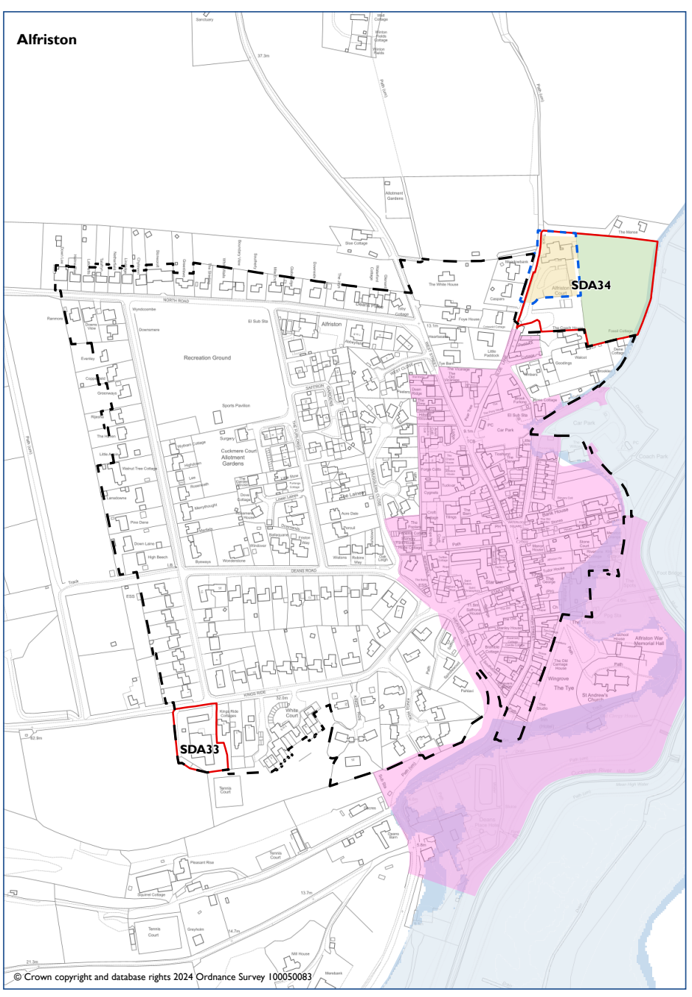

ALFRISTON
 |  | National Park’s landscape character, functionality and perception and special qualities. | Biodiversity and contribution to nature recovery. | Historic environment heritage assets and their settings and cultural heritage. | Impacts of climate change and to address the causes of climate change. | Protection & Sustainable Use of Resources | Employment and Economy. | Promote equality of opportunity and the elimination of discrimination | Holistic health and well-being. To create and sustain healthy and sustainable vibrant communities. | Efficient transport network | Good quality home, suitable to their need. New affordable homes. | Character of settlements, neighbourhoods and rural buildings. Highest quality of design.
Site appraisal | Stage A
Site | Policy
Alfriston Court | SDA34 | -- | + | - | ? | 0 | + | - | + | - | ++ | ?
Settlement Appraisal | Stage B
Alfriston |  | + | 0 | + | ? | - | - | - | + | - | + | +
In Combination | Stage C
 |  | 0 | 0 | - | ? | - | 0 | 0 | + | - | + | ?

General Comments
There is one Proposed Submission Local Plan site in Alfriston and one LP site (SDA33 Kings Ride). Therefore, an in-combination assessment is made.
Alfriston is located within the National Park which is of high landscape value. It has a conservation area and areas that are liable to flood. There are limited employment opportunities and transport is also limited with no train station. Traffic through the centre of the settlement can cause congestion.
In combination – it is considered the sites will have a neutral impact on landscape. They will have a neutral impact on heritage, employment and equalities over and above the existing situation. Further details are needed on design and layout considering the location of one of the sites near the historic core/conservation area.
Rejected sites: WE005, WE011

Owslebury (Winchester District)
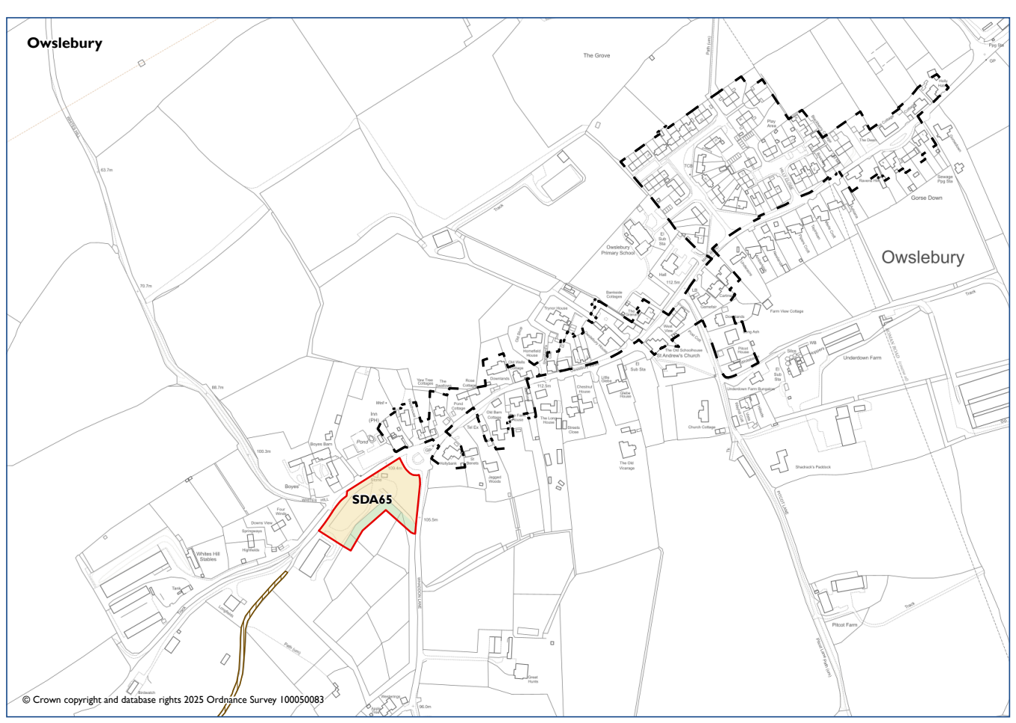

OWSLESBURY
 |  | National Park’s landscape character, functionality and perception and special qualities. | Biodiversity and contribution to nature recovery. | Historic environment heritage assets and their settings and cultural heritage. | Impacts of climate change and to address the causes of climate change. | Protection & Sustainable Use of Resources | Employment and Economy. | Promote equality of opportunity and the elimination of discrimination | Holistic health and well-being. To create and sustain healthy and sustainable vibrant communities. | Efficient transport network | Good quality home, suitable to their need. New affordable homes. | Character of settlements, neighbourhoods and rural buildings. Highest quality of design.
Site appraisal | Stage A
Site | Policy
Land at Old Green Farm | SDA65 | 0 | - | 0 | ? | 0 | - | - | + | - | + | ?
Settlement Appraisal | Stage B
Owlesbury |  | + | 0 | 0 | ? | 0 | 0 | - | + | - | + | 0

General Comments
There is one site in the Proposed Submission Local Plan sites in Owslebury. Therefore, an in-combination assessment is not made.
Owslebury is located within the National Park which is of high landscape value. There are no areas of nature conservation designation. There is no conservation area. The settlement is neutral in terms of employment. There are no large businesses but there are several farms in the surrounding area. Due to a limited number of services and facilities, the settlement scores negatively for equalities. The settlement has no train station and transport network is scored as negative.
Excluded sites: WI067, WI068, WI069
Rejected sites: WI070, WI101

Swanmore (Winchester District)
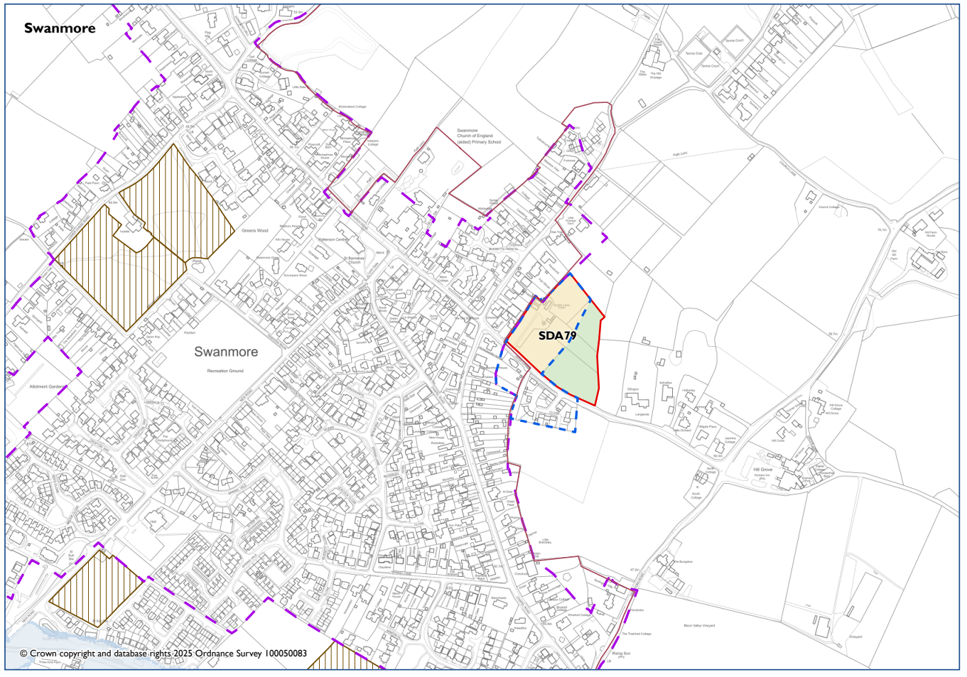

SWANMORE
 |  | National Park’s landscape character, functionality and perception and special qualities. | Biodiversity and contribution to nature recovery. | Historic environment heritage assets and their settings and cultural heritage. | Impacts of climate change and to address the causes of climate change. | Protection & Sustainable Use of Resources | Employment and Economy. | Promote equality of opportunity and the elimination of discrimination | Holistic health and well-being. To create and sustain healthy and sustainable vibrant communities. | Efficient transport network | Good quality home, suitable to their need. New affordable homes. | Character of settlements, neighbourhoods and rural buildings. Highest quality of design.
Site appraisal | Stage A
Site | Policy
Land north of Dodds Lane | SDA79 | - | - | 0 | ? | 0 | 0 | - | + | + | + | ?
Settlement Appraisal | Stage B
Swanmore |  | 0 | + | 0 | ? | 0 | - | - | + | - | + | 0

General Comments
There is only one Proposed Submission Local Plan site in Swanmore. Therefore, an in-combination assessment has not been made.
The settlement of Swanmore is not within the National Park. There is no conservation area but there are several nature conservation designated areas. As the settlement has no main employers or a train station it scores negatively against these objectives. There are also limited services and facilities and therefore it scores negatively for equalities. It is located near open countryside and scores positively for health and wellbeing.
Excluded sites: WI030, WI106, WI120
Rejected sites: WI001, WI031, WI036, WI103, WI118,

Twyford (Winchester District)
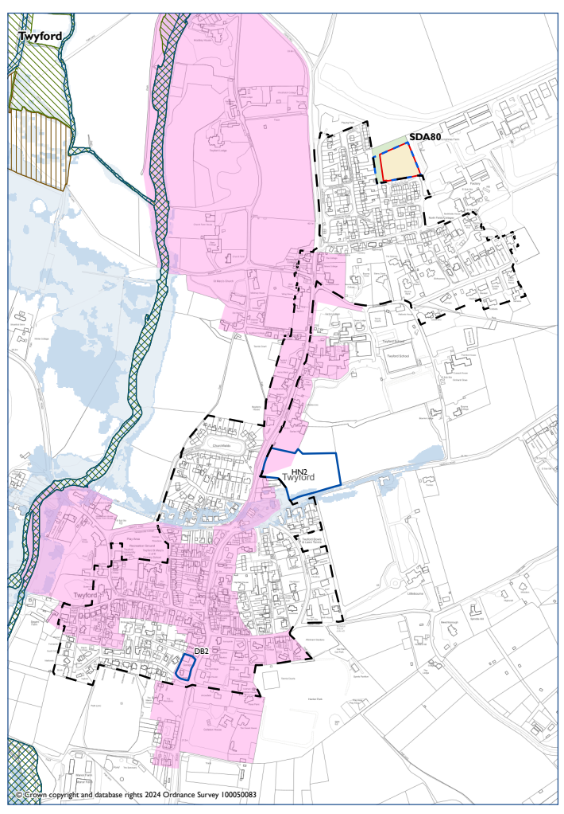
TWYFORD
 |  | National Park’s landscape character, functionality and perception and special qualities. | Biodiversity and contribution to nature recovery. | Historic environment heritage assets and their settings and cultural heritage. | Impacts of climate change and to address the causes of climate change. | Protection & Sustainable Use of Resources | Employment and Economy. | Promote equality of opportunity and the elimination of discrimination | Holistic health and well-being. To create and sustain healthy and sustainable vibrant communities. | Efficient transport network | Good quality home, suitable to their need. New affordable homes. | Character of settlements, neighbourhoods and rural buildings. Highest quality of design.
Site appraisal | Stage A
Site | Policy
Land north of Hewlett Close | SDA80 | 0 | - | 0 | ? | - | 0 | 0 | - | - | + | ?
Settlement Appraisal | Stage B
Twyford |  | + | + | + | ? | - | - | - | + | - | + | +
In Combination | Stage C
 |  | 0 | 0 | - | ? | 0 | 0 | 0 | + | 0 | + | ?

General Comments
There is one Proposed Submission Local Plan site and one NDP site in Twyford. Therefore, an in-combination assessment is made.
Twyford is located within the National Park which is of high landscape value. There is a conservation area and several areas of nature conservation designation. There are flood zones. There are limited employment opportunities and few facilities and services, although there is a primary school. There is no train service and transport options will be based around the use of private transport.
In combination – if both sites were developed – this would have a neutral impact on landscape and biodiversity. They would have a negative impact on heritage due to the extent of the conservation area. There would be a positive benefit to health and wellbeing as the sites will enable access to open countryside. The transport network would remain the same. Further details would be needed on design and layout due to the proximity of the conservation area.
Excluded sites: WI105, WI114, WI003, WI017, WI057
Rejected sites: WI046, WI104, WI006

