

Local Plan Review: First Public Consultation (Reg 18)

Consultation date: Monday 20 January – 17 March 2025 (23:59)

Please email planningpolicy@southdowns.gov.uk or return to Planning Policy Team, South Downs Centre, North Street, Midhurst, West Sussex, GU29 9DH

Please note that copies of the comments received will be available for the public to view and cannot be treated as confidential. Data will be processed and held in accordance with the Data Protection Act 1998. Further information on how we handle your data can be found via the Privacy webpage at https://www.southdowns.gov.uk/national-park-authority/our-work/transparency-finance/privacy-policy/

This response form has three parts:
Part A: Personal Details & demographic information
Part B: Introduction, Policies and Supporting Assessments survey
Part 3: Existing & Proposed site allocations survey. Please fill in a separate sheet for each site you wish to comment on.

Part A

What is your name:

Which organisation do you work for (if relevant):

Agent name providing comments on behalf of (if relevant):

What is your home postcode?:

What type of stakeholder are you / responding on behalf of?

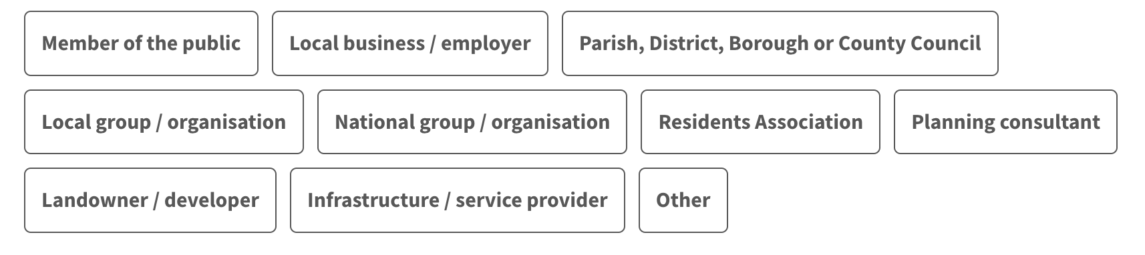
What is your connection to the area?
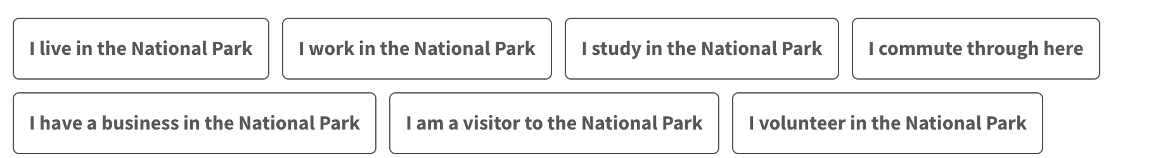

What is your age group?
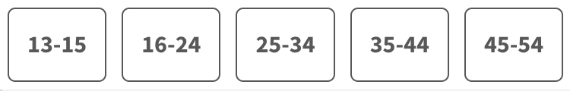


What is your employment status?
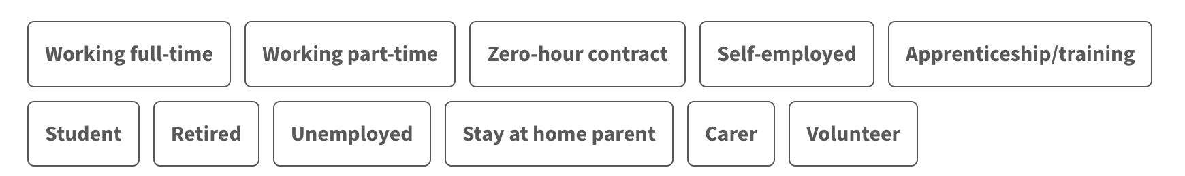

How do you usually travel in or around the area?
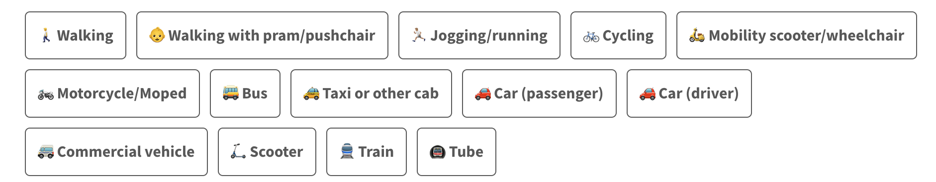

Please complete the following questions to help us put inclusivity and diversity at the heart of our local decision making. The following information about you is stored securely and will never be shared publicly.

How would you describe your gender?
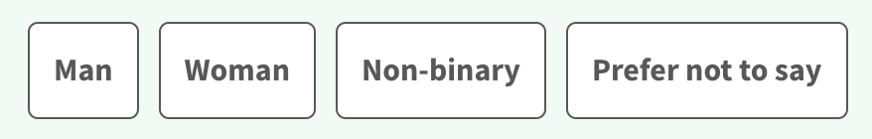
Do you consider yourself to be trans? (Trans is an umbrella term to describe people whose gender identity is not the same as the sex they were assigned at birth)

Which of the following best describes your sexual orientation?
Do you consider yourself as having a disability or long term health condition?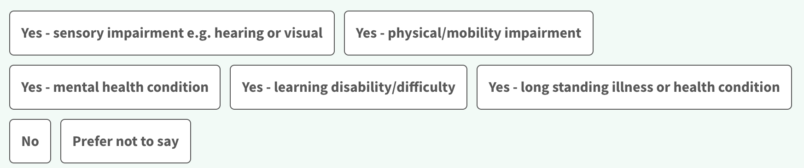

What is your ethnicity?

What is your religion/belief?
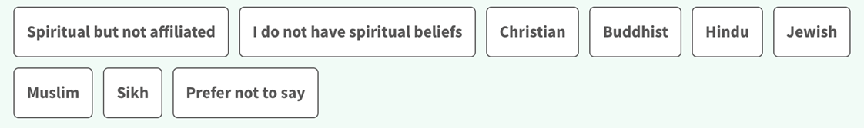

Part B

Introduction

This chapter explains why we are reviewing the Local Plan and what work has been undertaken so far. Take a look and let us know if you have any comments below.

Do you have any comments to make on the Introduction chapter?

……………………………………………………………………………………………………………………………..
……………………………………………………………………………………………………………………………..
……………………………………………………………………………………………………………………………..
……………………………………………………………………………………………………………………………..
……………………………………………………………………………………………………………………………..
……………………………………………………………………………………………………………………………..
……………………………………………………………………………………………………………………………..

Vision and Objectives

This chapter includes the Vision for the South Downs National Park and a number of strategic objectives for the Local Plan, based on the National Park purposes and duty. Take a look and let us know your comments below.

Do you have any comments to make on the Vision & Objectives chapter?

…………………………………………………………………………………………………….
…………………………………………………………………………………………………….
…………………………………………………………………………………………………….
…………………………………………………………………………………………………….
…………………………………………………………………………………………………….
…………………………………………………………………………………………………….
…………………………………………………………………………………………………….
…………………………………………………………………………………………………….
…………………………………………………………………………………………………….
…………………………………………………………………………………………………….
…………………………………………………………………………………………………….

Core Policies
This chapter sets out the Local Plan core policies, which provide the overarching framework for evaluating all development proposals in the National Park. These core policies will be used in the assessment of all planning applications and thereby avoids the need for duplicating criteria in other policies. The core policies apply equally across the National Park. Take a look and let us know your comments below.
Note on format of revised policies
As this is a Review of an existing award-winning Local Plan, policies have only been changed where there are strong reasons to do so. These reasons include:
• Changes to national policy and legislation which might impact the previous findings of the Planning Inspector that these policies were ‘sound’ (i.e passed all the legal and policy tests at the last Local Plan examination in 2018);
• Changes to the National Park Authority’s own priorities and objectives;
• New issues that have arisen since the last Local Plan was adopted (such as nutrient and water neutrality and the growth of viticulture); and
• Difficulties encountered in implementing the adopted policies which could be resolved by clarifying wording.
Where possible policy numbers have been kept the same as in the existing Local Plan to make it easier for people to see what we are proposing to change, however we have regrouped some of these policies so that those most closely related are easier to find. This means that the policy numbers are not always in order. We are not including supporting text at this time but will be adding some back in at the next stage where necessary to explain how to apply policies or to signpost other relevant policies.

What are your views on Policy SD1 Sustainable Development?


Please explain your answer here:
…………………………………………………………………………………………………….
…………………………………………………………………………………………………….
…………………………………………………………………………………………………….
…………………………………………………………………………………………………….
…………………………………………………………………………………………………….
…………………………………………………………………………………………………….
…………………………………………………………………………………………………….
…………………………………………………………………………………………………….
…………………………………………………………………………………………………….

What are your views on Policy SD2 Regenerative Design, Ecosystem Services and Environmental Net Gain?

Please explain your answer here:
…………………………………………………………………………………………………….
…………………………………………………………………………………………………….
…………………………………………………………………………………………………….
…………………………………………………………………………………………………….
…………………………………………………………………………………………………….
…………………………………………………………………………………………………….
…………………………………………………………………………………………………….
…………………………………………………………………………………………………….
………………………………………………………………………………………………………..

If an updated Environmental Benefits from Nature Metric is published, should we include a requirement for this to be submitted as part of applications for major development?

Please explain your answer here:
…………………………………………………………………………………………………….
…………………………………………………………………………………………………….
…………………………………………………………………………………………………….
…………………………………………………………………………………………………….
…………………………………………………………………………………………………….
…………………………………………………………………………………………………….
…………………………………………………………………………………………………….
…………………………………………………………………………………………………….
………………………………………………………………………………………………………..

What are your views on Policy SD3: Major Development?
Please explain your answer here:
…………………………………………………………………………………………………….
…………………………………………………………………………………………………….
…………………………………………………………………………………………………….
…………………………………………………………………………………………………….
…………………………………………………………………………………………………….
…………………………………………………………………………………………………….
…………………………………………………………………………………………………….
…………………………………………………………………………………………………….
………………………………………………………………………………………………………..

What are your views on Policy SD25: Development Strategy?

Please explain your answer here:
…………………………………………………………………………………………………….
…………………………………………………………………………………………………….
…………………………………………………………………………………………………….
…………………………………………………………………………………………………….
…………………………………………………………………………………………………….
…………………………………………………………………………………………………….
…………………………………………………………………………………………………….
…………………………………………………………………………………………………….
………………………………………………………………………………………………………..

Landscape and Heritage
This chapter includes policies covering landscape character, design, views, dark night skies and protection of the historic environment. Take a look and let us know your comments below.
What are your views on Policy SD4 Landscape Character?
Please explain your answer here:
…………………………………………………………………………………………………….
…………………………………………………………………………………………………….
…………………………………………………………………………………………………….
…………………………………………………………………………………………………….
…………………………………………………………………………………………………….
…………………………………………………………………………………………………….
…………………………………………………………………………………………………….
…………………………………………………………………………………………………….
………………………………………………………………………………………………………..
What are your views on Policy SD5 Design?
Please explain your answer here:
…………………………………………………………………………………………………….
…………………………………………………………………………………………………….
…………………………………………………………………………………………………….
…………………………………………………………………………………………………….
…………………………………………………………………………………………………….
…………………………………………………………………………………………………….
…………………………………………………………………………………………………….
…………………………………………………………………………………………………….
What are your views on Policy SD6 Safeguarding Views?
Please explain your answer here:
…………………………………………………………………………………………………….
…………………………………………………………………………………………………….
…………………………………………………………………………………………………….
…………………………………………………………………………………………………….
…………………………………………………………………………………………………….
…………………………………………………………………………………………………….
…………………………………………………………………………………………………….
…………………………………………………………………………………………………….
………………………………………………………………………………………………………..

What are your views on Policy SD7 Relative Tranquillity?
Please explain your answer here:
…………………………………………………………………………………………………….
…………………………………………………………………………………………………….
…………………………………………………………………………………………………….
…………………………………………………………………………………………………….
…………………………………………………………………………………………………….
…………………………………………………………………………………………………….
…………………………………………………………………………………………………….
…………………………………………………………………………………………………….
………………………………………………………………………………………………………..

What are your views on Policy SD8 Dark Night Skies?
Please explain your answer here:
…………………………………………………………………………………………………….
…………………………………………………………………………………………………….
…………………………………………………………………………………………………….
…………………………………………………………………………………………………….
…………………………………………………………………………………………………….
…………………………………………………………………………………………………….

What are your views on Policy SD12 Historic Environment?

Please explain your answer here:
…………………………………………………………………………………………………….
…………………………………………………………………………………………………….
…………………………………………………………………………………………………….
…………………………………………………………………………………………………….
…………………………………………………………………………………………………….
…………………………………………………………………………………………………….
…………………………………………………………………………………………………….
…………………………………………………………………………………………………….
………………………………………………………………………………………………………..

What are your views on Policy SD13 Listed Buildings?
Please explain your answer here:
…………………………………………………………………………………………………….
…………………………………………………………………………………………………….
…………………………………………………………………………………………………….
…………………………………………………………………………………………………….
…………………………………………………………………………………………………….
…………………………………………………………………………………………………….
…………………………………………………………………………………………………….
…………………………………………………………………………………………………….
………………………………………………………………………………………………………..

What are your views on Policy SD15 Conservation Areas?
Please explain your answer here:
…………………………………………………………………………………………………….
…………………………………………………………………………………………………….
…………………………………………………………………………………………………….
…………………………………………………………………………………………………….
…………………………………………………………………………………………………….
…………………………………………………………………………………………………….
…………………………………………………………………………………………………….
…………………………………………………………………………………………………….
………………………………………………………………………………………………………..

What are your views on Policy SD16 Archaeology?
Please explain your answer here:
…………………………………………………………………………………………………….
…………………………………………………………………………………………………….
…………………………………………………………………………………………………….
…………………………………………………………………………………………………….
…………………………………………………………………………………………………….
…………………………………………………………………………………………………….
…………………………………………………………………………………………………….
…………………………………………………………………………………………………….
………………………………………………………………………………………………………..

Nature Recovery
This chapter includes policies to support nature recovery and wildlife in the National Park. Take a look and let us know your comments below.
What are your views on Policy SD9 Nature Recovery?

Please explain your answer here:
…………………………………………………………………………………………………….
…………………………………………………………………………………………………….
…………………………………………………………………………………………………….
…………………………………………………………………………………………………….
…………………………………………………………………………………………………….
…………………………………………………………………………………………………….
…………………………………………………………………………………………………….
…………………………………………………………………………………………………….
Should the Local Plan have policy requirements for integrated wildlife boxes/bricks?
If yes, what matters should the policy address?
…………………………………………………………………………………………………….
…………………………………………………………………………………………………….
…………………………………………………………………………………………………….
…………………………………………………………………………………………………….
…………………………………………………………………………………………………….
Do you agree that a higher percentage of Biodiversity Net Gain (BNG), beyond the statutory minimum of 10% should be considered?

Please explain your answer here:
…………………………………………………………………………………………………….
…………………………………………………………………………………………………….
…………………………………………………………………………………………………….
…………………………………………………………………………………………………….
…………………………………………………………………………………………………….
…………………………………………………………………………………………………….
…………………………………………………………………………………………………….
…………………………………………………………………………………………………….
………………………………………………………………………………………………………..

Do you agree with the scenarios proposed to be tested?
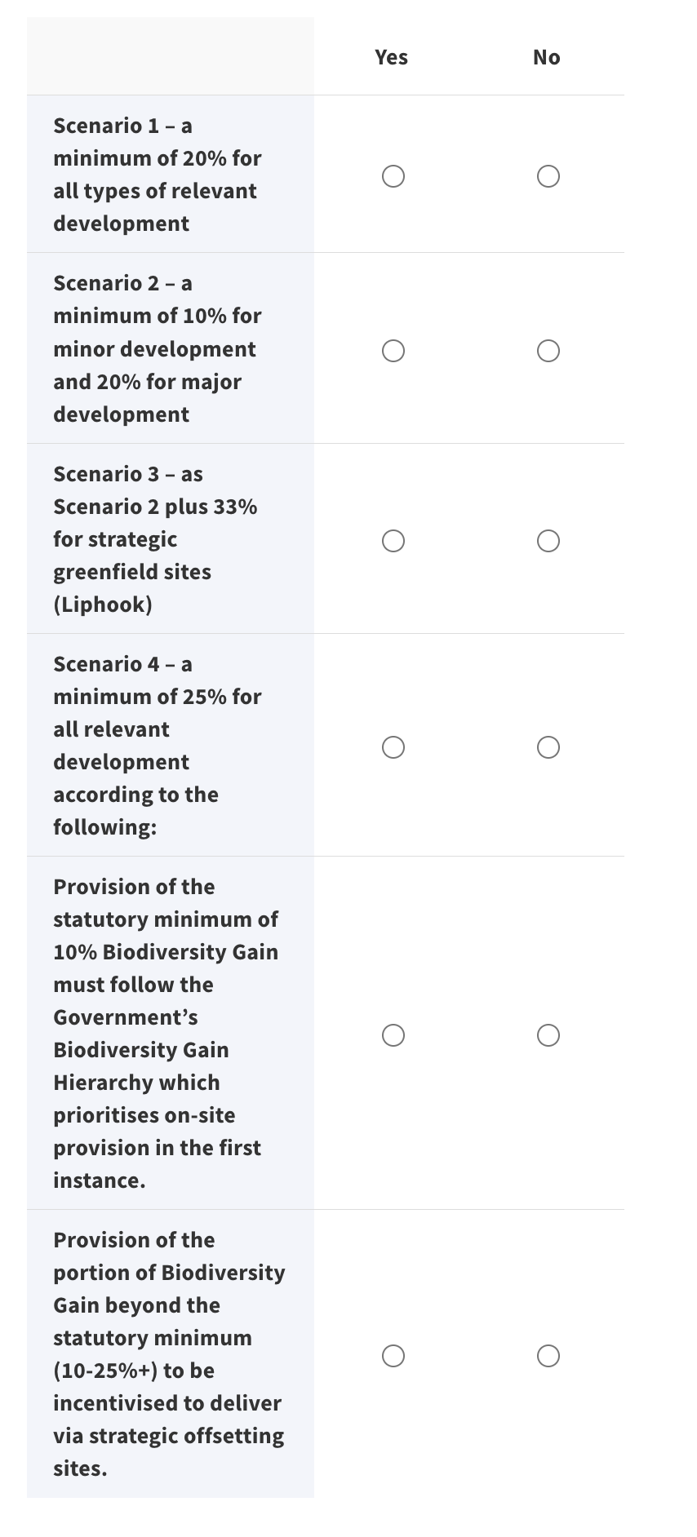

If you said no to any of the above, what other scenarios should be considered and why?
…………………………………………………………………………………………………….
…………………………………………………………………………………………………….
…………………………………………………………………………………………………….
…………………………………………………………………………………………………….
…………………………………………………………………………………………………….
…………………………………………………………………………………………………….
…………………………………………………………………………………………………….
What are your views on Policy NEW2 Designated Sites Hierarchy?
Please explain your answer here:
…………………………………………………………………………………………………….
…………………………………………………………………………………………………….
…………………………………………………………………………………………………….
…………………………………………………………………………………………………….
…………………………………………………………………………………………………….
…………………………………………………………………………………………………….
…………………………………………………………………………………………………….
…………………………………………………………………………………………………….
………………………………………………………………………………………………………..
What are your views on Policy SD10 The Sussex Bat Special Areas of Conservation (SAC): The Mens SAC, Ebernoe Commons SAC and Singleton & Cocking Tunnels SAC?

Please explain your answer here:
…………………………………………………………………………………………………….
…………………………………………………………………………………………………….
…………………………………………………………………………………………………….
…………………………………………………………………………………………………….
…………………………………………………………………………………………………….
…………………………………………………………………………………………………….
…………………………………………………………………………………………………….
…………………………………………………………………………………………………….
………………………………………………………………………………………………………..
What are your views on Policy NEW3 Arun Valley Special Protection Area (SPA): Functionally Linked Habitat?
Please explain your answer here:
…………………………………………………………………………………………………….
…………………………………………………………………………………………………….
…………………………………………………………………………………………………….
…………………………………………………………………………………………………….
…………………………………………………………………………………………………….
…………………………………………………………………………………………………….
…………………………………………………………………………………………………….
…………………………………………………………………………………………………….
………………………………………………………………………………………………………..
What are your views on Policy NEW4 Arun Valley SPA/SAC/Ramsar – Water Neutrality?

Please explain your answer here:
…………………………………………………………………………………………………….
…………………………………………………………………………………………………….
…………………………………………………………………………………………………….
…………………………………………………………………………………………………….
…………………………………………………………………………………………………….
…………………………………………………………………………………………………….
…………………………………………………………………………………………………….
…………………………………………………………………………………………………….
………………………………………………………………………………………………………..
What are your views on Policy NEW5 Wealden Heaths Phase II SPA – Urbanisation and Recreational Pressure?
Please explain your answer here:
…………………………………………………………………………………………………….
…………………………………………………………………………………………………….
…………………………………………………………………………………………………….
…………………………………………………………………………………………………….
…………………………………………………………………………………………………….
…………………………………………………………………………………………………….
…………………………………………………………………………………………………….
…………………………………………………………………………………………………….
………………………………………………………………………………………………………..
What are your views on Policy NEW6 Solent Coast SPAs – Recreational Pressure?

Please explain your answer here:
…………………………………………………………………………………………………….
…………………………………………………………………………………………………….
…………………………………………………………………………………………………….
…………………………………………………………………………………………………….
…………………………………………………………………………………………………….
…………………………………………………………………………………………………….
…………………………………………………………………………………………………….
…………………………………………………………………………………………………….
………………………………………………………………………………………………………..
What are your views on Policy NEW7 Solent Coast SPAs and SACs and the River Itchen SAC – Nutrient Neutrality?
Please explain your answer here:
…………………………………………………………………………………………………….
…………………………………………………………………………………………………….
…………………………………………………………………………………………………….
…………………………………………………………………………………………………….
…………………………………………………………………………………………………….
…………………………………………………………………………………………………….
…………………………………………………………………………………………………….
…………………………………………………………………………………………………….
………………………………………………………………………………………………………..
What are your views on Policy SD11 Trees, Woodlands, and Hedgerows?

Please explain your answer here:
…………………………………………………………………………………………………….
…………………………………………………………………………………………………….
…………………………………………………………………………………………………….
…………………………………………………………………………………………………….
…………………………………………………………………………………………………….
…………………………………………………………………………………………………….
…………………………………………………………………………………………………….

Climate Action
This chapter includes policies which set ambitious requirements for sustainable construction and support for appropriate renewable energy in the National Park, including community-led proposals. Take a look and let us know your comments below.
What are your views on Policy SD48 Climate Change and Sustainable Use of Resources?
Please explain your answer here:
…………………………………………………………………………………………………….
…………………………………………………………………………………………………….
…………………………………………………………………………………………………….
…………………………………………………………………………………………………….
…………………………………………………………………………………………………….
…………………………………………………………………………………………………….
…………………………………………………………………………………………………….
…………………………………………………………………………………………………….
………………………………………………………………………………………………………..

Are the standards in this policy appropriate, legible for applicants and decision-makers and likely to be relevant until 2032 (when this Local Plan is likely to be reviewed)?
Please explain your answer here:
…………………………………………………………………………………………………….
…………………………………………………………………………………………………….
…………………………………………………………………………………………………….
…………………………………………………………………………………………………….
…………………………………………………………………………………………………….
…………………………………………………………………………………………………….
…………………………………………………………………………………………………….
…………………………………………………………………………………………………….
………………………………………………………………………………………………………..
Should the policy cross-refer to the UK Net Zero Carbon Buildings Standard?
Please explain your answer here:
…………………………………………………………………………………………………….
…………………………………………………………………………………………………….
…………………………………………………………………………………………………….
…………………………………………………………………………………………………….
…………………………………………………………………………………………………….
…………………………………………………………………………………………………….
…………………………………………………………………………………………………….
…………………………………………………………………………………………………….
………………………………………………………………………………………………………..

Is criteria 2 on embodied carbon appropriate?
Please explain your answer here:
…………………………………………………………………………………………………….
…………………………………………………………………………………………………….
…………………………………………………………………………………………………….
…………………………………………………………………………………………………….
…………………………………………………………………………………………………….
…………………………………………………………………………………………………….
…………………………………………………………………………………………………….
…………………………………………………………………………………………………….
………………………………………………………………………………………………………..

Should small-scale development (<10 units or <1,000sqm) be required to prepare an embodied carbon assessment, without setting a specific target for upfront embodied carbon emissions?

Please explain your answer here:
…………………………………………………………………………………………………….
…………………………………………………………………………………………………….
…………………………………………………………………………………………………….
…………………………………………………………………………………………………….
…………………………………………………………………………………………………….
…………………………………………………………………………………………………….
…………………………………………………………………………………………………….
…………………………………………………………………………………………………….
………………………………………………………………………………………………………..
What are your views on Policy SD14 Climate Change Mitigation and Adaptation of Historic Buildings?
Please explain your answer here:
…………………………………………………………………………………………………….
…………………………………………………………………………………………………….
…………………………………………………………………………………………………….
…………………………………………………………………………………………………….
…………………………………………………………………………………………………….
…………………………………………………………………………………………………….
…………………………………………………………………………………………………….
…………………………………………………………………………………………………….
………………………………………………………………………………………………………..
What are your views on Policy SD51 Renewable Energy
Please explain your answer here:
…………………………………………………………………………………………………….
…………………………………………………………………………………………………….
…………………………………………………………………………………………………….
…………………………………………………………………………………………………….
…………………………………………………………………………………………………….
…………………………………………………………………………………………………….
…………………………………………………………………………………………………….
…………………………………………………………………………………………………….
………………………………………………………………………………………………………..

Are there other appropriate potential sites for community-led renewables proposals?
Please use the Call for Sites form to provide more details: https://shorturl.at/fx4Up

Water and Pollution
This chapter includes policies to protect the water environment and address flood risk. There are also policies to deal with pollution and contaminated land. Take a look and let us know your comments below.
What are your views on Policy SD17 Protection of the Water Environment?
Please explain your answer here:
…………………………………………………………………………………………………….
…………………………………………………………………………………………………….
…………………………………………………………………………………………………….
…………………………………………………………………………………………………….
…………………………………………………………………………………………………….
…………………………………………………………………………………………………….
…………………………………………………………………………………………………….
…………………………………………………………………………………………………….
………………………………………………………………………………………………………..
Are there any catchment specific matters not covered by the policy below?

If yes, please describe:
…………………………………………………………………………………………………….
…………………………………………………………………………………………………….
…………………………………………………………………………………………………….
…………………………………………………………………………………………………….
…………………………………………………………………………………………………….
…………………………………………………………………………………………………….
…………………………………………………………………………………………………….
…………………………………………………………………………………………………….
………………………………………………………………………………………………………..
Are there matters relating to chalk streams not covered by the policy below?
If yes, please describe:
…………………………………………………………………………………………………….
…………………………………………………………………………………………………….
…………………………………………………………………………………………………….
…………………………………………………………………………………………………….
…………………………………………………………………………………………………….
…………………………………………………………………………………………………….
…………………………………………………………………………………………………….
…………………………………………………………………………………………………….
………………………………………………………………………………………………………..

What are your views on Policy SD49 Flood Risk Management?

Please explain your answer here:
…………………………………………………………………………………………………….
…………………………………………………………………………………………………….
…………………………………………………………………………………………………….
…………………………………………………………………………………………………….
…………………………………………………………………………………………………….
…………………………………………………………………………………………………….
…………………………………………………………………………………………………….
…………………………………………………………………………………………………….

What are your views on Policy SD50 Sustainable Drainage?
Please explain your answer here:
…………………………………………………………………………………………………….
…………………………………………………………………………………………………….
…………………………………………………………………………………………………….
…………………………………………………………………………………………………….
…………………………………………………………………………………………………….
…………………………………………………………………………………………………….
…………………………………………………………………………………………………….
…………………………………………………………………………………………………….
What are your views on Policy SD18 Open Coast?

Please explain your answer here:
…………………………………………………………………………………………………….
…………………………………………………………………………………………………….
…………………………………………………………………………………………………….
…………………………………………………………………………………………………….
…………………………………………………………………………………………………….
…………………………………………………………………………………………………….
…………………………………………………………………………………………………….
…………………………………………………………………………………………………….
………………………………………………………………………………………………………..
What are your views on Policy SD54 Pollution and Air Quality?
Please explain your answer here:
…………………………………………………………………………………………………….
…………………………………………………………………………………………………….
…………………………………………………………………………………………………….
…………………………………………………………………………………………………….
…………………………………………………………………………………………………….
…………………………………………………………………………………………………….
…………………………………………………………………………………………………….
…………………………………………………………………………………………………….
………………………………………………………………………………………………………..
What are your views on Policy SD55 Contaminated Land?

Please explain your answer here:
…………………………………………………………………………………………………….
…………………………………………………………………………………………………….
…………………………………………………………………………………………………….
…………………………………………………………………………………………………….
…………………………………………………………………………………………………….
…………………………………………………………………………………………………….
…………………………………………………………………………………………………….
…………………………………………………………………………………………………….
………………………………………………………………………………………………………..

Homes
Policies in this chapter cover the supply and type of homes, including affordable homes. Policies on replacement homes and extensions are also included, as well as policy on accommodation for Gypsies, Travellers and Travelling Showpeople. Take a look and let us know your comments below.
What are your views on Policy SD26 Supply of Homes?
Please explain your answer here:
…………………………………………………………………………………………………….
…………………………………………………………………………………………………….
…………………………………………………………………………………………………….
…………………………………………………………………………………………………….
…………………………………………………………………………………………………….
…………………………………………………………………………………………………….
…………………………………………………………………………………………………….
…………………………………………………………………………………………………….
………………………………………………………………………………………………………..

Planned level of growth:
For context, the existing Local and Neighbourhood Plan allocations and planning permissions, together with proposed new allocations, amount to approximately 4,500 new homes 2024-2042 (or 250 per year excluding windfall). The existing Local Plan plans for 250 homes per year including a windfall allowance. Note that these supply figures are likely to change as we do more work on the proposed allocations and further sites are put forward.
What level of growth should the National Park be planning for?
…………………………………………………………………………………………………….
…………………………………………………………………………………………………….
…………………………………………………………………………………………………….
…………………………………………………………………………………………………….
…………………………………………………………………………………………………….
…………………………………………………………………………………………………….
…………………………………………………………………………………………………….
…………………………………………………………………………………………………….
………………………………………………………………………………………………………..
What are your views on Policy SD27 Mix of Homes?
Please explain your answer here:
…………………………………………………………………………………………………….
…………………………………………………………………………………………………….
…………………………………………………………………………………………………….
…………………………………………………………………………………………………….
…………………………………………………………………………………………………….
…………………………………………………………………………………………………….
…………………………………………………………………………………………………….
…………………………………………………………………………………………………….
………………………………………………………………………………………………………..

What types of homes do communities in the National Park need?
…………………………………………………………………………………………………….
…………………………………………………………………………………………………….
…………………………………………………………………………………………………….
…………………………………………………………………………………………………….
…………………………………………………………………………………………………….
…………………………………………………………………………………………………….
…………………………………………………………………………………………………….
…………………………………………………………………………………………………….
What are your views on Policy NEW1: Accessible Homes?
Please explain your answer here:
…………………………………………………………………………………………………….
…………………………………………………………………………………………………….
…………………………………………………………………………………………………….
…………………………………………………………………………………………………….
…………………………………………………………………………………………………….
…………………………………………………………………………………………………….
…………………………………………………………………………………………………….
The HEDNA suggests 10-15% of dwellings should be wheelchair accessible homes in the affordable sector. Should the policy require:
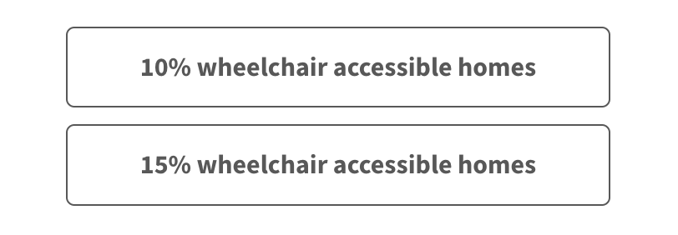

Please explain your answer here:
…………………………………………………………………………………………………….
…………………………………………………………………………………………………….
…………………………………………………………………………………………………….
…………………………………………………………………………………………………….
…………………………………………………………………………………………………….
…………………………………………………………………………………………………….
…………………………………………………………………………………………………….
…………………………………………………………………………………………………….
………………………………………………………………………………………………………..
What are your views on Policy SD28 Affordable Homes
Please explain your answer here:
…………………………………………………………………………………………………….
…………………………………………………………………………………………………….
…………………………………………………………………………………………………….
…………………………………………………………………………………………………….
…………………………………………………………………………………………………….
…………………………………………………………………………………………………….
…………………………………………………………………………………………………….
…………………………………………………………………………………………………….
………………………………………………………………………………………………………..
Is reference to First Homes in criteria 1 appropriate or desirable?

Please explain your answer here:
…………………………………………………………………………………………………….
…………………………………………………………………………………………………….
…………………………………………………………………………………………………….
…………………………………………………………………………………………………….
…………………………………………………………………………………………………….
…………………………………………………………………………………………………….
…………………………………………………………………………………………………….
…………………………………………………………………………………………………….
………………………………………………………………………………………………………..
Are the requirements of criteria 3 still appropriate and practicable for the ongoing management of affordable homes by a Registered or other recognised affordable housing provider?
Please explain your answer here:
…………………………………………………………………………………………………….
…………………………………………………………………………………………………….
…………………………………………………………………………………………………….
…………………………………………………………………………………………………….
…………………………………………………………………………………………………….
…………………………………………………………………………………………………….
…………………………………………………………………………………………………….
…………………………………………………………………………………………………….
………………………………………………………………………………………………………..

What are your views on Policy SD29 Rural Exception Sites?
Please explain your answer here:
…………………………………………………………………………………………………….
…………………………………………………………………………………………………….
…………………………………………………………………………………………………….
…………………………………………………………………………………………………….
…………………………………………………………………………………………………….
…………………………………………………………………………………………………….
…………………………………………………………………………………………………….
…………………………………………………………………………………………………….
………………………………………………………………………………………………………..
Is 20% the right level of cross-subsidy to assist in rural exception site delivery whilst limiting landowner hope value?
Please explain your answer here:
…………………………………………………………………………………………………….
…………………………………………………………………………………………………….
…………………………………………………………………………………………………….
…………………………………………………………………………………………………….
…………………………………………………………………………………………………….
…………………………………………………………………………………………………….
…………………………………………………………………………………………………….
…………………………………………………………………………………………………….
………………………………………………………………………………………………………..

Should a degree of flexibility be given to Rural Estates that develop affordable homes as part of a Whole Estate Plans, to determine occupancy conditions and tenure?
Please explain your answer here:
…………………………………………………………………………………………………….
…………………………………………………………………………………………………….
…………………………………………………………………………………………………….
…………………………………………………………………………………………………….
…………………………………………………………………………………………………….
…………………………………………………………………………………………………….
…………………………………………………………………………………………………….
…………………………………………………………………………………………………….
………………………………………………………………………………………………………..

What are your views on Policy SD30 Replace & Subdivision of Dwellings?
Please explain your answer here:
…………………………………………………………………………………………………….
…………………………………………………………………………………………………….
…………………………………………………………………………………………………….
…………………………………………………………………………………………………….
…………………………………………………………………………………………………….
…………………………………………………………………………………………………….
…………………………………………………………………………………………………….
…………………………………………………………………………………………………….
………………………………………………………………………………………………………..

What are your views on Policy SD31 Householder Development?
Please explain your answer here:
…………………………………………………………………………………………………….
…………………………………………………………………………………………………….
…………………………………………………………………………………………………….
…………………………………………………………………………………………………….
…………………………………………………………………………………………………….
…………………………………………………………………………………………………….
…………………………………………………………………………………………………….
…………………………………………………………………………………………………….
………………………………………………………………………………………………………..

Do these policies, in combination with Policies SD4 and SD5, adequately capture amenity and design considerations in relation to replacement dwellings, subdivisions, and householder developments?
Please explain your answer here:
…………………………………………………………………………………………………….
…………………………………………………………………………………………………….
…………………………………………………………………………………………………….
…………………………………………………………………………………………………….
…………………………………………………………………………………………………….
…………………………………………………………………………………………………….

Should the restriction on the size of extensions / replacement dwellings be applied to either:


Please explain your answer here:
…………………………………………………………………………………………………….
…………………………………………………………………………………………………….
…………………………………………………………………………………………………….
…………………………………………………………………………………………………….
…………………………………………………………………………………………………….
…………………………………………………………………………………………………….
…………………………………………………………………………………………………….

Is 30% the right percentage limit?

If not, what would be a reasonable figure?
…………………………………………………………………………………………………….
…………………………………………………………………………………………………….
…………………………………………………………………………………………………….
…………………………………………………………………………………………………….
…………………………………………………………………………………………………….
…………………………………………………………………………………………………….
…………………………………………………………………………………………………….
…………………………………………………………………………………………………….
………………………………………………………………………………………………………..

Should the percentage limitation be applied everywhere in the National Park or should a different approach be taken within Lewes and Petersfield?
Please explain your answer here:
…………………………………………………………………………………………………….
…………………………………………………………………………………………………….
…………………………………………………………………………………………………….
…………………………………………………………………………………………………….
…………………………………………………………………………………………………….
…………………………………………………………………………………………………….
…………………………………………………………………………………………………….
…………………………………………………………………………………………………….
………………………………………………………………………………………………………..

What are your views on Policy SD32 Rural Workers’ Dwellings?
Please explain your answer here:
…………………………………………………………………………………………………….
…………………………………………………………………………………………………….
…………………………………………………………………………………………………….
…………………………………………………………………………………………………….
…………………………………………………………………………………………………….
…………………………………………………………………………………………………….
…………………………………………………………………………………………………….
…………………………………………………………………………………………………….

What are your views on Policy SD33 Gypsies and Travellers?
Please explain your answer here:
…………………………………………………………………………………………………….
…………………………………………………………………………………………………….
…………………………………………………………………………………………………….
…………………………………………………………………………………………………….
…………………………………………………………………………………………………….
…………………………………………………………………………………………………….
…………………………………………………………………………………………………….
…………………………………………………………………………………………………….
………………………………………………………………………………………………………..

Are there any other sites that should be considered for Gypsies or Travellers accommodation? If yes, please complete the Call for Sites nomination form: www.southdowns.gov.uk/planning-policy/the-south-downs-local-plan-review/evidence-base/homes-and-econmy/land-availability-assessment/submit-a-site/

Economy
This chapter includes policies to support the local economy including the supply of employment land and criteria for different sectors such as tourism, viticulture, agriculture & forestry. Take a look and let us know your comments below.
What are your views on Policy SD34 Sustaining the Local Economy?
Please explain your answer here:
…………………………………………………………………………………………………….
…………………………………………………………………………………………………….
…………………………………………………………………………………………………….
…………………………………………………………………………………………………….
…………………………………………………………………………………………………….
…………………………………………………………………………………………………….
…………………………………………………………………………………………………….
…………………………………………………………………………………………………….
………………………………………………………………………………………………………..

What are your views on Policy SD35 Employment Land?
Please explain your answer here:
…………………………………………………………………………………………………….
…………………………………………………………………………………………………….
…………………………………………………………………………………………………….
…………………………………………………………………………………………………….
…………………………………………………………………………………………………….
…………………………………………………………………………………………………….
…………………………………………………………………………………………………….
…………………………………………………………………………………………………….
What are your views on Policy SD39 Agriculture and Forestry?
Please explain your answer here:
…………………………………………………………………………………………………….
…………………………………………………………………………………………………….
…………………………………………………………………………………………………….
…………………………………………………………………………………………………….
…………………………………………………………………………………………………….
…………………………………………………………………………………………………….
…………………………………………………………………………………………………….
…………………………………………………………………………………………………….
………………………………………………………………………………………………………..

What are your views on Policy SD40 Farm and Forestry Diversification?
Please explain your answer here:
…………………………………………………………………………………………………….
…………………………………………………………………………………………………….
…………………………………………………………………………………………………….
…………………………………………………………………………………………………….
…………………………………………………………………………………………………….
…………………………………………………………………………………………………….
…………………………………………………………………………………………………….
…………………………………………………………………………………………………….
………………………………………………………………………………………………………..

Does this policy facilitate farm diversification sufficiently to address changes to the economics of agriculture?
Please explain your answer here:
…………………………………………………………………………………………………….
…………………………………………………………………………………………………….
…………………………………………………………………………………………………….
…………………………………………………………………………………………………….
…………………………………………………………………………………………………….
…………………………………………………………………………………………………….
…………………………………………………………………………………………………….
…………………………………………………………………………………………………….
………………………………………………………………………………………………………..

Does this policy (in combination with others including SD5) adequately protect communities from the impacts of farm diversification schemes, including from incremental changes?
Please explain your answer here:
…………………………………………………………………………………………………….
…………………………………………………………………………………………………….
…………………………………………………………………………………………………….
…………………………………………………………………………………………………….
…………………………………………………………………………………………………….
…………………………………………………………………………………………………….
…………………………………………………………………………………………………….
…………………………………………………………………………………………………….
………………………………………………………………………………………………………..

What are your views on Policy SD41 Conversion of Redundant Agriculture or Forestry Buildings?
Please explain your answer here:
…………………………………………………………………………………………………….
…………………………………………………………………………………………………….
…………………………………………………………………………………………………….
…………………………………………………………………………………………………….
…………………………………………………………………………………………………….
…………………………………………………………………………………………………….
…………………………………………………………………………………………………….
…………………………………………………………………………………………………….
………………………………………………………………………………………………………..

What are your views on Policy NEW 8 Viticulture, Winemaking and Wine Tourism?
Please explain your answer here:
…………………………………………………………………………………………………….
…………………………………………………………………………………………………….
…………………………………………………………………………………………………….
…………………………………………………………………………………………………….
…………………………………………………………………………………………………….
…………………………………………………………………………………………………….
…………………………………………………………………………………………………….
…………………………………………………………………………………………………….
………………………………………………………………………………………………………..

What aspects of viticulture, winemaking, and wine tourism should this new policy address, consider and/or cover?
…………………………………………………………………………………………………….
…………………………………………………………………………………………………….
…………………………………………………………………………………………………….
…………………………………………………………………………………………………….
…………………………………………………………………………………………………….
…………………………………………………………………………………………………….
…………………………………………………………………………………………………….
…………………………………………………………………………………………………….

What are your views on Policy SD36 Town and Village Centres?
Please explain your answer here:
…………………………………………………………………………………………………….
…………………………………………………………………………………………………….
…………………………………………………………………………………………………….
…………………………………………………………………………………………………….
…………………………………………………………………………………………………….
…………………………………………………………………………………………………….
…………………………………………………………………………………………………….
…………………………………………………………………………………………………….
………………………………………………………………………………………………………..

What are your views on Policy SD37 Development in Town and Village Centres?

Please explain your answer here:
…………………………………………………………………………………………………….
…………………………………………………………………………………………………….
…………………………………………………………………………………………………….
…………………………………………………………………………………………………….
…………………………………………………………………………………………………….
…………………………………………………………………………………………………….
…………………………………………………………………………………………………….
…………………………………………………………………………………………………….
………………………………………………………………………………………………………..

What are your views on Policy SD38 Shops Centres?
Please explain your answer here:
…………………………………………………………………………………………………….
…………………………………………………………………………………………………….
…………………………………………………………………………………………………….
…………………………………………………………………………………………………….
…………………………………………………………………………………………………….
…………………………………………………………………………………………………….
…………………………………………………………………………………………………….
…………………………………………………………………………………………………….
………………………………………………………………………………………………………..

What are your views on Policy SD52 Shop Fronts?

Please explain your answer here:
…………………………………………………………………………………………………….
…………………………………………………………………………………………………….
…………………………………………………………………………………………………….
…………………………………………………………………………………………………….
…………………………………………………………………………………………………….
…………………………………………………………………………………………………….
…………………………………………………………………………………………………….
…………………………………………………………………………………………………….
………………………………………………………………………………………………………..

What are your views on Policy SD53 Adverts?
Please explain your answer here:
…………………………………………………………………………………………………….
…………………………………………………………………………………………………….
…………………………………………………………………………………………………….
…………………………………………………………………………………………………….
…………………………………………………………………………………………………….
…………………………………………………………………………………………………….
…………………………………………………………………………………………………….
…………………………………………………………………………………………………….
………………………………………………………………………………………………………..

What are your views on Policy SD23 Regenerative Tourism?

Please explain your answer here:
…………………………………………………………………………………………………….
…………………………………………………………………………………………………….
…………………………………………………………………………………………………….
…………………………………………………………………………………………………….
…………………………………………………………………………………………………….
…………………………………………………………………………………………………….
…………………………………………………………………………………………………….
…………………………………………………………………………………………………….
………………………………………………………………………………………………………..

Does the policy strike the right balance between furthering the purposes of the National Park and supporting the local economy?
Please explain your answer here:
…………………………………………………………………………………………………….
…………………………………………………………………………………………………….
…………………………………………………………………………………………………….
…………………………………………………………………………………………………….
…………………………………………………………………………………………………….
…………………………………………………………………………………………………….
…………………………………………………………………………………………………….
………………………………………………………………………………………………………..

What are your views on Policy SD24 Equestrian Development?

Please explain your answer here:
…………………………………………………………………………………………………….
…………………………………………………………………………………………………….
…………………………………………………………………………………………………….
…………………………………………………………………………………………………….
…………………………………………………………………………………………………….
…………………………………………………………………………………………………….
…………………………………………………………………………………………………….
…………………………………………………………………………………………………….
Does the policy sufficiently capture all considerations for equine development?
Please explain your answer here:
…………………………………………………………………………………………………….
…………………………………………………………………………………………………….
…………………………………………………………………………………………………….
…………………………………………………………………………………………………….
…………………………………………………………………………………………………….
…………………………………………………………………………………………………….
…………………………………………………………………………………………………….
…………………………………………………………………………………………………….
………………………………………………………………………………………………………..

Communities, Open Spaces and Active Travel
This chapter contains policies relating to the facilities, open spaces and public rights of way important to communities across the National Park. Take a look and let us know your comments below.

What are your views on Policy SD43 New and Existing Community Facilities?
Please explain your answer here:
…………………………………………………………………………………………………….
…………………………………………………………………………………………………….
…………………………………………………………………………………………………….
…………………………………………………………………………………………………….
…………………………………………………………………………………………………….
…………………………………………………………………………………………………….
…………………………………………………………………………………………………….
…………………………………………………………………………………………………….

Is the policy sufficient and proportionate for supporting the delivery of new community facilities and protecting against loss of existing community facilities?
Please explain your answer here:
…………………………………………………………………………………………………….
…………………………………………………………………………………………………….
…………………………………………………………………………………………………….
…………………………………………………………………………………………………….
…………………………………………………………………………………………………….
…………………………………………………………………………………………………….
…………………………………………………………………………………………………….

What are your views on Policy SD45 Green Infrastructure?
Please explain your answer here:
…………………………………………………………………………………………………….
…………………………………………………………………………………………………….
…………………………………………………………………………………………………….
…………………………………………………………………………………………………….
…………………………………………………………………………………………………….
…………………………………………………………………………………………………….
…………………………………………………………………………………………………….
…………………………………………………………………………………………………….

Should the policy be expanded to explicitly state blue infrastructure and better connect with design and water policies in relation to SuDS and water management?
Please explain your answer here:
…………………………………………………………………………………………………….
…………………………………………………………………………………………………….
…………………………………………………………………………………………………….
…………………………………………………………………………………………………….
…………………………………………………………………………………………………….
…………………………………………………………………………………………………….
…………………………………………………………………………………………………….
…………………………………………………………………………………………………….
………………………………………………………………………………………………………..

What are your views on Policy SD46 Provision and Protection of Open Space, Sport and Recreational Facilities and Burial Grounds / Cemeteries?

Please explain your answer here:
…………………………………………………………………………………………………….
…………………………………………………………………………………………………….
…………………………………………………………………………………………………….
…………………………………………………………………………………………………….
…………………………………………………………………………………………………….
…………………………………………………………………………………………………….

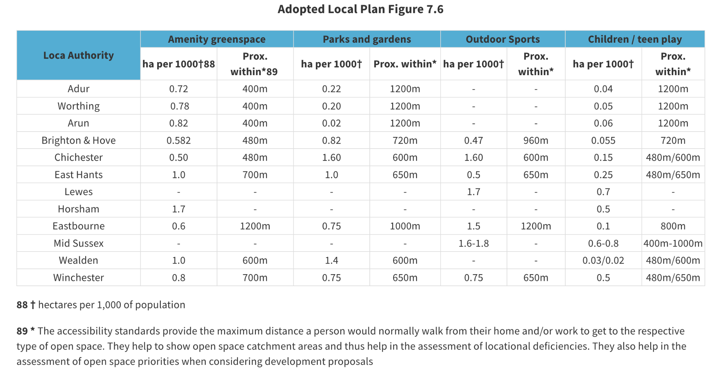

Do you think we should update Figure 7.6 (p153) of the Adopted Local Plan using either:
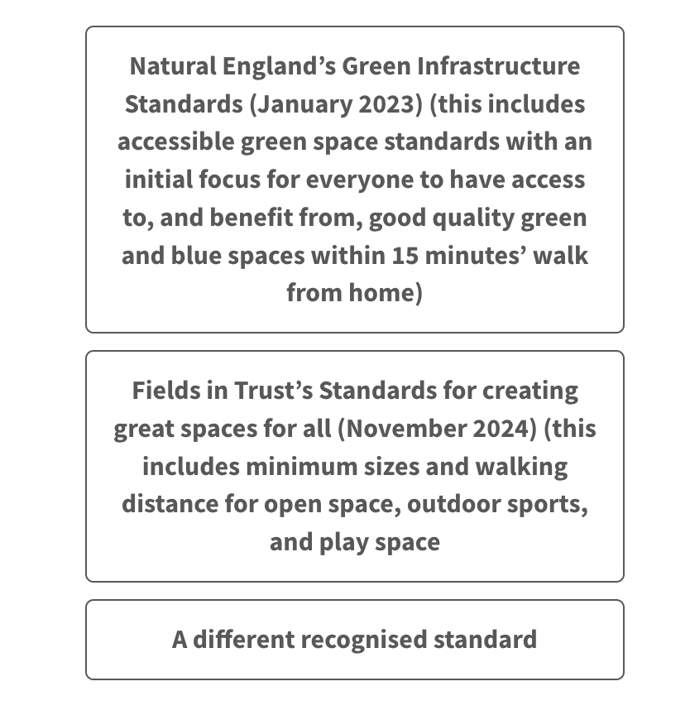
If you selected 'A different recognised standard' what should it be?
…………………………………………………………………………………………………….
…………………………………………………………………………………………………….
…………………………………………………………………………………………………….
…………………………………………………………………………………………………….
…………………………………………………………………………………………………….
…………………………………………………………………………………………………….

Should we require developments for 10 homes or more to provide open space, or set a higher threshold?


Please explain your answer here:
…………………………………………………………………………………………………….
…………………………………………………………………………………………………….
…………………………………………………………………………………………………….
…………………………………………………………………………………………………….
…………………………………………………………………………………………………….
…………………………………………………………………………………………………….
…………………………………………………………………………………………………….
…………………………………………………………………………………………………….
………………………………………………………………………………………………………..

Should we include requirements / considerations for allotments, community orchards, and community farms?

If so, what should these be and why? Please explain your answer here:
…………………………………………………………………………………………………….
…………………………………………………………………………………………………….
…………………………………………………………………………………………………….
…………………………………………………………………………………………………….
…………………………………………………………………………………………………….
…………………………………………………………………………………………………….
…………………………………………………………………………………………………….
…………………………………………………………………………………………………….

What are your views on Policy SD20 Walking, Cycling and Equestrian Routes?
Please explain your answer here:
…………………………………………………………………………………………………….
…………………………………………………………………………………………………….
…………………………………………………………………………………………………….
…………………………………………………………………………………………………….
…………………………………………………………………………………………………….
…………………………………………………………………………………………………….
…………………………………………………………………………………………………….
…………………………………………………………………………………………………….

Policy SD20: Should we include a criterion about wayfinding infrastructure?
Please explain your answer here:
…………………………………………………………………………………………………….
…………………………………………………………………………………………………….
…………………………………………………………………………………………………….
…………………………………………………………………………………………………….
…………………………………………………………………………………………………….
…………………………………………………………………………………………………….
…………………………………………………………………………………………………….

Should we include a criterion or supporting text about path materials and widths?
Please explain your answer here:
…………………………………………………………………………………………………….
…………………………………………………………………………………………………….
…………………………………………………………………………………………………….
…………………………………………………………………………………………………….
…………………………………………………………………………………………………….
…………………………………………………………………………………………………….
…………………………………………………………………………………………………….

What are your views on Policy SD47 Local Green Space?
Please explain your answer here:
…………………………………………………………………………………………………….
…………………………………………………………………………………………………….
…………………………………………………………………………………………………….
…………………………………………………………………………………………………….
…………………………………………………………………………………………………….
…………………………………………………………………………………………………….
…………………………………………………………………………………………………….
…………………………………………………………………………………………………….
Are there any other green areas which should be considered for designation as a local green space? If yes, please complete the South Downs Local Green Space Nomination Form: www.southdowns.gov.uk/planning-policy/the-south-downs-local-plan-review/evidence-base/communities/local-green-space-lgs-assessment/

Transport and Infrastructure
This chapter includes policies relating to transport, parking provision and other forms of infrastructure development. Take a look and let us know your comments below.
What are your views on Policy SD19 Transport & Accessibility?
Please explain your answer here:
…………………………………………………………………………………………………….
…………………………………………………………………………………………………….
…………………………………………………………………………………………………….
…………………………………………………………………………………………………….
…………………………………………………………………………………………………….
…………………………………………………………………………………………………….
…………………………………………………………………………………………………….
…………………………………………………………………………………………………….

What are your views on Policy SD21 Public Realm, Highway Design and Public Art?
Please explain your answer here:
…………………………………………………………………………………………………….
…………………………………………………………………………………………………….
…………………………………………………………………………………………………….
…………………………………………………………………………………………………….
…………………………………………………………………………………………………….
…………………………………………………………………………………………………….
…………………………………………………………………………………………………….
…………………………………………………………………………………………………….

What are your views on Policy SD22 Parking Provision?
Please explain your answer here:
…………………………………………………………………………………………………….
…………………………………………………………………………………………………….
…………………………………………………………………………………………………….
…………………………………………………………………………………………………….
…………………………………………………………………………………………………….
…………………………………………………………………………………………………….
…………………………………………………………………………………………………….
…………………………………………………………………………………………………….

What are your views on Policy SD42 Infrastructure?
Please explain your answer here:
…………………………………………………………………………………………………….
…………………………………………………………………………………………………….
…………………………………………………………………………………………………….
…………………………………………………………………………………………………….
…………………………………………………………………………………………………….
…………………………………………………………………………………………………….
…………………………………………………………………………………………………….
…………………………………………………………………………………………………….

What are your views on Policy SD44 Telecommunications?
Please explain your answer here:
…………………………………………………………………………………………………….
…………………………………………………………………………………………………….
…………………………………………………………………………………………………….
…………………………………………………………………………………………………….
…………………………………………………………………………………………………….
…………………………………………………………………………………………………….
…………………………………………………………………………………………………….
…………………………………………………………………………………………………….

Integrated Impact Assessment
As part of the evidence base to support the Local Plan Review an Integrated Impact Assessment has been produced. The Integrated Impact Assessment incorporates:
- Sustainability Appraisal, incorporating Strategical Environmental Assessment (SA/SEA)
- Equalities Impact Assessment (EIA) and
- Health Impact Assessment (HIA)
A set of objectives are used which cover all the relevant issues. The development strategy, policies and allocations of the Local Plan Review are assessed against these objectives. The outcomes from this Assessment should then inform the choices made about the content of the Local Plan Review.

Please tell us if you have comments to make on the Integrated Impact Assessment:
…………………………………………………………………………………………………….
…………………………………………………………………………………………………….
…………………………………………………………………………………………………….
…………………………………………………………………………………………………….
…………………………………………………………………………………………………….
…………………………………………………………………………………………………….
…………………………………………………………………………………………………….
…………………………………………………………………………………………………….
…………………………………………………………………………………………………….
…………………………………………………………………………………………………….
…………………………………………………………………………………………………….
…………………………………………………………………………………………………….
…………………………………………………………………………………………………….
…………………………………………………………………………………………………….
…………………………………………………………………………………………………….

Habitats Regulations Assessment
As part of the evidence base to support the Local Plan Review a ‘Habitats Regulations Assessment’ has been produced. This assesses the impact of the Local Plan Review on the 20 European Habitats Sites within or nearby the South Downs National Park. These are:
- Special Areas of Conservation (SAC) – designated for habitat types and species considered to be most in need of conservation at a European level (excluding birds);
- Special Protection Areas (SPA) – classified for rare and vulnerable birds and for regularly occurring migratory species; and
- Ramsar Sites – wetlands which are of international significance.
Please tell us if you have comments to make on the Habitats Regulations Assessment:
…………………………………………………………………………………………………….
…………………………………………………………………………………………………….
…………………………………………………………………………………………………….
…………………………………………………………………………………………………….
…………………………………………………………………………………………………….
…………………………………………………………………………………………………….
…………………………………………………………………………………………………….
…………………………………………………………………………………………………….
…………………………………………………………………………………………………….
…………………………………………………………………………………………………….
…………………………………………………………………………………………………….
…………………………………………………………………………………………………….
…………………………………………………………………………………………………….
…………………………………………………………………………………………………….
…………………………………………………………………………………………………….

Part C
Site Allocation surveys:

Please advise the site number you are commenting on:

…………………………………………………………………………………………………….

Is this an existing or proposed new site allocation? Please refer to the list if you are uncertain.

If Existing:
If applicable, do you agree with proposed amendments to this site allocation?
If no, please give your reasons.
…………………………………………………………………………………………………….
…………………………………………………………………………………………………….
…………………………………………………………………………………………………….
…………………………………………………………………………………………………….
…………………………………………………………………………………………………….
…………………………………………………………………………………………………….
…………………………………………………………………………………………………….
…………………………………………………………………………………………………….
…………………………………………………………………………………………………….
…………………………………………………………………………………………………….
…………………………………………………………………………………………………….
…………………………………………………………………………………………………….
…………………………………………………………………………………………………….
…………………………………………………………………………………………………….
Are there any significant changes in circumstances since the site was allocated in 2019 which would justify amendments to this allocation?
If yes, please explain your answer
…………………………………………………………………………………………………….
…………………………………………………………………………………………………….
…………………………………………………………………………………………………….
…………………………………………………………………………………………………….
…………………………………………………………………………………………………….
…………………………………………………………………………………………………….
…………………………………………………………………………………………………….
…………………………………………………………………………………………………….
…………………………………………………………………………………………………….
…………………………………………………………………………………………………….
…………………………………………………………………………………………………….
…………………………………………………………………………………………………….
…………………………………………………………………………………………………….
…………………………………………………………………………………………………….
…………………………………………………………………………………………………….
…………………………………………………………………………………………………….
…………………………………………………………………………………………………….
…………………………………………………………………………………………………….
…………………………………………………………………………………………………….
…………………………………………………………………………………………………….
…………………………………………………………………………………………………….
…………………………………………………………………………………………………….
…………………………………………………………………………………………………….
…………………………………………………………………………………………………….
…………………………………………………………………………………………………….
…………………………………………………………………………………………………….
…………………………………………………………………………………………………….
…………………………………………………………………………………………………….
…………………………………………………………………………………………………….
…………………………………………………………………………………………………….
IF A NEW ALLOCATION:
Please note the reference numbers provided here are from the Land Availability Assessment. The site boundary of the proposed allocation may vary from the boundary in the Land Availability Assessment.

What are your views on the proposed new site allocation?

Please explain your answer
…………………………………………………………………………………………………….
…………………………………………………………………………………………………….
…………………………………………………………………………………………………….
…………………………………………………………………………………………………….
…………………………………………………………………………………………………….
…………………………………………………………………………………………………….
…………………………………………………………………………………………………….
…………………………………………………………………………………………………….
…………………………………………………………………………………………………….
…………………………………………………………………………………………………….
…………………………………………………………………………………………………….
…………………………………………………………………………………………………….
…………………………………………………………………………………………………….
…………………………………………………………………………………………………….
…………………………………………………………………………………………………….
…………………………………………………………………………………………………….
…………………………………………………………………………………………………….
…………………………………………………………………………………………………….
…………………………………………………………………………………………………….
…………………………………………………………………………………………………….
…………………………………………………………………………………………………….
…………………………………………………………………………………………………….
…………………………………………………………………………………………………….
…………………………………………………………………………………………………….

