Project learning case studies
Case study 1: Building learning in from the outset in Power to Change’s Next Generation programme
The evaluation of Power to Change’s Next Generation programme was very learning-focussed right from the outset. One of the aims of the evaluation was to generate insights, through the evaluation, to enable continuous learning and support a proactive learning strategy that influences the programme and grantees, and informs future Power to Change programmes.
Their plan contained their initial learning priorities, whilst also acknowledging that a flexible approach was needed in order to allow them to respond to learnings as they go.
They used a simple concept called the Learning Cycle (see Figure 4 below), which states you want to be identifying learning needs, topics and issues of concern, and then going out and collecting evidence about them, and feeding that back into how future plans for the project. Essentially it means that the project needs to be having a ‘plan, do, review’ process built into it, in order to be flexible and able to respond to emerging learnings. This works well for projects that are in emerging fields and where best practice is not clear.

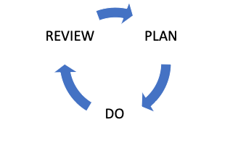
Figure 1. Learning Cycle

Case study 2: Brighton Energy Cooperative
The visual in 2 below illustrates how learning was built into a project by Brighton Energy Cooperative. Through the evaluation of their project, they wanted to learn about where EV chargepoints are most likely to add to the viability of solar PV investments. After sharing this learning, they then gained additional funding to support a wider roll-out of solar PV, including EV chargepoints where viable.

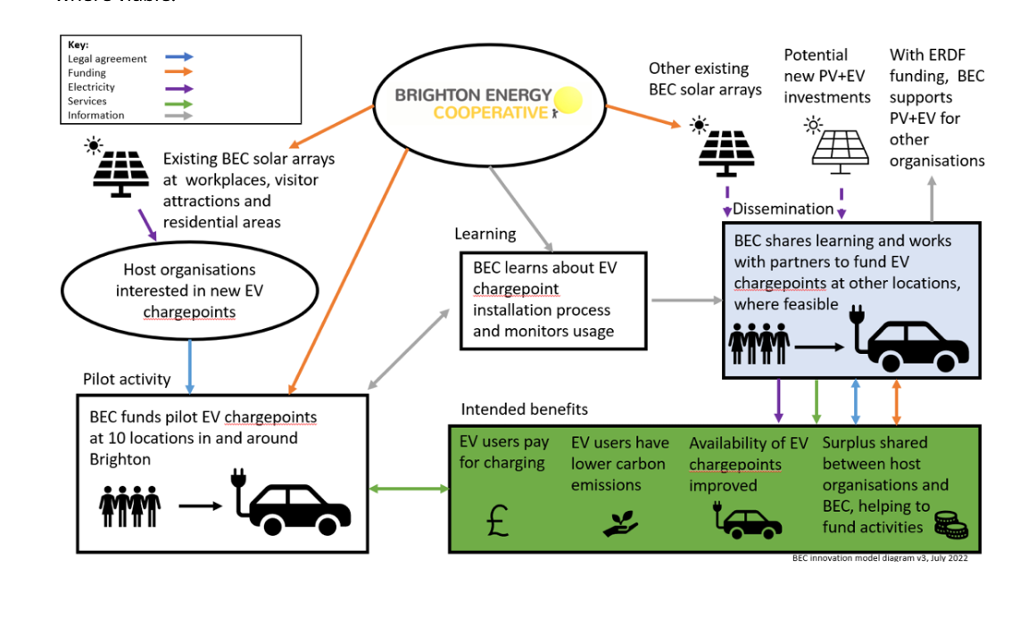
Figure 2. How learning was built into an EV project (Brighton Energy Cooperative)

Case study 3: Reflection workshop, Climate Action Fund project focussing on the food system
This 5-year programme involves over 15 different project partners, all starting and finishing at different times. Every 3 months, partners come together for a meeting, and part of the agenda is dedicated to a learning question on a theme that has been emerging in annual project evaluation reports, such as ‘What are we learning about what it takes to have a community-led approach?’.
While project leads share learnings, comments are put on an interactive whiteboard, as shown in Figure 3. This has the dual benefit of new project partners hearing learnings from more established partners about challenges (e.g. that it can take time to build up trust and relationships with their local community, and therefore more time needs to be built in to this at the early stages of a project), and opportunities (e.g. that more power should be transferred to members of the community, rather than paid staff who come from outside the borough, in order for it to be truly community-led). These learnings are then reflected in future project plans for projects and the programme.

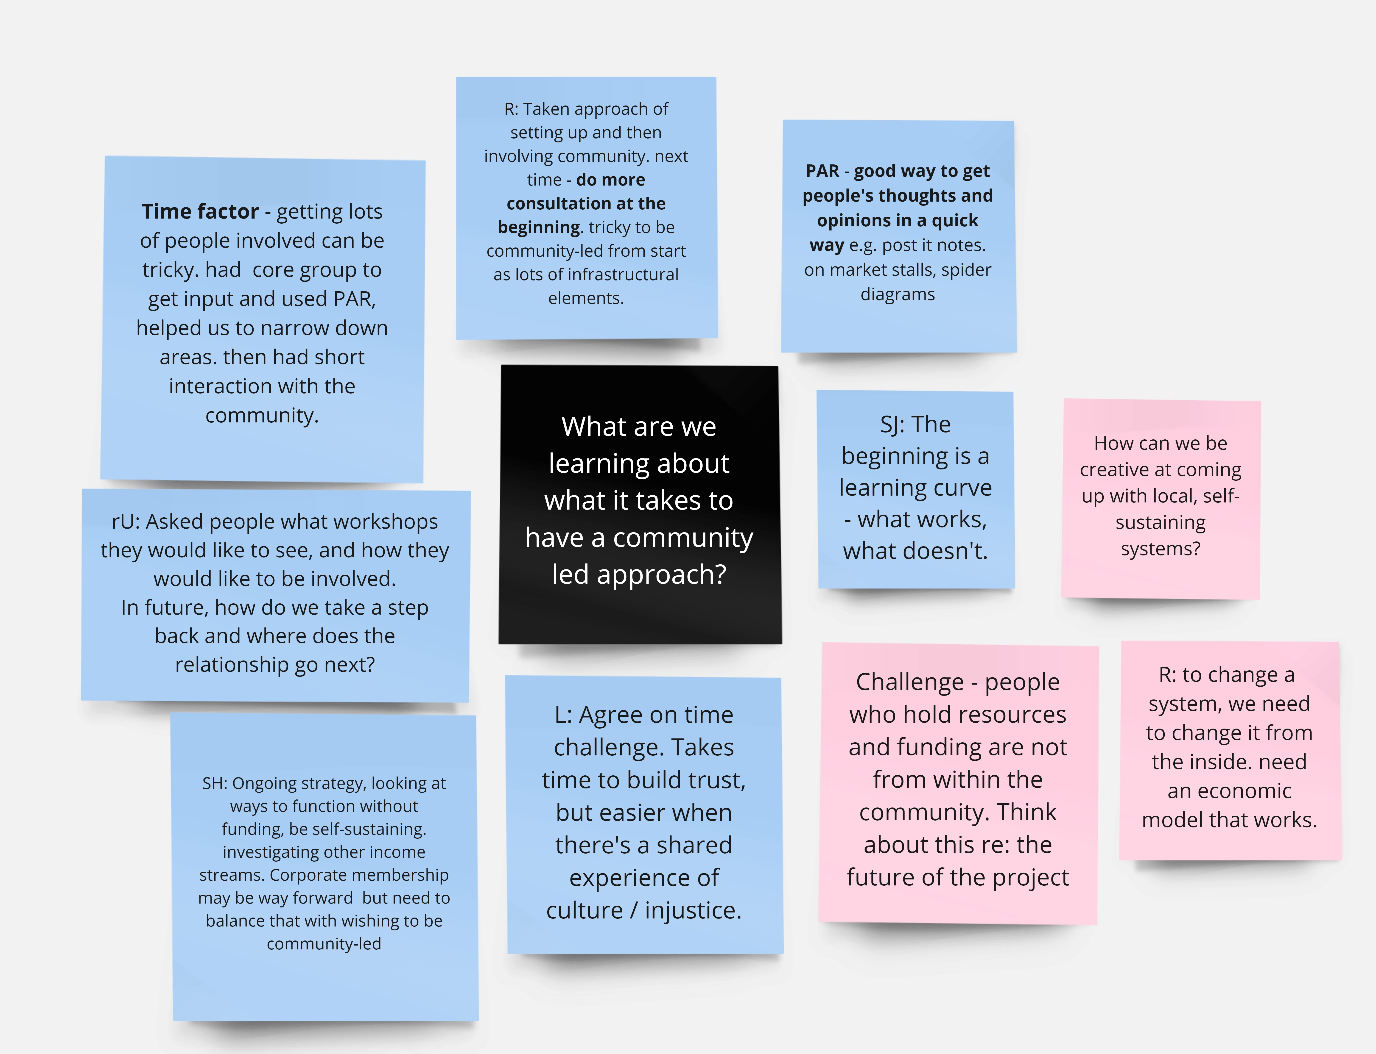
Figure 3: Example of partner reflections for a Climate Action Funded project

