John Muir – Who was he?
Get students to think about who John Muir was and the things he did in life.

John Muir was a Scottish American naturalist, author, environmental philosopher and an early advocate of the preservation of wilderness. He fought to protect wild places for both wildlife and as places where people could go for rest and inspiration. He opposed exploitation of natural resources and was instrumental in bringing about legislation that now forms the basis of protected landscapes around the world.

Task
This game enables students to discover some of the key facts about John Muir and his life. There are a number of ways to use the cards with both groups or as individuals.

In a group
Give out two cards to each person or pair. Go to each person and ask them to read out their fact and decide whether they think it is true or false. Listen to one card from each until all have read one out. Reveal that they are all true. Continue to read the cards out to discover more about John Muir. Ask the group about any they found surprising.
Alternatively, once you have learnt more about John Muir’s life, ask the children to organise themselves into the order in which the events took place. You can find the timeline of John Muir’s life as well as other fantastic resources on the John Muir website.
The facts can provide stimulus for further investigation or research.
Out and about
Place the facts cards along the length of a walk. The group can be given a map with their locations or simply use their observation skills to find them
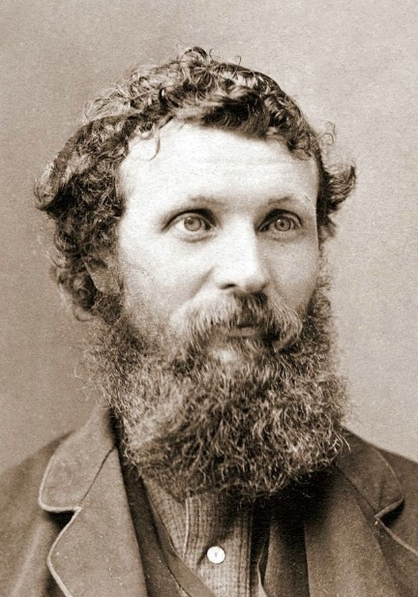
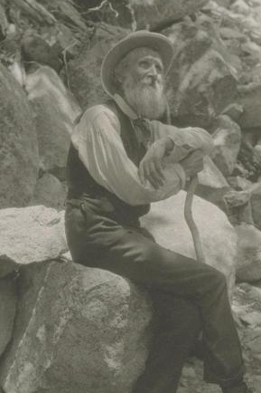
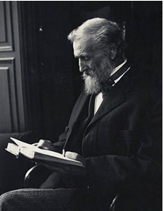

True or False  John Muir was a naughty boy who didn’t listen at school | True or False  John Muir was a Scotsman who spent his childhood in Dunbar
True or False  John Muir was an adventurous lad who dared his friend to jump waves and climb on the roof | True or False  John Muir was a father of two daughters
True or False  John Muir was an inventor who created a “get out of bed machine” | True or False  John Muir was a loyal and dedicated husband
True or False  John Muir was the “father of National Parks” | True or False  John Muir was the third child in a family of eight children
True or False  John Muir was a nature writer who influenced politicians and presidents | True or False  John Muir was a collector of bird’s eggs
True or False  John Muir was a restless spirit. | True or False  John Muir was an immigrant to the United States
True or False  John Muir was a fruit farmer | True or False  John Muir went to the university of Wisconsin-Madison but didn’t graduate
True or False  John Muir was a worker at a sawmill factory | True or False  John Muir was a supervisor at a wagon wheel factory earning $25 a week
True or False  John Muir was blind for 6 weeks in March 1867 | True or False  John Muir wandered over 1,000 miles
True or False  John Muir was an officer in the United States Coast Survey | True or False  John Muir suffered with malaria – it nearly killed him
True or False  John Muir was a shepherd | True or False  John Muir was a climber
True or False  Jonh Muir was a fan of naturalist Ralph Waldo Emerson | True or False  John Muir was a geologist with a special interest in glaciers
True or False  John Muri was a cofounder of the Sierra Club – a local alpine club for mountain lovers | True or False  John Muir was the president of the Sierra Club for 22 years
True or False  John Muir didn’t find writing easy | True or False  John Muir was a published writer of 300 articles and 12 books
True or False  John Muir was a maker of clocks | True or False  John Muir was a world traveller: Australia, South America, Africa, Europe, China, Japan, America, UK
True or False  John Muir was a campaigner for the protection of wild places | True or False  John Muir was a botanist with a deep interest in plants – inspired from a young age

